Aim
To write a Python program to solve the Water Jug Problem and obtain exactly 2 litres of water using a 4-litre jug and a 3-litre jug.

Algorithm
- Start with both jugs empty.
- Fill the 4-litre jug.
- Pour water from the 4-litre jug into the 3-litre jug.
- Empty the 3-litre jug when required.
- Repeat the filling and pouring steps.
- Stop when exactly 2 litres are obtained in the 4-litre jug.
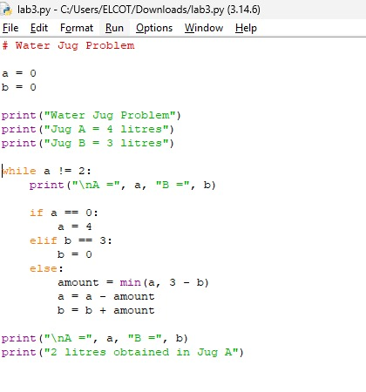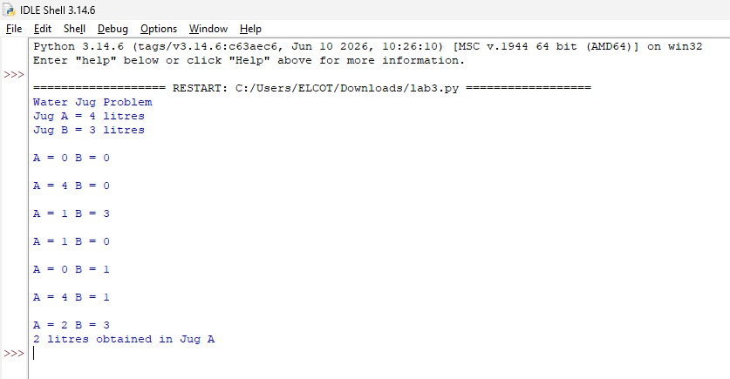

Result :
The Python program successfully solves the Water Jug Problem using a 4-litre jug and a 3-litre jug.

