EXPERIMENT 15
Question: Write the Python program to implement Decision Tree.
Aim:
To write and implement a Python program to demonstrate decision-making using a decision tree based on weather conditions.
Algorithm:
Start the program.
Display the available weather conditions.
Read the weather condition from the user.
If the weather is sunny, read the humidity level.
If humidity is high, decide not to play outside; otherwise, decide to play outside.
If the weather is rainy, decide not to play outside.
If the weather is cloudy, decide to play outside.
Display the decision based on the input.
Stop the program.
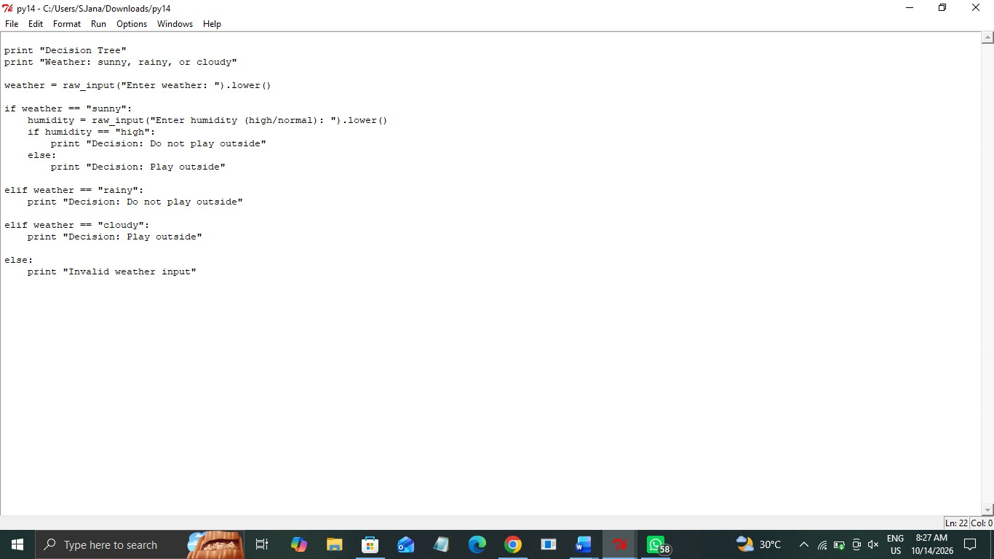
Code:
Output:

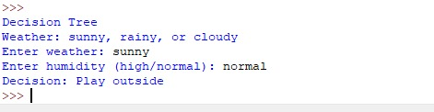

Result:
Thus, the Python program demonstrating decision-making using a tree-like structure was executed successfully, and the appropriate decision was displayed based on the given weather conditions.

