EXPERIMENT 13
Question: Write the Python program to implement Minimax algorithm for gaming.
Aim :
To write and implement a Python program using the Minimax algorithm to determine the best move in a Tic-Tac-Toe game.
Algorithm:
Start the program.
Initialize the Tic-Tac-Toe board with empty positions.
Display the board and allow the human player to enter a move.
Check whether the move is valid.
Check whether either player has won or the game is a draw.
Generate all possible moves for the computer.
Apply the Minimax algorithm to evaluate possible moves and select the best move.
Repeat the process until a player wins or the game ends in a draw.
Display the final board and the result.
Stop the program.
Code:
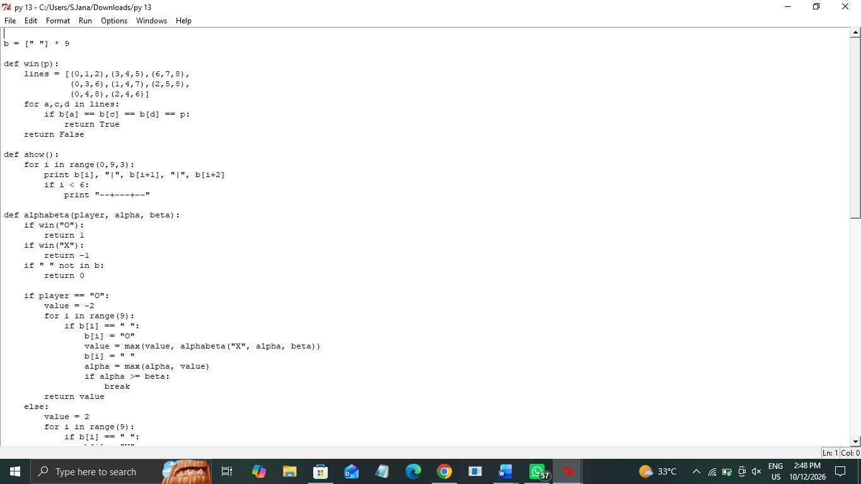

Output:

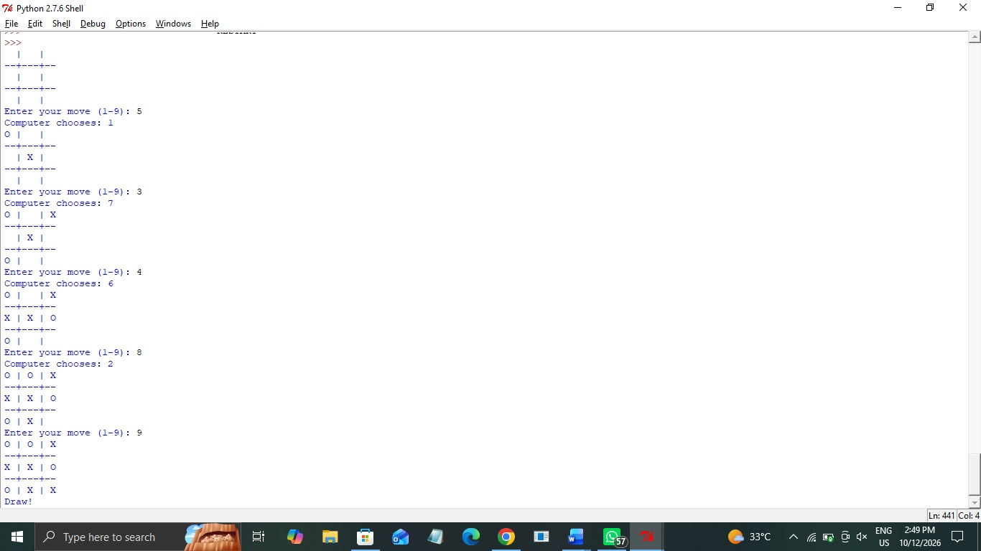

Result:
Thus, the Python program demonstrating decision-making using a tree-like structure was executed successfully, and the appropriate decision was displayed based on the given weather conditions.

