Aim
To write a Python program to solve the 8-puzzle problem using the Breadth-First Search (BFS) method.

Algorithm
- Start with the initial puzzle state.
- Set the goal state as 123456780.
- Find the position of the blank space 0.
- Move the blank space up, down, left, or right.
- Store the new states in a queue.
- Repeat until the goal state is reached.
- Display the solved puzzle.

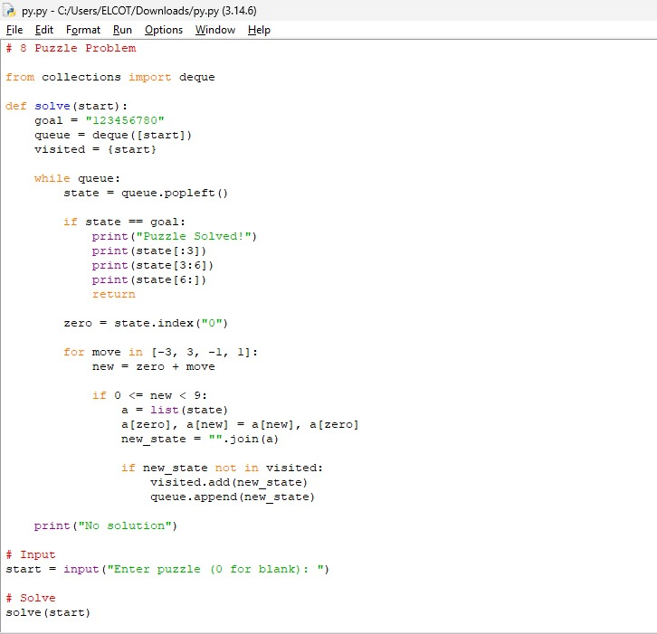

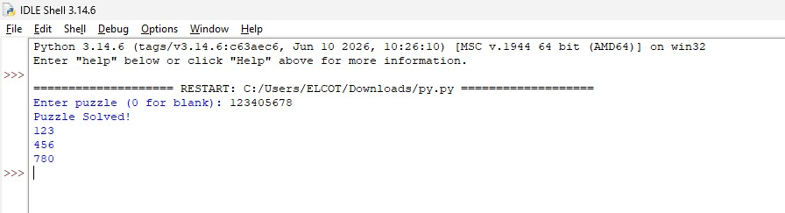

Result
Thus, the 8-puzzle problem was successfully solved using Python and the BFS method.

