EXERIMENT 14
Question: Write the Python program to implement Alpha-Beta pruning algorithm for gaming.

Aim:
To write and implement a Python program using the Alpha-Beta pruning algorithm to optimize the Minimax algorithm in gaming.
Algorithm:
Start the program.
Initialize the Tic-Tac-Toe game board.
Display the board and accept the human player's move.
Check whether the move is valid and update the board.
Check whether a player has won or the game is a draw.
Apply the Alpha-Beta pruning algorithm to evaluate possible computer moves.
Update the alpha and beta values to eliminate branches that cannot affect the final decision.
Select and execute the best move for the computer.
Repeat until a player wins or the game ends in a draw.
Display the final result and stop the progra

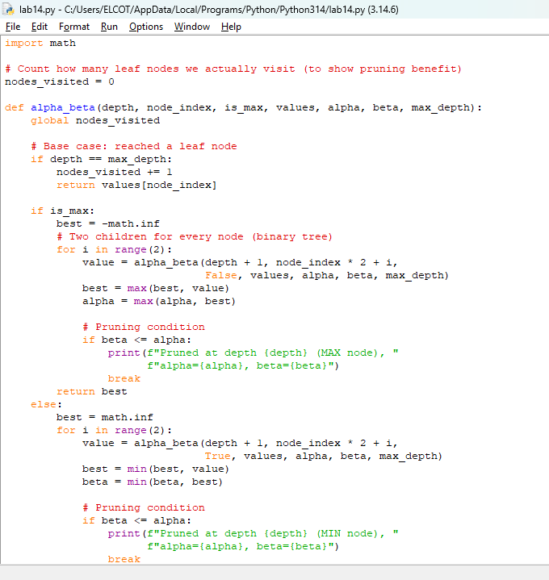
Code:

Output:
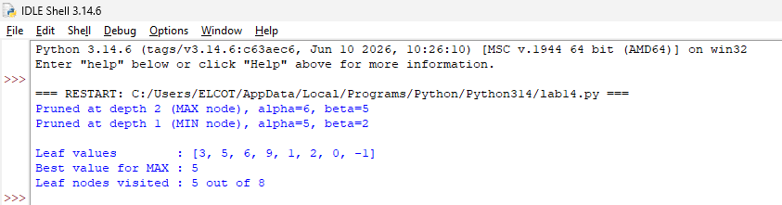

Result:
Thus, the Python program implementing the Alpha-Beta pruning algorithm for gaming was executed successfully, selecting suitable moves while reducing unnecessary search.

