EXPERIMENT 7

Question:

Write the python program for Implement BFS

Aim:
To write a Python program to implement Breadth First Search (BFS) for traversing a graph.

Algorithm:
- Start.
- Create a graph using an adjacency list.
- Take the starting node as input.
- Create an empty list visited and a queue. Put the starting node in both.
- Remove the first node from the queue and print it.
- Add all its unvisited neighbours to visited and to the queue.
- Repeat steps 5 and 6 until the queue is empty.
- Stop.

Code:

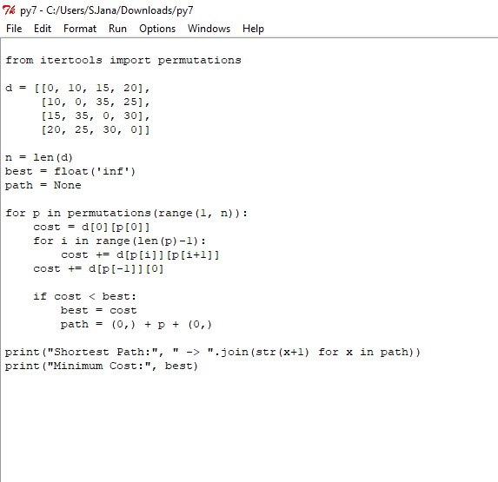

Output:

Result
The program ran successfully.
- The BFS started from node A.
- It first visited A, then the neighbours of A, which are B and C.
- Next, it visited the neighbours of B, which are D and E.
- At last, it visited F.
- The nodes were visited level by level, and the output was A B C D E F.

