EXPERIMENT 10
Question: Write the Python program to implement A* algorithm.
Aim: To write a Python program to implement the A* search algorithm to find the shortest path between a start node and a goal node.
Algorithm:
1. Start the program.
2. Read the number of nodes, adjacency matrix, heuristic values, start node, and goal node.
3. Initialize the cost of the start node to zero.
4. Select the node with the minimum evaluation function \(f(n)=g(n)+h(n)\), where \(g(n)\) is the path cost and \(h(n)\) is the heuristic value.
5. Expand the selected node and update the costs of its neighboring nodes.
6. Repeat until the goal node is reached or no path is available.
7. Display the shortest path and total cost.
8. Stop the program.

Code:
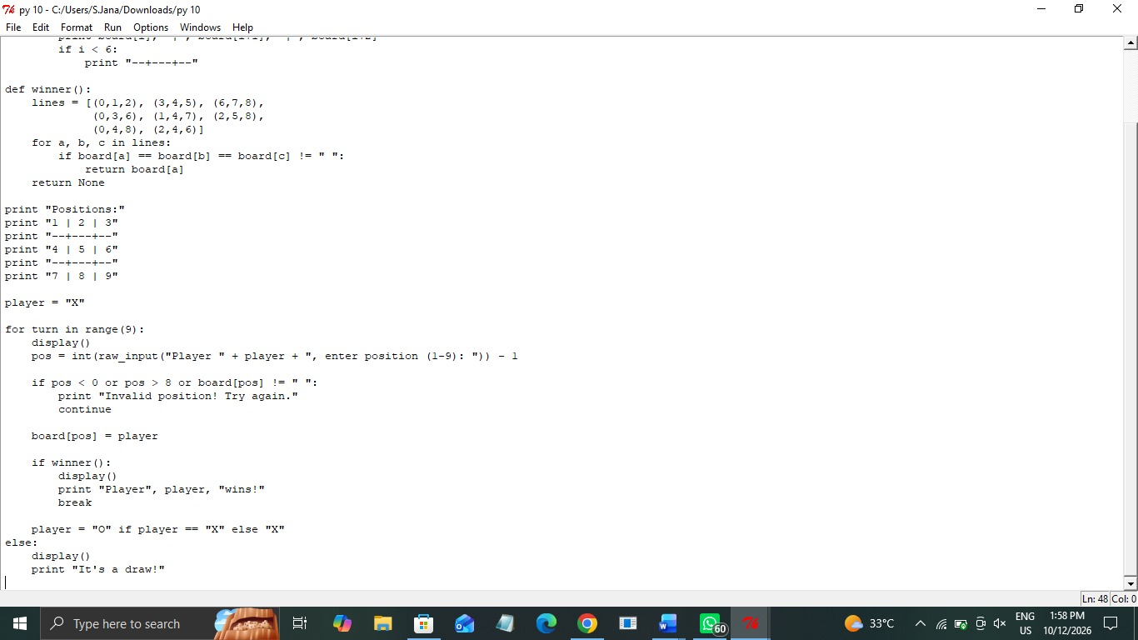

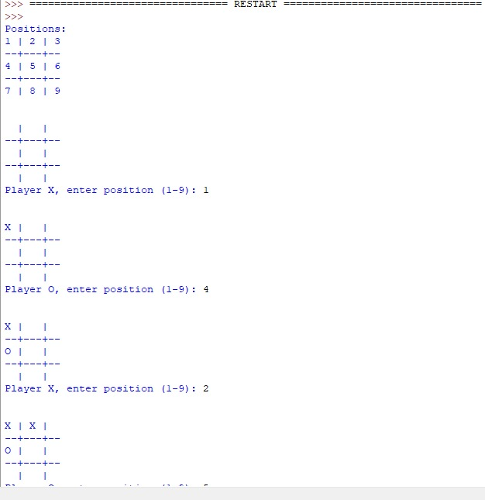
Output:
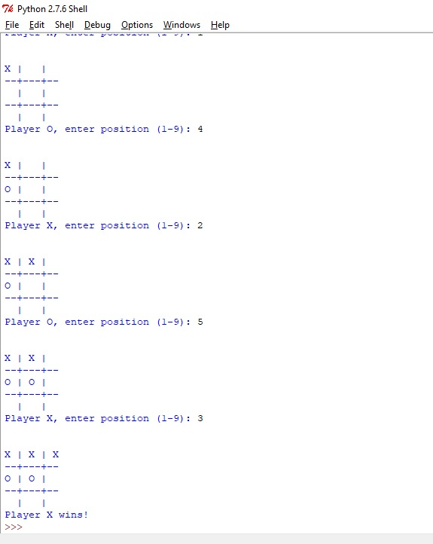
Result: Thus, the Python program implementing the A* search algorithm was executed successfully, and the path and its total cost were obtained.

