Aim
To write a Python program to solve the Crypt-Arithmetic Problem SEND + MORE = MONEY using permutations and find the value of each letter.

Algorithm
- Start the program.
- Import the permutations function.
- Generate different digit combinations for the letters S, E, N, D, M, O, R, Y.
- Make sure S and M are not zero because they are the first digits.
- Form the numbers SEND, MORE, and MONEY.
- Check whether SEND + MORE = MONEY.
- If the condition is true, display the solution.
- Stop the program.
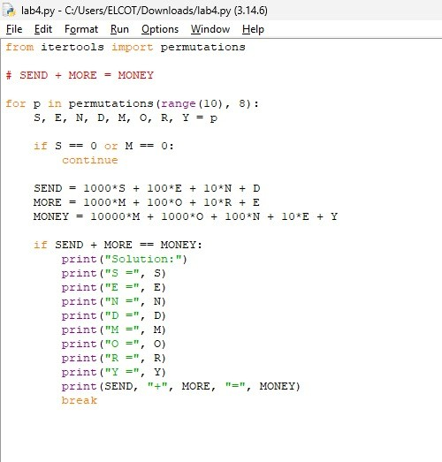

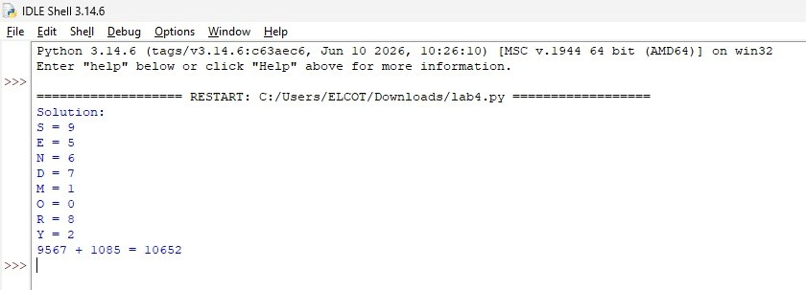

Result :
The program successfully solved the problem.
SEND + MORE = MONEY
9567 + 1085 = 10652

