EXPERIMENT 11
Question : Write the Python program for Map Coloring to implement CSP.
Aim:
To write a Python program to solve the Map Coloring Problem using a Constraint Satisfaction Problem (CSP), ensuring that no two adjacent regions have the same color.
Algorithm:
1. Start the program.
2. Read the number of regions, available colors, and adjacency matrix.
3. Assign a color to the first region.
4. Check whether the selected color conflicts with any adjacent region.
5. If there is no conflict, assign the color and proceed to the next region.
6. If a conflict occurs, try another color using backtracking.
7. Repeat until all regions are colored or no valid solution exists.
8. Display the color assigned to each region or report that no solution exists.
9. Stop the program.

Code:
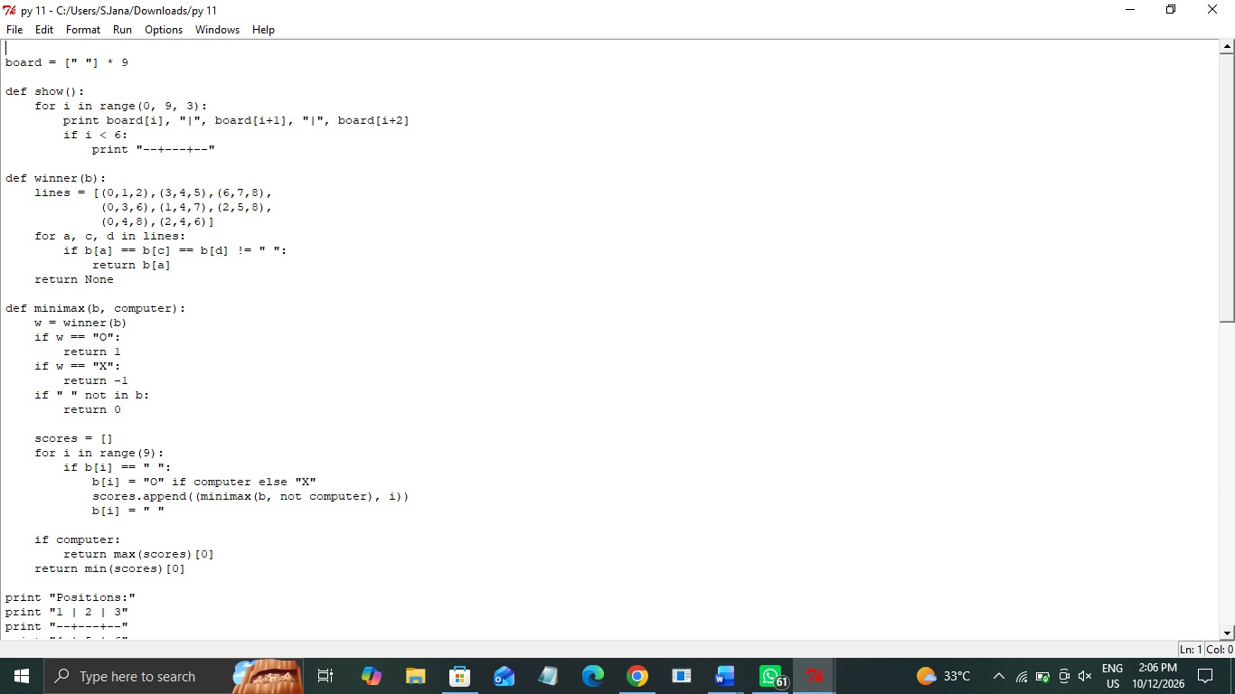
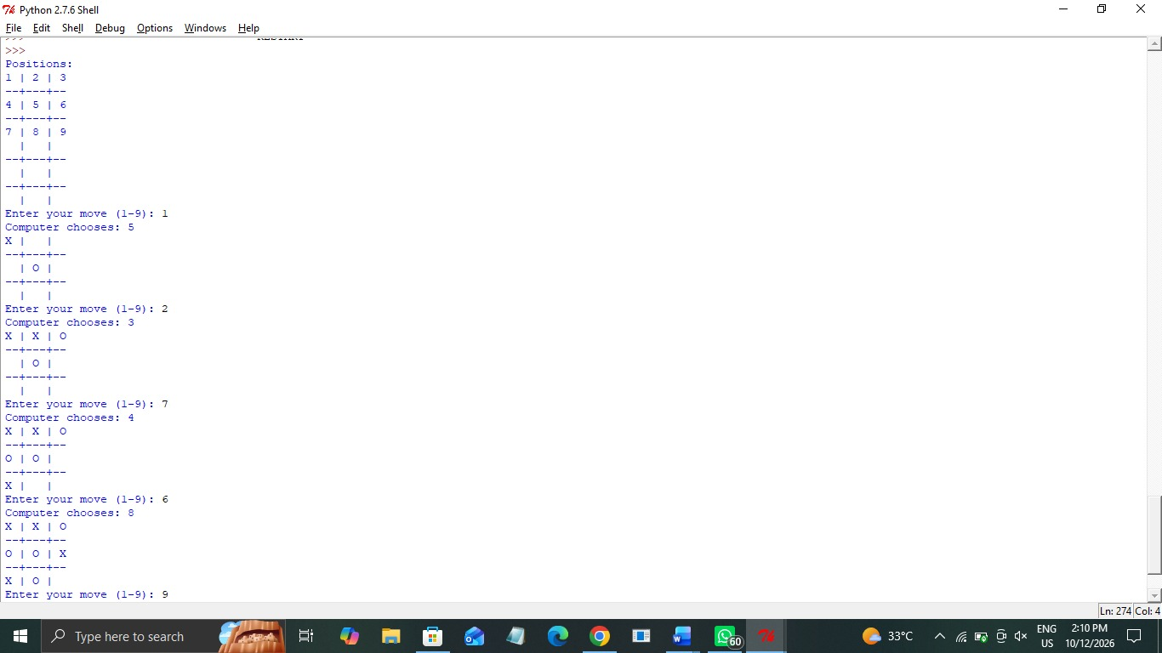
Output:
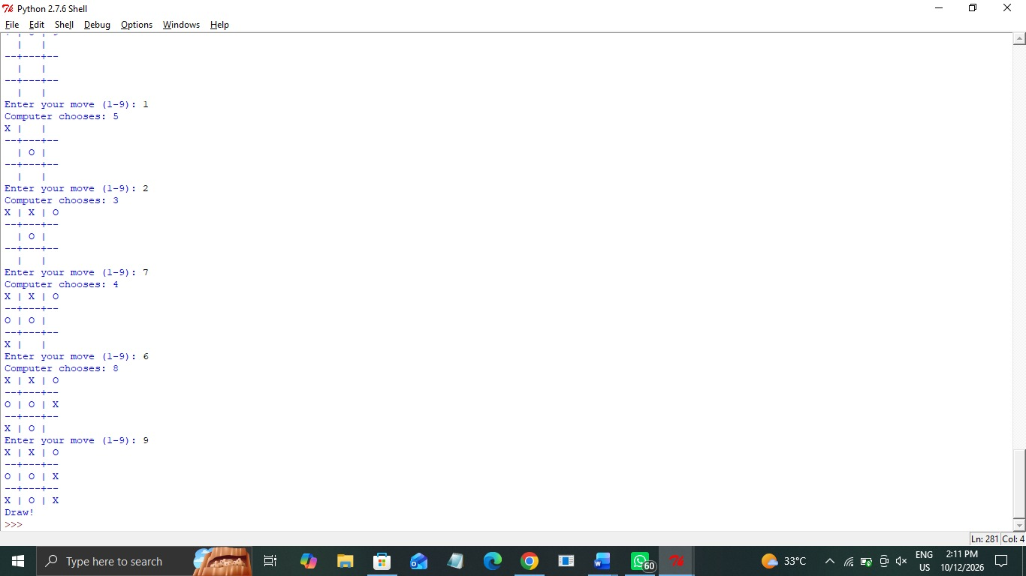

Result: Thus, the Python program to solve the Map Coloring Problem using CSP was executed successfully, and a valid coloring solution was obtained.

