EXPERIMENT 12
Question: Write the Python program for the Tic Tac Toe game.
Aim: To write a Python program to implement the Tic-Tac-Toe game for two players and determine the winner or draw.
Algorithm:
1. Start the program.
2. Initialize a 3 × 3 game board with empty positions.
3. Display the board with position numbers from 1 to 9.
4. Allow the players X and O to enter their moves alternately.
5. Check whether the selected position is valid and empty.
6. After each move, check whether a player has completed a row, column, or diagonal.
7. If a winning condition is satisfied, display the winner.
8. If all positions are filled without a winner, declare a draw.
9. Stop the program.

Code:
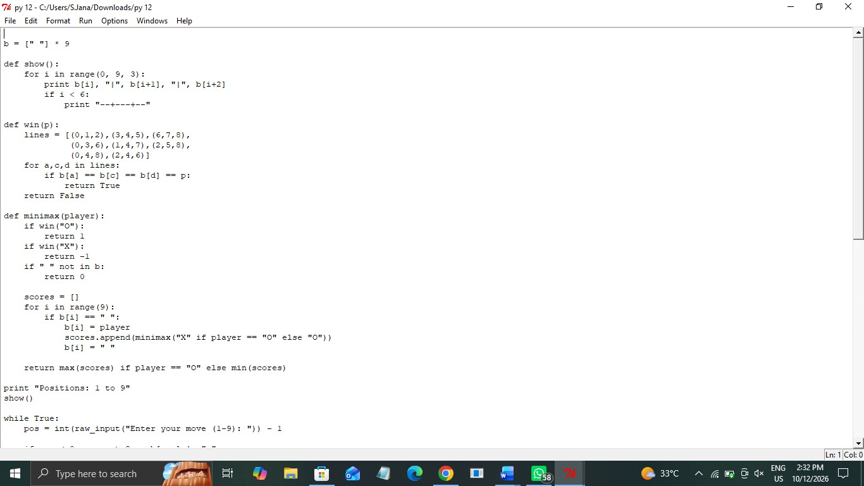

Output:

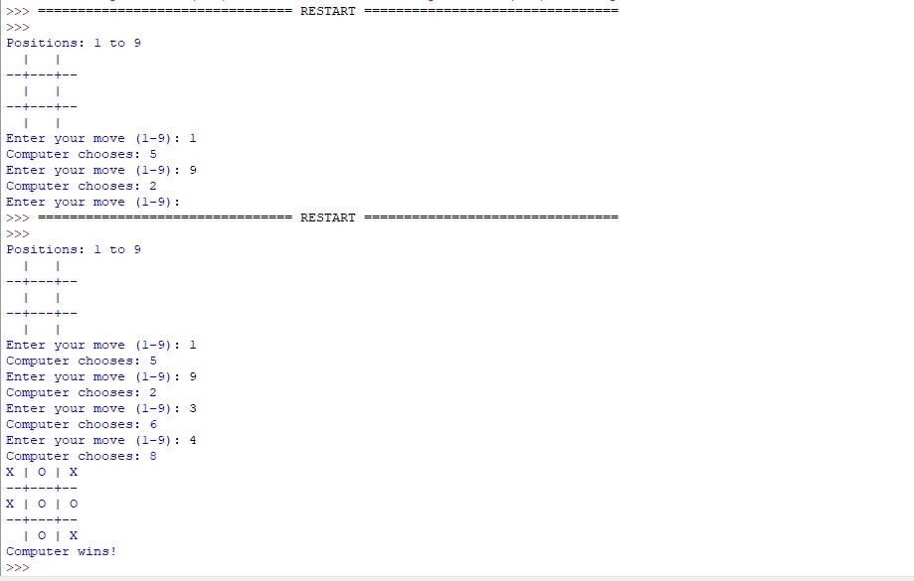

Result: Thus, the Python program to implement the Tic-Tac-Toe game was executed successfully, and the winner or draw was determined based on the game conditions.

