Aim
To write a Python program to solve the Missionaries and Cannibals Problem.

Algorithm
- Start the program.
- Set the initial state as (3, 3, 1).
- Generate possible boat movements.
- Check whether each new state is safe.
- Store the safe states in a queue.
- Continue until the goal state (0, 0, 0) is reached.
- Display the solution.
- Stop.

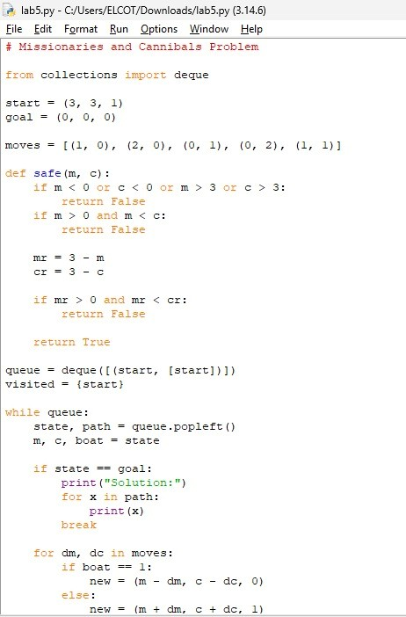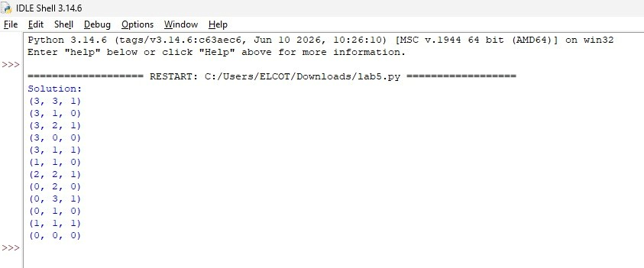

Result :
The program successfully finds a safe solution for the Missionaries and Cannibals Problem.

