**A Self-report Measure for Familiarity with Mental Silence**

*Joshua N. Pritikin and Karen Schmidt*

**Abstract**

The psychological state of complete mental silence is introduced. Although mental silence is an elusive state that may not yield to direct investigation, people commonly report that an episode of mental silence is a memorable experience. A new 10-item measure of familiarity with mental silence is proposed. 570 students from the local human subjects pool and 362 web surfers completed the measure. Data were analysed using Item Response Theory. Two items are explored in depth by comparing model predictions to actual data. Additional data collection and revision to the items are planned.

**Key Words:** Mental silence, self-report, Item Response Theory

**\*\*\*\*\***

**1. Introduction**

Is there a wakeful mental state during which there is a temporary cessation of thought? To approach mental silence is to reduce mental content including re-presentations of sensory input, such as imagination. Mental silence is an experience in which one is no longer thinking and no longer feels the urge to continuously engage in thought. The experience occurs in a normal, lucid waking state. Mental silence is not sleep or unconsciousness. Complete mental silence subsumes other prescriptions imposing limitations on permissible thought. For example, the notion of choiceless awareness considers the presence and action of choice as indicating confusion and, potentially, bias.[1] If there are no thoughts then there are no choices. Another example is mindfulness meditation's emphasis on non-judgemental awareness. If there are no thoughts, and consequentially no judgements, then the remaining awareness is non-judgemental. Complete mental silence is the most stringent limitation on permissible types of thought.

The notion of mental silence can be found in Hindu, Buddhist, German mystical, and Jewish mystical traditions.[2] Mental silence is said to be a gateway to self-knowledge. However, it is difficult to answer sceptics. It is not obvious how to cause oneself to experience complete mental silence. A naïve thought suppression approach fails.[3]

Moreover, it is not clear what evidence could conclusively prove that mental silence is a tenable state. If I claim to know arithmetic then you can test me by giving me some problems to solve. For mental silence, thought – the medium of self-report – is itself excluded from the experience. Self-reports concerning the content of mental silence[4] must be considered, at best, analogical and only accurate to some limit. Curiously, there is a comparable situation in the hardest of the hard sciences: mathematics, physics, and information theory. Certain fundamental axioms of these fields cannot be measured or proven with absolute certainty. That is, a certain facet of physical reality is provably unknowable.[5] Therefore, we should not despair but make the best of the situation.

As a topic, mental silence is particularly fascinating because people ostensibly venture into a mental state that is not only unknown but, in some sense, unknowable. The hard limits of physics and mathematics cannot be crossed but, in this case, there is the opportunity to develop personally a first-hand familiarity with this great mystery. To research the content of the experience of mental silence may not be feasible, but people do report that an episode of mental silence is memorable. Therefore, it should be possible to create a scale to assess familiarity with complete mental silence. No pre-existing scale could be found so we set out to create a new one.

likertItem Response Theory (IRT) is a mathematical approach to learning about the relationship between persons and items. One of the motivating factors for the development of IRT was Likert scales (figure 1). Suppose responses are scored from 1 (*Agree*) to 7 (*Disagree*). Although the circles are equally spaced, the psychological difference between adjacent circles in the middle is probably less than the difference between an endpoint and its adjacent circle. With a 10- or 15-point scale, the equal psychological interval assumption is even less tenable. Using sophisticated mathematics, IRT translates ordinal responses back to an interval scale, making them easy to interpret. In addition, IRT can obtain unbiased parameter estimates from an unrepresentative sample, place both items and persons on the same metric, and allow a measure to evolve with new items while maintaining a stable measurement scale.[6]

Figure 1: Example of a 7-point Likert scale

Many ingredients go into designing a new measure.[7] The items should reliably probe all relevant facets of the construct. Which experiences are closely proximate to mental silence? The factor structure needs exploration. Does familiarity with mental silence describe a single dimension or are multiple dimensions involved? How can the dimensions be characterized? Does the new measure correlate strongly with related measures and weakly with unrelated measures? Going beyond self-report, early evidence suggested that mental silence related practices have health effects.[8] Does the new self-report scale correlate with objective physical changes? The present report will begin to address some of these questions.

**2. Method**

*Participants*. Students were recruited through the local psychology human subjects pool and were compensated by partial fulfilment of a course requirement. The first author also reached out to communities with which he was familiar by email and in person.[9] In addition, a web link was published on various lists of psychology web studies May 2012.[10] The web group did not receive any compensation. Demographic data are given in Table 1. Among the web group, 30 had 12 or fewer years of school, 69 had some college coursework, 15 had an associate degree, 102 had a bachelor degree, 136 had a graduate degree, and 10 did not volunteer their educational background. 190 browsed from USA, 59 from India, 41 from Australia, 26 from UK, 12 from Canada, and a few from each of 22 other countries. In the debriefing, participants were encouraged to recruit their friends to participate.

Table 1: Demographics

|  |  |  |  |  |  |
| --- | --- | --- | --- | --- | --- |
| Recruitment | Women | Men | Median Age | 50% within age | Age range |
| Ss Pool | 395 | 173 | 19 | 18-19 | 17-29 |
| Web link | 203 | 151 | 37 | 26-51 | 13-83 |
| Note. Ten subjects did not disclose their sex. | | | | | |

*Questionnaire*. The first author developed the items in consultation with colleagues (see Table 2). Respondents rated each item on a 5-point Likert scale (*Agree*, *Agree somewhat*, *Not sure*, *Disagree somewhat*, *Disagree*). A number of pilot studies were conducted to test and refine the questionnaire. Some participants did not have a clear idea of what was meant by mental silence. To address this problem, an 80-word description of mental silence was developed with an accompanying animated illustration. There was a suspicion that some participants would find it socially desirable to exaggerate their familiarity with mental silence. To reduce demand characteristics, the items were embedded in a larger questionnaire investigating the extremes of the subjective passage of time. Boredom was presented as an opposite to mental silence. Participants were asked to rate the frequency of their experience of mental silence and boredom in various contexts.

Table 2: Scale items

|  |  |
| --- | --- |
| ID | Item |
| NOTA | Complete mental silence is not possible for anybody. |
| NOTS | Complete mental silence is not possible for myself. |
| MET | I have met, in person, someone who is convincingly familiar with complete mental silence. |
| ACCI | I have experienced complete mental silence accidentally. |
| SHAR | I have experienced complete mental silence with others in a shared context. |
| CAUS | I can intentionally cause myself to experience complete mental silence. |
| TEAC | I am able to teach other people how to experience complete mental silence. |
| EVER | I believe that complete mental silence is possible for everybody. |
| PAY | It is ethical to pay money in exchange for learning how to cause myself to experience complete mental silence. |
| TT | I know how to train teachers who can teach people how to experience complete mental silence. |

**3. Results and Discussion**

Of the 932 participants, 126 (14 per cent) were excluded due to missing data. All items were fit to the Generalized Partial Credit Model (GPCM) with standard Gauss-Hermite quadrature of 30 points and a lognormal prior for the discrimination parameters using Parscale 4.1.2328.4 (an implementation of the marginal maximum likelihood estimation method),[11] -2 log likelihood = 20816.14, *Χ2*(223) = 681.6, *p* ≈ 0. In this context, a significant *Χ2* test indicates that the model fit the data poorly. All items were statistically significant at the .05 level except for SHAR, *Χ2*(18), p = .092. Item *Χ2* statistics ranged from 26 (SHAR) to 167 (PAY) with 50 per cent of the statistics between 44 (TT) and 76 (NOTA). Item location standard errors (*SE*s) ranged from 0.039 to 1.134 with 50 per cent between 0.059 and 0.175 and the median at 0.116. Item discrimination *SE*s ranged from 0.007 to 0.127 with 50 per cent between 0.021 and 0.054 and the median at 0.038.

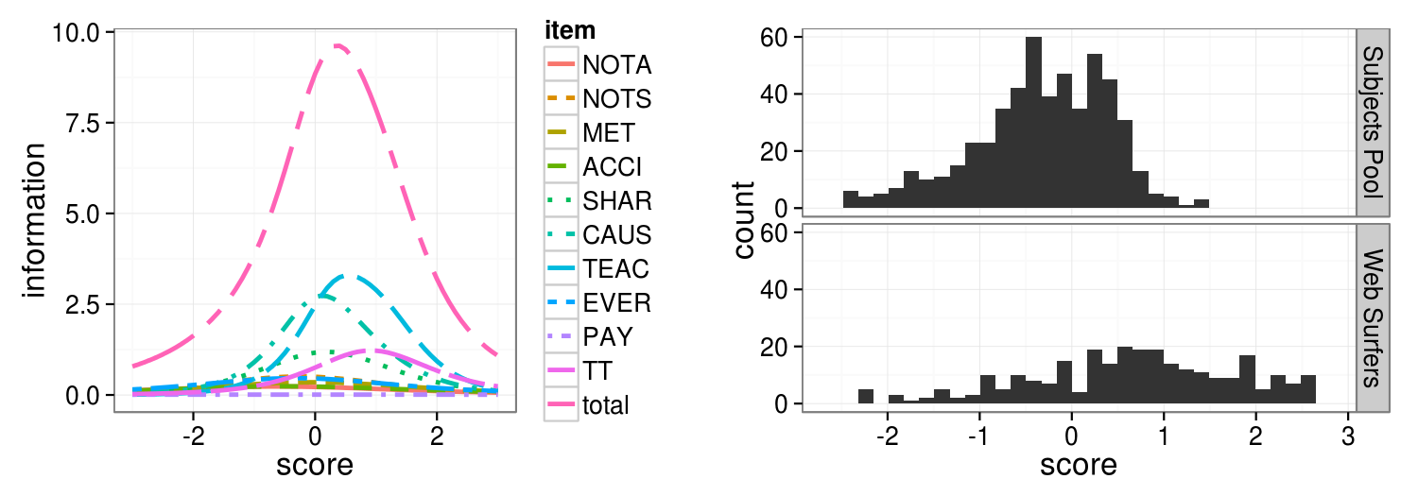

Figure 2: Item and total Fisher information are given on the left. The highest curve is the sum of the shorter per-item curves. Information is the precision of measurement. On the right, exhibited are participant scores by recruitment method.

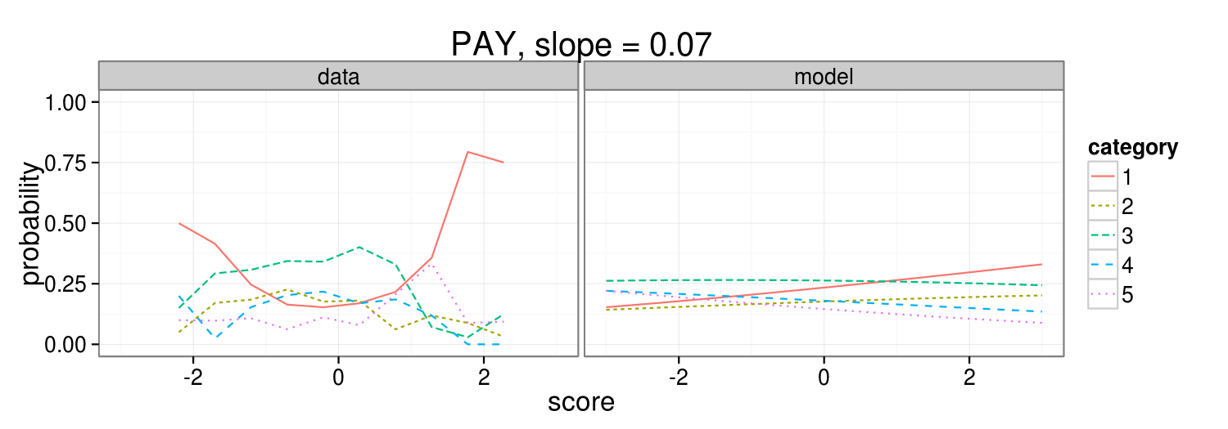For model identification, participant scores were scaled to the standard normal. Fisher information describes measurement precision and higher is better. Maximum total Fisher information was located near a score of 0.4 (Figure 2, left). A potential refinement is to add items to improve measurement of scores less than 0 (people unfamiliar with mental silence). Person score *SE*s ranged from 0.237 to 0.641 with 50 per cent between 0.243 and 0.356 and the median at 0.276. The web group was more familiar with mental silence than were students (Figure 2, right). However, it should not be inferred that internet users are more familiar with mental silence than college students in general. The web group was not a random sample. The first author set out to recruit people he expected to have higher than average scores. For IRT, it is important to sample the full range of the trait under study.

Figure 4: Actual (left) vs. model predicted (right) response curves for PAY.

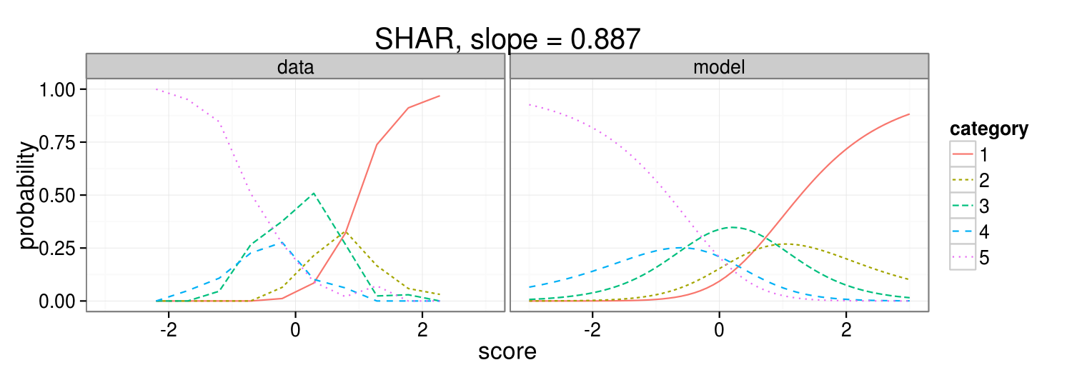One way to gain insight into an IRT model is to compare the predicted model curves to actual responses. In Figure 3, the model curves on the right indicate the predicted proportion of responses for each response category conditional on the examinee’s score. Observed responses proportions are given on the left. For example, near score 0, the observed proportion of category 3 (*Not sure*) is about .4. SHAR was the best fitting item of the scale. The observed proportion for category 3 (*Not sure*) is higher than model prediction near a score of 0. This means that people with average familiarity with mental silence are more likely to endorse *Not sure* than is predicted by the model. Notice that categories 2 (*Agree somewhat*) and 4 (*Disagree somewhat*) in the model are never the most likely category for people to endorse. This can be seen visually by verifying that the blue and dark green curves are always below some other category curve. This suggests that people are fairly certain about whether they have experienced mental silence with others in a shared context. The two *somewhat* categories may not improve the precision of measurement. Reducing the item to 3 categories (*Agree, Not sure, Disagree*) might make the item easier to digest.

Figure 3: Actual (left) vs. model predicted (right) response curves for SHAR.

PAY was the item with the poorest fit (Figure 4). The actual category curves suggest that people with high and low familiarity with mental silence (left and right sides) believe it is unethical to pay money in exchange for learning how to experience mental silence because of the U-shaped curve seen for category 5 (*Disagree*). However, people with a medium familiarity (middle) do not have a consensus opinion (*Not sure* is the most likely response). An item’s discrimination or slope is positively correlated with item information. The model cannot reproduce the U-shape of category 5, resulting in a slope – and information – close to zero. The GPCM assumes an S-shaped or difference of S-shaped curve which is not a good fit for the observed category proportions. Although this item did not work well, the shape of the data may shed light on an interesting dynamic. It is well known that a few spiritual teachers have amassed extraordinary wealth at the expense of their disciples. Other teachers have harshly criticized this practice and insisted that mental silence must be taught gratis or near gratis.[12] However, the ethical status of charging money for mental silence instruction appears fairly unrelated to familiarity with mental silence. Perhaps the question of ethics is best addressed in a separate questionnaire.

In our judgment, the CAUS and TEAC items performed well. Both of these items had a slope near 1.5, efficiently providing information about whether examinees are familiar with mental silence. Only the *Disagree somewhat* category was under used. Space does not allow for a reproduction of the category curves, but visual inspection suggested the model well predicted the data.

We have taken firm steps towards establishing a new scale for assessing familiarity with mental silence. A few of our items work well and a close inspection of poorly performing items suggests opportunities for improvement. During the spring, a new course on contemplative studies will be taught. Students enrolled in the course will be instructed in secular versions of meditation and spiritual practices and will be asked to practice at home. In our collaboration with the course instructors, we will have an opportunity to collect longitudinal data and examine correlation with a diverse range of measures of constructs such as well-being, mindfulness, compassion, cognitive emotion regulation, self-efficacy, stress, and flow.

Many spiritual leaders over the years have exhorted us to ‘Know thyself’. But what does this mean? Where can self-knowledge be obtained and what is its content? Is self-knowledge the awareness of one's mundane talents, qualities, and aspirations, as some scholars seem to believe?[13] Or is self-knowledge something we ought to seek beyond thought in a place we cannot know mentally but can experience viscerally? With a simple self-report measure for familiarity with complete mental silence, we hope to advance consideration of the latter alternative.

**Notes**

1. Jiddu Krishnamurti, *Freedom From the Known*, ed. Mary Lutyens (Harper, 1975), 105-110.
2. Robert K. C. Forman, *The Problem of Pure Consciousness: Mysticism and Philosophy*, (Oxford University Press, 1997); Ramesh Manocha, 'Scientific Evaluation of Mental Silence', (PhD diss., University of New South Wales, Australia, (2009), 93-102.
3. Daniel M. Wegner, 'Thought Suppression and Mental Control', in *Encyclopedia of Cognitive Science* (London: Macmillan, 2003), 395-397.
4. William Franke, *On What Cannot be Said: Apophatic Discourses in Philosophy*, (University of Notre Dame Press, 2007).
5. Cristian S. Calude and Michael A. Stay, 'From Heisenberg to Gödel via Chaitin', *International Journal of Theoretical Physics* 44(7) (2005), 1054-1065.
6. Susan E. Embretson, 'The New Rules of Measurement', *Psychological Assessment* 8(4), (1996) 341-349.
7. David A. Cook and Thomas J. Beckman, 'Current Concepts in Validity and Reliability for Psychometric Instruments: Theory and Application', *The American Journal of Medicine* 119 (2006).
8. Katya Rubia, 'The neurobiology of meditation and its clinical effectiveness in psychiatric disorders', *Biological Psychology* 82(1) (2009), 1-11.
9. Ramesh Manocha, http://www.speakingtree.in, http://imcw.org/, and http://fredericklenzfoundation.org
10. http://psych.hanover.edu/research/exponnet.html; http://www.socialpsychology.org/expts.htm; http://iresearch.deusto.es; and http://beta.in-mind.org/online-research
11. Eiji Muraki and R. D. Bock, *PARSCALE 4 for Windows: IRT based test scoring and item analysis for graded items and rating scales* [Computer software], (Skokie, IL: Scientific Software International, Inc, 2003).
12. “Comments from Shri Mataji,” eds. Derek Ferguson and John Noyce, accessed January 3, 2013, http://sahaja-library.blogspot.com/p/comments-from-shri-mataji.html
13. Simine Vazire and Tim D. Wilson, *Handbook of Self-Knowledge*, (Guilford Publication, 2012).

    **Bibliography**

    Calude, Cristian S. and Michael A. Stay. 'From Heisenberg to Gödel via Chaitin'. *International Journal of Theoretical Physics* 44(7) (2005): 1054-1065.

    Cook, David A. and Thomas J. Beckman. 'Current Concepts in Validity and Reliability for Psychometric Instruments: Theory and Application'. *The American Journal of Medicine* 119 (2006).

    Embretson, Susan E. 'The New Rules of Measurement'. *Psychological Assessment* 8(4), (1996): 341-349.

    Forman, Robert K. C. *The Problem of Pure Consciousness: Mysticism and Philosophy*. Oxford University Press, 1997.

    Franke, William. *On What Cannot be Said: Apophatic Discourses in Philosophy*. University of Notre Dame Press, 2007.

    Krishnamurti, Jiddu. *Freedom From the Known*, edited by Mary Lutyens, 105-110. Harper, 1975.

    Manocha, Ramesh. 'Scientific Evaluation of Mental Silence'. (PhD diss., University of New South Wales, Australia, 2009: 93-102.

    Muraki, Eiji and R. D. Bock. *PARSCALE 4 for Windows: IRT based test scoring and item analysis for graded items and rating scales* [Computer software]. Skokie, IL: Scientific Software International, Inc, 2003.

    Rubia, Katya. 'The neurobiology of meditation and its clinical effectiveness in psychiatric disorders'. *Biological Psychology* 82(1) (2009): 1-11.

    Srivastava, Nirmala. “Comments from Shri Mataji,” edited by Derek Ferguson and John Noyce, accessed January 3, 2013. http://sahaja-library.blogspot.com/p/comments-from-shri-mataji.html

    Vazire, Simine, and Tim D. Wilson. *Handbook of Self-Knowledge*. Guilford Publication, 2012.

    Wegner, Daniel M. 'Thought Suppression and Mental Control'. In *Encyclopedia of Cognitive Science*, 395-397. London: Macmillan, 2003.

    **Joshua N. Pritikin** is a graduate student and **Karen Schmidt** is a professor at University of Virginia. Joshua has practiced Sahaja Meditation for more than 10 years. We report all data exclusions, manipulations, and measures. Design, analysis, paper: J.P. Advice, encouragement: K.S. We thank Jean Hu, Michael Kubovy, and Susanna Williams. Materials and data are available here, http://openscienceframework.org/project/fpxmZ/