
UNIVERSITY OF TRANSPORT AND COMMUNICATIONS FACULTY OF INTERNATIONAL EDUCATION




GRADUATION PROJECT

HIGH-QUALITY PROGRAM OF ENGLISH – VIETNAMESE INFORMATION TECHNOLOGY

Topic
BUILD A PET CARE AND SALE WEBSITE
by

LE VAN A

COURSE 63
CLASS 1

HANOI - JUNE 2026
TABLE OF CONTENTS

Abstract

Acknowledgements

Declaration

Table of Contents

List of Acronyms

List of Figures

List of Tables

Chapter 1. Introduction

1.1 Motivation

1.2 Problem Statement

1.3 Scope and Limitations

1.4 Contributions of the Research

1.5 Structure of the Report

Chapter 2. Background and Related Work

2.1 Large Language Models

2.1.1 Transformer Architecture

2.1.2 Notable LLM Families

2.1.3 LLM Limitations and Hallucination

2.2 Retrieval-Augmented Generation

2.2.1 General RAG Architecture

2.2.2 Vector Embeddings and Similarity Search

2.2.3 Chunking Strategies

2.2.4 Advanced RAG Techniques

2.3 Foundational Technologies

2.3.1 Vector Database — Qdrant

2.3.2 Multilingual Embedding — BGE-M3

2.3.3 Containerization and Kubernetes

2.3.4 CI/CD Pipelines

2.3.5 Observability Stack

2.4 Related Work

2.5 Research Gap and Project Positioning

Chapter 3. Data Construction and Processing

3.1 Data Sources and Corpus Construction

3.1.1 Vietnamese Medical Journals (VMJ OJS)

3.1.2 MedlinePlus

3.1.3 NCBI Bookshelf

3.1.4 World Health Organization (WHO)

3.2 Data Preprocessing and Normalization

3.2.1 PDF Extraction and Text Normalization

3.2.2 JSONL Schema and Metadata Fields

3.3 Pre-Ingest Quality Assurance

3.3.1 Three-Layer QA Gate

3.3.2 Composite Score Threshold

3.4 Dataset Versioning and Migration

Chapter 4. System Design and Implementation

4.1 System Architecture Overview

4.2 RAG Retrieval Pipeline

4.2.1 Structure-Aware Chunking

4.2.2 Embedding and Indexing

4.2.3 Query Rewriter

4.2.4 Query Router

4.2.5 Auto Filter Detector

4.2.6 Post-Processing

4.2.7 Article Aggregator

4.2.8 Evidence Extractor

4.3 Answer Generation

4.3.1 System Prompt Design

4.3.2 Coverage Scorer

4.3.3 Conflict Detector

4.3.4 Guardrails

4.4 User Interface

4.4.1 Streamlit Chat Interface

4.4.2 Multi-Turn Conversation and Session Management

4.5 Cloud-Native Deployment Architecture

4.5.1 Containerization

4.5.2 Kubernetes Deployment on GKE

4.5.3 Infrastructure-as-Code with Terraform

4.5.4 CI/CD Pipeline

4.5.5 Observability Stack

4.6 Security Design

Chapter 5. Experiments and Evaluation

5.1 Experimental Setup

5.1.1 Hardware and Software Environment

5.1.2 Dataset Statistics

5.1.3 Models Used

5.2 Retrieval Evaluation

5.2.1 Evaluation Methodology

5.2.2 Results on Vietnamese Corpus

5.2.3 Results on English Corpus

5.2.4 Retrieval Error Analysis

5.3 End-to-End QA Evaluation

5.3.1 Synthetic Gold Dataset Pipeline

5.3.2 Evaluation Metrics

5.3.3 Results on Dev and Holdout Sets

5.3.4 Generation Error Analysis

5.4 System Performance Evaluation

5.5 Comparison with Baseline Approaches

5.6 Discussion

Chapter 6. Conclusion and Future Work

6.1 Conclusion

6.2 Limitations

6.3 Future Work

References

Appendix A. System Configuration

Appendix B. Prompt Engineering Details

Appendix C. Evaluation Details

Appendix D. System Screenshots

LIST OF FIGURES
Figure 1.1 Search function 14
Figure 1.2 Figure classification function 14
Figure 1.3 Cart Functions- Petmart 15
Figure 1.4 Payment Functions- Petmart 16
Figure 1.5 Search function - Paddy 17
Figure 1.6 Filter function - Paddy 17
Figure 1.7 View Product Details - Paddy 18
Figure 1.8 Cart Functions - Paddy 19
Figure 1.9 Payment Functions - Paddy 19
Figure 1.10 Functions to receive online notifications - Paddy 20
Figure 1.11 Online Consultation Functions - Paddy 20
Figure 1.12 Catalog Classification Functions - Paddy 21
Figure 2.1 .Net Framework 24
Figure 2.1 Database Management System 25
Figure 3.1 General use case Diagram 29
Figure 3.2 Order case diagram 31
Figure 3.3 Registration case Diagram 32
Figure 3.4 Product Management Case Diagram 33
Figure 3.5 Sales invoice management case Diagram 35
Figure 3.6 Statistical report use case diagram 36
Figure 3.7 Order function action diagram 33
Figure3.8 Order management function action diagram 34
Figure 3.9 Order function sequential diagram 35
Figure 4.1 Login screen 50
Figure 4.2 Registration screen 51
Figure 4.3 Home screen 52
Figure 4.4 Pet list screen 53
Figure 4.5 Product List Screen 53
Figure 4.6 Service list screen 54
Figure 4.7 Deposit Registration Screen 54
Figure 4.8 Intro Screen (1) 55
Figure 4.9 Introductory Screens (2) 55
Figure 4.10 Personal InFigureation Screen 56
Figure 4.11 Customer Support Management Screen 57
Figure 4.12 Account Management Screen 58
Figure 4.13 Employee Management Screen 59
Figure 4.14 Customer Management Screen 60
Figure 4.15 Permissions Screen 61
Figure 4.16 Product Management Screen 62
Figure 4.17 Customer Management Screen 63
Figure 4.18 Pet Management Screen 64
Figure 4.19 Deposit Management Screen 65
Figure 4.20 Invoice Management Screen 66
Figure 4.21 Statistical Report Screen (1) 67
Figure 4.22 Statistical Report Screen (2) 67

LIST OF TABLES
Table 1.1 Functional Dashboard 21
Table 3.1 Agent description table 27
Table 3.2 Use case description table Select cart 29
Table 3.3 Table describing the Reservation log use case 31
Table 3.4 Product Management Case Description Table 32
Table 3.5 Sales Invoice Management Case Description 34
Table 3.6 Description table of statistical report cases 35
Table 3.7 Account Table 44
Table 3.8 Customer Table 44
Table 3.9 Employee Table 44
Table 3.10 Table Products 45
Table 3.11 QR Code Table 45
Table 3.12 Pet Board 45
Table 3.13 Billitems 46
Table 3.14 Bill 46
Table 3.£15 Image 46
Table 3.16 Table Reservation 47
Table 3.17 Panel Screen 47
Table 3.18 Service Table 47
Table 3.19 Support Table 47
Table 3.20 UserScreen Tables 48
Table 3.21 Slide Boards 48
Table 3.22 TypePet boards 48
Table 3.23 TypePetChilds 48
Table 3.24 PetLog Table 49
Table 3.25 Table Feedback 49
Table 3.26 Rate 49

INTRODUCTION

Why choose the topic

Implementation methods

Layout of the theme
The content of the topic will consist of 4 chapters:

Chapter 1: ….

Chapter 2: …..

Chapter 3: …

Conclude
CHAPTER 1: SURVEYING AND QUESTIONING

Problem

Actual survey criteria

Actual survey subjects

Conduct surveys

PetMart Website Survey

…….

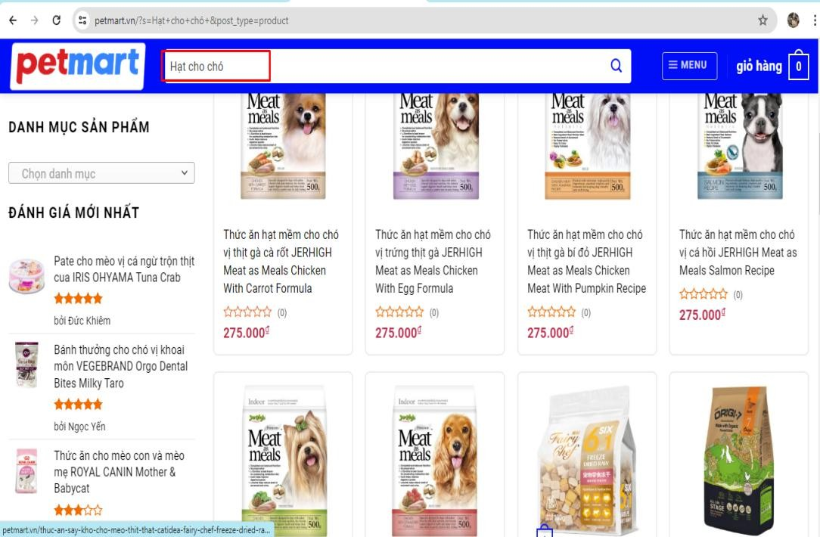

Figure 1.1 Search function

CONCLUSION
In the project, I focus on developing the basic operations of an online sales website:
- Results
- Restrict

- Development direction of the topic

REFERENCES
- Tài liệu về C#: https://itviec.com/blog/lap-trinh-c-2/
- SQL Server documentation: https://datapot.vn/tai-lieu-tu-hoc-sql-tieng-viet-sieu- co-ban-chapter-1/
- .NET Framework documentation: https://codegym.vn/blog/c-la-gi-tim-hieu-ve- ngon-ngu-lap-trinh-
- Website khảo sát: “Paddy.vn”,”Petmart.vn”s

