CEVA Hands Free Profile - HF Unit Design

Revision 1.2, 04 November 2004

CEVA, Inc.

Mary Ross Center,

Holland Road,

Limerick,

Ireland

http://www.ceva-dsp.com

Table of Contents

Table of Contents 2
1 Legend 3
2 Introduction 4
3 Supported Features 4
4 API 5
4.1 Initialisation 6
4.2 Discovery 8
4.3 Service Level Connection and Connection Management 8
4.3.1 API for Service Level Connection and Connection Management. 9
4.3.2 Callbacks for Service Level Connection 10
4.4 Call Handling 12
4.4.1 API Calls 12
4.4.2 API Callback Functions 15
4.4.3 MSCs for Call Handling 18
4.5 Audio Handling 19
4.5.1 API Calls for Audio Handling 19
4.5.2 Audio Callbacks 20
4.6 Supplementary Features and Status Infomation 23
4.6.1 API Calls for Supplementary Features 23
4.6.2 API Calls For Status Information 25
void HF_Read_Phone_Status_Information(t_bdaddr ag_bdaddr) 25
This API allows the user to interrogate the status information pertaining to a give Audio Gateway for each of the following information types : 25
service_status 25
call indicator status 25
call setup status 25
The response is sent in the user in the “HF_CB_Phone_Status_Inf” callback. 25
4.6.3 Callbacks for Supplementary Features 25
4.6.4 Callbacks for Phone Status Information 26
5 Basic Implementation Design 27

Legend
AG Audio Gateway
BT Bluetooth
CLIP Calling Line Identified Party
HF Hands Free
HFP Hands Free Profile
SCN Server Channel Number
SDP Service Discovery Protocol
SLC Service Level Connection

Introduction
This document overviews the design of the CEVA Hands Free Profile for the Hands Free Unit. The main focus of the design documentation is to describe the API which will be presented to the user of the Hands Free Unit.

The API is designed to be feature rich, thus presenting the user with as much information as possible. This is intended to facilitate interworking between the HF and other profiles executing on the Hands Free device.

Supported Features
The features to be supported in the HF unit are shown below in Table 1. While the implementation of the system is restricted to support of these features only, the API has been designed to support the full set of features.

Id | Name | Support
1 | Connection Management | Y
2 | Phone Status Information | Y
3 | Audio Connection Handling | Y
4 | Accept and Incoming Call | Y
5 | Reject an incoming Call | Y
6 | Terminate a Call | Y
7 | Audio Connection Transfer during a call | Y
8 | Place a call using supplied number | Y
9 | Place a call using memory dialing | Y
10 | Place a call to last number | Y
11 | Call Waiting notification | Y
12 | Three Way calling | Y
13 | Calling Line Identification | Y
14 | Echo canceling and noise reduction | N
15 | Voice Recognition activation | Y
16 | Attach a phone number to a voice tag | N
17 | Ability to transmit DTMF tones | Y
18 | Remote Audio Volume Control | N

Table 1 :- Features Supported in the Hands Free Unit

API
To facilitate the description of the API, the operation of the HF unit is divided into a number of separate procedures described below :

1/ HF Initialisation
Initialisation of SDP record for the HF device and registration of callbacks to be used for interfacing to the HF user.

2/ Service Discovery
Performs an SDP search to determine which devices support the HFP AG and the Server Channel Number to be used for connecting to the device is returned.

3/ Service Level Connection
This encompasses the establishment of a connection between the HF unit and the AG. The HFP Unit will support up to 5 links to different Audio Gateways, When an ACL link is not in active use (i.e no SLC established) it will be placed in one of the Bluetooth low power modes. The default low power mode to be used is Sniff mode.

If an SLC is lost due to Link Supervision Timeout the Hands Free Unit will attempt to re-establish the the link to the Audio Gateway – after a timeout period equivalent to the Link Supervision Timeout. If this re-connection fails the user will be informed of the SLC release and no further action will be taken by the Hands Free Unit without user intervention,

4/ Call Handling
This encompasses the establishment of an incoming/outgoing call to the AG. An audio component can optionally be present.

5/ Audio Handling
Encompasses the control of the Audio link normally associated with a call.

6/ Supplementary Features
Control of additional supplementary features (e.g call waiting, calling line id, DTMF transmission).

In the following sections the API calls associated with each of these procedures is described.

Initialisation
Prior to using the HF profile in a system it has to be initialised. This initialisation encompasses the correct setup and configuration of the SDP records for the Hands Free Unit and the registration of the callback functions to be used for interacting with the user.

void HF_Init(u_int8 server_channel_number, t_hf_callbacks* hf_callbacks)
This API call initialises the HF unit.

Parameters
server_channel_number
This is the number which will be stored in the SDP record for the HF unit. This SCN should be used by the AG to connect to the HF unit.

hf_callbacks
A pointer to a structure containing the callback functions to be used for delivery of events to the user. For each type of event there is corresponding member in this structure. Each member is a pointer to the function to be invoked on occurrence of the event.

HF_CB_ Command_Complete
Indicates that a previous API call for call handling is complete.

HF_CB_SLC_Requested_Ind
Informs the user of an incoming SCL request from an Audio Gateway.
HF_CB_SLC_Established_Ind
Indicates a Service Level connection has been setup.
HF_CB_SLC_Released_Ind
Indicates the a Service Level connection has been releases
HF_CB_ServiceDiscoveryResult
Indicates the Address and SCN of an AG found to support the HFP.
HF_CB_Ring_Indication
Ring indication to the user.
HF_CB_Call_Waiting
Indication that there is a call waiting,
HF_CB_Call_Active
Indication that a call has reached the active state.
HF_CB_Call_Alerting
Indication that the remote party is being alerted.
HF_CB_Call_Release_Complete
Indication that a call has been successfully released.
HF_CB_Remote_Supplementary_Feature_Update
Indicate the status of the supplementary features has changed.
HF_CB_Send_DTMF_Complete
Indication that the transmission of a DTMF sequence is complete
HF_CB_Audio_Link_Released
Indicates audio connection released by either the AG or the HF.
HF_CB_Audio_Link_Established
Indicates audio connection has been established, initiated by either the local device or the HF
HF_CB_Volume_Setting_Change_Req
Indicate request from peer to change volume settings is complete.
HF_CB_Change_Volume_Complete
Indicates that the AG has been informed of local volume changes.

HF_ CB_Phone_Status_Inf
Informs the user of a change in phone status information.

returns
none

void HF_Close(void)
This closes the Hands Free Unit and frees any resources which have been allocated to it.

Parameters
None

returns
none

Discovery
void HF_ServiceDiscover_AG(u_int8 timeout)
This API invokes the SDP browse and attribute retrieval to determine if a device supports the Hands Free Profile and to retrieve the Server Channel Number used for the profile in the AG.

Parameters
ag_bdaddr
The BD_Addr of the AG device to which a service level connection can be established.

returns
none

void HF_CB_ServiceDiscoveryResult (u_int8 outcome, t_bdaddr ag_bdaddr, u_int8 service_channel_number)
This callback is used to inform the user that a new AG has been found. Both its Bluetooth address and bluetooth name are presented to the user.

Parameters
Outcome
Indicates if the given BD_Addr supports the HFP Audio Gateway profile.
0 :- No Support in Peer
1 :- Supported in Peer.

ag_bdaddr
The BD_Addr of the AG device to which a service level connection can be established.

service_channel_number
The server channel to be used for the RFCOMM connection to the AG.

returns
none

Service Level Connection and Connection Management
Following Discovery and SDP database interegation the next action to be performed is the establishment of a service level connection between the AG and the HF.

The Service Level Connection can be initiated by either the HF or the AG and consists of the following sequence of steps.

- RFCOMM Connection ( initiated by AG or HF )
- Supported Feature exchange ( initiated by HF )
- Determine supported indicators and indicators status update (initiated by HF)
- Retrieval of Multiparty call handling information (initiated by HF)
- Microphone and Speaker gain settings exchange (initiated by HF)

In the CEVA implementation of the HF, all the standard indicators will be supported. Thus call, service and call setup indicators will be supported and actively used. The HF enables all available indicators in the AG during SLC establishment.

If an SLC is lost due to Link Supervision Timeout the Hands Free Unit will attempt to re-establish the the link to the Audio Gateway – after a timeout period equivalent to the Link Supervision Timeout. If this re-connection fails the user will be informed of the SLC release and no further action will be taken by the Hands Free Unit without user intervention,

API for Service Level Connection and Connection Management.

void HF_Setup_SLC(t_bd_addr ag_bdaddr, u_int16 server_channel_number)
This function initiates a Service level connection between the AG and the HF. It encompasses the establishment of an RFCOMM connection to server channel number presented on the API and the procedures of service level connection establishment as described in Section 4.2 of “Hand-Free Profile Adopted Version 1.0”.

During SLC establishment the HF retrieves the indicators which are supported by the AG. The following standard indications can be supported by this profile

Service Service Availability indication
Call Standard call status indicator call active | call inactive }
Call Setup Optional for the HF in the Bluetooth specification , it will be supported by default in this implementation.

Parameters
ag_bdaddr
The BD_Addr of the AG device to which the Service level connection is to be established.

server_channel_number
The Server Channel Number (SCN) to which the RFCOMM connection is to be established. The SCN is determined from the SDP record of the AG.

returns
none

Once the Service Level Connection (SLC)is established, a callback (HF_CB_SLC_Established_Inf) is given to the user.

void HF_Release_SLC(t_bd_addr ag_bdaddr)
This function initiates the release of the current SLC which exists to the AG. In an Audio link exists to the AG this will automatically be removed. In addition, the removal of the SCL will remove existing L2CAP and ACL connection.

Parameters
ag_bdaddr
The BD_Addr of the AG device to which the Service level connection is to be released.

returns
none

Once the Service Level Connection has been fully is released a callback ( HF_CB_SLC_Released_Ind) is given to the user.

void HF_Accept_SLC(t_bdaddr ag_bdaddr)
This API is invoked by the user to accept an incoming SLC from an Audio Gateway. This primitive is only relevant following receipt of an “HF_CB_SLC_Requested_Ind” callback indicating the same Audio Gateway.

Parameters
ag_bdaddr
The BD_Addr of the AG device to which the Service level connection is to be completed.

returns
none

void HF_Reject_SLC(t_bdaddr ag_bdaddr)
This API is invoked by the user to reject an incoming SLC from an Audio Gateway. This primitive is only relevant following receipt of an “HF_CB_SLC_Requested_Ind” callback indicating the same Audio Gateway.

Parameters
ag_bdaddr
The BD_Addr of the AG device to which the Service level connection is to be rejected.

returns
none

Callbacks for Service Level Connection

void HF_CB_SLC_Established_Ind(t_bdaddr ag_bdaddr)
This callback is invoked when an SLC has been successfully established. This callback is invoked if the SCL is initiated by either the HF user or the remote AG.

Parameters
ag_bdaddr
The BD_Addr of the AG device to which the Service level connection is to be established.

returns
none
This callback can be also be invoked following a successful re-attachment procedure by the Hands Free Unit.

void HF_CB_SLC_Released_Ind( t_bdaddr ag_bdaddr, u_int8 reattaching)
This callback is invoked that when an SLC has been released. This callback is invoked if the SLC is released by either the HF user or the remote AG.

Parameters
ag_bdaddr
The BD_Addr of the AG device to which the Service level connection is to be established.

reattaching
This informs the user if the Hand Free Unit is attempting to re-establish the SLC. The following values are used by this parameter :
0 – Indicates that reattachment will not take place. This can be due to the SLC being explicitely released or after a failed attempt to re-establish the SLC.

1 – Indicates reattachment will be automatically initiated by the Hands Free Unit after a period of time equivalent to the link supervision timeout.

returns
none

void HF_CB_SLC_Requested_Ind(t_bdaddr ag_bdaddr)
This callback is invoked when an SLC has been initiated by the peer. It allow the user to accept or reject the incoming SLC. This primitive is invoked when an RFCOMM DLC is being established for the SCN of the Hands Free Unit.

Parameters
ag_bdaddr
The BD_Addr of the AG device which is establishing the Service level connection.

returns
none

Call Handling
Call handling is the main component of the API for the Hands Free Unit. The following sections describe both the API calls and the callbacks which are available to the user. To facilitate interworking with other profiles (e.g CTP) as much information as possible is transferred to the user. The “call setup” indicators in the AG are enabled prior to any call establishment and these are used to deliver callbacks to the user when the state of a call changes during call establishment.

API Calls
u_int8 HF_Call_Request[t_bdaddr ag_bdaddr, u_int8 Type, char* called_party_num_string, u_int16 memory_id]
This API is used to establishing an outgoing call from the HF unit the AG. The HF profile supports 3 different types of call request which are supported by this API primitive.

Parameters

ag_bdaddr
The BD_Addr of the AG device to which the call is to be established.

Type
- Standard calling using dialled number contained in “called_party_num_string”.
- Memory dialing, the index to the AG phone book memory is given in “memory_id”
- Last Number redial, informs the AG to re-dial the last number.

called_party_num_string
This a null terminated string which is used when a call request of Type 0 is initiated. The string contains the digits to be dialled by the AG (.i.e “+35387617128\0”). If Type 1 or Type 2 call dialing is used then the called_party_num_string is assumed to have the value “\0”.

memory_id
This is an index into the AG phone memory. The AG will start the call establishment procedure using the phone number stored in the AG memory location given by “memory_id”. If Type 0 or Type 2 call dialing is used then the “memory_id” is assumed to have the value 0.

returns
Call_Id
A unique identifier to be used for this outgoing call. This identifier is persistent throughout the call and should be used for Call Release.

When this command is complete HF_ Command_Complete callback is generated.

void HF_Call_Accept[ u_int8 Call_Id ]
This allows the user of the HF device to accept an incoming call, identified by Call_Id. The usage of this API is only valid while the user of the HF is being alerted.

Parameters
Call_Id
A unique identifier to be used for this call. The value is obtained from the Ring_Indication callback. This identifier is persistent throughout the call and should be used for Call Release.
returns
none

When this command is complete HF_CB_Command_Complete callback is generated.

void HF_Call_Reject [u_int8 Call_Id ]
This allows the user of the HF device to reject an incoming call, identified by Call_Id. The usage of this API is only valid while the user of the HF is being alerted.

Parameters
Call_Id
A unique identifier to be used for this call. The value is obtained from the Ring_Indication callback. This identifier is persistent throughout the call and should be used for Call Release.

returns
none

When this command is complete HF_ CB_Command_Complete callback is generated.

void HF_Call_Release [u_int8 Call_Id ]
This allows the user of the HF device to release the currently active call. The usage of this API is only valid while a call is active to the HF unit.

Parameters
Call_id
This is an identifier for the call which was presented to the user during Call_Request or Ring_Indication.
returns
none

When this command is complete HF_ CB_Command_Complete callback is generated.

void HF_Multiparty_Call_Handling[t_bdaddr ag_bdaddr, u_int8 Action ]
This API call allows the user to control Multi-party Call handling in the AG.

Parameters

ag_bdaddr
The BD_Addr of the AG device in which the multipart call handling should be modified.

Action
Determines the action to take in this multiparty call.
- Releases all held calls or sets UDUB for the waiting call.
- Releases all active calls and accepts the held or waiting call
- Places all active calls on hold and accepts the held or waiting call.
- Adds a held call to the conversation.
- Connect both calls and disconnect the subscriber from both calls.

returns
none

When this command is complete HF_CB_Command_Complete callback is generated.

API Callback Functions

void HF_CB_ Command_Complete[t_bdaddr ag_bdaddr, u_int8 API_command_id]
This callback is used to verify to the User that the actions in the AG corresponding to an API call are proceeding. In most cases this is initiated in response to either an “OK” or “+CIEV” command from the AG, in relation to a call control command.

Parameters

ag_bdaddr
The BD_Addr of the AG device to which the API call was targeted.

API_Command_id
1 Call Request [ on Rx of +CIEV(callsetup =2) ]
2 Call Accept [ on Rx of +CIEV(call =0) ]
3 Call Reject [ on Rx of +CIEV(callsetup =0) ]
4 Call Release [ on Rx of +CIEV(call =0) ]
5 Multi-Party Call Handling [ on Rx of OK ]

returns
none

void HF_CB_Ring_Indication[t_bdaddr ag_bdaddr, u_int8 Call_id, char* Clip]
This callback informs the HF user of an incoming call. This callback is repeated as long as the AG continues to the send the AT RING command.

Parameter

ag_bdaddr
The BD_Addr of the AG device which is delivering the incoming call.

Call_Id
A unique identifier for the call. This Identified is to be used when the user wishes to Accept/Reject the call.

Clip
A null terminated string containing the calling phone number digits. If no Clip information is present the user is presented with a null string (e.g. “\0”).

returns
none

void HF_CB_Call_Waiting[u_int8 Call_id, char* Clip]
This callback informs the HF user that there is a call waiting. This callback is only invoked if the HF user previously invoked Call Waiting notification in the AG. Unlike the “Ring_Indication” this callback is not repeated.

Parameter
Call_Id
Unique identifier for the call. This Identified is to be used when the user wishes to Accept/Reject the call.

Clip
A null terminated string containing the calling phone number digits. If no Clip information is present the user is presented with a null string (e.g. “\0”).

returns
none

void HF_CB_Call_Active[u_int8 Call_id]
This callback is invoked when either the AG or the remote party has answered a call. It indicates that the call has reached the active state and the audio connection has been established.

Parameter
Call_Id
A unique identifier for the call. This identifier is to be used when the user wishes to Accept/Reject the call.

Clip
A null terminated string containing the calling phone number digits. If no Clip information is present the user is presented with a null string (e.g. “\0”).

returns
none

void HF_CB_Call_Alerting[u_int8 Call_id]
This callback is invoked for outgoing calls when the AG informs the HF that the remote party is being alerted.

Parameter
Call_Id
A unique identifier for the call. The value of this identifier should be identical to the value returned during the corresponding call request. This Identifier is to be used when the user wishes to Release the call.

returns
none

void HF_CB_Call_Release_Complete[u_int8 Call_Id, u_int8 reason]
This callback is invoked on the completion of either a Call Reject or a Call Terminate by either the HF or the AG.

Parameter
Call_Id
A unique identifier for the call.

Reason
The reason parameter informs the HF user of the reason for dropping the call. The four different reason codes correspond to the four different call release scenarios described in sections 4.9-4.10 of “Hands-Free Profile Adopted Version 1.0” [Ref 1].

- Handsfree User Initiated Call Reject
- AG Initiated Call Reject
- Handsfree User Call Terminate
- AG Initiated Call Terminate

returns
none

MSCs for Call Handling
Figure 1 shows the sequence of API calls and callbacks which take place during a HF unit initiated call. The HF user issues the “HF_Call_Request” API indicated that the call is of Type 0 (full number dialing).

The user receives a “HF_Command_Complete” which indicates that the outgoing call setup has been successfully initiated in the AG. Subsequently the user receives the HF_Alerting callback when the remote party is being altered and finally the “HF_Call_Active” is received when the call has been through connected.

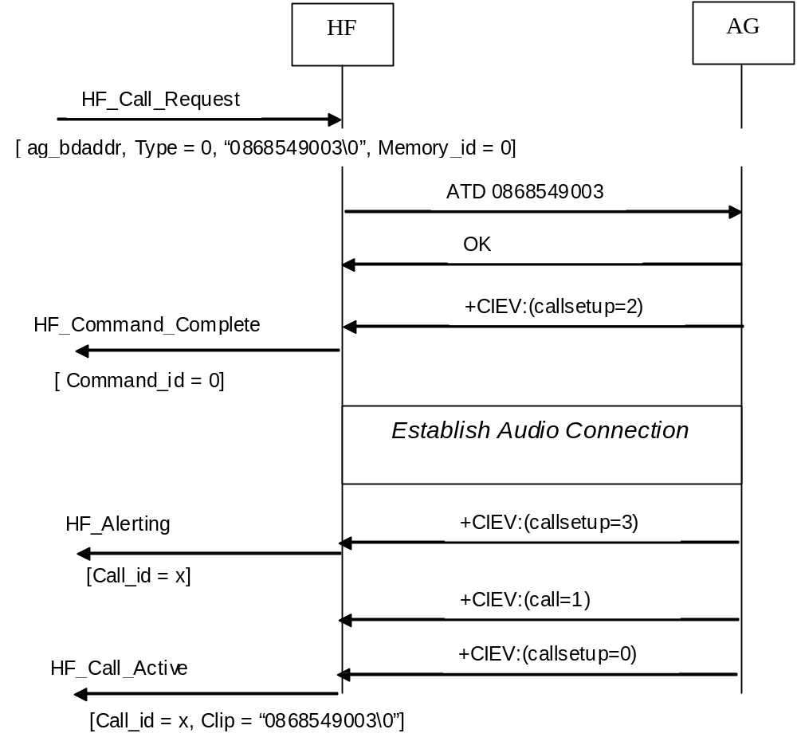

Figure 1 :- Hands Free Unit initiated call setup - number dialing

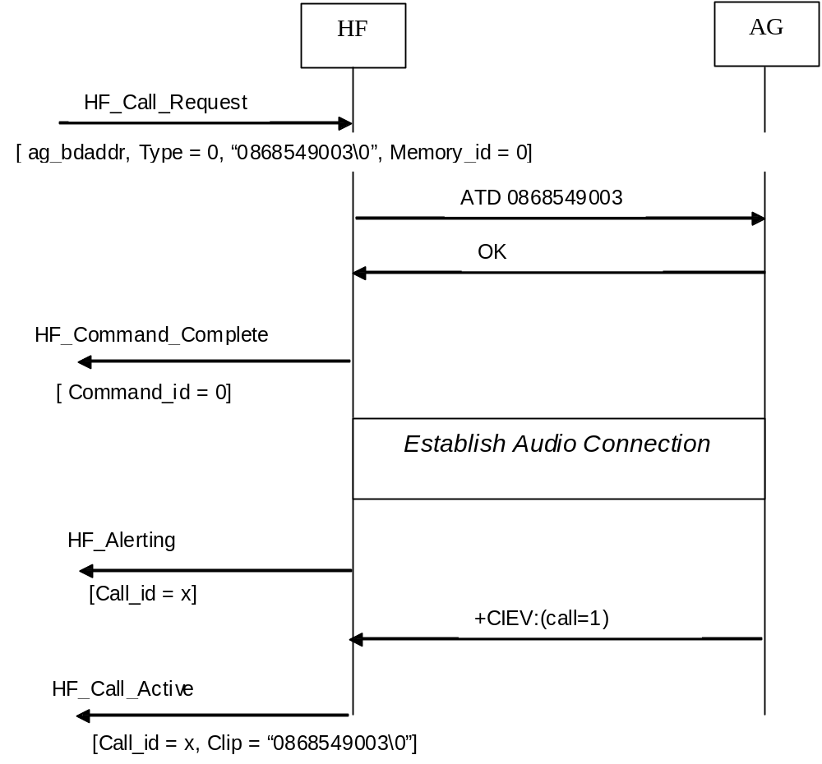

Figure 1 :- Hands Free Unit initiated call setup - number dialing [ no callsetup ind ]

Figure 2 show the sequence of interactions on the API when the Hands Free unit receives an incoming call from the AG. The user repeatedly receives a HF_Ring_Indication containing the Call Id and Calling Line Id (if present). The user accepts the call using the “HF_Call_Accept” and is later informed when the call has been connected using the “HF_Call_Active” callback.
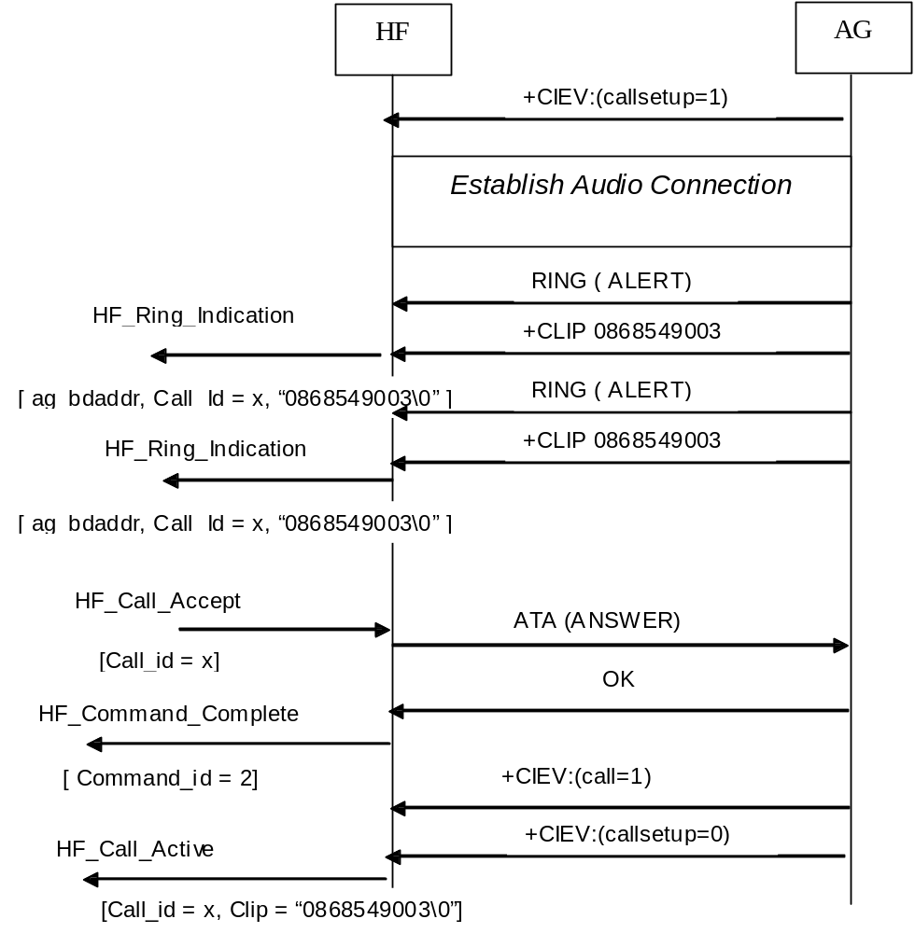
Figure 2 :- AG initiated call setup - HF Accepts

Audio Handling
This section encompasses API calls specific to the handling of the Audio component. The Hands Free Profile allows the Audio link to be established independently of the telephony call. The profile also allows the Audio link for a call to be transferred between the Hands Free unit and the AG.

API Calls for Audio Handling

void HF_Audio_Setup(t_bdaddr ag_bdaddr)
This API call allows the HF user to establish an Audio link to the AG. If no call is active the usage of this API call is not required as normally the AG will autonomously establish the Audio link without intervention from the user, for procedures which require an audio link to be in place.

If a call is in place and the AG has not already established an Audio link to the HF, this API call can be used to initiate an Audio transfer from the AG to the HF unit - as described in section 4.11 of “Hands-Free Profile Adopted Version 1.0”.

Parameters
ag_bdaddr
The BD_Addr of the AG device to which the audio link is to be established.

returns
none

A maximum of one Audio link will exist between the HF and the AG at any time.

void HF_Audio_Release(t_bdaddr ag_bdaddr)
This API allows the HF user to release an Audio link to the AG, if an Audio link is present. If a call is in place this procedure corresponds to “Audio Connection Transfer towards the AG” as described in section 4.12 of [Ref 2].

Calling this API will result in the Service Level connection to the AG being released until the current call is completed. Following the termination of the call, the AG will re-establish the Service Level Connection.

Parameters
ag_bdaddr
The BD_Addr of the AG device to which the audio link is to be established.

returns
none

void HF_Change_Volume_Setting[t_bdaddr ag_bdaddr , u_int8 target, u_int8 volume_setting ]
This API call is used to inform an AG of Micophone or Speaker volume changes in the HF unit.

Parameter

ag_bdaddr
The BD_Addr of the AG device which should be informed of the volume change.

target
Identifies if it is the Micophone or Speaker which needs the gain modification
0 Speaker
1 Microphone

volume_setting
Number in the range of 0-15.

returns
none

Audio Callbacks

void HF_CB_Audio_Link_Released(t_bdaddr ag_bdaddr , u_int16 connection_handle, u_int8 lmp_sco_handle, u_int8 sco_index)
This callback is invoked by the HF when an Audio link has been successfully released. It can also be used to trigger interactions with DSP for the release of Codec resources or control of a voice interworking unit.

Parameters
ag_bdaddr
The BD_Addr of the AG device to which the Audio link existed.

connection_handle
The connection handle used on the HCI interface to uniquely identify the SCO link,

lmp_sco_handle
The SCO handle used by the Link Manager layer to uniquely identify the Audio link to the AG.

sco_index
Propietrary identifier for the Audio link used on the interface to the Audio DSP codec.

returns
none

void HF_CB_Audio_Link_Established(t_bdaddr ag_bdaddr , u_int16 connection_handle, u_int8 lmp_sco_handle, u_int8 sco_index)
This callback is invoked by the HF when an Audio link has been successfully established. It can also be used to trigger interactions with DSP for the configuration of Codec resources or control of a voice interworking unit.

Parameters
ag_bdaddr
The BD_Addr of the AG device to which the Audio link is established.

connection_handle
The connection handle used on the HCI interface to uniquely identify the SCO link,

lmp_sco_handle
The SCO handle used by the Link Manager layer to uniquely identify the Audio link to the AG.

sco_index
Propietrary identifier for the Audio link used on the interface to the Audio DSP codec.

returns
none

void HF_CB_Volume_Setting_Change_Req[t_bdaddr ag_bdaddr, u_int8 target, u_int8 volume_setting ]
This Callback informs the user of a request from the AG to change the volume settings in the HF unit. It corresponds directly to the receipt of a +VGM or +VGS command from the AG.

Parameter
ag_bdaddr
The BD_Addr of the AG device initiating the request to change.

target
Identifies if it is the Micophone or Speaker which needs the gain modification
0 Speaker
1 Microphone

volume_setting
Number in the range of 0-15.

returns
none

void HF_CB_Change_Volume_Complete(t_bdaddr ag_bdaddr)
This callback informs the HF user that a previous API call HF_Change_Volume_Setting has completed and the AG has been informed of the change.

Parameter
ag_bdaddr
The BD_Addr of the Audio Gateway informed of the change.

returns
none

Supplementary Features and Status Infomation
The Hands Free Profile supports a number of supplementary features which can be enabled/disabled in the AG. In addition, DTMF can be transmitted from the Hands Free unit to the AG. The following sub-sections described how the API is used to control these capabilities.

API Calls for Supplementary Features
void HF_Modify_Remote_Supplementary_Feature[t_bdaddr ag_bdaddr,u_int8 feature_id , u_int8 enable]
This API call is used to allow the user of the HF to enable/disable functions in an AG. The user of the HF is informed of the success or failure to modify the remote capabilities using the HF_CB_Remote_Supplementary_Features_Update callback.

Parameters
ag_bdaddr
The BD_Addr of the Audio Gateway in which the supplementary features should be modified.

feature_id
feature id is one of the following values
1 Call Waiting
Call Waiting Notificaition Activation/De-activation (see 4.16 of [Ref 1])
2 Calling Line Identity
Calling Link identification Activation/De-Activation (see 4.18 of [Ref 1])
4 Echo Cancellation and noise reduction
De-activation of EC and NR in the AG (see 4.18 of [Ref 1])
8 Voice Recognition Activation
Activation/De-activation of voice recognition in the AG (see 4.19 of [Ref 1]

enable
- Turns the feature ON in the AG
- Turns the feature OFF in the AG

returns
none

Figure 3, shown the interactions at the API during the modification of Call Line Identity and Call Waiting indicators in the AG.

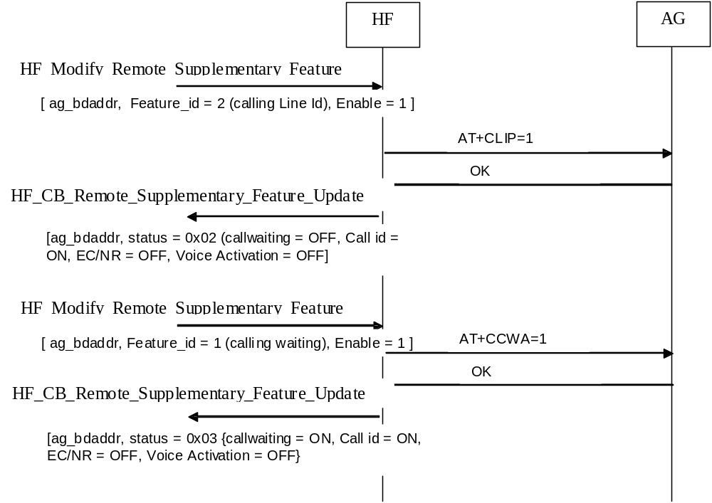
Figure 3 :- Modification of CLIP and Call Waiting Indicators in the AG

void HF_Read_Remote_Supplementary_Feature[t_bdaddr ag_bdaddr]
Request the current status of user controllable features in the AG. The response is returned in the “HF_CB_Remote_Supplementary_Feature_Update” callback.

Parameters
none

returns
none

void HF_Send_DTMF[t_bdaddr ag_bdaddr, char* dtmf_sequence ]
This API call is used to transmit a sequence of DTMF tones to a peer Audio Gateway. Each DTFM tone will be transmitted separately to the AG. When the sequence of DTMF tone transmission is complete, a callback function “HF_CB_Send_DTMF_Complete(..)” will be called.

Parameters

ag_bdaddr
The BD_Addr of the AG device to which the DTMF tones will be sent.

dtmf_sequence
Null terminated string containing only valid DTMF characters ( e.g. “0”-“9”,”#”,”*”, “A”-“D”).

returns
none

Figure 4, shows the interactions which take place for the transmission of a sequence of DTMF tones. The “HF_Send_DTMF” API is called with a sequence of four DTMF characters (i.e 8,6,#,1 ). Each of these is then transmitted separately to the AG. When the AG has acknowledged receipt of the last DTMF character the user is informed using the “HF_CB_Send_DTMF_Complete.

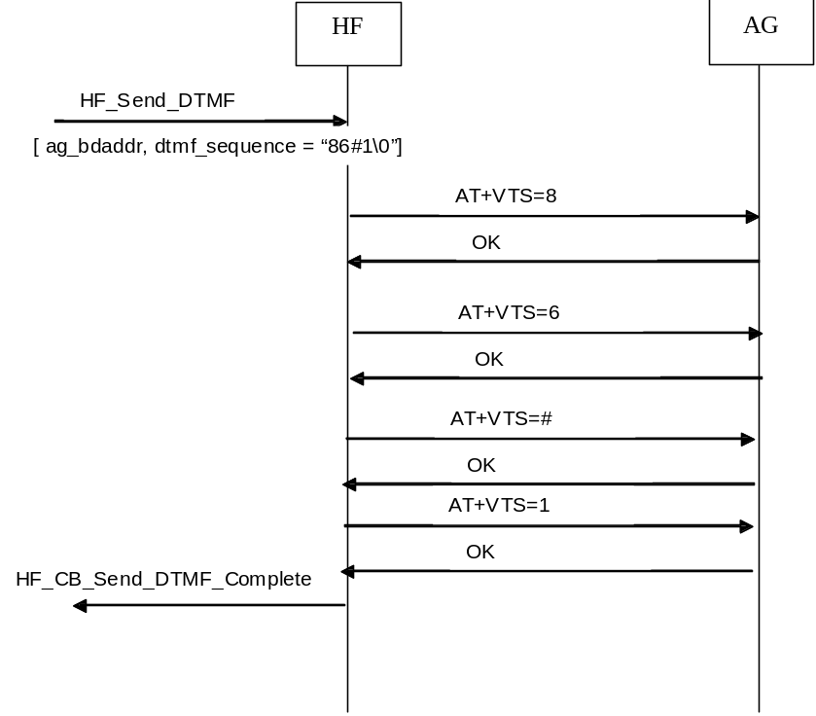
Figure 4 :- Transmission of four DTMF characters from the HF.

API Calls For Status Information

void HF_Read_Phone_Status_Information(t_bdaddr ag_bdaddr)

This API allows the user to interrogate the status information pertaining to a give Audio Gateway for each of the following information types :

service_status

call indicator status

call setup status

The response is sent in the user in the “HF_CB_Phone_Status_Inf” callback.

Callbacks for Supplementary Features
void HF_CB_Remote_Supplementary_Feature_Update [[t_bdaddr ag_bdaddr , u_int8 status_byte]
This callback is invoked when the current status of the four supplementary features has been successfully modified by either the local HF user or the remote AG. It updates the user of the current status of each of these four features.

Parameters

ag_bdaddr
The BD_Addr of the AG device in which the supplementary features have been modified.
status_byte
Byte containing the feature status information. Bit 0-3 of this byte indicate the status of the four supplementary features.

Bit 0 -- Status of Call Waiting ( 0 = OFF, 1 = ON)
Bit 1 -- Status of Calling Line Id ( 0 = OFF, 1 = ON)
Bit 2 -- Status of EC and RN (0 = OFF, 1 = ON)
Bit 3 -- Status of Voice Activation ( 0 = OFF, 1 = ON)

void HF_CB_Send_DTMF_Complete[t_bdaddr ag_bdaddr]
This callback is invoked in response to an API call HF_Send_DTMF.(..). When the HF unit has successfully sent the last DTMF tone, this callback is invoked.

Parameters

ag_bdaddr
The BD_Addr of the AG device to which the DTMF tones were sent..

Callbacks for Phone Status Information

void HF_ CB_Phone_Status_Inf(t_bdaddr address, u_int8 service_status, u_int8 call_status, u_int8 callsetup status)
This callback is sent in response to a request to read the phone status information using “HF_Read_Phone_Status_Information”. It presents the user with the current values of the status information for a link to a given Bluetooth Address. Valid ranges of these parameters are shown below :

service_status :-
0 - No Network Available
1 - Network Available

call_status
0 - No Call Active
1 - Call Active

call_setup_status
0 - Not currently in call setup
1 – Incoming call in progress
2 – Outgoing call in pregress
3 – Remote party being alerted in outgoing call.

This callback is also invoked whenever there is a change in status of any of the 3 status indicators – triggered from the Audio Gateway.

Basic Implementation Design
The Design of the CEVA Hands Free Profile is based on the existing model used by Cust20. The focus is to decouple the task which is running the profile from the context of other tasks in the system.

All API calls are decoupled from the application task using OS Queues. Similarly all callbacks to the HF profile layer from the underlying bluetooth stack are decoupled from the HF profile task using the same OS queue.

This basic architecture is depicted in Figure 5.

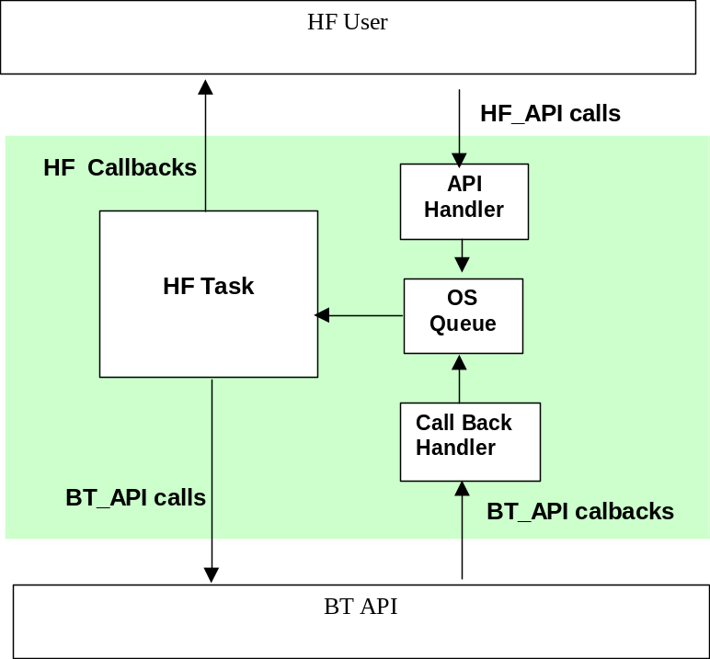

Figure 5 :- High Level Design of the HF profile application.

