Future (Inter)Net(Works): FINe

Master in Innovation and Research in Informatics

November 4, 2020

**Name**: Juan Pablo **Surname**: Royo Sales

**Question 1 (1 point)**

1. Internet usage keeps growing, but still barriers lie ahead. Which are these barriers? Mention three of them, those that you consider the most significants (in, maximum, one line of text each).
2. **The first one is the GENDER GAP, which has been increasing from 2013 to 2019.**
3. **The second one is Offline population in least developed countries which is still high.**
4. **The third one is the ICT skills, because still half of the 84% of population with access to Internet doesn’t have ICT skills to use these resources.**
5. Briefly state some pros and cons about the access to Internet through mobile phones.

Pros:

1. **People can have access from everywhere where there is a Mobile Network access and according to the report (Fact and Figures) this is shown because most of the population lives in places with access to Mobile Network**
2. **The coverage has increased and is still increasing which more and more people has access to it**
3. **People dont need an internet home connection, which decreases cost for accessing to internet**
4. **It is cheaper, easy and practical to have a phone rather than to have a laptop or PC.**

Cons:

1. **Still there are differences between different regions in the world where the coverage of the newest mobile technologies like LTE is not present as in Developed countries.**
2. **One of the main cons is privacy, because with mobile phones on one hand we can be track by Carriers and on the other hand as well there exists a lot of tracking for personalized advertisement as well.**

**Question 2 (1 point)**

Concerning the models for building and managing the Internet infrastructures that Roger Baig mentioned in his class…

1. List **(just list)** the models he mentioned and mark with a cross (**X**) the one that currently predominates?

* **Public sector**
* **X ---> Private sector**
* **Public-Private partnership (PPP)**

**Question 2 (continued)**

1. Which is the alternative model he defended? Briefly describe the most relevant characteristic of this model.

**The alternative model is the Commons, which is a mixture between the Private Sector which provide the main service at some point, the People that collaborates with resources and time to build the small network and Public which is supporting the process.**

**The main characteristics are:**

* **Maximization of the size and share of commons goods**
* **Common resources**
* **Optimization of cooperation**
* **It is long term because the goal is collective and not short term for profit**
* **There is self regulation among the participants of the network**
* **It is sustainable and cost oriented**

**Question 3 (1 point)**

In the the ASON architecture drawn below, appear a lot of acronyms. **Indicate the meaning** of the acronyms that you consider **the most significant for carrying out the ASON functionalities**.

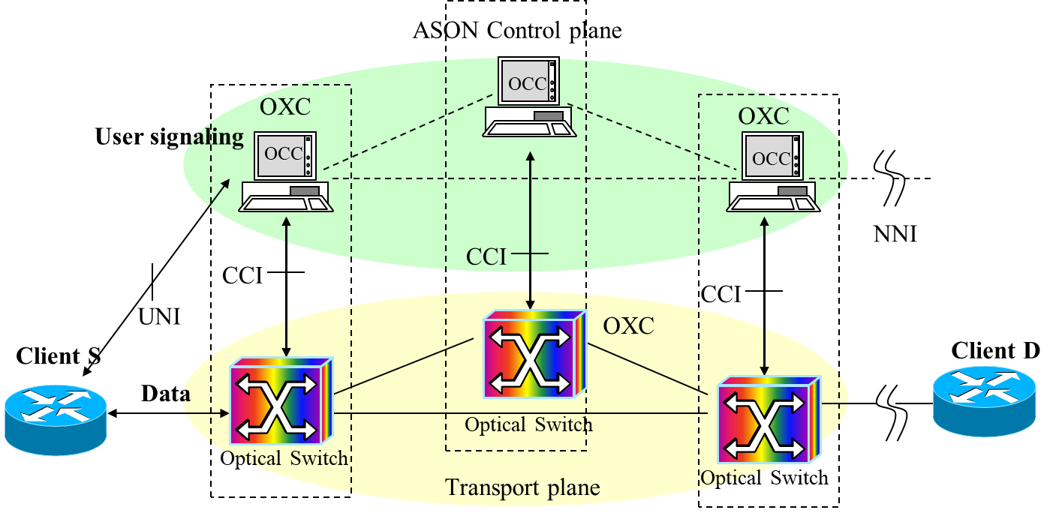

* **CCI: Connection Control Interface**
* **OCC: Optical Connection Controller**
* **UNI: User Network Interface**

**Question 4 (2 points)**

In the SDN Architecture:

1. Write in your own words, **but in one sentence**, what the SDN controller is **useful for**.

**Since the goal of SDN is to provide a physical separation between the Control Plane and the Transport Plane, it is useful for deciding new routes, establishing alternative routes on failure, establishing specific routes base on demand, etc. Basically to have a unified view and control the transport architecture providing Traffic Engineering capabilities, QoS, security, etc.**

1. Write in your own words, **but in one sentence**, what the OpenFlow protocol is **useful for**.

**OpenFlow Protocol is useful to establish a Standard Communication Interface between Control Plane and Transport Plane. Basically the Standard communication mechanism for Southbound interface.**

1. In the following figure, which represents the SDN architecture:



Say where the **Northbound** **and Southbound interfaces** are placed (between what elements?), and which elements communicates the **OpenFlow protocol**.

**Northbound Interfaces are place between *Apps* and *Logically centralized network operating system* and Southbound are place between *Logically centralized network operating system and Network devices.***

**As I mentioned in my previous answer, OpenFlow is the standard for Southbound Interface.**

**Question 5 (2 points)**

Question on Traffic Monitoring and Analysis:

1. List (just list them, **do not explain**) the four algorithms/techniques taught in class for reducing the effect of the scalability problem in the traffic measurements.
   1. **Bloom filters**
   2. **Bitmap**
   3. **Count-min sketch**
   4. **One-way delay**
2. One of these techniques is traffic sampling:
   * + - 1. Briefly (**in one sentence**) define it.

**Bloom filters are used for traffic sampling. Basically it checks set membership using a set of hash functions in which given an entry it calculates all the functions and that gives us a set of positions in a table. If all those positions already have a 1 set it, it is because the flow was already seen. Otherwise those positions are mark to 1 and the flow can be sampled. It has low rate of false positives.**

* + - * 1. Briefly explain **when** it is necessaryapplying traffic sampling for monitoring the IP traffic, and **what** **needs** this technique to achieve good results.

**When we do passive traffic monitoring the amount of packets are huge and dealing with all that data it would required massive amount of storage and computational power. Because of these reason it is needed to do sampling the traffic to take some of the packets that are flowing and not all of them, with some probabilistic techniques as the one as I numbered in previous answer. To achieve good results sampling should have a very low probability of false positive, be fast, and use the smallest storage as possible.**

1. Two of the main purposes (applications) of Network Monitoring (Traffic Measurements) discussed in class are **Traffic Classification** and **Anomaly Detection**. Why is each of these two applications **useful for**? Put an example to illustrate each of the two cases.

* **Traffic Classification is useful in order for example to determine which application is generating that traffic. For example if we want to setup a dedicated path for streaming Youtube we need to detect those packets that comes from Youtube, and this can be done automatically without human intervention with traffic classification.**
* **On the other hand Anomaly Detection is also useful to prevent a wrong use of the network. For example in a DDoS attack we can detect a huge amount of packets that are targeting some particular network.**

**Question 6 (2 points)**

1. Concerning **Traffic Measurements in SDN** based networks, given that the **OpenFlow protocol** is the dominant protocol for the southbound interface in SDN, what are the **main features** that this protocol offersfor performing traffic measurements in SDN based networks?

**Basically the flow tables are the main feature that OpenFlow provides to do traffic measurement. Through this flow tables we can know through the Action field what are the rules to apply to an specific packet and for example if the packet is a packet that needs to be monitor or not.**

1. Concerning **Traffic Classification** **in SDN** based networks, how it can be efficiently performed in OpenFlow based environents? List the main actions/mechanisms that José Suarez recommended to apply for addressing this problem.

* **Using sampling based on IP suffixes**
* **Using Hash-based sampling**

**Question 7 (1 point)**

1. Cite **(just cite them)** the Web Tracking mechanisms mentioned in class.

* **Cookies**
* **Session-only**
* **Storage-based**
* **Cache-based**
* **Fingerprints**
* **Others: Telephone metadata, Fake captcha, Clickjacking, etc.**

1. Briefly describe one of them, the one you consider the most dangerous for violating the personal data privacy, and justify why it is dangerous.

**I think the most dangerous one is the Fingerprint because it can do an accurate profile of user’s behavior, location, history pages he/she visited, etc, without using cookies or traditional mechanisms which in many cases they are disabled or blocked by the user. This may allowed not only to do personalize advertisement but for some malicious site could lead to an Identity Theft problem for the user.**

**Question 8 (1 point) -Bonus question-**

1. Reproduce one of the questions that have been proposed for Chapters 1, 2 and 3, either yours or from one of the groupmates you evaluated. The one you liked the most among all of them (yours or of your groupmates).

**Suppose that I have to send a set of messages S = {1,2,…,n} from a Source A to a Destination B in 2 different IP Networks. It is now that the messages are not arriving in order and there is no delay on establishing the route from A to B, because there is no fixed route for transfer them. Explain what kind of Traffic Network it is implemented behind this and justify your response.**

1. Write the right answer to this question.

**The traffic Network behind this it is using Virtual Packet Switching, and in particular It is in Datagram mode or Approach. In Packet Switching Network, on the contrary of Circuit Switching Network, there is no need to establish a fixed path between source a destination. We can detect that the Datagram mode is used because there is no ACK on package received in B and there is no need that packets arrives in order.**