The difference between the two imports lies in how you access the members of the datetime module and the datetime class within it. Here’s a breakdown of each:

1. from datetime import datetime
2. import datetime

1. from datetime import datetime
This import specifically brings the datetime class from the datetime module into your local namespace directly, meaning you can use datetime without prefixing it with the module name.
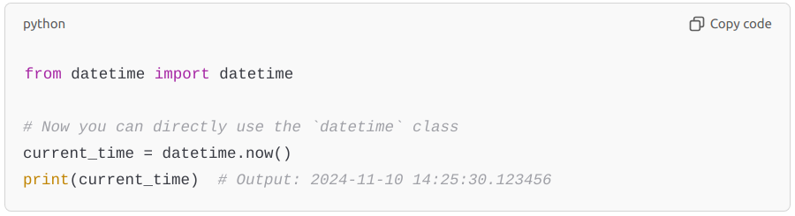
In this case:
- datetime refers to the class datetime within the datetime module.
- You can use methods like datetime.now() without needing to reference the datetime module itself.

2. import datetime
This import brings the entire datetime module into your namespace, so you need to use the full module path (datetime.datetime) to access the datetime class within it.
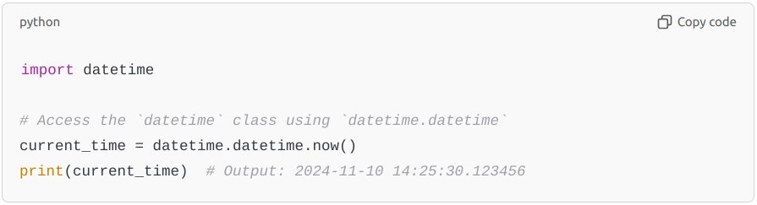
In this case:
- datetime refers to the module datetime, and datetime.datetime refers to the class datetime within it.
- You must use datetime.datetime to call methods like now().

Summary of Differences
Import Statement | Access Syntax | Usage Example
from datetime import datetime | datetime | datetime.now()
import datetime | datetime.datetime | datetime.datetime.now()

When to Use Each
- Use from datetime import datetime if you only need the datetime class and want a shorter reference.
- Use import datetime if you may need other classes or functions in the datetime module, like datetime.date, datetime.timedelta, etc., to avoid potential confusion between the module and the class names.
from datetime import datetime, timedelta, date

