What are __slots__ in Python?
__slots__ is a special attribute you can define in a Python class to restrict the creation of instance attributes to a fixed set. It prevents the dynamic creation of attributes by default, thereby optimizing memory usage and potentially improving performance.
When __slots__ is defined, Python doesn't use a standard dictionary (__dict__) to store instance attributes. Instead, it uses a more memory-efficient structure like a tuple or an array.

How to Define __slots__
__slots__ is defined as a class-level attribute, typically as a tuple or list of strings, where each string represents the name of an allowable instance attribute.

Example:
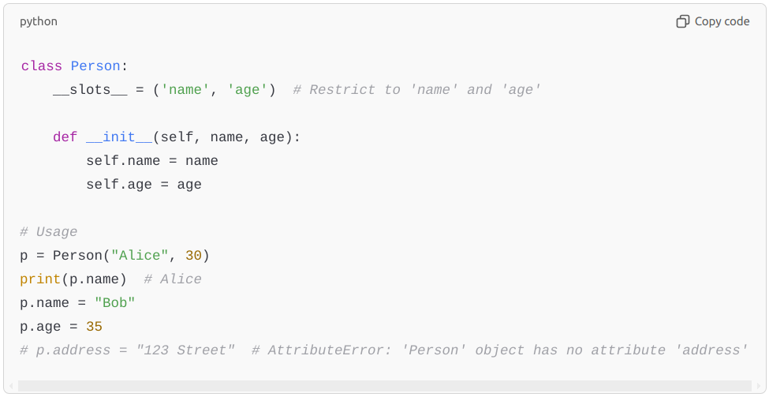

Benefits of Using __slots__
- Memory Optimization:
  - Without __slots__, each instance of a class has a __dict__ attribute to store its attributes, which consumes memory.
  - With __slots__, Python avoids creating a __dict__, leading to lower memory overhead, especially in scenarios where many instances of a class are created.
- Performance Improvement:
  - Attribute access (e.g., p.name) can be slightly faster because the attribute lookup avoids the dictionary.
- Error Prevention:
  - __slots__ restricts the creation of attributes, reducing the chances of introducing errors by mistakenly creating attributes.

When to Use __slots__
- Large Numbers of Instances:
  - When you are creating a large number of instances of a class and want to reduce memory consumption.
- Performance Critical Code:
  - In scenarios where optimizing memory or access speed is important.
- Restricting Attribute Creation:
  - To enforce a fixed schema for instances, preventing the accidental addition of new attributes.

Limitations of __slots__
- No Dynamic Attributes:
  - You cannot dynamically add attributes that are not defined in __slots__.
- No __dict__ or __weakref__ by Default:
  - If you need these attributes (e.g., for weak references), you must explicitly include '__dict__' or '__weakref__' in __slots__.
python
Copy code
class Example:
__slots__ = ('a', '__dict__', '__weakref__')
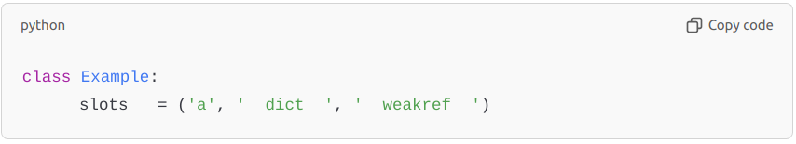
- Not Inherited Automatically:
  - If a subclass does not define its own __slots__, it will have a __dict__, potentially defeating the purpose.
python
Copy code
class Parent:
__slots__ = ('a',)

class Child(Parent):
pass # Child will have a __dict__
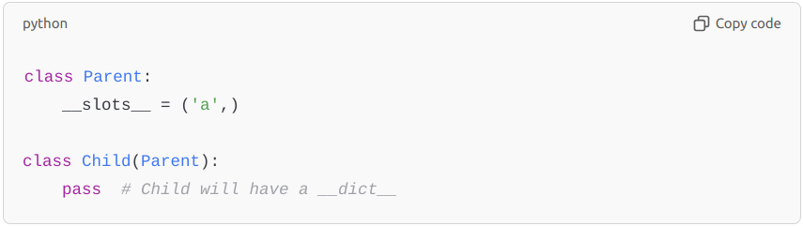
- Limited to Instance Attributes:
  - __slots__ only affects instance attributes, not class attributes or methods.
- Code Maintainability:
  - Adding or modifying attributes later requires updating the __slots__ declaration, which might complicate development.

Practical Use Cases
- Data-Heavy Applications:
  - For example, in numerical simulations or data processing where millions of small objects are created.
- Memory-Constrained Environments:
  - Embedded systems or applications running on resource-limited devices.
- Performance Optimization:
  - Applications like real-time systems or game engines, where every bit of memory and speed matters.

Comparison: With and Without __slots__

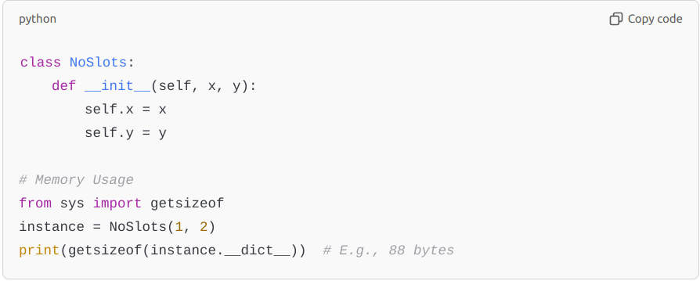
Without __slots__:

python
Copy code
class NoSlots:
def __init__(self, x, y):
self.x = x
self.y = y

# Memory Usage
from sys import getsizeof
instance = NoSlots(1, 2)
print(getsizeof(instance.__dict__)) # E.g., 88 bytes

With __slots__:
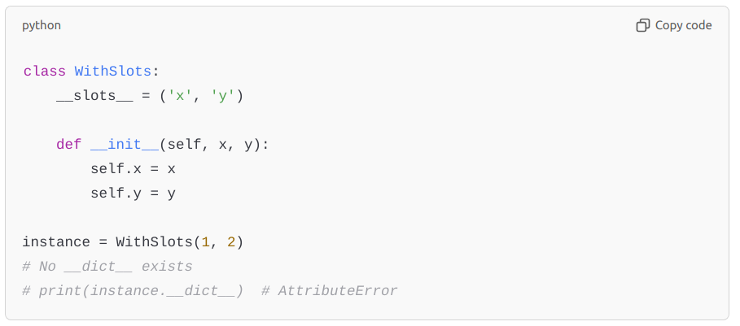
python
Copy code
class WithSlots:
__slots__ = ('x', 'y')

def __init__(self, x, y):
self.x = x
self.y = y

instance = WithSlots(1, 2)
# No __dict__ exists
# print(instance.__dict__) # AttributeError
By using __slots__, the memory consumption per instance decreases significantly, as shown in the above examples.

In summary, __slots__ is a powerful tool for optimizing memory usage and improving performance in Python when used appropriately in specific scenarios. However, its limitations mean it should be used judiciously and only when its benefits outweigh the added constraints.

