  - 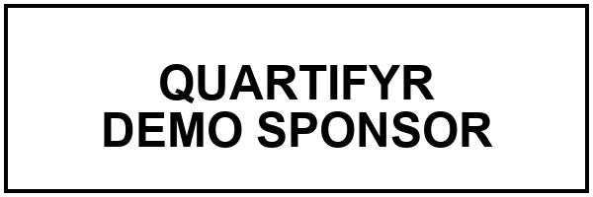
  - MODELING ANALYSIS REPORT

Population Pharmacokinetics of Theophylline

Title Page
  - Demonstration Report
FINAL

Date | 2026-08-11
Lead Scientist | Jane Doe, PharmD
Version | 1.0
Confidentiality | Confidential — Do Not Distribute
Address | quartifyr Demo Sponsor  123 Research Parkway, Suite 400  Raleigh, NC 27609
Sponsor | quartifyr Demo Sponsor
Report Number | RPT-2026-014

Signatures
Contributors
Author
Jane Doe, PharmD
Lead Scientist

Reviewer
John Smith, PhD
Senior Biostatistician

Approvers
Medical Director
Alice Lee, MD

Synopsis
Title: Population Pharmacokinetics of Theophylline
Objectives: To characterize the pharmacokinetics of theophylline following oral administration.
Methods: Individual concentration-time profiles were summarized descriptively from the built-in Theoph dataset; no model-based estimation was performed for this demonstration report.
Results: Peak concentrations and inter-participant variability are summarized in Table 1 and Figure 1. Individual profiles show wide variability in both peak concentration and time to peak across participants, consistent with typical oral absorption variability for this compound.
The synopsis figure below is a duplicate rendering of that same concentration-time profile – demonstrating multi-line values with an embedded figure, not a numbered figure of its own (it’s excluded from the List of Figures, unlike Figure 1 in the body). It’s a separate saved copy (conc-time-synopsis.png) rather than a second reference to conc-time.png, since reportifyr dedupes figure metadata footnotes by filename document-wide and Figure 1’s own footnote should win that dedup, not the synopsis preview’s.
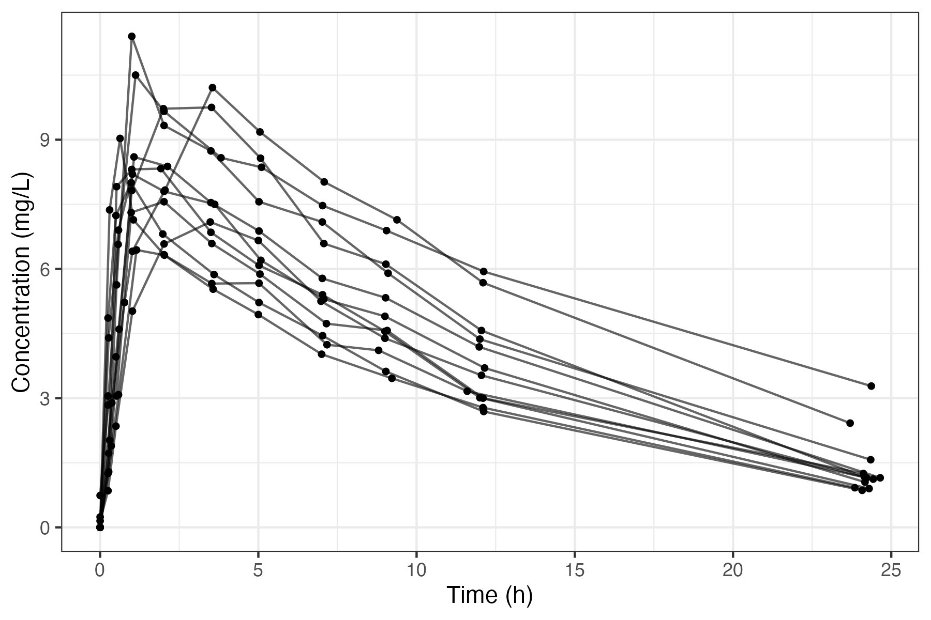
[Source: scripts/01_analysis.R 2026-08-11 22:28:55]
Notes: This plot shows individual concentration-time trajectories for subjects in the study. The x-axis represents time (hours) and the y-axis shows drug concentration (ng/mL). Each line corresponds to a subject's concentration profile, illustrating variability in pharmacokinetics across the population. Key points like peak concentration (Cmax) and time to peak (Tmax) can be identified visually. No aggregation or smoothing has been applied, preserving the raw individual data. Synopsis preview of the concentration-time profile shown in full as Figure 1.
Abbreviations: PK: pharmacokinetic.

Table of Contents
Right-click to update field

List of Figures

List of Tables

Abbreviations
Terms and abbreviations used in this report are listed below.
PK | Pharmacokinetic

1. Introduction
This demonstration report summarizes a pharmacokinetic (PK) analysis of theophylline concentrations from the built-in Theoph dataset [1], rendered end to end through quartifyr’s two-pass shell/fill pipeline.

2. Results

2.1 Summary Statistics
Table 1 Per-participant PK summary statistics
Participant | Cmax | Cmin | Cavg
6 | 6.44 | 0.00 | 3.53
7 | 7.09 | 0.15 | 3.91
8 | 7.56 | 0.00 | 4.27
11 | 8.00 | 0.00 | 4.51
3 | 8.20 | 0.00 | 5.09
2 | 8.33 | 0.00 | 4.82
4 | 8.60 | 0.00 | 4.94
9 | 9.03 | 0.00 | 4.89
12 | 9.75 | 0.00 | 5.41
10 | 10.21 | 0.24 | 5.93
1 | 10.50 | 0.74 | 6.44
5 | 11.40 | 0.00 | 5.78
[Source: scripts/01_analysis.R 2026-08-12 20:55:43]
Notes: Values are per-participant summary statistics computed directly from observed concentrations; no imputation or model-based estimation was performed. This table is filled from a plain data frame, so reportifyr renders it in its own default table styling (Arial Narrow) rather than this report's own body font -- contrast with the participant demographics table below, filled from a pre-styled flextable object.
Abbreviations: PK: pharmacokinetic.
Per-participant maximum, minimum, and average observed concentration across the sampling period.

2.2 Concentration-Time Profile
Figure 1 Concentration-time profile

[Source: scripts/01_analysis.R 2026-08-11 22:28:55]
Notes: This plot shows individual concentration-time trajectories for subjects in the study. The x-axis represents time (hours) and the y-axis shows drug concentration (ng/mL). Each line corresponds to a subject's concentration profile, illustrating variability in pharmacokinetics across the population. Key points like peak concentration (Cmax) and time to peak (Tmax) can be identified visually. No aggregation or smoothing has been applied, preserving the raw individual data. Data are from the built-in Theoph dataset.
Abbreviations: PK: pharmacokinetic.
Individual concentration-time trajectories for all participants in the study, plotted on the same axes, summarized numerically in Table 1.

2.3 Participant Demographics
Table 2 Participant demographic and dosing summary
Participant | Weight (kg) | Dose (mg/kg)
1 | 79.6 | 4.02
2 | 72.4 | 4.40
3 | 70.5 | 4.53
4 | 72.7 | 4.40
5 | 54.6 | 5.86
6 | 80.0 | 4.00
7 | 64.6 | 4.95
8 | 70.5 | 4.53
9 | 86.4 | 3.10
10 | 58.2 | 5.50
11 | 65.0 | 4.92
12 | 60.5 | 5.30
[Source: scripts/01_analysis.R 2026-08-12 20:55:43]
Notes: Body weight and weight-normalized dose for each participant. Unlike the PK summary table above, this table is filled from a pre-built, hand-styled flextable object rather than a plain data frame, so it renders in this report's own reference-doc font (Times New Roman) instead of reportifyr's default table styling.
Abbreviations: N/A
Body weight and weight-normalized dose for each participant in the study.

References
1. Boeckmann AJ, Sheiner LB, Beal SL. Theoph: An nlme dataset for theophylline kinetics. NONMEM Users Guide. 1994;5.
2. Pinheiro JC, Bates DM. Approximations to the log-likelihood function in the nonlinear mixed-effects model. Journal of Computational and Graphical Statistics. 1995;4(1):12–35.

Appendix A: Statistical Methods
Per-participant summary statistics were computed directly from the observed concentration-time data; no model-based estimation (e.g. the nonlinear mixed-effects approach in [2]) was performed for this demonstration report. See Appendix ? for the complete methodology.

Appendix A: Analysis Code
The complete R script used to produce this report’s tables and figure (Appendix ? above) is reproduced below for reference.
# Generates the demo report's artifacts: a PK parameter summary table, a
# participant demographics table, and a concentration-time figure, using
# base R's built-in Theoph dataset (the same one reportifyr's own README/
# examples use). Run from this project's root (examples/demo-report/), e.g.:
#
# cd examples/demo-report && Rscript scripts/01_analysis.R
library(reportifyr)
library(ggplot2)
library(flextable)
library(officer)
stopifnot(basename(getwd()) == "demo-report")
config_yaml <- file.path("report", "config.yaml")
# Theoph's own column is "Subject" -- renamed to "Participant" to match
# current org convention before it reaches any output.
theoph <- Theoph
names(theoph)[names(theoph) == "Subject"] <- "Participant"
pk_summary <- aggregate(
conc ~ Participant,
data = theoph,
FUN = function(x) c(Cmax = max(x), Cmin = min(x), Cavg = mean(x))
)
pk_summary <- data.frame(
Participant = pk_summary$Participant,
round(pk_summary$conc, 2)
)
# meta_abbrevs entries are keys looked up in report/standard_footnotes.yaml's
# abbreviations: section (reportifyr errors if a key isn't defined there) --
# free text goes in meta_notes instead. meta_type works the same way against
# that file's table_footnotes:/figure_footnotes: sections, for a canned
# methodology blurb; left unset here since none of the existing table_footnotes
# entries (regression/covariate-model writeups) fit a plain summary table.
write_csv_with_metadata(
object = pk_summary,
file = file.path("OUTPUTS", "tables", "pk-summary.csv"),
config_yaml = config_yaml,
meta_notes = "Values are per-participant summary statistics computed directly from observed concentrations; no imputation or model-based estimation was performed. This table is filled from a plain data frame, so reportifyr renders it in its own default table styling (Arial Narrow) rather than this report's own body font -- contrast with the participant demographics table below, filled from a pre-styled flextable object.",
meta_abbrevs = "PK",
row.names = FALSE
)
# A second table, complementing pk_summary above to show reportifyr's two
# ways of filling an rpfy-prefixed table magic string: a plain data frame
# (.csv, above) vs. a pre-built `flextable` object (.rds, here). This matters
# because reportifyr::add_tables() (process_table_file(), R/add_tables.R)
# only runs its own formatting -- format_flextable(), which hardcodes
# Arial Narrow 10pt borders/spacing regardless of the reference-doc's
# actual body font -- on objects that AREN'T already `flextable`s; an
# .rds that already `inherits(data_in, "flextable")` when read back is
# inserted completely as-is, untouched. So pk_summary above (a plain data
# frame) always renders in reportifyr's hardcoded Arial Narrow 10pt no
# matter what this doc's reference-doc sets fonts.body to (Times New
# Roman here, per inst/python/styles/default.yaml -- see report/config.yaml's
# footnotes_font comment for the same clash affecting table *footnotes*,
# fixed there but not fixable for a plain data frame's own table body).
# Building a flextable by hand, styled to match those same values, is the
# only way to escape that -- demonstrated below.
theoph_demographics <- unique(theoph[, c("Participant", "Wt", "Dose")])
theoph_demographics <- theoph_demographics[
order(as.numeric(as.character(theoph_demographics$Participant))),
]
names(theoph_demographics) <- c("Participant", "Weight (kg)", "Dose (mg/kg)")
demographics_ft <- flextable(theoph_demographics) |>
set_table_properties(layout = "autofit", width = 1) |>
align(align = "left", part = "all") |>
bold(bold = TRUE, part = "header") |>
bg(bg = "#D9D9D9", part = "header") |>
border(border = fp_border(color = "#000000"), part = "all") |>
font(fontname = "Times New Roman", part = "all") |>
fontsize(size = 11, part = "all") |>
line_spacing(space = 1.15, part = "all") |>
padding(padding.bottom = 2, padding.top = 2, part = "all")
save_rds_with_metadata(
object = demographics_ft,
file = file.path("OUTPUTS", "tables", "participant-demographics.rds"),
config_yaml = config_yaml,
meta_notes = "Body weight and weight-normalized dose for each participant. Unlike the PK summary table above, this table is filled from a pre-built, hand-styled flextable object rather than a plain data frame, so it renders in this report's own reference-doc font (Times New Roman) instead of reportifyr's default table styling."
)
figures_path <- file.path("OUTPUTS", "figures")
plot_file <- file.path(figures_path, "conc-time.png")
g <- ggplot(theoph, aes(x = Time, y = conc, group = Participant)) +
geom_line(alpha = 0.6) +
geom_point(size = 1) +
labs(x = "Time (h)", y = "Concentration (mg/L)") +
theme_bw()
# meta_type = "conc-time-trajectories" pulls report/standard_footnotes.yaml's
# existing canned figure_footnotes entry for this exact plot type; meta_notes
# adds a dataset-specific note on top of it.
ggsave_with_metadata(
filename = plot_file,
plot = g,
width = 6,
height = 4,
config_yaml = config_yaml,
meta_type = "conc-time-trajectories",
meta_notes = "Data are from the built-in Theoph dataset.",
meta_abbrevs = "PK"
)
# reportifyr's own add_figure_footnotes() dedupes footnotes by filename
# document-wide (a bookmark-name xpath check, unconditional -- no
# config.yaml knob controls it): the *first* rpfy-prefixed occurrence of a
# given filename gets the metadata footnote and every later occurrence of
# that same filename is silently skipped. The synopsis intentionally
# embeds the same plot as a preview ahead of the numbered Figure 1 in the
# body (see report.qmd), so it needs its own copy under a distinct
# filename -- otherwise the synopsis preview would claim the footnote and
# leave the numbered, List-of-Figures-tracked Figure 1 without one.
synopsis_plot_file <- file.path(figures_path, "conc-time-synopsis.png")
ggsave_with_metadata(
filename = synopsis_plot_file,
plot = g,
width = 6,
height = 4,
config_yaml = config_yaml,
meta_type = "conc-time-trajectories",
meta_notes = "Synopsis preview of the concentration-time profile shown in full as Figure 1.",
meta_abbrevs = "PK"
)
cat("Wrote:\n")
cat(" -", file.path("OUTPUTS", "tables", "pk-summary.csv"), "\n")
cat(" -", file.path("OUTPUTS", "tables", "participant-demographics.rds"), "\n")
cat(" -", plot_file, "\n")
cat(" -", synopsis_plot_file, "\n")
End of script.

