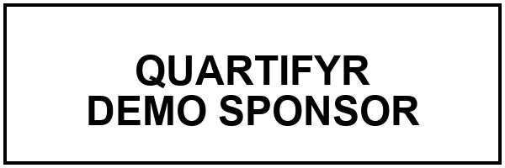

MEMORANDUM

To | Jane Doe, CFO
From | John Smith, Controller
Date | 2026-08-12
Re | Q3 Budget Review Timeline
Cc | Finance Committee
Memo Number | MEMO-2026-014

FINAL

Purpose
This memo summarizes the proposed timeline for the Q3 budget review and requests sign-off on the schedule below before circulating it to department heads.
No table of contents, list of figures/tables, or abbreviations list is included – unlike examples/demo-report, a memo’s “loose structure” deliberately skips all of that (see the examples/memo-example/README.md and _extensions/quartifyr/README.md’s “Memo cover page” section for why none of that requires any quartifyr code changes to omit).

Proposed Schedule
- Department budget submissions due August 21
- Finance Committee review August 24-28
- Consolidated review meeting September 2
- Final sign-off September 9
Figure 1 Proposed Q3 budget review timeline
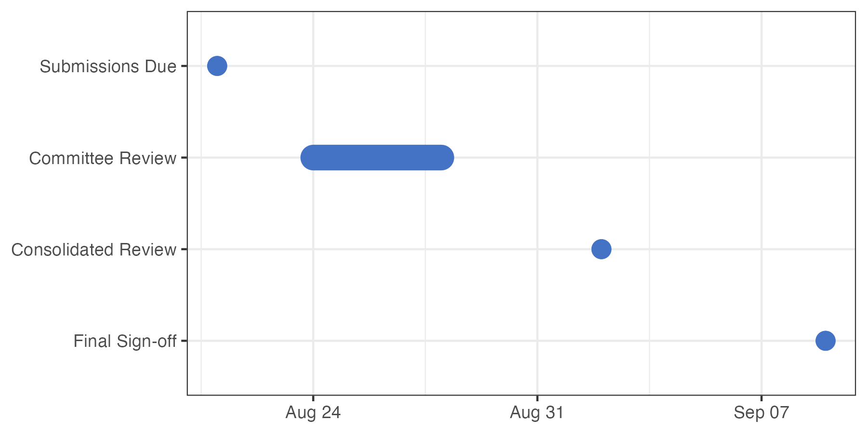
[Source: scripts/01_analysis.R 2026-08-12 18:09:11]
Notes: Proposed Q3 budget review milestones.
Abbreviations: N/A
Milestone dates from the list above, shown as a single timeline for a quick visual check before circulating (see Figure 1).

Next Steps
Please review the schedule above and reply with any conflicts by August 19 so the timeline can be finalized before submissions open.

