Project Mint Code Editor
Requirements Specification
26/07/18

Introduction
This document describes the desired functionality of the above code editor. The currently available lightweight Linux text editors have been found wanting. The name comes from the Linux Mint distro (which I use).
As a side-note, I hate the way other Linux desktops look like – let it be GNOME 3+, KDE 4+ etc. - they all have thrown away every sane human interface guideline developed over the last couple of decades in the sake of being 'creative' and 'innovative'. This being said, Gnome 2.X and KDE 3.X were going in the right direction, but this was around mid 2000'. Currently only Cinnamon remains as a bastion of a competent UI design.

What problem does it solve better?
The existing Linux code editors are a sad joke. Vim and Emacs are relics of a bygone age, not modern tools. Gedit and Geany are to buggy and awkward to use, and the rest is either unusable or tries to be a poor man's IDE rather than just a code editor. One exception is Textadept which is pretty neat, but too limited to be useful. Sublime Text deserves a mention as well, but it is too expensive.

Design Goals
The main goal is speed and simplicity. I am definitely in favour of minimalism. The language of choice is plain C, and the GUI toolkit will be GTK+ 2.24 with GtkScintilla widget.

This set-up will provide the best portability, speed and native look among all major Linux Desktops.

At this point I don't care about adding plug-in support.

Main Components
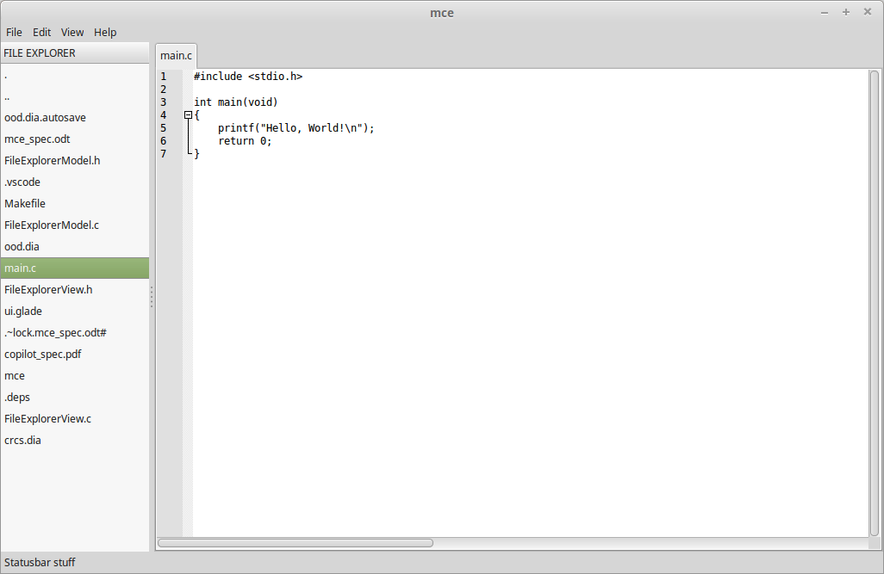
1
2
3
4

File Explorer
Just a simple file manager for displaying files and browsing directories. It will have two pop-up menus for common file or directory actions.

Code Editor
Implemented as Scintilla widget inside a tabbed notebook. Features:
- opening a new file creates a new tab
- modified files will be highlighted
- closing a modified tab will trigger a confirmation pop-up
- tabs will have a pop-up menu (close tabs to left / right, close others)
- Implementation note: will need to add a 'x' (close) button to tab labels
- tabs can be moved left and right
- there will be an option to have two tabs open in parallel (split-screen mode, useful for diffing)

Menu Bar
Just a bunch of common operations:
File
Edit
Tools
View
Help

Status Bar
Simple stuff: current language, caret position etc.

Find / Replace
This will be a port from Notepad++ (in terms of functionality). The main feature of interest is 'Find / Replace' dialog allowing to trawl through all the open source files. The search results of 'Find' will be displayed in a separate pane (at the bottom of the editor) and will be hyper linked to allow quick browsing through multiple source files.
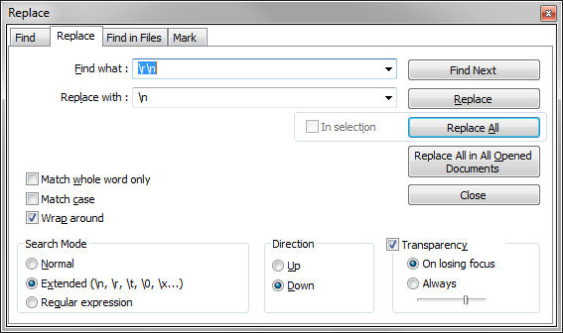

Basic Functionality

Highlighter Themes
The editor will support syntax highlighting themes. The default theme will be obsidian from N++ or my own teal/olive theme.

Settings
Will be stored as a flat INI file. Included will be things like editor appearance, last open session, window position and size etc.

