ALERTS
hijo
Alert Type: The Alert Type list all alert type that is defined, it is a Template that allow user to create Alert Definition
Filter list Alert Type: The Filter function limits the amount of data that the PROS display, Filter refines to search and reduces the time required to process and display the data.
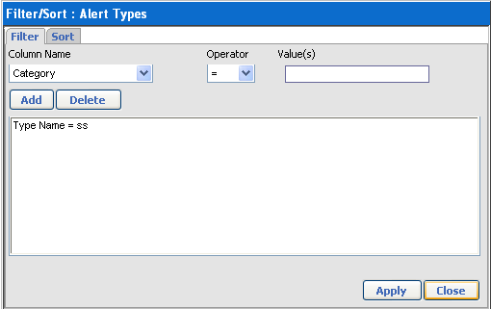
Add Alert Type:
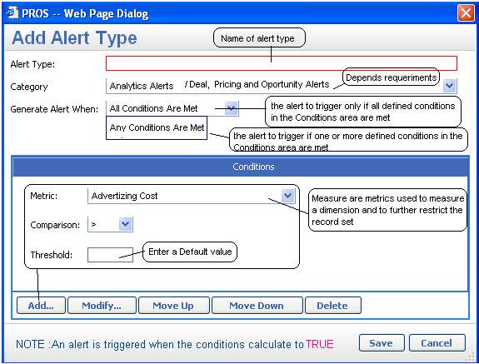
Alert Definition: List the user-defined alerts which are applicable to your user profile and work Team.
From this table you can build data driven alerts that monitor areas of business that are not performing as expected.
Add Alert Definition:
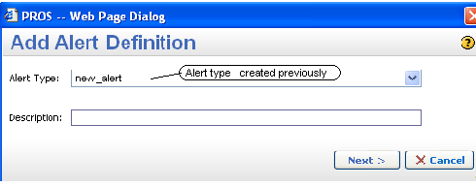
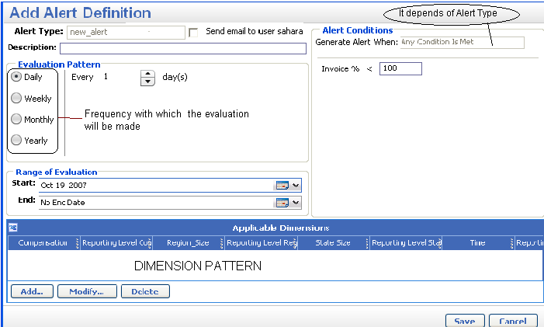
Add Dimension pattern
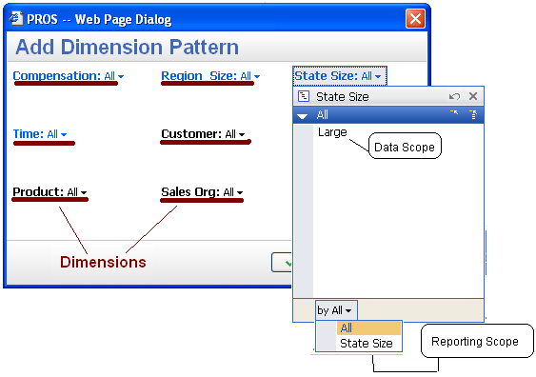
Triggered Alert: This page lists alerts that were triggered when the metric passes the threshold
Filter Triggered Alert: The user can reduce the list of Triggered alert.
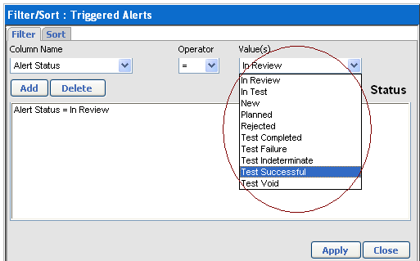

PRICING MODULE
The purpose is for creating, updating, and generating prices while automating the price generation based on user defined parameters.
The Pricing Manager allows:
- Define pricing strategies and calculate prices
- Price a category of products using formulas that define how the price is calculated
- Automatically update prices based changing costs, indices or other business conditions
- Automate the pricing approval processes
- Create, maintain and monitor discount, surcharge and rebate programs at multiple levels or segments of the business
- Make mass price changes

Within the Pricing Manager module there is a work flow to manage and route price change request
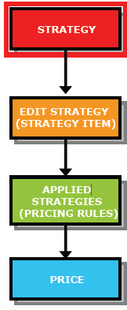
Strategies: The strategy is a collection of formulas that determines a price
The strategy is formed by Strategy Name, Pricing Area, Domain, Pricing Type and items (strategies)
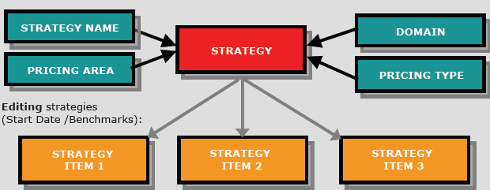
- Domain: A set of dimensions used to organize products over which a price can be set, Sets the level of granularity for a price
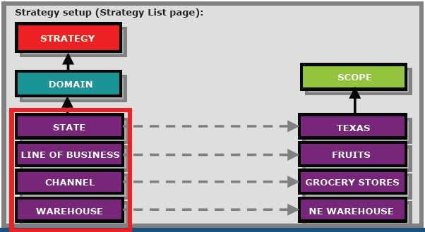
- Scope: An instance of a pricing domain
  - Determines the values used in the price calculation
  - Specifies the domain
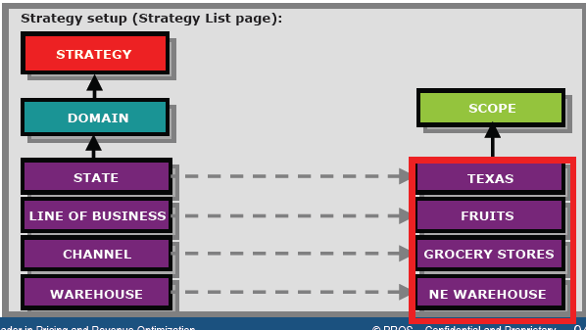
- Pricing Area: The way a business is segmented for operation
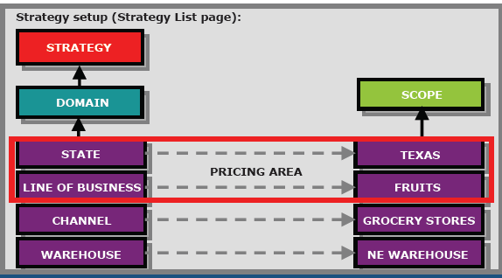
- Pricing Type: Represent a different usage of a price for the same product, often requiring a different method of formulation
Edit Strategies: Allows
  - Add a start date
  - Add strategy elements such as benchmarks, variables and subtotals
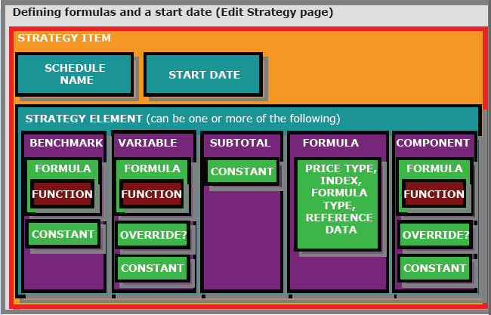
Strategy Elements
  - Variables: The variables are a type of strategy element, they are used when determining a price, can contain formulas and functions, can be overridable
  - Formulas: They are part of a pricing element; they are algebraic expressions that are comprised of:
Terms: Constant or function
Operators: Parenthesis, Multiplication, Division, Addition
  - Benchmarks (Overview) (reference): Allows answer the following
    - What the target is -- target (objective)
    - When a price is profitable (rentable)
    - What price the competition is selling the product
    - What amount the product sold at recently
These could serve as a threshold in the approval process, also can be defined as a base formula
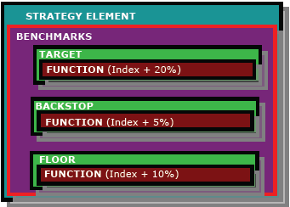
Benchmarks (Target Prices):
These are set regional levels to reflect local business conditions also these are set above the floor
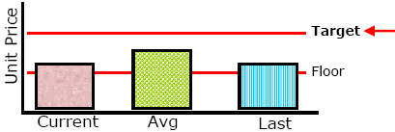
Benchmarks (Floor Price)
It is the minimum price allowed to be offered to a given customer or customer group, can be a percentage of list price, contains a formula.

Benchmarks (Backstop):
It is the minimum price at which each product can be sold, it is lower than floor, Is a reference point that can be applied to pricing.

Applied Strategies:
This page lists all pricing rules for approved and active strategy schedules selected in the context bar. An applied strategy (sometimes referred to as a pricing rule) includes all the price elements used to determine a price for a specific data scope, given a strategy and price type.

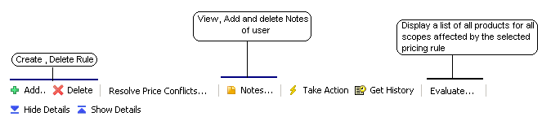
In summary the generation of price is:
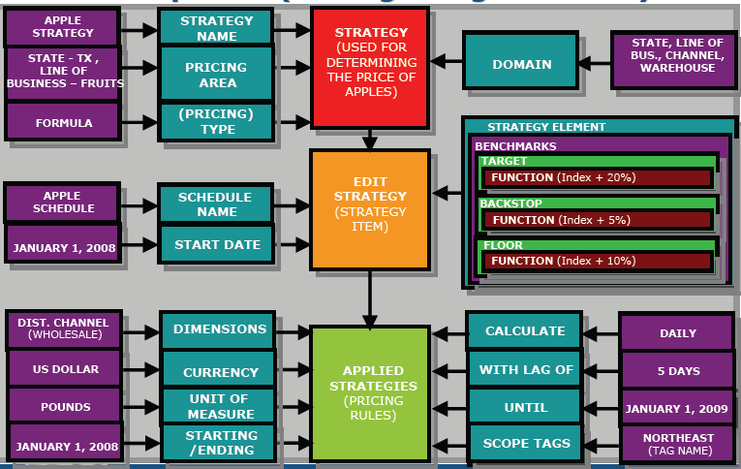

Prices are automatically generated when:
- Triggered by predefined pricing schedule
- Major change in a price formula element
- Change in a market condition

Price Lists
Pending Price Changes list
•Displays pending prices which have not yet been approved
Current price list
•Displays all current and approved prices
Product price list
•Lists external prices by product -can be changed and filtered
Customer price list
- Lists all customer-specific prices by customer and by product
- Can be used to notify customers of price changes
- Include prices that have been loaded into the application
- Let users export prices to a spreadsheet application, edit the prices, and import the prices back to the price lists
Index Lists
  - All Index Values page: lists all index values in the PROS Pricing Solution Suite that the user has access to view. This includes both approved and unapproved index values. Approved index values are those that display Approved in the Status column, while unapproved values display Working.
  - Latest Index Values page: lists the most recently approved value of each index as well as the date it was approved
  - Unapproved Indexes Values page: lists the values for all indices that have not yet been approved in the PROS Pricing Solution Suite
Currency Exchange Rates
Are automatically applied to strategy input values when they are in a different currency from the specified currency for the resulting list price or deal line item
User Defined Lookups
The Lookup tasks are managed independently of the processes that use the data. There is no data check at the time of data loading, but the PROS Pricing Solution Suite can check whether the data is within a user defined range after the data is loaded. Alerts are triggered in cases where values outside of this range are observed.
Are comprised of lookup definitions and lookup data
Lookup definitions define the domain and parameters for a type of lookup. They can be called in strategies using dedicated functions
Lookup data records provide numerical values, formulas, or text strings associated with defined scopes. When a strategy formula requests the lookup for a scope, the lookup data record returns the appropriate data
Mappings
The Search Mappings page allows users, with the appropriate privileges, to map a price scope to another set of prices, by creating to define leader/follower relationships.
This function assists in managing distribution of prices across brands, across pack sizes, and across geographies. Once this mapping has been created, price strategies can be applied to price scopes to take advantage of the mapping

