Name: Jack Reddan
PID: A59010543

[Q01] Tell me the name of a protein you are interested in. Include the species and the accession number. This can be a human protein or a protein from any other species as long as it's function is known.

Name: glutathione reductase
Accession: NP_191026
Species: Arabidopsis thaliana
Function: glutathione-disulfide reductase activity

[Q02] Perform a BLAST search against a DNA database, such as a database consisting of genomic DNA or ESTs. The BLAST server can be at NCBI or elsewhere. Include details of the BLAST method used, database searched and any limits applied (e.g. Organism).

Method: NCBI TBLASTN (v2.12.0) searched against all ESTs
Database: Expressed Sequence Tags [est] database
Organism: None
Results:
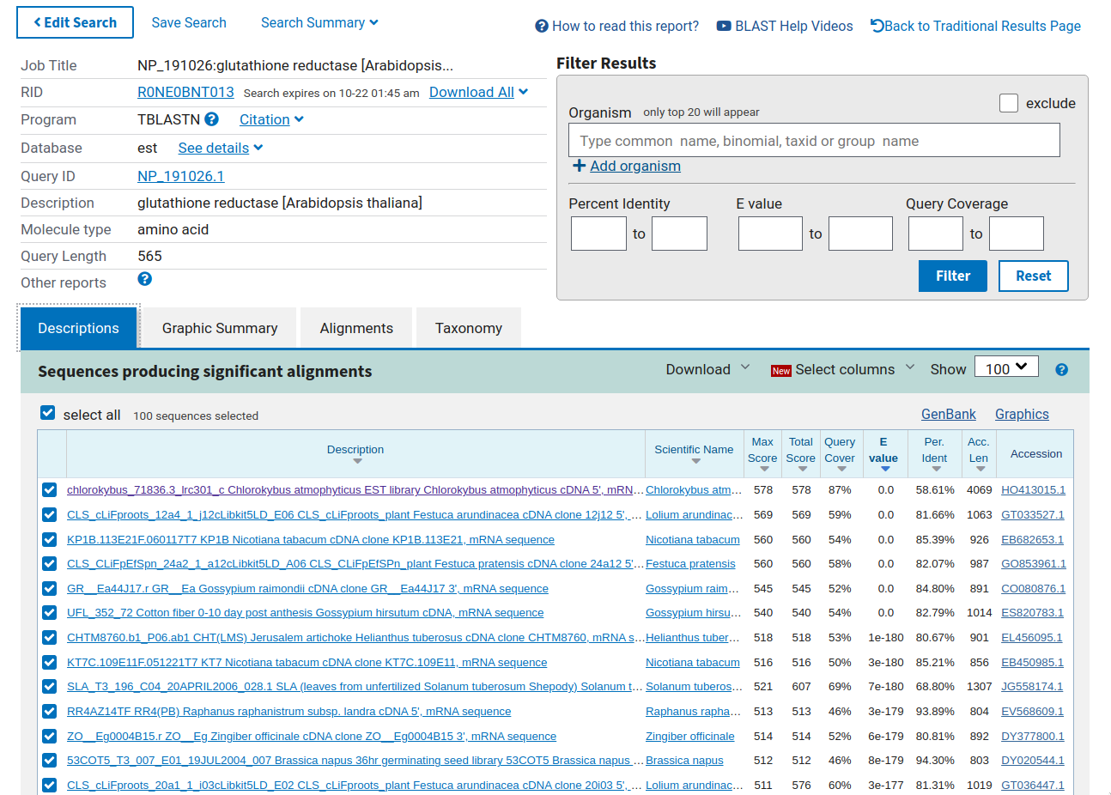

Chosen match: Accession HO413015.1, 4069 bp Chlorokybus atmophytus mRNA sequence, highlighted in purple above. Alignment details are printed below:

Query: glutathione reductase [Arabidopsis thaliana] Query ID: NP_191026.1 Length: 565

>chlorokybus_71836.3_lrc301_c Chlorokybus atmophyticus EST library Chlorokybus atmophyticus cDNA 5', mRNA sequence
Sequence ID: HO413015.1 Length: 4069
Range 1: 2451 to 3941

Score:578 bits(1489), Expect:0.0,
Method:Compositional matrix adjust.,
Identities:296/505(59%), Positives:363/505(71%), Gaps:17/505(3%)

Query 52 LRPRIALLSNHRYYHSRRFS---------VCASTDNGAESDRHYDFDLFTIGAGSGGVRA 102
LRP L HSR+ S V AS++ YD+D+ TIGAGSGGVRA
Sbjct 3941 LRPS-GLAQGQSRPHSRQQSRTVQRYGLRVIASSNGSG-----YDYDVITIGAGSGGVRA 3780

Query 103 SRFATSFGASAAVCELPFSTISSDTAGGVGGTCVLRGCVPKKLLVYASKYSHEFEDSHGF 162
SR A+ GA A E+PF+ ++SDT GGVGGTCVLRGCVPKKLLVY S +S+EF+DS GF
Sbjct 3779 SRIASQLGAKVACVEMPFNNVASDTEGGVGGTCVLRGCVPKKLLVYGSIFSNEFDDSAGF 3600

Query 163 GWKYETEPSHDWTTLIANKNAELQRLTGIYKNILSKANVKLIEGRGKVIDPHTVDVDGKI 222
GWK EP W TL NKN EL RL +Y+NILSKANV+L+EGR ++D HTVD+DGK
Sbjct 3599 GWKLPGEPKFTWQTLNENKNKELTRLNNVYRNILSKANVELLEGRASLVDAHTVDIDGKQ 3420

Query 223 YTTRNILIAVGGRPFIPDIPGKEFAIDSDAALDLPSKPKKIAIVGGGYIALEFAGIFNGL 282
T +NI++A GGR F IPG E AIDSD AL L PK+IAI GGGYIALEFA IF+G
Sbjct 3419 LTAKNIILATGGRSFALPIPGAEHAIDSDKALSLDEVPKRIAIYGGGYIALEFACIFSGF 3240

Query 283 NCEVHVFIRQKKVLRGFDEDVRDFVGEQMSLRGIEFHTEESPEAIIKAGDGSFSLKTSKG 342
+V VF R LRGFDE++R+ + E++ +GI H + + E I K +G ++LKT+ G
Sbjct 3239 GAKVDVFYRAPLPLRGFDEEIRNALVEELGKKGINLHPKCTAEEIRKEANGEYTLKTNCG 3060

Query 343 TVEGFSHVMFATGRKPNTKNLGLENVGVKMAKNGAIEVDEYSQTSVPSIWAVGDVTDRIN 402
+ VMFATGR PNTK L L+ VGV + GAI VDEYS+T+VP+I+A+GDVT+RIN
Sbjct 3059 EFKA-DLVMFATGRTPNTKYLNLDAVGVDTTEKGAIVVDEYSRTTVPNIFAIGDVTNRIN 2883

Query 403 LTPVALMEGGALAKTLFQNEPTKPDYRAVPCAVFSQPPIGTVGLTEEQAIEQYGDVDVYT 462
LTPVALMEG A+AKT+ Q EPTKPD+ VP AVF+QPPIGT GLTEE+A EQ+ +VDVYT
Sbjct 2882 LTPVALMEGTAVAKTI-QGEPTKPDHVNVPSAVFTQPPIGTAGLTEEEAKEQFDEVDVYT 2706

Query 463 SNFRPLKATLSGLPDRVFMKLIVCANTNKVLGVHMCGEDSPEIIQGFGVAVKAGLTKADF 522
S+FRP+K T+SG +R MK+IV T+KVLG+HM GE SPEI+QGF VA+K G TK
Sbjct 2705 SSFRPMKHTISGRDERSLMKIIVDVKTDKVLGIHMLGESSPEILQGFAVALKCGATKKQL 2526

Query 523 DATVGVHPTAAEEFVTMRAPTRKFR 547
DAT+G+HPTAAEEFVTMR TR+ R
Sbjct 2525 DATIGIHPTAAEEFVTMRTVTRQHR 2451

[Q03] Gather information about this “novel” protein. At a minimum, show me the protein sequence of the “novel” protein as displayed in your BLAST results from [Q2] as FASTA format (you can copy and paste the aligned sequence subject lines from your BLAST
result page if necessary) or translate your novel DNA sequence using a tool called EMBOSS Transeq at the EBI. Don’t forget to translate all six reading frames; the ORF (open reading frame) is likely to be the longest sequence without a stop codon. It may not start with a methionine if you don’t have the complete coding region. Make sure the sequence you provide includes a header/subject line and is in traditional FASTA format.

Chosen sequence [from EMBOSS Transeq of the TBLASTN result in Q2]:

>2451-3941_6 chlorokybus_71836.3_lrc301_c Chlorokybus atmophyticus EST library Chlorokybus atmophyticus cDNA 5', mRNA sequence
ALLPAPRVAAVATRSSSSRRSELPGLLARPLGVSRSFRGFSGLRPSGLAQGQSRPHSRQQ
SRTVQRYGLRVIASSNGSGYDYDVITIGAGSGGVRASRIASQLGAKVACVEMPFNNVASD
TEGGVGGTCVLRGCVPKKLLVYGSIFSNEFDDSAGFGWKLPGEPKFTWQTLNENKNKELT
RLNNVYRNILSKANVELLEGRASLVDAHTVDIDGKQLTAKNIILATGGRSFALPIPGAEH
AIDSDKALSLDEVPKRIAIYGGGYIALEFACIFSGFGAKVDVFYRAPLPLRGFDEEIRNA
LVEELGKKGINLHPKCTAEEIRKEANGEYTLKTNCGEFKADLVMFATGRTPNTKYLNLDA
VGVDTTEKGAIVVDEYSRTTVPNIFAIGDVTNRINLTPVALMEGTAVAKTIQGEPTKPDH
VNVPSAVFTQPPIGTAGLTEEEAKEQFDEVDVYTSSFRPMKHTISGRDERSLMKIIVDVK
TDKVLGIHMLGESSPEILQGFAVALKCGATKKQLDATIGIHPTAAEEFVTMRTVTRQHRK
EKQQQQQEEKEKVAAAK*

Name (Unofficial): Chlorokybus glutathione reductase.

Species: Chlorokybus atmophyticus: Cellular organisms; Eukaryota; Viridiplantae; Streptophyta; Chlorokybophyceae; Chlorokybales; Chlorokybaceae; Chlorokybus

[Q04] Prove that this gene, and its corresponding protein, are novel. For the purposes of this project, “novel” is defined as follows. Take the protein sequence (your answer to [Q3]), and use it as a query in a blastp search of the nr database at NCBI.

Conducted a BLASTP search against the NR database using the protein sequences listed in [Q3]:

Method: NCBI BLASTP (v2.12.0) searched all nr protein entries
Database: non-redundant protein sequences [nr] database
Organism: None

Results:

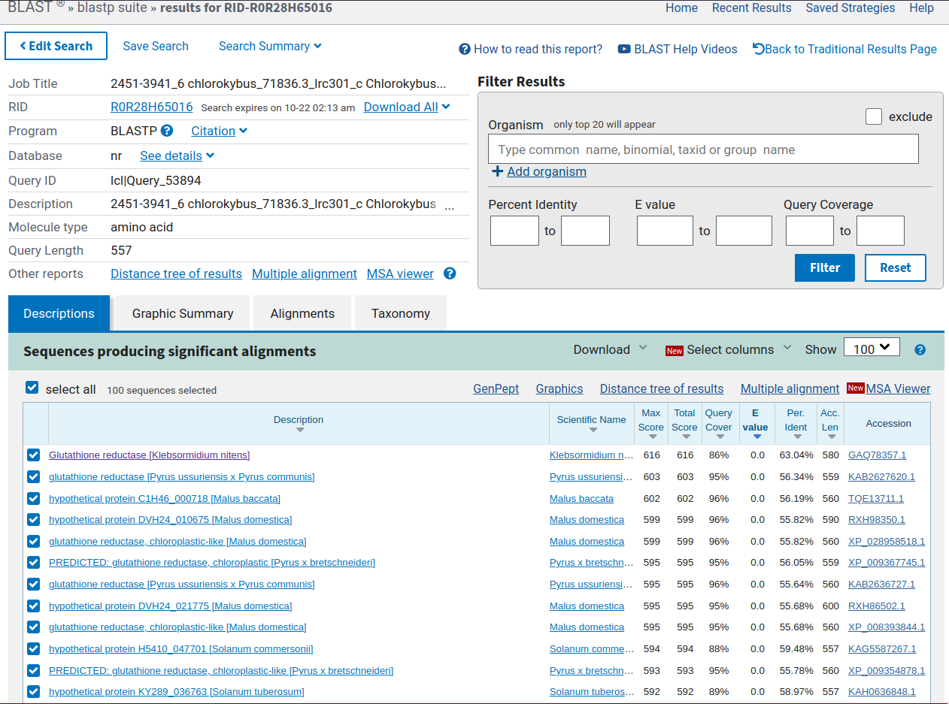
The top result was glutathione reductase in Klebsormidium nitens highlighted in purple above. Alignment is printed below:

Query: 2451-3941_6 chlorokybus_71836.3_lrc301_c Chlorokybus atmophyticus EST library Chlorokybus atmophyticus cDNA 5', mRNA sequence Query ID: lcl|Query_53894 Length: 557

>Glutathione reductase [Klebsormidium nitens]
Sequence ID: GAQ78357.1 Length: 580
Range 1: 93 to 579

Score:616 bits(1588), Expect:0.0,
Method:Compositional matrix adjust.,
Identities:307/487(63%), Positives:366/487(75%), Gaps:3/487(0%)

Query 73 ASSNGSGYDYDVITIGAGSGGVRASRIASQLGAKVACVEMPFNNVASDTEGGVGGTCVLR 132
++ +G +DYD+ TIGAGSGGVRASR ASQ GAKVA E+PF+ ASD +GGVGGTCVLR
Sbjct 93 STEDGQQFDYDLFTIGAGSGGVRASRFASQYGAKVAVCELPFSTKASDDKGGVGGTCVLR 152

Query 133 GCVPKKLLVYGSIFSNEFDDSAGFGWKLPG-EPKFTWQTLNENKNKELTRLNNVYRNILS 191
GCVPKKLLVYGS F++ F+DS GFGW PG EP+ W L E KNKEL RLNN Y+ L
Sbjct 153 GCVPKKLLVYGSHFADYFEDSRGFGWSFPGGEPEVDWSHLIEKKNKELDRLNNAYKTTLK 212

Query 192 KANVELLEGRASLVDAHTVDIDGKQLTAKNIILATGGRSFALPIPGAEHAIDSDKALSLD 251
A V+L+EG+ ++VD HTVD+DGK+ KNI++ATGGR F PIPGAEH I SD AL L
Sbjct 213 NAKVDLIEGKGTIVDRHTVDVDGKRFKVKNILIATGGRIFVPPIPGAEHVITSDDALDLT 272

Query 252 EVPKRIAIYGGGYIALEFACIFSGFGAKVDVFYRAPLPLRGFDEEIRNALVEELGKKGIN 311
VP +IAI GGGYIALEFA IF+ GA+VD+F R LRGFD+E+R L E+L +GI
Sbjct 273 SVPSKIAIVGGGYIALEFAGIFNSAGAEVDIFVRGDKLLRGFDDEVREFLAEQLQAQGIR 332

Query 312 LHPKCTAEEIRKEANGEYTLKTNCGE-FKADLVMFATGRTPNTKYLNLDAVGVDTTEKGA 370
+H EI K + TLKT G+ ++ VMFATGR PN K L L+ GVD +K A
Sbjct 333 IHFGAKPVEIEKRDEDQLTLKTEQGDTWQGSHVMFATGRRPNIKGLGLEEAGVDVDDKTA 392

Query 371 IVVDEYSRTTVPNIFAIGDVTNRINLTPVALMEGTAVAKT-IQGEPTKPDHVNVPSAVFT 429
I VDEYSRT+V NI+A+GDVT+RINLTPVALMEG A AKT Q EPTKPDH NVPSAVFT
Sbjct 393 IKVDEYSRTSVDNIWAVGDVTDRINLTPVALMEGMAFAKTAFQDEPTKPDHTNVPSAVFT 452

Query 430 QPPIGTAGLTEEEAKEQFDEVDVYTSSFRPMKHTISGRDERSLMKIIVDVKTDKVLGIHM 489
PPIGT GLTE EA EQ+ +VDV+TS+FRPMK TISG R+ +KI+VD TDKV+G+HM
Sbjct 453 NPPIGTVGLTEAEAVEQYGDVDVFTSTFRPMKSTISGNPVRTFVKILVDAATDKVIGLHM 512

Query 490 LGESSPEILQGFAVALKCGATKKQLDATIGIHPTAAEEFVTMRTVTRQHRKEKQQQQQEE 549
GE PEI+QGFAVA++ G TKKQ+D+T+GIHPT+AEE VTMRT TRQ RKE+ Q + E
Sbjct 513 CGEDGPEIMQGFAVAVRMGVTKKQMDSTVGIHPTSAEELVTMRTPTRQIRKEEAQNGKGE 572

Query 550 KEKVAAA 556
KE AAA
Sbjct 573 KEMAAAA 579

This result matches almost all classification of “novel” for this class project:

- There is no 100% match found in the database for the protein sequence in the original species (Chlorokybus atmophyticus).

- The top match reported has less than 100% identity.

- There is no 100% match to a different species (redundant to above).

x There are no database matches to the original query when no organism is specified, but when you refine the search to the original query (Arabidopsis thaliana) there is a database match (see below):
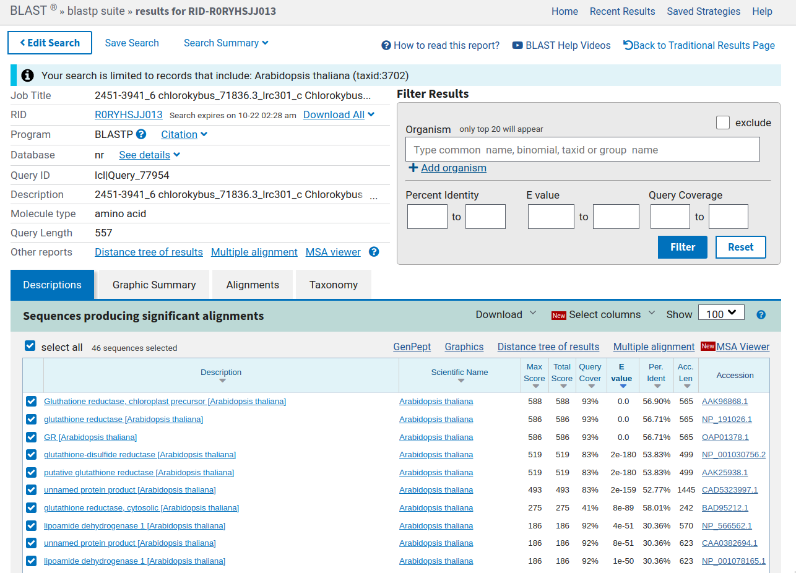

[Q05] Generate a multiple sequence alignment with your novel protein, your original query protein, and a group of other members of this family from different species. A typical number of proteins to use in a multiple sequence alignment for this assignment purpose is a minimum of 5 and a maximum of 20 - although the exact number is up to you. Include the multiple sequence alignment in your report. Use Courier font with a size appropriate to fit page width.

Malus domestica [XP_028958518.1] -----------------------------------
Pyrus x bretschneideri [XP_009367745.1] --------------------------------P--
Pistacia vera [XP_031258822.1] -----------------------------------
Gossypium hirsutum [XP_016709857.2] -----------------------------------
Rosa chinensis [XP_024166425.1] -----------------------------------
Fragaria vesca subsp. vesca [XP_004289892.1] -----------------------------------
Arachis hypogaea [XP_025604791.1] -----------------------------------
Arachis duranensis [XP_015969716.1] -----------------------------------
Arachis ipaensis [XP_016204709.1] -----------------------------------
Prosopis alba [XP_028758428.1] -----------------------------------
Prunus persica [XP_007199772.1] --------------------------------P--
Solanum tuberosum [XP_006349748.1] -----------------------------------
Solanum lycopersicum [NP_001234243.2] -----------------------------------
Solanum pennellii [XP_015087986.1] -----------------------------------
Capsicum annuum [XP_016565503.1] -----------------------------------
Sesamum indicum [XP_011079991.1] -----------------------------------
Arabidopsis lyrata subsp. lyrata [XP_020880886.1] -----------------------------------
Camelina sativa [XP_010427174.1] -----------------------------------
Arabidopsis thaliana [NP_191026.1] -MASTPKLTSTISSSSPSLQFLCKKLPIAIHLPSS
Chlorokybus atmophyticus [tHO_413015.1] ALLPAPRVAAVATRSSSSRR---SELPGLLARP--

XP_028958518.1 -----LSLPKTLTSLSHLR----RTSTSHPHHH-----LNSRRHFSI--RASDSGNGA-DSTRHYDFDLF
XP_009367745.1 -----LSLPKTLSPLSHLR----RTSTSHPHHH-----LHSRRRFSV--RAVDSGNGA-DSTRHYDFDLF
XP_031258822.1 ----------------------------------------------------------------YDFDLF
XP_016709857.2 -------------------------SRFHLHHHHPTPRFHPRRLFAV--RA-ESENGA-EPLRHYDFDLF
XP_024166425.1 ----------------------------------------------------------------YDFDLF
XP_004289892.1 -----------------------------------------------------SDNGAGDPSRHYDFDLF
XP_025604791.1 -------------------------------HH----TRTRRRSFTL--SA--SANPH-----NYDFDLF
XP_015969716.1 -------------------------------HH----TRTRRRSFTL--SA--SANPH-----NYDFDLF
XP_016204709.1 -------------------------------HH----TRTRRRSFTL--SA--SANPH-----NYDFDLF
XP_028758428.1 ----------------------------------------------------------------YDFDLF
XP_007199772.1 -----LSLRRTLTSLSHLH----RTSISPLHHH------SRRRSFSV--RA-DSGNGA-DSGSHYDYDLF
XP_006349748.1 ------------------------------HPR--TSSLSYGRRFTTT-RA-ESSNGA-ETPRHYDFDLF
NP_001234243.2 ------------------------------HTR--TSSLSYGRRFTTP-RA-ESSNGA-ETPRHYDFDLF
XP_015087986.1 ------------------------------HTR--TSSLSYGRRFTTP-RA-ESSNGV-ETPRHYDFDLF
XP_016565503.1 ----------------------------------------------------------------YDFDLF
XP_011079991.1 ---------------------------SSPHPR---------RAFTTSIRA-DSTNGS-EPPRNYDFDLF
XP_020880886.1 -----LSLPKTLTSLYSLRP---RIAVLSNHRYY------HSRRFSV--RA-STDNGA-DSERHYDFDLF
XP_010427174.1 -----LSLPKTLTSLYSLRP---RVAVLSNHRYY-----HHSRRFSV--SA-SSDNGT-DSERHYDFDLF
NP_191026.1 SSSSFLSLPKTLTSLYSLRP---RIALLSNHRYY------HSRRFSV--CA-STDNGA-ESDRHYDFDLF
tHO_413015.1 -----LGVSRSFRGFSGLRPSGLAQGQSRPHSRQ---QSRTVQRYGL--RVIASSNGS-----GYDYDVI

XP_028958518.1 TIGAGSGGVRASRFAANFGASVAVCELPFSTISSDTTGGVGGTCVLRGCVPKKLLVYASKFAHEFEESNG
XP_009367745.1 TIGAGSGGVRASRFAANFGASVAVCELPFSTISSATAGGVGGTCVLRGCVPKKLLVYASKFAHEFEESNG
XP_031258822.1 TIGAGSGGVRASRFASNFGASVAVCELPFSTISSETTGGVGGTCVLRGCVPKKLMVYASKFSHEFDESNG
XP_016709857.2 TIGAGSGGVRASRFAANFGASVAVCELPFSTISSETTGGVGGTCVLRGCVPKKLMVYASKYSHEFDESNG
XP_024166425.1 TIGAGSGGVRASRFASNFGAKVAVCELPFAAISSDTTGGVGGTCVLRGCVPKKLLVYASKYTHEFDDSIG
XP_004289892.1 TIGAGSGGVRASRFAANFGAKVAVCELPFATISSETAGGVGGTCVLRGCVPKKLMVYASKYSHEFEDSIG
XP_025604791.1 TIGAGSGGVRASRFAANYGASVAICELPFSTISSDVTGGVGGTCVLRGCVPKKLLVYSSKYSHEFEESNG
XP_015969716.1 TIGAGSGGVRASRFAANYGASVAICELPFSTISSDVTGGVGGTCVLRGCVPKKLLVYSSKYSHEFEESNG
XP_016204709.1 TIGAGSGGVRASRFAANYGASVAICELPFSTISSDVTGGVGGTCVLRGCVPKKLLVYSSKYSHEFEESNG
XP_028758428.1 TIGAGSGGVRASRFAANFGASVAICELPFSTISSDTTGGVGGTCVLRGCVPKKLLVYSSKYAHEFEESNG
XP_007199772.1 TIGAGSGGVRASRFAANFGASVAICELPFATIASDTAGGVGGTCVLRGCVPKKLLVYASQFAHEFEESNG
XP_006349748.1 TIGAGSGGVRASRFASNFGASVAVCELPFSTISSDSTGGVGGTCVLRGCVPKKLLVYASKYSHEFEESCG
NP_001234243.2 TIGAGSGGVRASRFASNFGASVAVCELPFSTISSDSTGGVGGTCVLRGCVPKKLLVYASKYSHEFEESCG
XP_015087986.1 TIGAGSGGVRASRFASNFGASVAVCELPFSTISSDSTGGVGGTCVLRGCVPKKLLVYASKYSHEFEESCG
XP_016565503.1 TIGAGSGGVRASRFASNFGASVAVCELPFSTISSDSTGGVGGTCVLRGCVPKKLLVYASKYSHEFEESCG
XP_011079991.1 TIGAGSGGVRASRFAANFGAKVAVCELPFATISSDTTGGVGGTCVLRGCVPKKLLVYASKFSHEFQESCG
XP_020880886.1 TIGAGSGGVRASRISTSFGASAAVCELPFSTISSDTAGGVGGTCVLRGCVPKKLLVYASKYSHEFEDSHG
XP_010427174.1 TIGAGSGGVRASRFATSFGASAAVCELPFSTISSDTAGGVGGTCVLRGCVPKKLLVYASKYSHEFEDSHG
NP_191026.1 TIGAGSGGVRASRFATSFGASAAVCELPFSTISSDTAGGVGGTCVLRGCVPKKLLVYASKYSHEFEDSHG
tHO_413015.1 TIGAGSGGVRASRIASQLGAKVACVEMPFNNVASDTEGGVGGTCVLRGCVPKKLLVYGSIFSNEFDDSAG

XP_028958518.1 FGWRYETEPKHDWSTLLANKNAELQRLTGIYKNVLKNANVTLIEGRGKIVDPHTVDVDGKLYSARHILVS
XP_009367745.1 FGWRYETEPKHDWSTLIANKNAELKRLTGIYKNVLSNANVTLIEGRGKIVDPHTVDVEGKLYSARHILVS
XP_031258822.1 FGWKYEVEPQHDWSTLIANKNAELQRLTGIYKNVLKNANVTLLEGRGKIVDPHTVDVDGKLYTARHILIS
XP_016709857.2 FGWKYDTEPKHDWSTLMANKNAELQRLTGIYKNILNKAGVTLIEGRGKVVDPHTVDVDGKLYTARHILIS
XP_024166425.1 YGWKYETEPKHDWSTLMANKNAELQRLTGIYKNVLKNANVTLVQGRGKVVDPHTVDVDGKLYSARHILIS
XP_004289892.1 YGWKYETEPKHDWSTLMANKNAELQRLTGIYKNVLKNANVSLLEGRGKIVDPHTVDVDGQLYSARHILIS
XP_025604791.1 FGWKYESEPKHDWSTLIANKNAELQRLTGIYKNILKNSNVQLIEGRGKIVDPHTVDVDGKLYTARHILVS
XP_015969716.1 FGWKYESEPKHDWSTLIANKNAELQRLTGIYKNILKNSNVQLIEGRGKIVDPHTVDVDGKLYTARHILVS
XP_016204709.1 FGWKYESEPKHDWSTLIANKNAELQRLTGIYKNILKNSNVQLIEGRGKIVDPHTVDVDGKLYTARHILVS
XP_028758428.1 FGWKYDSEPKHDWSTLMANKNAELQRLTGIYKNILKNSDVKLIEGRGKIVDPHTVDVDGKLYSARHIIIS
XP_007199772.1 FGWRYETEPKHDWSTLMANKNAELQRLTGIYKNVLKNAGVALIEGRGKIVDPHTVDVDGKLYSARHIIVS
XP_006349748.1 FGWNYEAEPKHDWSILIANKNAELQRLTGIYKNILKNADVTLIEGRGKVVDPHTVDVDGKLYSAKNILIS
NP_001234243.2 FGWNYEAEPKHDWSTLIANKNAELQRLTGIYKNILKNADVTLIEGRGKVVDPHTVDVDGKLYSAKNILIS
XP_015087986.1 FGWNYEAEPKHDWSTLIANKNAELQRLTGIYKNILKNADVTLIEGRGKVVDPHTVDVDGKLYSAKNILIS
XP_016565503.1 FGWNYEAEPKHDWNTLIANKNAELQRLMGIYKNILKNANVTLIEGRGKVVDPHTVDVDGKLYSAKNILIS
XP_011079991.1 FGWNYEAEPKHDWSTLIANKNAELQRLTGIYKNILKNAGVALIEGRGKIVDPHTVEVNGKLYSAKNILIS
XP_020880886.1 FGWKYETEPSHDWTTLIANKNAELQRLTGIYKNILSKANVKLIEGRGKVIDPHTVDVDGKIYTTRNILIA
XP_010427174.1 FGWKYDTEPTHDWSTLIANKNAELQRLTGIYKNILSKANVKLVEGRGKVIDPHTVDVDGKIYTTRNILIA
NP_191026.1 FGWKYETEPSHDWTTLIANKNAELQRLTGIYKNILSKANVKLIEGRGKVIDPHTVDVDGKIYTTRNILIA
tHO_413015.1 FGWKLPGEPKFTWQTLNENKNKELTRLNNVYRNILSKANVELLEGRASLVDAHTVDIDGKQLTAKNIILA

XP_028958518.1 VGGRPFIPEIPGSEYAIDSDAALDLPTKPEKIAIVGGGYIAVEFAGIFNGLTSDVHVFIRQKKVLRGFDE
XP_009367745.1 VGGRPFIPEIPGSEYAIDSDAALDLPTKPEKIAIVGGGYIAVEFAGIFNGLTSDVHVFIRQKKVLRGFDE
XP_031258822.1 VGGRPFIPDIPGSEHAIDSDAALDLPSKPKKIAIIGGGYIALEFAGIFNGLTSDVHVFIRQKKVLRGFDE
XP_016709857.2 VGGRPFIPDIPGSEYAIDSDAALDLPSKPEKVAIVGGGYIALEFAGIFNGLTSEVHVFIRQKKVLRGFDE
XP_024166425.1 VGGRPFIPDIPGSEYAIDSDAALDLPDKPGKIAIVGGGYIALEFAGIFNGLRSDVHVFIRQKQVLRGFDE
XP_004289892.1 VGGRPFIPDIPGSKYAIDSDAALDLPERPGKIAIVGGGYIALEFAGIFNGLKSDVHVFIRQKQILRGFDD
XP_025604791.1 VGGRPFIPDIPGSEHAIDSDAALDLPSKPEKIAIVGGGYIALEFAGIFNGLKSDVHVFIRQKKVLRGFDE
XP_015969716.1 VGGRPFIPDIPGSEHAIDSDAALDLPSKPEKIAIVGGGYIALEFAGIFNGLKSDVHVFIRQKKVLRGFDE
XP_016204709.1 VGGRPFIPDIPGSEHAIDSDAALDLPSKPEKIAIVGGGYIALEFAGIFNGLKSDVHVFIRQKKVLRGFDE
XP_028758428.1 VGGRPFIPDIPGREYAIDSDAALDLPSKPEKIAIVGGGYIALEFAGIFNGLASEVHVFIRQKKVLRGFDE
XP_007199772.1 VGGRPFIPEIPGIEYAIDSDAALDLPSKPKKIAIVGGGYIAVEFAGIFNGLSSDVHVFIRQKKVLRGFDE
XP_006349748.1 VGGRPFIPDIPGSEYAIDSDAALDLPTKPDKIAIVGGGYIALEFAGIFNGLKSEVHVFIRQKKVLRGFDE
NP_001234243.2 VGGRPFIPDIPGSEYAIDSDAALDLPTKPDKIAIVGGGYIALEFAGIFNGLKSEVHVFIRQKKVLRGFDE
XP_015087986.1 VGGRPFIPDIPGSEYAIDSDAALDLPTKPDKIAIVGGGYIALEFAGIFNGLKSEVHVFIRQKKVLRGFDE
XP_016565503.1 VGGRPFIPNIPGSEYAIDSDAALDLPTKPNKIAIVGGGYIALEFAGIFNGLTSEVHVFIRQKKVLRGFDE
XP_011079991.1 VGGRPFIPDIPGREYVIDSDAALDLPSKPTKIAIVGGGYIALEFAGIFNGLTSSVHVFIRQKKVLRGFDE
XP_020880886.1 VGGRPFIPDIPGKEFAIDSDAALDLPSKPKKIAIVGGGYIALEFAGIFNGLNSEVHVFIRQKKVLRGFDE
XP_010427174.1 VGGRPFIPDIPGKEFAIDSDAALDLPSKPKKIAIVGGGYIALEFAGIFNGLNSEVHVFIRQKKVLRGFDE
NP_191026.1 VGGRPFIPDIPGKEFAIDSDAALDLPSKPKKIAIVGGGYIALEFAGIFNGLNCEVHVFIRQKKVLRGFDE
tHO_413015.1 TGGRSFALPIPGAEHAIDSDKALSLDEVPKRIAIYGGGYIALEFACIFSGFGAKVDVFYRAPLPLRGFDE

XP_028958518.1 EVRDFVQEQMALRGIEFHTEESPQAIVKAADGSLSLKTNKGTIEGFSHIMFATGRRPNTKNLGLEAIGVK
XP_009367745.1 EVRDFVQEQMALRGIEFHAEESPQAIVKAADGSLSLKTNKGTIEGFSHIMFATGRRPNTKDLGLEAVGVK
XP_031258822.1 EIRDFVAEQMSVRGIEFHTEESPEAILKSADGSLSLKTNKGTVEGFSHIMFATGRRPNTKNLGLEKVGVK
XP_016709857.2 EIRDFVGEQMALRGIQFHTEESPQAIVKSADGSLSLKTNEGTIEGFSHIMFATGRRPNTKNLGLESVGVK
XP_024166425.1 EIRGFVSEQMSVRGIEFHTEESPQAILKSADGSFSLKTNKGTVGGFSHVMFATGRRPNTKNLGLEEVGVK
XP_004289892.1 EIRGFLAEQMSLRGIEFHTEESPQAILKSSDGSFSLKTNKGTVEGFSHVMFATGRRPNTKNLGLEAVGVK
XP_025604791.1 EIRDFVGEQMALRGIEFHTEESPQAIVKSADGSLSLKTNKGTVEGFSYIMFATGRKPNTKNIGLESVGVK
XP_015969716.1 EIRDFVGEQMALRGIEFHTEESPQAIVKSADGSLSLKTNKGTVEGFSHIMFATGRKPNTKNIGLESVGVK
XP_016204709.1 EIRDFVGEQMALRGIEFHTEESPQAVVKSADGSLSLKTNKGTVEGFSHIMFATGRKPNTKNIGLESVGVK
XP_028758428.1 EVRDFVSEQMAIRGIEFHVEETPQAIIKSADGSLSLKTNKGTVEGFSHIMFATGRTPNTKNLGLESVGVK
XP_007199772.1 EVRDFVQEHMSLRGIEFHAEESPQAIVKSADGSLSLKTNKGTLEGFSHIMFATGRRPNTKNLGLEEVGVK
XP_006349748.1 EIRDFVGEQMSLRGIEFHTEESPQAIVKSADGSLSLKTNRGTVEGFSHIMFATGRSPNTKNLGLDTVGVK
NP_001234243.2 EIRDFVGEQMSLRGIEFHTEESPQAIVKSADGSLSIKTNRGTVEGFSHIMFATGRSPNTKNLGLDTVGVK
XP_015087986.1 EIRDFVGEQMSLRGIEFHTEESPQAIVKSADGSLSIKTNRGTVEGFSHIMFATGRSPNTKNLGLDTVGVR
XP_016565503.1 EIRDFVGEQMSLRGIEFHTEESPQAIVKSADGSLSLKTNRGTVEGFSHIMFATGRRPNTKNLGLDTVGVK
XP_011079991.1 EIRDFVGEQMSLRGIEFHTEETPQAIVKSSDGLLSLKTNKGTVDGFSHVMFATGRRPNTKNLGLEAVGVK
XP_020880886.1 DVRDFVGEQMSLRGIEFHTEESPEAIIKAGDGSLSLKTSKGTVEGFSHVMFATGRKPNTKNLGLENVGVK
XP_010427174.1 DVRDFVGEQMSLRGIEFHTEESPEAIIKSGDGSLSLKTSKGTVEGFSHVMFATGRKPNTKNLGLENVGVK
NP_191026.1 DVRDFVGEQMSLRGIEFHTEESPEAIIKAGDGSFSLKTSKGTVEGFSHVMFATGRKPNTKNLGLENVGVK
tHO_413015.1 EIRNALVEELGKKGINLHPKCTAEEIRKEANGEYTLKTNCGEFKA-DLVMFATGRTPNTKYLNLDAVGVD

XP_028958518.1 LSKNGAIEVDEFSRTEVPSIWAIGDVTDRVNLTPIALMEGGAIAKTLFLNEPTKPDYRAVPSAVFSQPPI
XP_009367745.1 LSKNGAIEVDKFSRTAVPSIWAVGDVTDRVNLTPVALMEGGAIAKTLFLNEPTMPDYRAVPSAVFSQPPI
XP_031258822.1 MSKNGAIQVDEYSRTSVPSIWAVGDVTDRINLTPVALMEGGALAKTLFQDEPTKPDYRAVPSAVFCQPPI
XP_016709857.2 INKNGAIEVDEYSRTTVPSIWAVGDVTDRINLTPVALMEGAALAKTLFQNEPTKPDYRAVPSAVFSQPPI
XP_024166425.1 IAKNGAIEVDEFSRTSVPSIWAVGDVTDRVNLTPVALMEGGALAKTLFLNEPTKPDYRAIPSAVFSQPPI
XP_004289892.1 MANSGAIEVDEFSRTSVPSIWAVGDVTDRVNLTPVALMEGGALAKTLFLNEPTKPDYRAIPSAVFSQPPI
XP_025604791.1 IDKKGAIEVNEYSQSSVPSIWAVGDVTDRINLTPVALMEGVALAKTLFLNEPTKPDYSYVPSAVFSQPPI
XP_015969716.1 IDKKGAIEVNEYSQSSVPSIWAVGDVTDRINLTPVALMEGVALAKTLFLNEPTKPDYSYVPSAVFSQPPI
XP_016204709.1 IDKKGAIEVNEYSQSSVPSIWAVGDVTDRINLTPVALMEGVALAKTLFLNEPTKPEYSYVPSAVFSQPPI
XP_028758428.1 TAKNGAIEVDEYSQTSVPSIWAVGDVTDRMNLTPVALMEGMALAKTLFQNNPTKPDYRAVPSAVFSQPPI
XP_007199772.1 LSKTGAIEVDEFSRTSVPSIWAVGDVTDRVNLTPVALMEGGALAKTLFLNEPTKPDYRAVPSAVFSQPPI
XP_006349748.1 MTKNGAIEVDEYSRTSVPSIWAVGDVTDRINLTPVALMEGGALAKTIFAGEPTKPDYRNVPCAVFSQPPI
NP_001234243.2 MTKNGAIEVDEYSRTSVPSIWAVGDVTDRINLTPVALMEGGALAKTIFAGEPTKPDYRNVPCAVFSQPPI
XP_015087986.1 MTKNGAIEVDEYSRTSVPSIWAVGDVTDRINLTPVALMEGGALAKTIFAGEPTKPDYRNVPCAVFSQPPI
XP_016565503.1 MARNGAIEVDEYSRTSVPSIWAVGDVTDRINLTPVALMEGGALAKTIFAGEPTKPDYRNVPCAVFSQPPI
XP_011079991.1 LSKNGAVEVDEYSRTSVPSIWAVGDVTDRINLTPVALMEGGALAKTLFANEPTKPDFSNVPSAVFSQPPI
XP_020880886.1 MAKNGAIEVDEYSQTSVPSIWAVGDVTDRINLTPVALMEGGALAKTLFQNEPTKPDYRAVPCAVFSQPPI
XP_010427174.1 MAKNGAIEVDEYSQTSVPSIWAVGDVTDRINLTPVALMEGGALAKTLFQNEPTKPDYRAVPCAVFSQPPI
NP_191026.1 MAKNGAIEVDEYSQTSVPSIWAVGDVTDRINLTPVALMEGGALAKTLFQNEPTKPDYRAVPCAVFSQPPI
tHO_413015.1 TTEKGAIVVDEYSRTTVPNIFAIGDVTNRINLTPVALMEGTAVAKTI-QGEPTKPDHVNVPSAVFTQPPI

XP_028958518.1 GQVGLSEEQAVEQYGDVDIYTSNFRPLKATVSGLPDRTFMKLIVCAKTNKVLGLHMCGEDSPEIVQGFAV
XP_009367745.1 GQVGLSEEQAVEQYGDVDIYTSNFRPLKATLSGLPDRTFMKLIVCAKTNKVLGLHMCGEDSPEIVQGFAV
XP_031258822.1 GQVGLSEEQAIQEYGDIDVFTANFRPLKATLSGLPDRVFMKLIVCAKTNKVLGLHMCGEDAPEIVQGFAV
XP_016709857.2 GQVGLTEEQARKEYGDIDVYTANFRPLKATLSGLPDRVFMKLIVCAKTNKVIGLHMCGEDSAEIAQGFAV
XP_024166425.1 GQVGLSEEQATEQYGDVDIYTSNFRPMKATLSGLPDRVFMKLVVCAKTNKLLGLHMCGEDSPEIVQGFAV
XP_004289892.1 GQVGLSEEQATEQYGDVDIYTSNFKPMKATLSGLPDRVFMKLIVCAKTNKILGLHMCGDDSPEIVQGFAV
XP_025604791.1 GQVGLTEEQAVEQYGDVDIFTSNFRPLKATLSGLPDRTFMKLIVCAKTNKVLGLHMCGEDSPEITQGFAV
XP_015969716.1 GQVGLTEEQAVEQYGDVDIFTSNFRPLKATLSGLPDRTFMKLIVCAKTNKVLGLHMCGEDSPEITQGFAV
XP_016204709.1 GQVGLTEEQAVEQYGDVDIFTSNFRPLKATLSGLPDRTFMKLIVCAKTNKVLGLHMCGEDSPEITQGFAV
XP_028758428.1 GQVGLTEEQAVQQYGNVDIFTANFKPLKATLSGLPDRAFMKLIVCAKTNKVLGLHMCGEDSPEIVQGFAV
XP_007199772.1 GQVGLTEEQAIEQYGDVDIYTSNFRPLKATLSGLPDRVFMKLLVCAKTNKVLGLHMCGEDSAEIVQGFAV
XP_006349748.1 GLVGLTEEEAIKEYGDVDVYTANFRPLKATLSGLPDRAFMKLIVCSKTSKVLGLHMCGEDAPEIVQGFAV
NP_001234243.2 GLVGLTEEEAIKEYGDVDVYTANFRPLKATLSGLPDRVFMKLVVCAKSSKVLGLHMCGDDAPEIVQGFAV
XP_015087986.1 GLVGLTEEEAIKEYGDVDVYTANFRPLKATLSGLPDRVFMKLVVCAKSSKVLGLHMCGDDAPEIVQGFAV
XP_016565503.1 GIVGLTEEQAINEYGDIDVYTTNFRPLKATLSGLPDRVFMKLIVCAKSSKVLGLHMCGEDAPEIVQGFAV
XP_011079991.1 GQVGLTEEQAIKEYGDIDVYTANFRPMKATLSGLPDRVFMKLIVCAKTNKVLGVHMCGEDSPEIIQGFAV
XP_020880886.1 GTVGLTEEQAIEQYGDVDVFTSNFRPLKATLSGLPDRVFMKLIVCANTNKVLGVHMCGEDSPEIIQGFGV
XP_010427174.1 GTVGLTEEQAIEQYGDVDVYTSNFRPLKATLSGLPDRVFMKLIVCANTNKVVGVHMCGEDSPEIIQGFGV
NP_191026.1 GTVGLTEEQAIEQYGDVDVYTSNFRPLKATLSGLPDRVFMKLIVCANTNKVLGVHMCGEDSPEIIQGFGV
tHO_413015.1 GTAGLTEEEAKEQFDEVDVYTSSFRPMKHTISGRDERSLMKIIVDVKTDKVLGIHMLGESSPEILQGFAV

XP_028958518.1 AVKAGLTKADLDSTIGIHPTAAEEFVTMRTPTRKIR------------------
XP_009367745.1 AVKAGLTKADLDSTIGIHPTAAEEFVTMRTPTRKIR------------------
XP_031258822.1 AVKAGLTKADFDTTVGIHPTAAEEFVTMRTPTRKIR------------------
XP_016709857.2 AVKAGLTKADFDATVGIHPTSAEEFVTMRTPTRKIR------------------
XP_024166425.1 AVKAGLTKADLDATIGIHPTAAEEFVTMRTPTRKIR------------------
XP_004289892.1 AVKAGLTKADLDATIGIHPTAAEELVTMRTPTRKIR------------------
XP_025604791.1 AIKAGLTKGDFDATVGIHPTAAEEFVTMRTPTRKIR------------------
XP_015969716.1 AIKAGLTKGDFDATVGIHPTAAEEFVTMRTPTRKIR------------------
XP_016204709.1 AIKAGLTKADFDATVGIHPTAAEEFVTMRTPTRKIR------------------
XP_028758428.1 AVKAGLTKADFDATVGVHPTAAEEFVTMRTTTRKIR------------------
XP_007199772.1 VVKAGLTKADLDATIGIHPTAAEEFVTMRTPTRKIR------------------
XP_006349748.1 AVKAGLTKADFDATVGIHPTAAEEFVTMRTPTRKVR------------------
NP_001234243.2 AVKAGLTKADFDTTVGIHPTAAEEFVTMRTPTRKIR------------------
XP_015087986.1 AVKAGLTKADFDTTVGIHPTAAEEFVTMRTPTRKIR------------------
XP_016565503.1 AVKAGLTKADFDATVGIHPTAAEEFVTMRTPTRKVR------------------
XP_011079991.1 AVKAGLTKADFDATVGIHPTAAEELVTMRTPTRKIR------------------
XP_020880886.1 AVKAGLTKADFDATVGVHPTAAEEFVTMRTPTRKIR------------------
XP_010427174.1 AVKAGLTKADFDATVGVHPTASEEFVTMRTPTRKIR------------------
NP_191026.1 AVKAGLTKADFDATVGVHPTAAEEFVTMRAPTRKFRKDSSEGKASPEAKTAAGV
tHO_413015.1 ALKCGATKKQLDATIGIHPTAAEEFVTMRTVTRQHRKEKQQQQQEEKEKVAAAK

[Q06] Create a phylogenetic tree, using either a parsimony or distance-based approach. Bootstrapping and tree rooting are optional. Use “simple phylogeny” online from the EBI or any respected phylogeny program (such as MEGA, PAUP, or Phylip). Paste an image of your Cladogram or tree output in your report.

Neighbour-joining unrooted tree for glutathione reductase homologs.
Original query protein: Arabidopsis thaliana
Novel protein: Chlorokybus atmophyticus

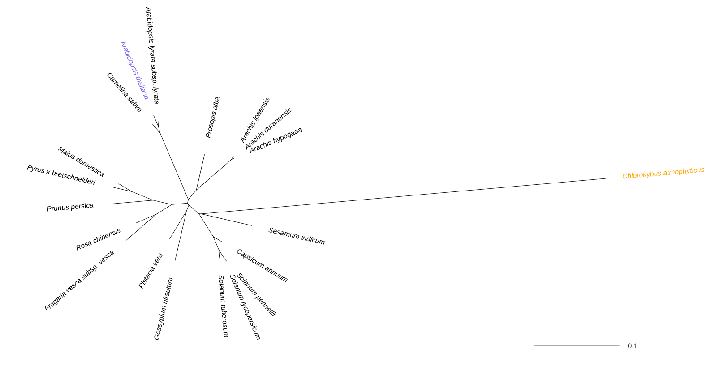
Phylogenetic tree parameters for ‘Simple Phylogeny’ on the EBI:
MSA: See Q05 above
TREE FORMAT: Default
DISTANCE CORRECTION: on
EXCLUDE GAPS: off
CLUSTERING METHOD: Neighbour-joining
P.I.M.: off
[Q7] Generate a sequence identity based heatmap of your aligned sequences using R.

[Q8] Using R/Bio3D (or an online blast server if you prefer), search the main protein
structure database for the most similar atomic resolution structures to your aligned
sequences.
List the top 3 unique hits (i.e. not hits representing different chains from the same
structure) along with their Evalue and sequence identity to your query. Please also add
annotation details of these structures. For example include the annotation terms PDB
identifier (structureId), Method used to solve the structure (experimentalTechnique),
resolution (resolution), and source organism (source).

[Q9] Generate a molecular figure of one of your identified PDB structures using VMD.
You can optionally highlight conserved residues that are likely to be functional. Please use a white or transparent background for your figure (i.e. not the default black). Based on sequence similarity. How likely is this structure to be similar to your “novel”

[Q10] Perform a “Target” search of ChEMBEL ( https://www.ebi.ac.uk/chembl/ ) with
your novel sequence. Are there any Target Associated Assays and ligand efficiency
data reported that may be useful starting points for exploring potential inhibition of your

