**Terms to review:**

literal string

literal constant

identifier

variable

constant

declaration

initialization

assignment

argument

data type

***block***

***scope***

***control statement***

***conditional operator (aka. ternary operator)***

***switch structure***

***case label***

***nesting***

***truth table***

***not operator***

***short-circuit evaluation***

***range check***

**Homework & Labs**

*// Please name your projects LB1, LB2, LB3, etc*

1. Complete Naming Conventions Handout

2. Complete Data Types Handout

3. Write a GUI program that determines eligibility for college applicants:

* Prompt the user for the high-school GPA and admission test score.
* Display “Accept” if the student’s GPA is 3.0 or higher and their admission test score is 60 or greater.
* Display “Accept” if the student’s GPA is less than 3.0 and their admission test score is 80 or greater.
* Otherwise display “Reject”

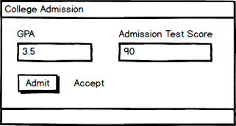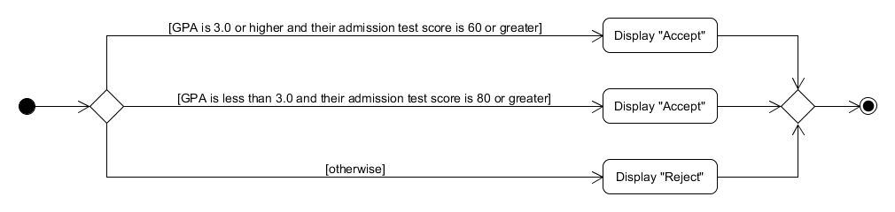

4. Write a GUI program that estimates the category of a hurricane based on the wind speed (based on the Saffir-Simpson Hurricane Scale):

* Category 5 hurricanes have sustained winds of at least 157 miles per hour.
* Category 4 hurricanes have sustained winds of at least 130 miles per hour.
* Category 3 hurricanes have sustained winds of at least 111 miles per hour.
* Category 2 hurricanes have sustained winds of at least 96 miles per hour.
* Category 1 hurricanes have sustained winds of at least 74 miles per hour.
* Any storm with winds of less than 74 miles per hour is not classified as a hurricane.

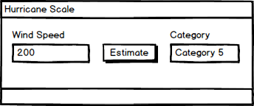

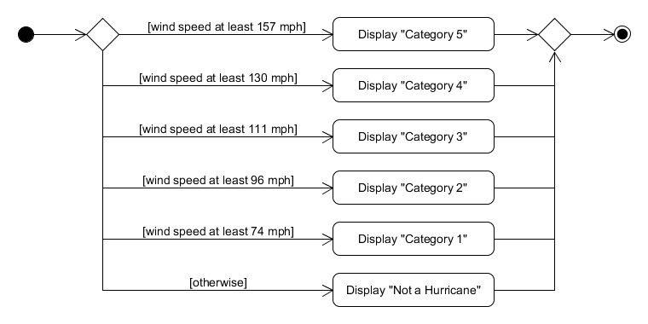

5. You can randomly generate three numbers as follows:

Random rand = new Random();

int num1 = rand.Next(1, 4);

int num2 = rand.Next(1, 11);

int num3 = rand.Next(1, 101);

Console.WriteLine(“{0}, {1}, {2}”, num1, num2, num3);

See here for the official documentation of the Random class:

https://msdn.microsoft.com/en-us/library/system.random(v=vs.110).aspx

Build a GUI program that allows the user to play three rounds of Rock Paper Scissors. Once all three rounds are over, display the winner.

