**Terms to review:**

identifier

variable

constant

data type

value data type

reference data type

class

object/instance

constructor

field (aka. member variable or instance variable)

method

encapsulation

composition

aggregation

polymorphism

inheritance

base class

subclass

overloaded method

overridden method

virtual method

abstract method

abstract class

interface

**control**

**check box**

**radio button**

**list box**

**combo box**

**modal window**

**UserControl**

**delegate**

**composed delegate**

**event**

**focus**

**mouse event**

**keyboard event**

**event-driven programming**

**Homework & Labs**

*// Please name your projects LB1, LB2, LB3, etc*

LBI. Complete Naming Conventions Handout

LBII. Complete Data Types Handout

**LB1 SuperHeroDatabase**

Create a GUI application to look up information about superheroes.

1. Program must contain information about at least 5 superheroes.
2. Dropdown must be populated programmatically.
3. Dropdown must contain an option to select no superhero. (hint: null)
4. When the user selects an option from the dropdown, display all available information about that superhero.
5. Create a **SuperHero** class that contains all of the information about a single superhero.

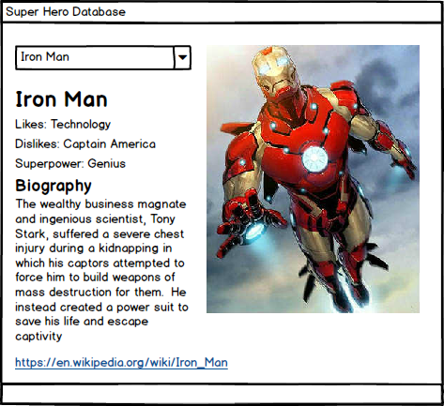

**LB2 JobDatabase**

Create a GUI application to search for job openings.

1. Program must contain at least 5 industries.
2. Program must contain information about at least 5 jobs.
3. ListBox must be populated programmatically.
4. ListBox must allow multiple industries to be selected.
5. Clicking the search button will show the search results in a new window.
6. Search results must be populated programmatically.
7. Create a **Job** class that contains all of the information about a single job.
8. Create a **Industry** class that contains the name of the industry and an array of jobs.

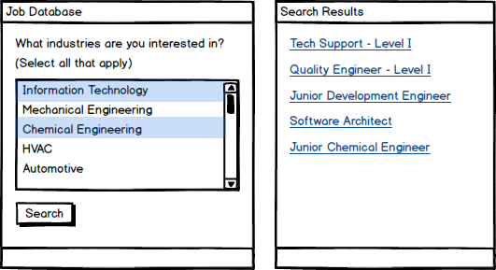

**LB3 Clock**

Create a GUI application that demonstrates focus, keyboard, and mouse events.

* When the user **clicks** on a TextBox change the background color to **Yellow**
* When a TextBox **receives focus** change the background color to **LightBlue**
* When a TextBox **loses focus** change the background color to **LightGray**
* When a the user presses down the **up arrow** on the keyboard, change the focus to **TextBox 1**
* When a the user presses down the **right arrow** on the keyboard, change the focus to **TextBox 3**
* When a the user presses down the **down arrow** on the keyboard, change the focus to **TextBox 5**
* When a the user presses down the **left arrow** on the keyboard, change the focus to **TextBox 7**

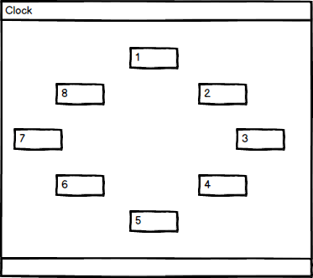

**LB4 MultiSearch**

Create a GUI application that can search for students by both first name and last name.

* The user can search for students by first name.
* The user can search for students by last name.
* When a student is found the search results display the student's first name, last name, course, course grade, and overall GPA.
* When a student is not found display an error message.
* **The user must be able to initiate a search by pressing Enter on the keyboard, in the corresponding TextBox (Hint: PerformClick)**

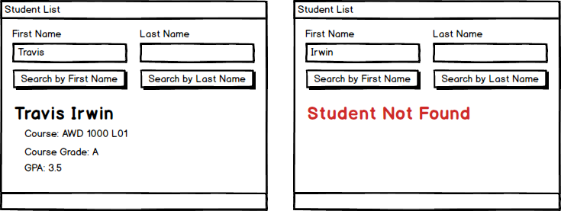

**LB9 Build-A-Lab**

Create your own lab.

* Submit your design to the bin in class.
* Submit your implementation to bitbucket.
* Program must have tab order configured.
* Program must follow naming conventions for all controls, variables, constants, methods, classes, enumerations, interfaces, and exceptions.
* **Program must have at least two classes (not including Form or Exception subclasses).**
* **Program must have at least one dropdown.**
* **Program must have at least two windows.**
* **Program must respond to either focus events, keyboard events, or mouse events.**