**Terms to review:**

Generic Method

Generic Class

Indexer

Iterator

Interface

IEnumerator

IEnumerable

List

Dictionary

**Homework & Labs**

*// Please name your projects LB1, LB2, LB3, etc*

**LB01 StudentList**

* Create a **Student** class.
* Create a **Course** class that has a name and **List** of **Student** objects.
* When the form loads, populate a rich text box with several students
* Provide the user with a way to add students to a course, update the rich text box to reflect this.
* Provide the user with a way to remove students from the course, update the rich text box to reflect this.

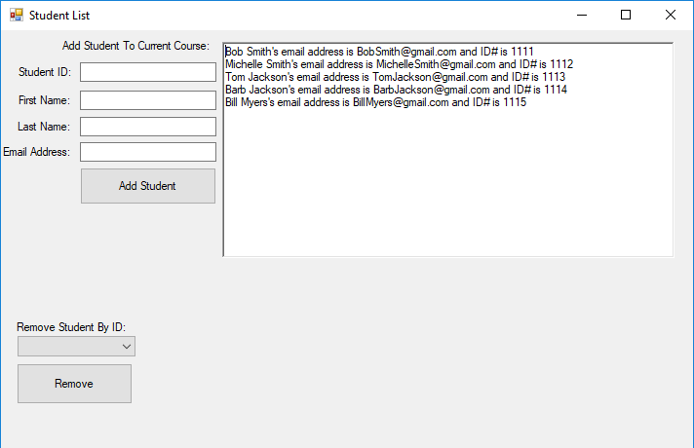

**LB02 StudentDictionary**

* Create a **Student** class.
* Create a **Course** class that has a name and **Dictionary** of **Student** objects. (Use the last name of the student as the key into the dictionary.)
* When the form loads, populate a rich text box with several students
* Provide the user with a way to add students to a course, update the rich text box to reflect this.
* Provide the user with a way to remove students from the course, update the rich text box to reflect this.
* Provide a way to search a Student by ID

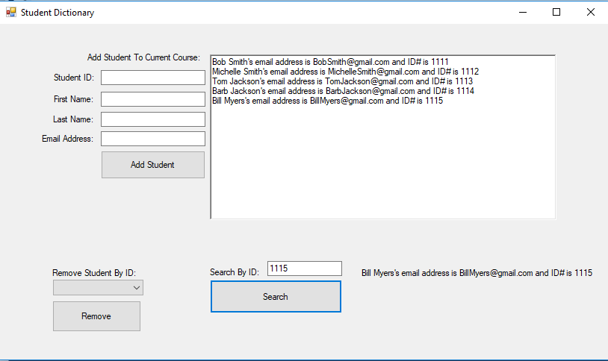

**LB03 StudentCourses**

* Create a **Student** class.
* Create a **Course** collection of at least 2 courses. Each course should have a unique **List** of **Student** objects
* Allow the user to select a course and see the unique students in that course.
* Provide the user with a way to add students to a course.
* Provide the user with a way to remove students from the course.

