**Terms to review:**

identifier

variable

constant

declaration

initialization

assignment

argument

data type

function

method

invoke / call

calling method

called method

method declaration

method body

return type

parameter

parameter list

argument

local variable

nested method call

return statement

implementation hiding

**overloaded method**

**mandatory parameter**

**optional parameter**

**value type**

**reference type**

**value parameter**

**reference parameter**

**output parameter**

**parameter array**

**positional argument**

**named argument**

**Homework & Labs**

*// Please name your projects LB1, LB2, LB3, etc*

LB1. Complete Naming Conventions Handout

LB2. Complete Data Types Handout

LB3. Write a GUI application that can reverse the order of four numbers entered by the user.

Create a method named **Reverse4()** that accepts four integers by reference and has no return value. This method should reverse the order of all 4 integers that were passed in.

*Program must pass all provided unit tests.*

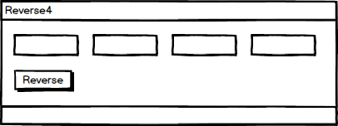

LB4. Write a GUI application that sorts all of the words in a phrase entered by the user.

Create a method named **SortWords()** that accepts a parameter array for the unsorted words and returns an array with the sorted words.

*Program must pass all provided unit tests. You may want to look up the String.Split() method for this lab.*

[*https://msdn.microsoft.com/en-us/library/b873y76a(v=vs.110).aspx*](https://msdn.microsoft.com/en-us/library/b873y76a(v=vs.110).aspx)

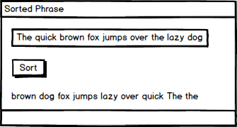

LB5. Write a GUI application that accepts bids for an online auction in a variety of formats.

The following bid formats should be accepted:

* 34
* 34.0
* 34.00
* 34.000
* $34
* $34.0
* $ 34
* $ 34.0
* 34 dollars
* 34.0 dollars
* 34.00 dollars
* etc.

For any bid that does not fall into one of the above formats, display an error message of "Invalid Bid"

In all cases the minimum bid is $10. Display an error message of "Bid must be at least $10" for any bid of less than $10.

For any bid that is in a valid format and meets the minimum bid requirement, display "Bid of $x.xx accepted!" (where x.xx is the amount that the user bid).

Create a method named **ParseBid()** that accepts a string for the bid and returns string for the message. **This method should not have any side effects.**

*Program must pass all provided unit tests. Several methods of the String class will be useful for this lab.*

[*https://msdn.microsoft.com/en-us/library/system.string(v=vs.110).aspx*](https://msdn.microsoft.com/en-us/library/system.string(v=vs.110).aspx)

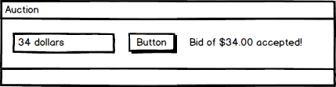

LB6. Write a GUI application that accepts up to 20 integers and calculates some statistics about those integers.

If the user enters a value that is not a valid integer, then display an error message next to that field instead of crashing the program.

The entered integers should be stored in an integer array named **numbers.** And the count of numbers entered sofar should be stored in an integer named **count.**

Create a method named **CalculateStats()** which:

1. Has an **int** output parameter named **min** for the lowest number passed in
2. Has an **int** output parameter named **max** for the highest number passed in
3. Has a **double** output parameter named **sum** for the sum of the numbers passed in
4. Has a **double** output parameter named **avg** for the average of the numbers passed in
5. Accepts a parameter array of **ints** containing all of the numbers you wish to calculate statistics for
6. Does not have a return value
7. **Has no side effects**

*Program must pass all provided unit tests. Please remember to set the tab order.*

