
Physical Chemistry I

Module SSPK

The presentation and analysis of scientific images

Questions
- Which image processing software will be used?
- What does the color in an AFM image represent?
- What two things should be included in every scientific image with false color?
- What does the acronym FFT stand for?
- What is the radial distribution function (RDF)? What else is it called?

Suggested background
- Topics & terminology
  - Fourier analysis, FFT, Reciprocal lattice, Radial distribution function.
- ImageJ website and user guide
  - https://imagej.nih.gov/ij/index.html
  - https://imagej.nih.gov/ij/docs/guide/index.html
  - Again, just a starting point. ImageJ has a large (mostly biological) user community which you can tap into with a web search.

Objective of lab course
In this lab course we will introduce and use software tools to prepare and analyze images from scientific instruments. We will use the free software ImageJ to analyze images, and this lab will use example images from TEM and AFM to teach students the analysis methods. Structural information will be derived from Fourier transforms, allowing us to identify and calculate the average distance between particles, structural anisotropy, and the radial distribution function. This will prepare students for making their own independent analyses.

Introduction
“A picture is worth a thousand words,” or so goes the saying in English. (“Ein Bild sagt mehr als tausend Worte.”) That is because “pictures,” i.e., spatially presented information, grab our attention and engage with the analytic brain in unique and intuitive ways like no text can. Images in particular appeal to our natural aptitudes, and scientific images use that familiar format to quickly and effectively convey new types of information that are not directly accessible to our senses. Therefore, proper presentation and analysis of images from scientific instruments are important parts of modern scientific communication.

As useful as they can be, it is important to remember that all scientific images are a construction, i.e., this is data from an instrument and not light bouncing off objects as seen by our eyes. Therefore, we have to ask several critical questions in order to interpret them. The first critical question should always be, “What information does this image represent?” In an AFM, the image represents the amplitude or phase of a tiny lever tapping a surface. This can generally be interpreted as the height and hardness/stickiness of the surface, but understanding the limitations of this interpretation is important.

Conventionally, this information is presented in colored images. But what does the color represent? Is there an intrinsic difference between red and yellow in the AFM image, like the different wavelengths of light with our direct observations with eyes? If not, then why are AFM images in color, and how else could they be presented? This highlights a second critical topic in the presentation of scientific images, “Why is the image colored? And what does the color represent?” Whenever the color is ambiguous (i.e., “false color”), it is important to include a color bar relating the image colors to the data collected, or at the very least describe the method by which the image was colored.

The last critical point in interpretation of a scientific image is scale: “How big is this image?” This point is an integral part of understanding not only the imaging technique, but also which natural processes could be involved. Therefore, a scale bar is of critical importance to the presentation of every scientific image. Every scientific image must be approached with these three critical points in mind, during both the preparation and the reading of a scientific report.

When there is structure in an image, a Fourier transform can convey the structural information much more succinctly. A Fourier transform of an image gives the relative abundances of the spatial frequencies in the image, i.e., how prevalent are patterns that repeat every 10 pixels? 20 pixels? etc. This information is called the power spectrum, and the distance of repetition is the spatial period. The Fourier transform power spectrum of an image is itself an image of the same size, and conventionally the spatial frequencies are organized radially, with the longest spatial periods at the center and the shortest spatial periods at the edges. When organized this way, the Fourier transform power spectrum image is directly related to a diffraction pattern through the same structure. Therefore, the Fourier transform provides the connection between the “real space” of an image and the “reciprocal space” of a scattering or diffraction pattern. This means that we can extract the same information from the Fourier transform of an image as we could from the diffraction experiment through the same area, such as the radial distribution function (RDF), also known variously as g(r), the pair correlation function, and g⁽²⁾(r). This connection can be invaluable when the corresponding diffraction experiment is not possible or difficult, such as with AFM images.

A bigger and more difficult topic in scientific communication is the role of scientific images in conveying data: When is an image the best way to communicate this information? One of the appeals of presenting data as an image is for rapid qualitative analysis. Readers can rely on intuition and convention to familiarize themselves with the image, and then quickly extract the scientific value and meaning. However, for quantitative observations and relationships, the data in scientific images must be extracted and carefully analyzed. Subsequently, this data can be presented as a graph or chart which more succinctly conveys the meaning and scientific value. Therefore, it is important to be able to extract data from scientific images.

Here we will use a combination of qualitative and quantitative methods to analyze the structures in two scientific images. We will use ImageJ, a free application that has become a standard of the scientific community for its significant analytic power and extensibility, and a goal of this lab is to familiarize and orient you with ImageJ. ImageJ supports the production of publication-ready scientific images with accurate scale bars, and it also supports measurements in the image. We will learn how to do both of these in this tutorial.

We will also use the Fourier transform power spectrum to qualitatively analyze structure in our images and the RDF to quantitatively determine the average inter-particle distance. We will compare the value from the Fourier transform to real space measurements and another closely related analytic technique (the Autocorrelation). The Fourier transform not only gives spatial frequency abundances, but also in which direction that pattern repeats. We will use this information to assess structural anisotropy in our images. Lastly, Fourier transforms are really only valuable and conventional because of an efficient computational algorithm, the fast Fourier transform (FFT). ImageJ includes an efficient and easy implementation of the FFT algorithm. The RDF is calculated from the FFT, and we will learn how to install and modify some simple plugins and macro scripts in ImageJ to compute the RDF.

As a result of this tutorial, you will be prepared to make your own analysis of an AFM image of a structured sample.

Experiment

A. Installation of ImageJ software
To get started, we need to install the ImageJ image analysis software. It is a small and self-contained application, so we can run it from anywhere on the computer. Laptops will be provided so that all students can work on this process during the lab period. However, feel free to bring your own laptop so that you do not have to repeat all the installation steps.
- Open a web browser and navigate to
https://imagej.nih.gov/ij/
Alternatively, use a search engine to find the main page for ImageJ.
- Navigate to the download page
https://imagej.nih.gov/ij/download.html
Scroll down to the Windows heading, and download the link “bundled with 64-bit Java 1.8.0_112”
- When the download is finished, un-compress the downloaded file (ij150-win-java8.zip).
- Navigate to the new folder, and then the subfolder “ImageJ”. Open the application by double-clicking the “ImageJ.exe” icon. Click through “run”. Your lab instructor will help you with Administrator access if needed. A small gray bar with the ImageJ icons and tools should pop up in your screen. This is the basic interface. You now have ImageJ installed on your computer.
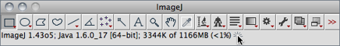
- Familiarize yourself with the tools available. The ImageJ User Guide can help.
https://imagej.nih.gov/ij/docs/guide/146-Part-IV.html

B. Orientation, preparing images for publication
The purpose of this exercise is to familiarize you with ImageJ. To facilitate this orientation, we will open and prepare two scientific images for publication. We will also measure the average particle size and nearest neighbor center-to-center distance. We will use these images and methods for further analysis, so this section forms a foundation for later exercises.
- Download the example images that we will prepare for publication.
https://github.com/jpsfitz/sspk
This includes a TEM image (“.dm3”) and an AFM image (“.png”).
- We will start with the TEM image. Select the raw data/image file (“AW5-273_0015.dm3”). Drag the file over and drop it on the ImageJ toolbar. The image will open, and we can begin preparing it for export.
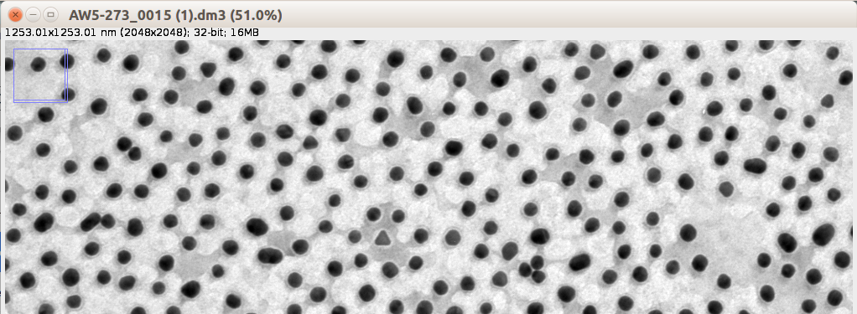
This is a black-and-white TEM image of Au nanoparticles with polymer shells. The brightness represents the percentage of electrons that transmit through the sample. The black is Au, since it blocks most electrons, while the white background is a thin substrate that the nanoparticles were deposited on, which was designed to have high electron transmission. The gray between and surrounding the nanoparticles is dehydrated polymer and solvent residue.
Notice the information at the top of the window, above the image. This contains the image size in pixels and in nanometers, as well as the amount of information in each pixel (32-bit) and the size of the image. The file format “.dm3” contains this information with the conversion factor, while a normal image format would only contain the pixel size. This makes export of the image easy.
- We are going to prepare a 1000 nm x 1000 nm version of the TEM image with a scale bar which would be suitable to include in a publication or report. We will also take a few distance measurements to get an idea of the nanoparticle sizes and nearest neighbor distances.
  - Use the “Rectangular Selection Tool” and make a selection in the image window. Initially, any size will do. Pay attention to the information in the toolbar window. Using that information, resize the selection to be 1000 nm x 1000 nm.
  - You will probably need to zoom in to make fine adjustments. This can be done in any of three ways: (i) using the “+” and “-” keys on the keyboard, (ii) using the scroll wheel with the “Ctrl” key, or (iii) selecting the “Magnify Tool” and left-clicking to zoom in, right-clicking to zoom out.
  - When your selection area is 1000 nm x 1000 nm, it should cover about 80% of the length and width, or about 65% of the image area. You can reposition the selection area to highlight region that look best to you (e.g., low polydispersity, few particles cut off by image edges). When you are ready, use the “Image” drop-down menu to Crop to the selection. Save a version of the image at this point.
  - Now we are going to add a scale bar. Use the “Analyze” drop-down menu. The last option in “Tools”, and then select “Scale Bar…”. This will pop up with a dialog where you can work on the scale bar. A scale bar length of about 200 nm should look good. The other default options are fine, but easy to work with in the future. If you don’t like the look of the scale bar when the dialog closes, use the “Undo” action (“Ctrl-Z” or in the “Edit” menu) to remove it and start over.
  - When you are satisfied with the size of the image and the scale bar, save the image to file as a PNG, Jpeg, or Tiff. Open the saved image with another program to confirm that it saved appropriately. You have now prepared a publication-ready TEM image.
  - Zoom into an area, and using the “Straight line selection tool” draw a line through the center of two nearby particles. Make a plot of the image intensity through this line using the menu “Analyze” and then select “Plot Profile”. Determine the diameters of the two nanoparticles from the plot profile. Then determine the center-to-center distance. Repeat this measurement with 9 more randomly selected areas. Take the averages and standard deviations of these 20 diameters and 10 center-to-center distances, and note any other interesting length scales or features. The below image uses the “Edit” > “Invert” function.
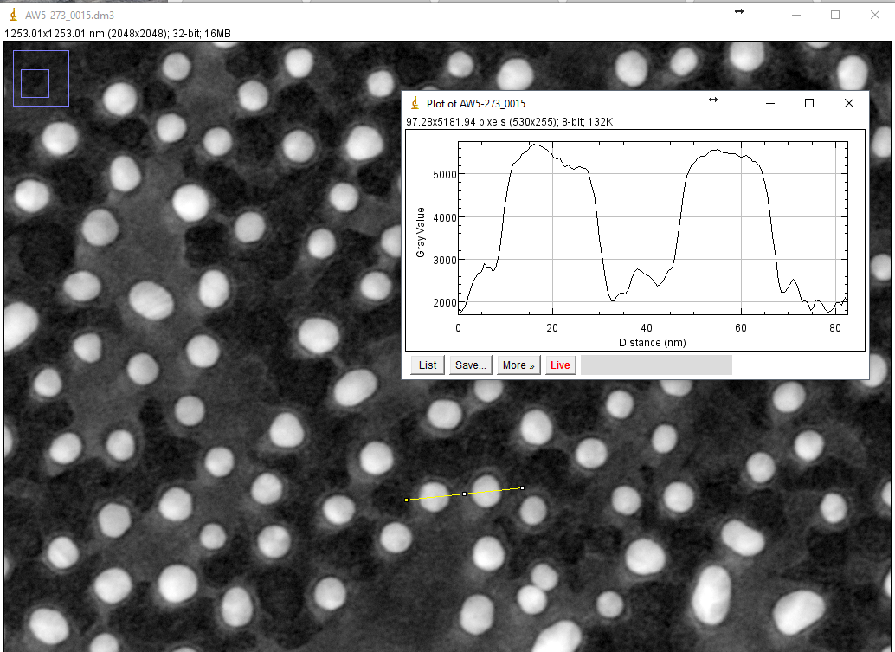
- Next we are going to prepare the AFM image with a scale bar.
  - Drag and drop the AFM image (“kv032-rem-1-17.007_1.png”) to ImageJ to open it. This is a large file, so it may take a moment to open. Notice the information at the top of this window. This is simply an image, so it has no length scale except in pixels, and it is in color, so the “32-bit” is replaced by “RGB”.
  - We need to manually add a length to pixel conversion scale to this image. This is a large AFM scan, 40 μm x 40 μm for the total image size. The pixel size is also rather large, 4096 x 4096. Therefore, we need to add a scale of 40000 nm per 4096 px, (9.7656 nm/px or 0.1024 px/nm) before we can add a scale bar. This can be done with the “Analyze” drop-down menu, using the option “Set Scale…”.
The “Distance in pixels:” is the full pixel width of the image (4096), and the known distance is the full scan width in nanometers (40000). The aspect ratio is the default 1.0, and the unit of length is “nm”. Confirm that the “Scale” is 0.1024 px/nm, then click “OK”. When you are done, you will see that the image information is updated to include the image size in nanometers.
  - Now we can add a scale bar just as before. Use the “Analyze” drop-down menu. The last option in “Tools”, and then select “Scale Bar…”. A distance of 5000 - 10000 nm is probably about right, and a larger font size (e.g., 120) may be better. You can now export this image.
  - In this case, the image contains a lot of pixels, and may be difficult to include in your report simply because it is too big (depending on the RAM on your computer). If you do not need the full size, you can scale the image using the “Image” drop-down menu, and selecting “Scale…”. Here, a scaling factor of 0.5 still gives a very large, publication-ready image, and further scaling may be needed, depending on the final printed size. When saving the scaled file, you should be careful to retain the original image at full size for further data analysis.
  - Use the “Straight line selection tool” and “Analyze” > “Plot Profile” to determine the average particle diameter and nearest neighbor center-to-center distance from 10 randomly selected areas. Take the averages and standard deviations of these measurements, and note any other interesting length scales or features. Can you use the high periodicity of this structure to improve the nearest neighbor center-to-center distance measurement?

C. FFT (Fast Fourier transform) and Autocorrelation
In this exercise, we will use the FFT and inverse FFT computations in order to study order and determine nearest neighbor distances in images. We will use the example TEM image as a first exposure, and then repeat the process with the example AFM image.
- First, we will do the FFT computations on the disordered example TEM image.
  - Open the TEM image (“AW5-273_0015.dm3”). If you are not reloading the image from file, make sure that there is no scale bar.
  - Compute the Fourier transform image using the FFT function. In the menu “Process” under “FFT” select “FFT”. A new window should pop up showing the Fourier transform of the original image.
  - Open the “Contrast/Brightness” dialog (menu “Image”, under “Adjust”) and adjust/zoom into your image until it looks something like the one below. When that is done, save the full size FFT to file.
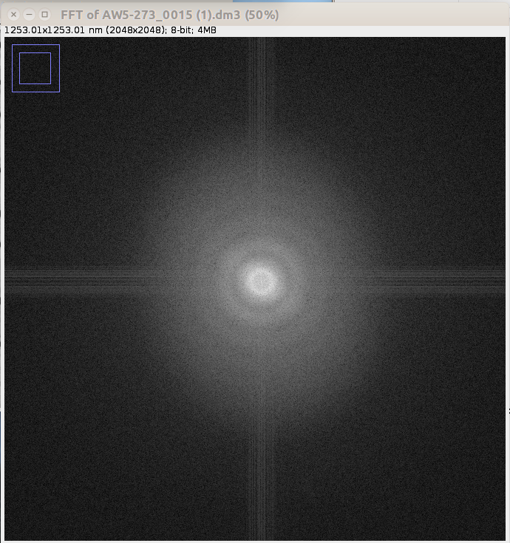
The FFT of a TEM image presents something very similar to the physical electron diffraction micrograph. It represents the frequencies of spatial information in the original image, with long distances at the center of the FFT image and short distances at the edges. This computation preserves angular information, although real space x (y) distances are represented in FFT reciprocal space y (x). Moving your mouse over the FFT, notice the “r” and “theta” values in the toolbar. The “r” coordinate is given in nm/cycle, and gives the spatial distance in the original image corresponding of that FFT frequency. What is the largest value of “r” in the FFT, and where is it located?
The longest possible distance in the original image is the length of the whole image, and the edges of the original image produce the cross pattern going through the center of the image. This is an artifact of the FFT computation, and it is not real. Also notice that most of the image information about the image is located near the center, corresponding to relatively long distances. The shortest possible distance in the original image that still contains real information is the resolution of the image. We can measure the resolution of the image by finding the edge of the central spot. Here it is about 2-3 nm. Notice that the edge is not perfectly circular, but instead is elongated with the y-axis. This is an image artifact from the TEM called astigmatism.
There are several other rings in the FFT, with some of the larger maxima located at approximately 42 nm, 13 nm, and 7.5 nm. What do you think these distances correspond to in the original image? Notice that there are only rings in the FFT, i.e., there are no stripes, points, or other anisotropic shapes. Why is this?
  - Next compute the FFT Autocorrelation. In the menu “Process” under “FFT” select “FD Math”. A dialog will pop up. Make sure “Image 1” and “Image 2” are both the same (here “AW5-273_0015.dm3”), and the “Operation” is correlate. Name the result something memorable, e.g., “Autocorrelation TEM”, tick the “Do inverse transform”, and click “OK”. A new window should pop up showing the autocorrelation. This is a real space image that represents the “average” nanoparticle and its surroundings.
  - Using the “Line tool”, make a profile plot of the central area. Once you have the line positioned as you want, you can make a profile plot using the menu “Analyze” and selecting “Plot Profile”. This will pop up with a new graph window, and the result should look something like the image below.
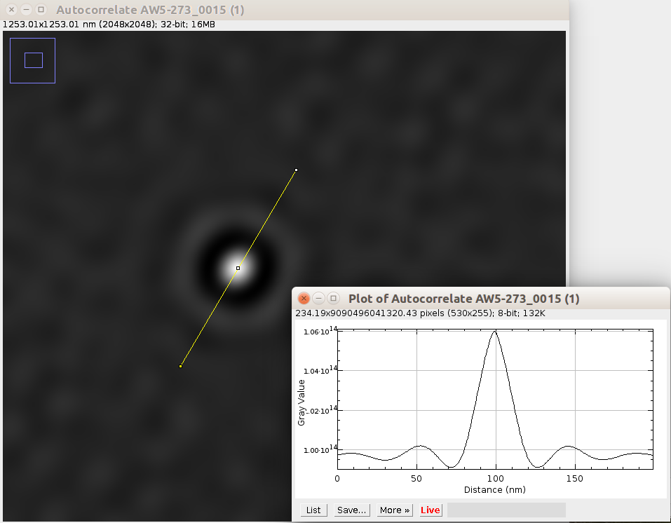
What is the full width at half maximum (FWHM) of the central peak? This distance represents the average size of a nanoparticle or, in this case, nanoparticle-polymer cluster. What is the center-to-center distance between the central peak and the first ring? This distance represents the average nearest neighbor distance between clusters.
- Next, we would like to repeat the FFT and Autocorrelation analysis with the AFM example image. This image shows long-range order, so we expect this FFT to give us more information than the with the TEM image.
  - Open “kv032-rem-1-17.007_1.png”. As before, make sure there is no scale bar in the image, but also make sure you have set the image scale (“Analyze” > “Set Scale…”).
  - The FFT only works in grayscale, so using the FFT computation will produce a grayscale image. ImageJ is smart enough to convert the color image to grayscale internally, so you can apply the FFT directly to the color image. However, doing the grayscale conversion yourself not only makes the connection more obvious and can also improve the resulting FFT. To convert to grayscale, use the menu “Image”, and under “Type” select “8-bit”.
  - Now compute the FFT (“Process” > “FFT” > “FFT”), and then adjust the contrast/brightness as before (“Image” > “Adjust” > “Contrast/Brightness”, the “Auto” button usually gets the minimum value right, the maximum should probably be turned up all the way).
Describe what you see and how it compares to the disordered TEM image FFT. Do you see peaks or other anisotropic features? Where are they, and how are they arranged? What do these features correspond to? What does this tell you about the order in the AFM image? Are they points, or are they “smeared out” in the coordinates “r” and “theta”? What does the shape of the peaks in “r” and “theta” tell you about order in the AFM image? What would they look like if the AFM nanoparticles were replaced by points? How does the “resolution edge” shape compare to the TEM? Is this really the resolution of the AFM scan in this case?
  - Now return focus to the original image, and compute the FFT Autocorrelation (“Process” > “FFT” > “FD Math...”, the default settings are usually close to correct, but make sure to name the window).
Again, describe what you see and how it compares to the disordered TEM image FFT Autocorrelation. How far from the center can you clearly distinguish particles? This is an indicator of the average crystalline domain size and local order. How well do these observations correspond to the original image?
  - Find the central particle in the image. It is a little more difficult this time, but it is the brightest particle in the image, and there is a “barrel distortion” surrounding it. As you zoom in, this distortion should become a little more obvious. Create a line profile through the central particle and two nearest neighbors (use the “Line Tool”, and then “Analyze” > “Plot Profile”). What is the FWHM of the central peak? What does this correspond to? What are the two nearest neighbor distances along this line profile? What about the distances to the next order peaks? Repeat these measurements in all three unique directions and take the average to get the average interparticle spacing in the lattice. Does the nearest neighbor distance change with direction? If so, why?

D. Radial distribution function g(r)
As a last exercise, we will use an external plugin+macro to calculate the radial distribution function g(r), also known as the pair correlation function g⁽²⁾(r). We will do some basic editing of the macro in order to customize its output. Again we will use the example TEM image as a tutorial, and then repeat the steps for the example AFM image.
- We will be using the plugin and macro described at
http://imagejdocu.tudor.lu/doku.php?id=macro:radial_distribution_function
The installation instructions are summarized here for convenience.
  - Download the plugin:
https://imagej.nih.gov/ij/plugins/download/Radial_Profile.class
  - Move/copy the downloaded file into the ImageJ folder “Plugins”.
  - Restart ImageJ. Confirm that the plugin is installed: In the drop-down menu “Plugins” there should be an entry “Radial Profile”. It will be in the lower half, organized alphabetically.
  - Next we will install the macro. Under the “Plugins” menu, select “New” and then “Macro”. A new window should pop up titled “Macro.txt”. This is really just a text editor.
  - Navigate to the macro page
http://imagejdocu.tudor.lu/doku.php?id=macro:radial_distribution_function
Scroll down to the “Code” section. Select everything in the code block text box. This text begins with “// ImageJ Macro …” and ends with “} //End Macro”.
  - Copy this to the ImageJ Macro text editor. Use the menu in that window to save it as “RadialDistributonFunction.txt” (not possible from the Toolbar menu). Note the folder it is saved in. The default folder is ImageJ/macros. When we want to run the macro script, we can run it from the text editor or from the file in this folder. The macro is now installed.
- First, we will analyze the TEM image to find the radial distribution function (RDF) or g(r).
  - Open the image (“AW5-273_0015.dm3”), and convert it to an 8-bit image (“Image” > “Type” > “8-bit”).
  - We will use the function “Find Maxima...” to find the nanoparticle centers. Before we do this, look at the image and estimate how many nanoparticles there are so that we can evaluate whether this process works. What is your estimate?
  - Now, in the “Process” menu, select “Find Maxima...”. In the pop-up window, select “Output type:” “Single Points”, and tick all three boxes. Do not hit “OK” yet. How many particles does this method detect? Adjust the “Noise tolerance” until the number of maxima roughly matches your estimated number of nanoparticles. Then, look at the point selections to double check your threshold choice, i.e., there are no points in the middle of the background and that all particles are marked. This will always be a trade-off. Note and write down this threshold value. You can safely close the pop-up window with the point selections.
  - Next we will run the macro script to calculate the RDF. Close all image files except the TEM image that you want to analyze. If you still have the macro text editor open, bring it to the front. In that window, use the menu “Macros” and select “Run Macro”. Otherwise, use the Toolbar menu “Plugins” > “Macros” > “Run…”, and select the previously saved macro txt file. Enter the noise threshold from the previous step, and tick the output option. This uses macro uses and FFT-based method to calculate the RDF, which will pop up in a new window.
  - This graph is your primary result. Play with the size and axis options, and then save the result. Alternatively, you can export the data and plot it in your preferred graphing program. How many peaks are in the RDF? What units are on the x-axis? From the peak position(s), calculate the nearest neighbor distance. Does the RDF give any evidence of long-range order in this image? How does this compare to results from the FFT and FFT Autocorrelation analysis?
- Next, we will repeat the analysis with the AFM image, and we will modify the macro script to display the x-axis in nanometers.
  - Open the image (“kv032-rem-1-17.007_1.png”), and convert it to an 8-bit image (“Image” > “Type” > “8-bit”). Then invert the colors so the image is black particles on a white background (“Edit” > “Invert”). Set the image scale (“Analyze” > “Set Scale…”).
  - Estimate the number of particles in this image. Now use Find Maxima to detect particles (“Process” > “Find Maxima…”) using the same options as before. Optimize the threshold value to match your estimate, then check through the image to make sure it is working properly. You may find that this image is significantly less sensitive to the threshold value. When you are satisfied, note the threshold value.
  - Run the RDF macro on the image, using the appropriate threshold value. Enter the noise threshold from the previous step, and tick the output option. How many peaks are in the RDF? How does this compare to the TEM image RDF? What units are on the x-axis? From the peak position(s), calculate the nearest neighbor distance, and use the FWHM of the peak(s) to give the position average positional deviation/uncertainty. Does the RDF give any evidence of long-range order in this image? How does this compare to results from the FFT and FFT Autocorrelation analysis?
  - Unfortunately, the RDF from the 8-bit image does not show as good order as the particles actually have. This is because the centers of the particles do not always align with the maximum height. We can fix this problem by thresholding the image first.
In the menu “Image” select “Adjust” then “Threshold…” Click the “Auto”, check that it seems reasonable, and then click “Apply” and close the Threshold window. Now the particles have a single brightness level, and Find Maxima will find the center of the particle. Determine the proper threshold value for Find Maxima, and then run the RDF macro function. What differences do you see?
- As a last step, we are going to edit the macro script to display the RDF as a function of nanometers. Part of the purpose here is to familiarize you with the macro scripting language.
  - Open the macro script txt in the macro editor.
  - Next convert the x-axis from pixels to nanometers. Find the line:
Plot.getValues(x, y);
This line occurs twice. Below the second one (before “Plot.create”), add the lines:
xnm = newArray(y.length);
for (i=0; i<y.length; i++) {xnm[i] = (40000/4096)*x[i]; }
Match the indentation of the previous and following lines. Note that the code is specific to this AFM image. It should be relatively straightforward to edit it for your own analysis.
  - Lastly, we will plot the converted x-axis. In the next line make a few changes:
Find: "Distance (pixel)".
Replace “(pixel)” with “[nm]”.
Find “x, y”.
Replace with “xnm, y”.
  - Save the macro script text.
  - Now run the macro. Do the peak positions in nanometers match your expectations?
  - This graph is your primary result. Play with the size and axis options, and then save the result. Alternatively, you can export the data and plot it in your preferred graphing program.

Guidelines for the lab report
Your lab report will present an analysis of the average order and nearest-neighbor center-to-center distance of a nanoparticle monolayer deposited on a glass substrate using an AFM image of the monolayer as the primary source of data. You will analyze the AFM image to characterize your sample. Your lab report will follow the format of a publishable research article, and it should contain:
- An introduction to your sample, what measurements characterize your sample, and what tools you will use to obtain this measurement. If it helps to write the introduction, you may also include any motivation or theoretical points that seem relevant here, but an introduction with this broader scope is not necessary.
- An AFM image of your sample. Explain this image and what it tells us about your sample. Include a color bar with the image that shows the relationship between height and color.
- A FFT power spectrum image of your sample. Comment of the major features of the FFT image, and the relationship between these features and the order in your sample, including structural anisotropy.
- The RDF plot and analysis. Cite the method by which it was obtained, and describe the features in the RDF plot. Give the nearest neighbor distance with an uncertainty estimate.
- Briefly summarize your methods and results. If possible, also include a brief outlook for how these results could be useful.
These five sections and three figures should only be a few pages. If you feel any other information is relevant, such as the Autocorrelation technique, you may include it as an appendix. Prepare your manuscript in a review format, with double-spaced lines and large enough figures that any indicated features can be easily seen. Prepare your work as a Word, OpenOffice, or PDF document, and in addition to the printed version, also send a digital version to your instructor. This is to ensure that the quality and color of your figures is accurately represented. An email address and deadline will be discussed during the lab.

