Style_Reference

Joe Shannon

September 21, 2015

# R Markdown

This is an R Markdown document. Markdown is a simple formatting syntax for authoring HTML, PDF, and MS Word documents. For more details on using R Markdown see <http://rmarkdown.rstudio.com>.

When you click the Knit button a document will be generated that includes both content as well as the output of any embedded R code chunks within the document. You can embed an R code chunk like this:

summary(cars)

## speed dist   
## Min. : 4.0 Min. : 2.00   
## 1st Qu.:12.0 1st Qu.: 26.00   
## Median :15.0 Median : 36.00   
## Mean :15.4 Mean : 42.98   
## 3rd Qu.:19.0 3rd Qu.: 56.00   
## Max. :25.0 Max. :120.00

## Including Plots

You can also embed plots, for example:

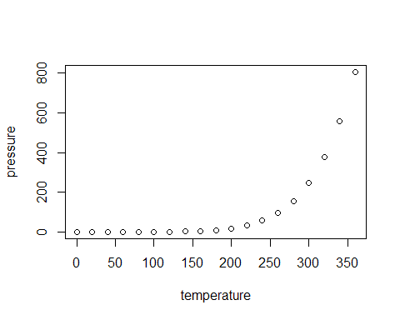

Note that the echo = FALSE parameter was added to the code chunk to prevent printing of the R code that generated the plot.

|  |  |  |
| --- | --- | --- |
| species | Probes | Days |
| beal | 19 | 120 |
| acru | 18 | 118 |
| frni | 15 | 99 |
| acsa | 58 | 107 |
| potr | 12 | 28 |

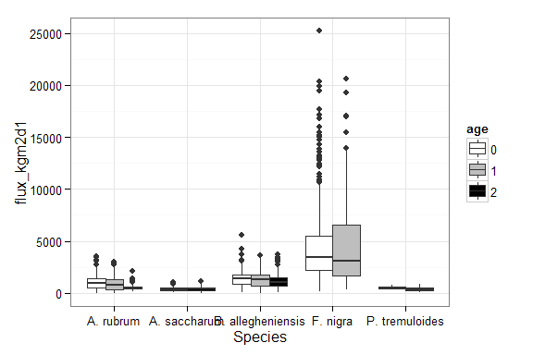

Daily sap flux by species and probe age

## References

Brice, Tim, and Todd Hall. 2014. “Vapor Pressure.” Web Page. University of Utah. <http://www.srh.noaa.gov/epz/?n=wxcalc_vaporpressure>.

Center, Western Regional Climate. 2015. “RAWS USA Climate Archive.” Web Page. <http://www.raws.dri.edu/index.html>.

MesoWest. 2015. “MesoWest.” Web Page. University of Utah. <http://mesowest.utah.edu/>.

Oren, Ram, Reiner Zimmermann, and John Terbough. 1996. “Transpiration in Upper Amazonia Floodplain and Upland Forests in Response to Drought-Breaking Rains.” Journal Article. *Ecology* 77 (3): 968–73.

Phillips, Nathan, and Ram Oren. 2001. “Intra- and Inter-Annual Variations in Transpiration of a Pine Forest.” *Ecological Applications* 11 (2): 385–96.