

Microsoft Office And OpenOffice
Table of Contents
OpenOffice Is More Flexible Than Microsoft Word 1
PART 1 1
Microsoft And OpenOffice On Your computer 1
Open Files 2
Save Files 2
Getting Microsoft Files From The Internet 3
Icons 4
Stop Microsoft Files Opening Into OpenOffice Formats 4
Method 1: Change The Three Letter Extension 4
Method 2: Change The Default Setting Within OpenOffice 4
PART 2 5
Sending OpenOffice Files To Others 5

PART 1 of this tutorial is for Users who have both OpenOffice and Microsoft Office on their computer. PART 2 is for OpenOffice Users who share files with others who do not have OpenOffice on their computers.

OpenOffice Is More Flexible Than Microsoft Word
OpenOffice can work with files in either OpenOffice file formats or in Microsoft file formats. However,Microsoft Office, such as Microsoft Word, can only work with files in Microsoft file formats.

PART 1

Microsoft And OpenOffice On Your computer
Both OpenOffice and Microsoft Office can be on your computer at the same time and work well together. However, it can be confusing when you are opening and closing files on your computer. It may appear as if your Microsoft files are converted into OpenOffice files and you cannot get the Microsoft files back. This tutorial will allow you to avoid the confusion.

Open Files
- When you installed OpenOffce, you were given the choice to use OpenOffice or Microsoft to open Microsoft files.
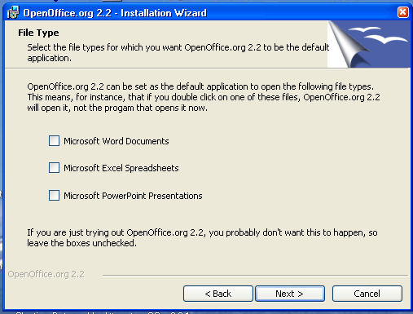
- By default there are no check marks in the boxes before “Microsoft Word Documents”, “Microsoft Excel Spreadsheets”, and “Microsoft Power Point Presentations”
- IF a check-mark WAS NOT placed in the boxes when OpenOffice is installed, Microsoft Office will open and use Microsoft Office files in the normal way..
- IF a check-mark IS placed in the boxes when installing OpenOffice , OpenOffice will open Microsoft files into the OpenOffice file format. (To open the Microsoft file, be in OpenOffice then click File > Open) OpenOffice can work with the file than originally was in the Microsoft format.
- If you are just trying out OpenOffice, you probably do not want to add check-marks.

Save Files
- IF you are working in Microsoft Word, do a normal “Save”. The file will be saved in the Microsoft format.
- IF you are working in OpenOffice, you can choose to save the file in either the Microsoft format or in the OpenOffice format (Click File > Save As. In the “File type:” box, select the format of your choice.)
- IF you have opened a Microsoft document in OpenOffice and have made no changes to the Microsoft document (.doc) and click File > Close, the file will be saved in the Microsoft format, (.doc) IF you have made changes to the Microsoft document, ( .doc) and click Close, you will get a choice to Save , Discard, or Cancel.
- IF you click Cancel, the option of closing is canceled and you will go back into the the document.
- IF If you click Discard, the modified Microsoft file that you were working with will be discarded (will be lost), however the original Microsoft file that you had opened will still be there..
- IF you click Save, you will get this message:
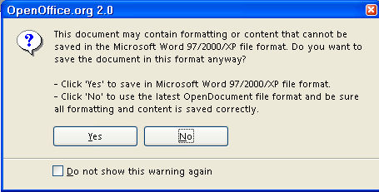

Getting Microsoft Files From The Internet
- On the Internet, Copy the Microsoft material of your choice.
- In OpenOffice, click the to the right of the Paste 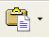 icon to open the menu below.
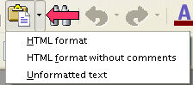
- Click Unformatted text. (The material appears on your OpenOffice document.)
- If you have already saved material from the Internet in OpenOffice and you did NOT use Paste > Unformatted text, the following will happen
- When you open the document to make changes, you may experience some difficulties when you attempt to add headings to paragraphs so that you can add a Table of Contents. (It may be written in MS Word.) Click the Non-printing characters icon. If you see this icon at the end of each paragraph instead of the OpenOffice Non-printing characters icon, you will need to delete those icons and replace them with the OpenOffice Non-printing characters icon. After doing that, you can make formatting changes without any problems. There may be other formatting issues affected by the difference between OpenOffice and other word processing programs.
- Note: You have to manually delete and replace the with the OpenOffice Non-printing characters . None of the steps below will replace the with the OpenOffice Non-printing characters .
- Format > Default Formatting
- Clicking on in the Apply Styles > Clear Formatting
- Saving the document in OpenOffice format

Icons
The icon of a file indicates what application Windows uses to open the file.
- IF check marks are NOT added, the icon for a Microsoft file will be the Microsoft icon.
- IF check marks ARE added, the icon for a Microsoft file will be the OpenOffice icon. Even though the OpenOffice icon appears for a file with a Microsoft extension (DOC, XLS, PPT), that file on the hard-drive is still in a Microsoft format.

Stop Microsoft Files Opening Into OpenOffice Formats
When you installed OpenOffice, If you chose to click on the boxes to put check marks by “Microsoft Word Documents”, “Microsoft Excel Spreadsheets”, and “Microsoft Power Point Presentations” to have OpenOffice start when these file types are opened and you change your mind, you will need to re-associate all word processing, spreadsheet or presentation files with the appropriate file type.
Use one of the following methods;

Method 1: Change The Three Letter Extension
- Go into your file types setting (it should be under either Tools or Folder Options) from one of the windows in My Computer.
- Delete the association for .doc, .xls, and any other file types that you do not want associated with OpenOffice.
- When you next click on a file of that type (such as .doc or .xls), it will ask you what you want to use to open it. Click on word, excel, or whatever you want to use. You will also be given the option to select always use this application to open the file type.

Method 2: Change The Default Setting Within OpenOffice
- Launch any OpenOffice.org application such as OpenOffice Writer.
- Click on Tools > Options.
- Expand the Load/Save section in the left pane by clicking the + (plus sign).
- Click on General under the Load/Save section.
- In the area labeled as Default file format near the bottom of the dialog window, select the type of document you want, for example, Text Document for Writer files, in the Document Type drop-down list.
- To the right drop down list labeled as Always save as, change or select the format as Microsoft Word 97/2000/XP.
- Repeat the above 2 steps for other documents such as spreadsheets or presentations that you want to save in Microsoft Office file format, and select the appropriate default save as format for them.
- Click OK to save the settings.
- From now on, whenever you want to save a document, the default format will be .doc, .xls or .ppt and other Microsoft Office file formats and extensions.

PART 2

Sending OpenOffice Files To Others
- If you send a file in the OpenOffice format to someone who does not have OpenOffice on his or her computer, he or she cannot open the file.
- If you send a file to someone without OpenOffice on his or her computer, send the file in the Microsoft file format. Most people may have Microsoft Office (or Word) on their computers.
- If someone does not have OpenOffice on their computer, you might suggest they download OpenOffice to their computer.
- Another solution for a person who only has Microsoft on their computer is to download a free plugin that will give users of Microsoft Office the ability to open, edit, and save files in the OpenOffice format. To get more information go to http://www.sun.com/software/star/odf_plugin

Notes

Tutorials are improved by input from users. We welcome your constructive criticism.
E-mail suggestions and comments to: contact@tutorialsforopenoffice.org
For other free tutorials go to: http://www.tutorialsforopenoffice.org

This work is licensed under a Creative Commons Attribution 3.0 License

