Nome do meu artigo - não muito longo

Primeiro Autor, Segundo Autor e Terceiro Autor (nome dos autores)
Nome e endereço da Instituição (se possível, tudo em uma única linha)

Abstarct ⎯ Descrição de modo direto e objetivo das realizações. Resultados significativos atingidos. Não deve conter fórmulas e figuras. Tamanho: de 100 a 150 palavras.

Palavras-Chave ⎯ Coloque suas palavras-chave aqui separadas por vírgulas, até três palavras.

- introduction

The increase of the aircraft operational costs associated with the fuel consumption makes this subject one of the main concern in the development of the new aircraft projects. In this scenario, the aviation market has been changed the design perception with respect of use of the electrical system. The electrical system dependency to power an increasing number of embedded systems and, in some cases, replacing the power source where it used to be powered by hydraulic and pneumatic system has increased in the past few years, creating the concept of the More Electrical Aircraft (MEA).
This context raised the relevance of the electrical system in the hole of aircraft operational safety. In this way, the electrical system needs to have a greater reliability and to operate in a way to avoid failures of the equipment connected to it. However, the rise of electrical equipment connected in the electrical system, specially the non-linear loads, has increased the harmonic distortion content being introduced in the electrical grid, diminishing the power quality and becoming a subject of study in aircraft operational safety. To allow the systems equipment and electrical systems proper integration, some documents were released to standardize the electrical parameters, such as the DO-160 and the MIL-STD 704. These documents bring the electrical parameter acceptance, and one of these constraints are regarding of the power quality and Total Harmonic Distortion (THD). \todo[inline]{talvez seja retirado}.
To improve the power quality with the decreasing of the THD, some power conditioners are applied in the equipment power input and in the electrical power distribution systems, such as filters and high power factor converters. However, the implementation of these conditioners has a drawback, which is the increase of the weight, volume and complexity, whereas the reliability decreases.
\todo[inline]{colocar as devidas referências}
\todo[inline]{terminar esse capítulo de acordo com o conteúdo que será apresentado no restante do artigo}

A introdução deve conter três pontos importantes.
Motivação do trabalho: interesse, aplicações possíveis e problema sendo resolvido.
Realizações anteriores: mencione artigos que descrevam trabalhos semelhantes (mesmo problema ou outras soluções). Não descreva com detalhes as realizações anteriores, destaque pontos importantes que deixem claro a contribuição do seu trabalho.
Contribuição do trabalho: qual a novidade que está sendo proposta (uma nova solução, uma nova arquitetura, um desempenho melhor etc.).

- Power quality in aricraft

\todo[inline]{falar das normas aeronáuticas que estabelecem limites para o conteúdo harmônico na rede elétrica}
\todo[inline]{colocar os principais métodos de correção de fator de potência empregado e justificar o emprego do filtro ativo}
Descrição com mais detalhes de realizações anteriores. Necessário pesquisar outras fontes e colocá-las no item Referências.
Compare: resultados atingidos, limitações, desempenho, pontos de destaque, problemas etc. Explique com as suas próprias palavras os trabalhos anteriores.
NUNCA copie um texto integramente de um outro artigo.
\todo{filtros ativos shun, pr estarem em paralelo não fodem com o sistema quando para de funcionar}
- Active Filters

The active filter operates creating waveforms to interact with the voltages and currents presented in the electrical grid to establish a power factor equal to one. This is accomplished by measuring the voltage waveforms from the power source and the current waveforms from the load, and then using these parameters on the instantaneous power theory to determine the current reference as an input to be set in a compensator. The compensator injects current waveforms in the circuit with symmetrical values of the components which degrades the power factor. The typical system compounded by a non-linear load with an active filter is presented in Figure 1 (\ref{fig:compensador.png}).

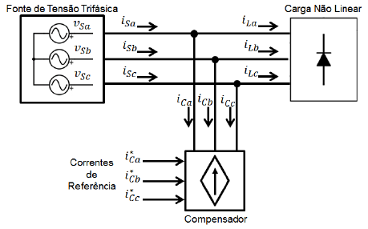
Fig. 1 Active Compensator
  - Instantaneous Power Theory

The instantaneous power theory was presented by Akagi \cite{Akagi}, which proposed some new concepts for the instantaneous active and reactive power. This theory can be used in three phase, three or four wire system and in steady or transient state \cite{Akagi,Akagi}. In this theory, the manipulation of the active and reactive power calculations brings a tool to determine the currents that carry some content which degrade the power factor, such as harmonic distortion and phase shift.
Considering a three-phase system, composed by the phases $a$, $b$ and $c$, the instantaneous power theory is based in the coordinates transformation from the $abc$ to $\alpha \beta 0 $. This is known as the Clarke Transformation and is shown in eq. (2) \ref{eq:Clarke}.

Equation 1 (2)
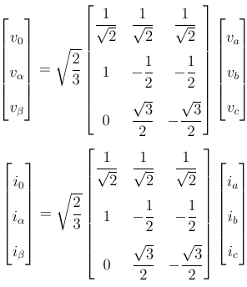

According to \cite{Akagi}, the instantaneous power is defined as shown in eq (3) \ref{eq:pq_0}, where the $p_0$, $p$ and $q$ are the instantaneous zero-sequence power, the active instantaneous power and the reactive instantaneous power, respectively \cite{Akagi,Peng1996}.

Equation 2 (3)
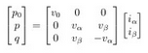

Considering a system without zero-sequence voltage and/or current, such as the aircraft electrical system, the eq (3) can be simplified as the eq (4), where the instantaneous zero-sequence power is absent.

Equation 3 (4)
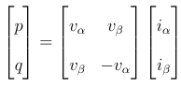

The reverse calculation, i.e., the determination of the currents $i_{\alpha}$ and $i_{\beta}$ when the voltages $v_{alpha}$ and $v_{\beta}$ and the instantaneous power $p$ and $q$ are known is presented in eq. (5) \ref{eq:i_alphabeta}.

Equation 4 (5)
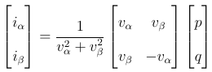

By definition, the active instantaneous power is composed by the energy that is swapped between two subsystems, whereas the reactive power is composed by the energy being swapped between the 3 phases of the system \cite{Akagi}. Furthermore, both $p$ and $q$ can be defined as a composition of an average ($\overline{p}$ and $\overline{q}$) and an oscillating ($\tilde{p}$ and $\tilde{q}$) values, as defined in eq. (6) \ref{eq:pq_m_o}.

Equation 5 (6)
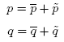

To create an active filter to coordinate a power factor equal to 1, the only permitted power flowing in the transmission lines is the average value of the instantaneous active power ($\overline{p}$). To ensure this condition, the filter must inject in the lines currents which contains the symmetrical values of the instantaneous reactive power ($q$) and the oscillating portion of the instantaneous active power ($\tilde{p}$) created by the non-linear load. By doing this, these powers are cancelled in the same way as the current harmonic content. Thereby, the selection of power to be compensate and processed by the filter must contains the values of the $-\tilde{p}$ and $-q$ only.
The filter full operation is defined by the instantaneous power $p$ and $q$ calculation, followed by the selection of the power to be compensated, i.e., $-\tilde{p}$ and $-q$. Afterwards, the currents $i_{\alpha}$ and $i_{\beta}$ are calculated using the eq (5) \ref{eq:i_alphabeta} with the values $-\tilde{p}$ and $-q$, followed by the inverse Clarke transformation to acquire the current in $abc$ coordinates to be applied as a reference in the compensator. The whole active filter reference definition is shown in Fig. (7) \ref{fig:diagrama_filtro.png}.

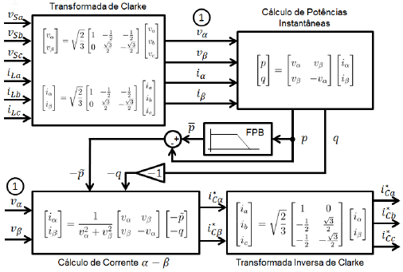
Fig. 2 Active filter reference definition

  - Control Strategy

The active filter specified by the procedure defined in Fig (7) \ref{fig:diagrama_filtro.png} presents very effective to set the current reference to be applied in the compensator to mitigate the electrical system harmonic content. However, this calculation is valid to produce sinusoidal current waveforms only when the voltages measured and used in the filter input is pure sine waves. This happens because the filter operates in such way that only the mean value of the active instantaneous power flows in the circuit. Therefore, the use of a non-sinusoidal voltage waveform in the input of the filter cause it to creates a non-sinusoidal current waveform to establish the power flow with only $\overline{p}$.
In aircraft electrical power system, the voltage waveforms stated in the point of common connection (PCC) are presented as non-sinusoidal, but still limited by the aeronautical standards. As the voltages used in the filter are measured at this point, its operation is not optimal for power quality purposes, and further, in some cases, it may decrease the power quality and operates unstably depending the levels of harmonic distortion presented in the voltages waveforms.
According to \ cite {Akagi2007}, the p-q theory proves insufficient to satisfy the condition to create a current sine wave and a power flow consisted of only the mean value of the active instantaneous power, at the same time the voltage waveforms measured and presented on the PCC are previously distorted. To overcome this situation a control strategy based on the use of a positive-sequence voltage detector is employed to ensure a sinusoidal current control. With this, the power flow between the load and the source is not defined as the mean value of the active instantaneous power, however, the control strategy relays on the appropriate sine wave current being set between the non-linear load and the PCC. This control é concebido pela utilização fundamental de sequencia positive sendo empregda na entrada n
The positive-sequence detector is a apparatus easily implemented which detects the positive sequence voltage
This is the PLL and the entire stuff Is the figure below
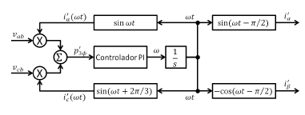

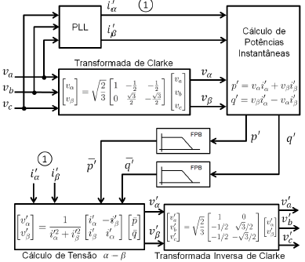

\todo[inline]{Colocar os métodos de controle, focando no método de controle de corrente senoidal}
\todo[inline]{Falar do controle de tensão do capacitor (se couber, ou falar bem sucintamente)}

Descrição da sua proposta com detalhes. Método empregado para resolução do problema (equacionamento, pseudo código, diagrama de blocos etc.).
Caso utilize componentes específicos na implementação (circuito integrado, sensor etc.), não exagere na descrição dos mesmos (fotos, dados técnicos, especificação etc.). O leitor pode obter estes dados na referência que você indicou.

- Simulation of the shunt active filter operating with an electrohidraulic acuator

A simulation was used to evaluate the shunt active filter operating in an aircraft electrical system. The system is composed by the generation and distribution system and some loads constituted by electrohydraulic actuators with shunt active filter connected to its respective inputs.

  - Active filer model

[Comente logo que você está se referindo a figura xx e explique o fluxo dos sinais identificando os principais elementos. Talvez colocar sub blocos pontilhados para facilitar a localização. Ela é complexa, convêm logo posicionar o leitor]
The shunt active filter model is composed by the current reference calculator and the compensator blocks. The reference calculator block defines the proper reference to be applied in the compensator input. The compensator block consists of a voltage source converter (VSC) and a capacitor DC voltage regulated by a closed-loop controller. The compensator also has the hysteresis controller, which creates the commands applied to VSC switching devices.
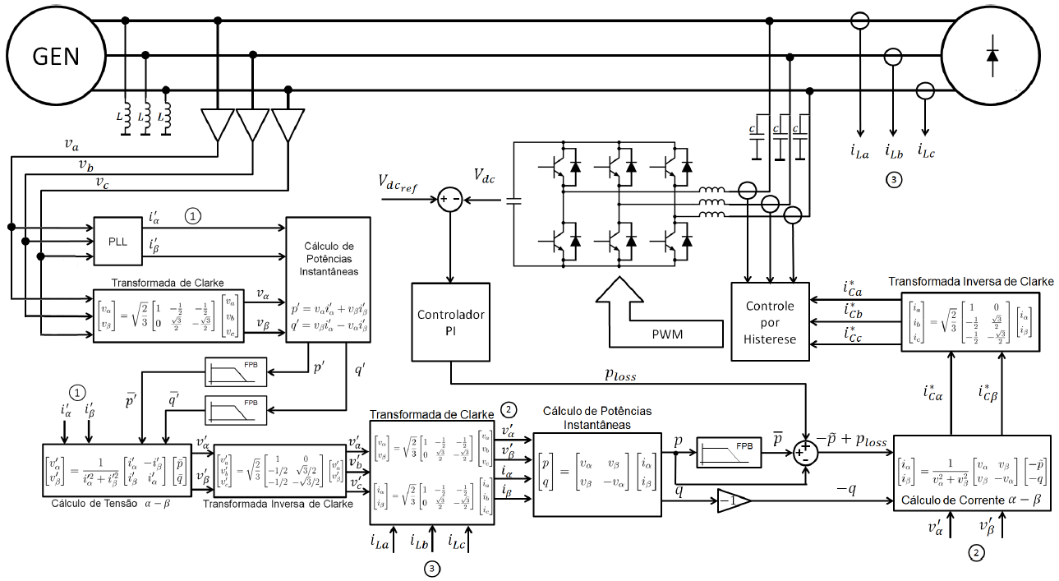
The active filter operation requires a passive capacitor filter applied in the transmission lines to eliminate the high frequency content injected in the system by the switching commutation \cite{}. Due to the high switching commutation frequency, the passive filter is lightweight and does not impact significantly in the aircraft system. However, the presence of capacitors in the transmission lines may decrease the power factor due to current phase shift. To eliminate this, inductors may be applied in the lines to compensate the reactive power flow.
The shunt active filter diagram is presented in Fig. \ref{fig:filtro_blocos.png}. This figure shows the blocks where each calculation step is accomplished, and the points where the active filter with its respective voltage and current measurement probes are connected to the electrical grid.

  - Electrical system model

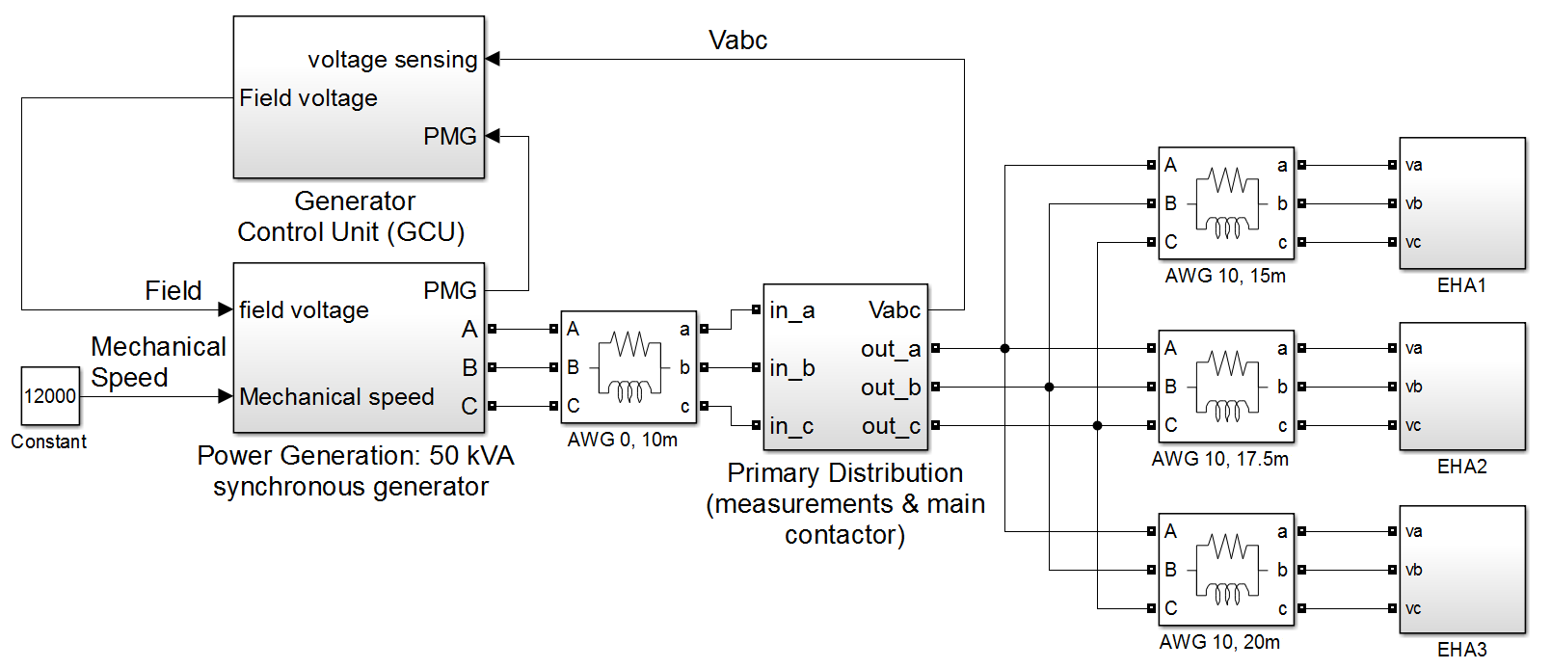
The aircraft electrical system model considers the operation of the generation and distribution system with its respective non-idealities, which affect the power quality due to voltage drop. The simulation has a generator system, a power distribution system and three EHAs connected in parallel as the loads, as shown in Fig. \ref{fig:simulacao_simulink.png}.
The generator system consists of a synchronous machine and a generator control unit (GCU).
[Não fica mais claro trazer o parágrafo em verde neste ponto?]
The GCU works as a field excitation controller to set the proper voltage in the PCC. The synchronous machine also has resistive and inductive reactance connected in series with the voltage source to model the resistance and the inductance presented in the generator coils.
The power distribution system is composed by the transmission lines between the generator and the PCC and between the PCC and EHAs. Probes in the PCC measure the system voltages levels to be sent as the reference input to the GCU. The power transmission lines are modeled as resistive and inductive reactance in series for each of the 3 phase lines.
The EHA controls the latero-directional and longitudinal aerodynamic surfaces. This equipment is a non-linear load, since in its input has a 3-phase diode bridge. The EHAs model has a 3 phase Graetz diode bridge with a current controlled source placed in its respective DC side. The controlled current source is defined to operate in such way to recreates the apparent power consumption of a real EHA. Thereby, this guarantees the application of the distorted current waveforms generated by the EHA in real operation.

  - Results

The simulation results show the voltages and currents waveforms measured in the PCC, the frequency spectrum, the amplitude constrains defined by the MIL-STD 704F, and the calculated value of the voltage THD and IHC.
The test is divided in two conditions: the EHAs without load: EHAs are starting their operation (maximum load). The results also show the cases where the active filters are connected and disconnected from the EHAs power input.
For the portion where the EHAs are not operating, Fig. \ref{fig:artigo_unfilt_1.eps} and Fig. \ref{fig:artigo_unfilt_2.eps} show the waveforms when the system has no active filters operating. [Texto estranho] For the same period, Fig. \ref{fig:artigo_filt_1.eps} and Fig. \ref{fig:artigo_filt_2.eps} show the waveforms when the active filters are connected in the EHAs power input. During this time interval, the presence of the active filters degrades the power quality, since the THD increases, and the frequency spectrum presents more harmonic content. This noise is inserted in the system due to the commutation of the VSC switching devices. Thus, even with the presence of the capacitor filter in the lines, it was observed some high frequency content injected in the grid. However, despite of this adversity, the results are still inside the limits defined by aeronautical standards.
For the portion where the EHA is requiring maximum load, Fig. \ref{fig:artigo_unfilt_3.eps} and Fig. \ref{fig:artigo_unfilt_4.eps} show the waveform when the active filters are not connected in the grid. In the same period, Fig. \ref{fig:artigo_filt_3.eps} and Fig. \ref{fig:artigo_filt_4.eps} show the waveforms when the active filters are connected in the EHAs power input. In this interval, it is clear the active filter enhancement in the system power quality. Considering these results, the active filters mitigates the harmonic content and set it within the limits of the MIL-STD 704F.
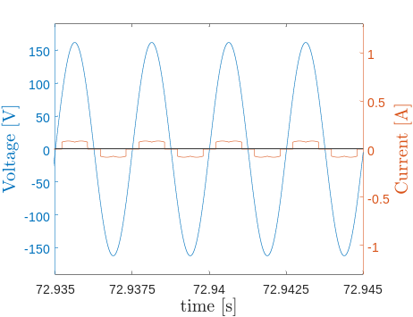
Fig. 3 Voltage and current waveforms for the system without load and filter
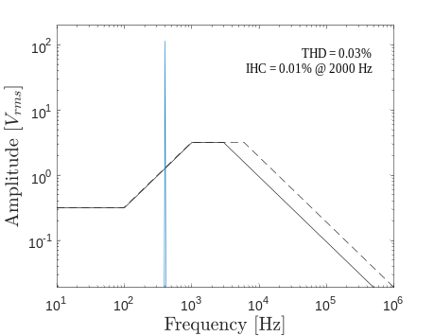
Fig. 4 Voltage spectrum for the system without load and filter
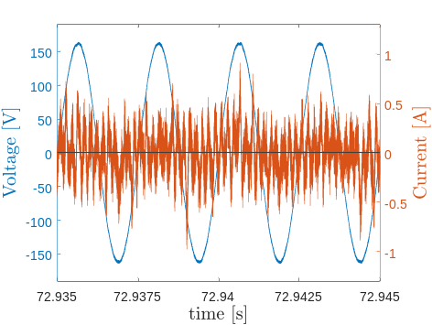
Fig. 5 Voltage and current waveforms for the system without load and with filter
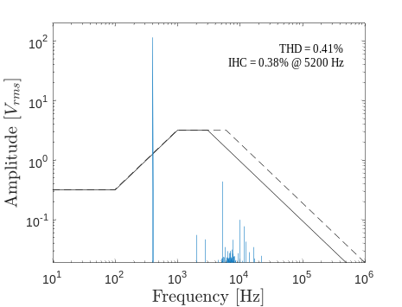
Fig. 6 Voltage spectrum for the system without load and with filter
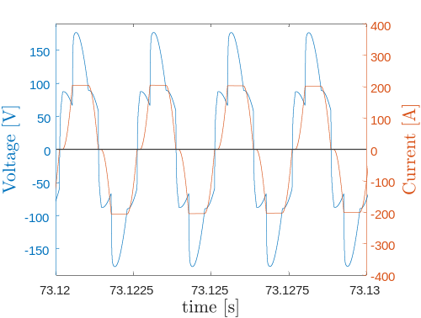
Fig. 7 Voltage and current waveforms for the system with load and without filter
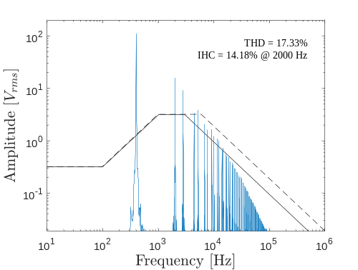
Fig. 8 Voltage spectrum for the system with load and without filter
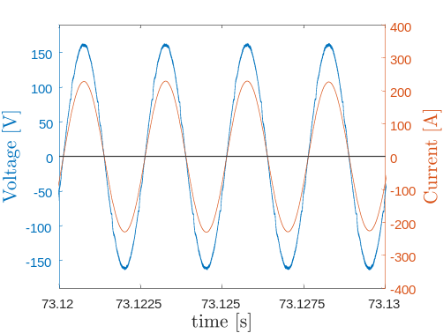
Fig. 9 Voltage and current waveforms for the system with load and filter
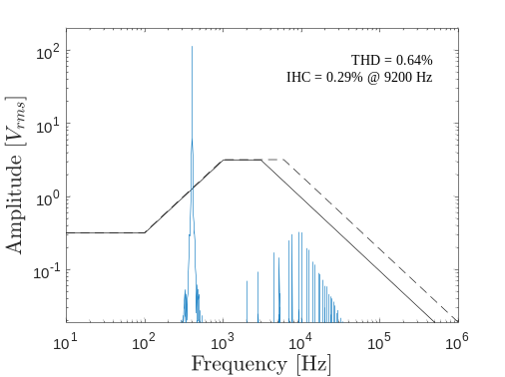
Fig. 10 - Voltage spectrum for the system with load and filter

V. Conclusions

The simulation results showed an correct active filter response under high load variation, keeping the voltage within the limits defined by the aeronautical standards in terms of harmonic content.
There are some drawbacks when non-linear loads, connected with their respective active filters, require low power consumption. In this case, the power quality is slightly degraded, however, not substantially to make the system operate infringing the aeronautical standards.
It should be noticed that even when the loads do not consume power, the set composed by the loads and the filters draw current from the source. This is caused by the energy loss in the filter operation, mainly due to the non-idealities of the switching devices, which is considerable when compared to energy drawn by the load operating with low consumption.

References

Procure referências de artigos (base de dados da CAPES), livros etc. Referências da Internet podem ser empregadas com cuidado.

Todas referências citadas devem estar no texto.

Resumo ⎯ Estas instruções fornecem as orientações básicas para a preparação de um artigo para o XIV SIGE (XIV Simpósio de Aplicações Operacionais em Áreas de Defesa). O texto pode ser escrito em português ou inglês. Não cite referências no resumo. Use parágrafo, três espaços, nas seções. Após as palavras “Resumo” e “Palavras-chaves” use um traço longo (⎯). O resumo não deve exceder 150 palavras. Evite usar abreviaturas no título e, caso sejam necessárias, descreva-as no resumo. Siga atentamente estas instruções, permitindo um texto legível e uniforme.

Palavras-Chave ⎯ Coloque suas palavras-chave aqui separadas por vírgulas, até três palavras.

I. INTRODUÇÃO

Este formato apresenta a aparência usual de um artigo para o XIV SIGE, sendo semelhante ao formato adotado nos artigos do IEEE. Prepare o artigo em papel tamanho 21,0 cm × 29,7 cm, papel A4. Utilize fonte Times New Roman. Não utilize numeração nas páginas. O número mínimo e máximo de páginas é 3 e 8, respectivamente.

Preparação do artigo

1) Formato: Na configuração da página, ajuste a margem superior e inferior para 2,0 cm, a margem esquerda para 1,8 cm e a margem direita para 1,2 cm. As duas colunas devem ser ajustadas para 8,8cm de largura com afastamento entre elas de 0,5cm.
Use o formato duas colunas em todo o texto, ambas justificadas. Sempre que possível, procure manter as duas colunas com o mesmo tamanho e a última página completamente preenchida. Para obter esse resultado, o tamanho das figuras pode ser ajustado, desde que a qualidade não seja comprometida. Não utilize espaço entre os parágrafos. Utilize uma linha de espaço entre o título da seção e o texto. Utilize uma ou duas linhas de espaço entre o texto e as equações, títulos de figuras, cabeçalhos de tabelas, notas de rodapé. Utilize hifenação automática.

P. Autor, primeiro@vdr.cta.br, S. Autor, segundo@ ita.cta.br, Tel +55-12-3333333, ramal 273, Fax +55-12-3333333; terceiro@ieav.cta.br, Tel. +55-12-3333333, ramal 272, Fax +55-12-3333333
Este trabalho foi parcialmente financiado pelo COMAER, através do Projeto X-SP, No. B-12345/6789 (Financiamentos nesta nota de rodapé.)
Esta é a única nota de rodapé admitida. Não deve haver nenhuma linha após esta nota. Identifique os autores apenas na versão final, após aceitação.

TABELA I Tamanho e estilo do texto
Tamanho (pts) | Texto | Estilo
8  8  8  9  10  10  10  11  8  24 | Título de tabela  Referências e título de figuras  Notas de rodapé  Resumo e palavras-chaves  Título das seções  Título das subseções  Texto principal e equações  Nome dos autores  Instituição  Título do artigo | Maiúsculas  Normal  Normal  Negrito  Maiúsculas  Itálico  Normal  Normal  Normal  Normal

II. Observações Finais

Evite colocar figuras e tabelas antes da primeira citação no texto. Use a abreviatura “Fig.”, mesmo no início de uma sentença.



Fig. 1. Logotipo do XIV SIGE.

Não abrevie a palavra “Tabela”, usando algarismos romanos para sua numeração. Simplifique as referências através de [3] ou [5]-[8]. Não use “Ref. [3]” ou “referência [3]”, exceto no começo de sentenças: “Referência [3] apresenta….”. Limite o nome de autores a cinco; substitua os demais por “et al.”. O número das equações deve vir entre parênteses, alinhado com o lado direito da coluna,

2jk ∂u/∂z = ∂²u/∂x² + k² (n² - β²) u . (1)

Refira-se a “(1)”, e não a “Eq. (1)” ou “Equação (1)”, exceto no começo de uma sentença: “Equação (1) é…”. Apêndices, se necessários, devem aparecer antes da última seção: Referências. Não coloque figuras, ou qualquer outra coisa, após as referências. Não numere as seções apêndice e referências.

REFERÊNCIAS

- G. Eason, B. Noble, I. N. Sneddon, “On certain integrals of Lipschitz-Hankel type involving products of Bessel functions”, Phil. Trans. Roy. Soc. London, vol. A247, p. 529–551, Abril 1955.
- J. Clerk Maxwell, “A Treatise on Electricity and Magnetism”, 3ed., vol. 2. Oxford: Clarendon, 1892, p.68–73.
- I. S. Jacobs, C. P. Bean, “Fine particles, thin films and exchange anisotropy” In Magnetism, vol. III, G. T. Rado e H. Suhl, Eds. New York: Academic, 1963, p. 271–350.
- K. Elissa, “Título do paper caso conhecido”, não publicado.

- R. Nicole, “Título de papaers com somente a primeira palavra iniciando em maiúscula”, J. Name Stand. Abbrev., em publicação.
- Y. Yorozu, M. Hirano, K. Oka, Y. Tagawa, “Electron spectroscopy studies on magneto-optical media and plastic substrate interface”, IEEE Transl. J. Magn. Japão, vol. 2, p. 740–741, Agosto 1987 [Digests 9th Annual Conf. Magnetics Japan, p. 301, 1982].
- M. Young, The Technical Writer's Handbook. Mill Valley, CA: University Science, 1989.
- A. Sheth, C. Henson, e S. S. Sahoo, “Semantic Sensor Web”, IEEE Internet Computing, July/August 2008. Disponível em: <http://www.computer.org/internet/ >. Acesso em: 11/03/2009.

