Simulation of Shunt Active Filter for Aircraft Electrical System

Primeiro Autor, Segundo Autor e Terceiro Autor (nome dos autores)
Nome e endereço da Instituição (se possível, tudo em uma única linha)

Abstract ⎯ The power quality in aircrafts electrical systems became an important issue due to the continuous expansion of electrical loads connected to the distribution system. This study focuses in the power quality improvement and power factor correction by the utilization of active filtering in an aeronautical electrical system. A simulation is proposed with an active filter operating in a power generation and distribution system connected at the power input of an electro hydrostatic actuator. The results obtained comprise the system voltages waveforms within the aeronautical MIL-STD 704F standard constraints for total harmonic content and distortion spectrum.

Keywords - Power Quality, THD, Simulation, Active Filter

- introduction

The increase of the aircraft operational costs associated with the fuel consumption drives the development of new aircraft projects \cite{Babikian2002} [1]. In this scenario, the aviation market has changed the design perception regarding the electrical system, replacing hydraulic and pneumatic’s power source to electrical ones, creating the concept of the More Electrical Aircraft (MEA) \cite{Moir1999} [2].
This context raised the relevance of the electrical system in the role of aircraft operational safety. This way, the electrical system needs to have a greater reliability and to operate avoiding failures of the equipment connected to it. However, the rise of electrical equipment connected in the electrical system, specially the non-linear loads, has increased the harmonic distortion content introduced in the electrical grid \cite{Singer2012} [11], diminishing the power quality and becoming a subject of study in aircraft operational safety.
To improve the power quality with the reduction of the total harmonic distortion (THD), some conditioners have to be applied in the equipment power input and in the electrical grid. The implementation of these conditioners must considers the reliability, the weight and cost to be feasible in aircraft systems.
In this context, some topologies to increase the power quality are already use in the aircraft electrical system, such as the multi-pulse rectifiers \cite{Zhu2014,Gong2003,Lobo2005} [34,26,27]. However, because its weight and volume, this topology are applicable only to specific equipment, see section II.
With the increase of the non-linear loads applied to the electrical grid, and requirements to ensure power quality, some alternatives have been proposed. The use of a shunt active filter applied in an electrical aircraft system is an item of recent study, considering different active filters topologies \cite{Chen2012research,Chen2012novel,Chen2012control} [36,38,39].
This article analyses the use of a shunt active filter to improve the power quality in an aircraft electrical system. It starts by reviewing the active filter operation, the instantaneous power theory, and continues discussing control techniques. A simulation is presented to analyze the shunt active filter operation with three electrohydraulic actuators (EHA) connected in parallel as loads in an aircraft power system.

- Power quality in aIrcraft

The power quality in aircraft electrical generation and distribution system is a concern regarding the safe airworthiness. The electrical equipment used in aircraft design must be qualified to ensure the proper operation and integration. Thereby, the power quality is one of the subjects considered in the qualification tests, which are specified by standard test procedures issued by aeronautical authorities. The most used qualifications standards for electrical systems are the MIL-STD 704, which qualifies the system, and the DO-160, Part 16, which qualifies the embedded equipment. To ensure the proper equipment operation, the electrical power generation and distribution system (EPGDS) must comply with these standards.
The non-linear loads inject harmonic distortion content in the system, which degrade the power quality and decrease the power factor. Furthermore, the increase in the number of electrical equipment connected in the grid enhances the degradation of the power quality. Thus, techniques for power factor correction must be applied in the EPGDS to limit the system operation within the constraints of aeronautical standards.
Some techniques are already used in aircraft electrical system to reduce the power factor and increase the power quality. One of this technique is the multi-pulse converters, which is most employed in high non-linear loads to improve the power quality. However, despite of the good reliability, they are bulky and heavy. There are some other topologies that are useful for harmonic content reduction, but their characteristics do not make them feasible to operate in the aircraft systems. Some of these topologies are the passive filters and power factor correction (PFC) converters. For the passive filters, despite of good reliability and low cost, the high weight is the main problem to its implementation in aircraft \cite{Barruel2004}. For the PFC converters, the downside lies in the low reliability and low density of energy conditioned \cite{Zhu2014,Gong2003,Lobo2005} [34,26,27]..
In this scenario, the active filter, due to its features as lightweight and fast response to load variation, appears to be a doable topology to reduce the harmonic content and increase the power factor \cite{Zhu2014,Chen2012control,Karatzaferis2013} [34,39, 40]. There are some drawbacks in its use, as the high complexity and low reliability, but the advances in power electronics are making them practical to be implemented in aircraft electrical system \cite{Abdelhafez2009} [3].

- Active Filters

The operation of active filters is based on the generation of voltages/currents to interact with the electrical grid waveforms to achieve a power factor equal to one. This is accomplished by measuring the voltage waveforms from the source and the current waveforms from the load to determine a reference current to be set in a compensator, see Fig \ref{fig:compensador.png} \cite{Akagi2006}. The compensator injects current waveforms with symmetrical harmonic components values to compensate the harmonic content responsible for the power factor degradation.

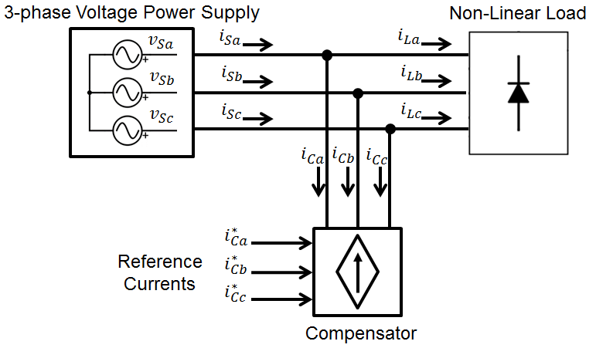
Fig. 1 Shunt active Compensator

  - Instantaneous Power Theory

The instantaneous power theory was presented by Akagi \cite{Akagi1984}, which proposed new concepts for the instantaneous active and reactive power. It can be used in three phase, three or four wire system and in steady or transient state \cite{Akagi2007}. In this theory, the manipulation of the active and reactive power calculations furnishes a tool to determine the currents that carry some content which degrade the power factor, such as harmonic distortion and phase shift.
Considering a three-phase system, composed by the phases $a$, $b$ and $c$, the instantaneous power theory is based in the coordinates transformation from the $abc$ to $\alpha \beta 0 $. This is known as the Clarke Transformation and is shown in eq. ( ) \ref{eq:Clarke}.

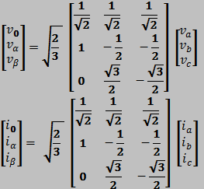 | ( )

According to \cite{Akagi2007}, the instantaneous power is defined as shown in eq ( ) \ref{eq:pq_0}, where the $p_0$, $p$ and $q$ are the instantaneous zero-sequence power, the active instantaneous power and the reactive instantaneous power, respectively \cite{Akagi2006,Peng1996}.

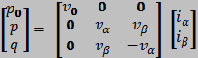 | ( )

Considering a system without zero-sequence voltage and/or current, such as the aircraft electrical system, the eq ( ) \ref{eq:pq_0}(3) can be simplified as the eq \ref{eq:pq} ( ), where the instantaneous zero-sequence power is absent.

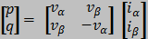 | ( )

The reverse calculation, i.e., the determination of the currents $i_{\alpha}$ and $i_{\beta}$ when the voltages $v_{\alpha}$ and $v_{\beta}$ and the instantaneous power $p$ and $q$ are known is presented in eq. ( ) \ref{eq:i_alphabeta}.

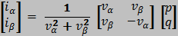 | ( )

By definition, the active instantaneous power is composed by the energy that is swapped between two subsystems, whereas the reactive power is composed by the energy being swapped between the 3 phases of the system \cite{Akagi1984,Peng1996}. Furthermore, both $p$ and $q$ are defined as a composition of an average ($\overline{p}$ and $\overline{q}$) and an oscillating ($\tilde{p}$ and $\tilde{q}$) values, as defined in eq. ( ) \ref{eq:pq_m_o}.

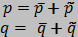 | ( )

To create an active filter to achieve a power factor equal to 1, the only permitted power flowing in the transmission lines is the average value of the instantaneous active power ($\overline{p}$). To ensure this condition, the filter must inject in the lines currents with symmetrical values of the instantaneous reactive power ($q$) and the oscillating portion of the instantaneous active power ($\tilde{p}$) created by the non-linear load. By doing this, these powers are cancelled in the same way as the current harmonic content. Thereby, the selection of power to be compensate and processed by the filter must contains the values of $-\tilde{p}$ and $-q$ only.
The filter full operation is defined by the instantaneous power $p$ and $q$ calculation, followed by the selection of the power to be compensated, i.e., $-\tilde{p}$ and $-q$. Afterwards, the currents $i_{\alpha}$ and $i_{\beta}$ are calculated using the eq ( ) \ref{eq:i_alphabeta} with the values $-\tilde{p}$ and $-q$, followed by the inverse Clarke transformation to acquire the current in $abc$ coordinates to be applied as a reference in the compensator. The whole active filter reference definition is shown in Fig. 2 \ref{fig:diagrama_filtro.png}.

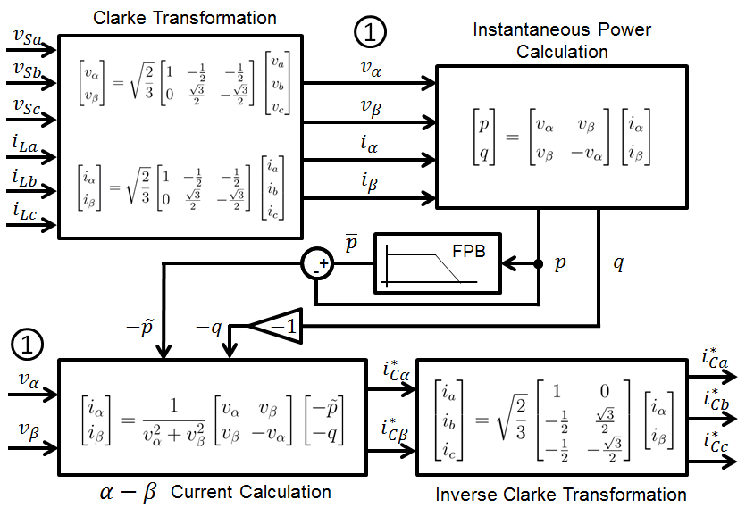
Fig. 2 Active filter reference definition

  - Control Strategy

The active filter specified in Fig 2 \ref{fig:diagrama_filtro.png} presents very effective to set the current reference to be applied in the compensator for mitigation of the electrical system harmonic content. However, this calculation is valid to produce sinusoidal current waveforms only when the voltages measured and used in the filter input are pure sine waves \cite{Akagi2007}. This happens insofar as the filter operates allowing only the mean value of the active instantaneous power flowing in the circuit. Therefore, the use of a non-sinusoidal voltage waveform in the input of the filter requires a non-sinusoidal current waveform to establish the power flow consisted of $\overline{p}$.
In aircraft electrical systems, the voltage waveforms in the point of common connection (PCC) are presented as non-sinusoidal, however, they are still limited by aeronautical standards. As the voltages used in the active filter are measured at the PCC or beyond this point, the filter defined as per Fig 2 \ref{fig:diagrama_filtro.png} is not optimal for power quality purposes. In some cases, it may decrease the power quality and have an unstable operation depending the levels of harmonic distortion presented in the voltages waveforms \cite{Akagi2007}.
According to \cite{Akagi2007}, the p-q theory proves insufficient to create a current sine wave and a mean value of the active instantaneous power flow, simultaneously when distorted voltage waveforms are measured on the PCC. To overcome this problem, a control strategy based on the use of a positive-sequence voltage detector is employed to ensure a sinusoidal current control. This way, the power flow between the load and the source is not defined as the mean value of the active instantaneous power, in contrast, the control strategy relays on the appropriate sine wave current insertion to establish the proper power quality at the system.
The sinusoidal current control is designed using the positive-sequence voltage detector, which operates to extract the fundamental positive-sequence component from the distorted voltages. This component is required by the active filter to define the current shape to be applied in the electrical grid to create a sinusoidal waveform.
The positive-sequence voltage detector operates based on the p-q dual theory, where it is used a phase locked loop (PLL) and the p-q theory to extract the fundamental frequency and amplitude of the distorted voltages \cite{Akagi2007}. The PLL is show in Fig. \ref{fig:PLL.png} and operates acquiring the fundamental frequency and phase. The scheme shown in Fig. \ref{fig:detector_seq_positiva.png} uses the p-q theory and the information coming from the PLL to define the amplitude of the fundamental voltages component to be used in the active filter calculations.

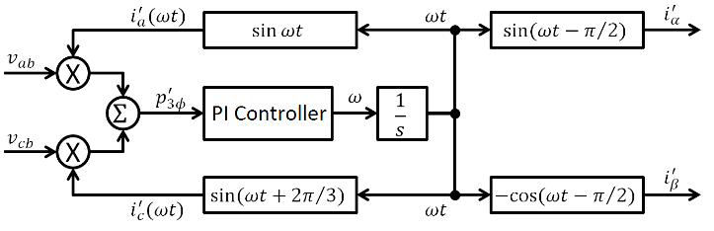
Fig. 3 Phase Locked Loop

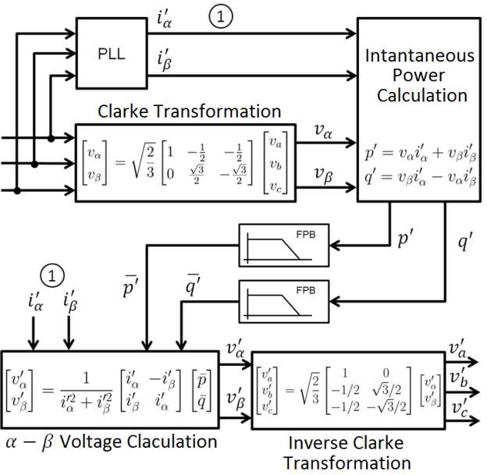
Fig. 4 Positive-sequence voltage detector

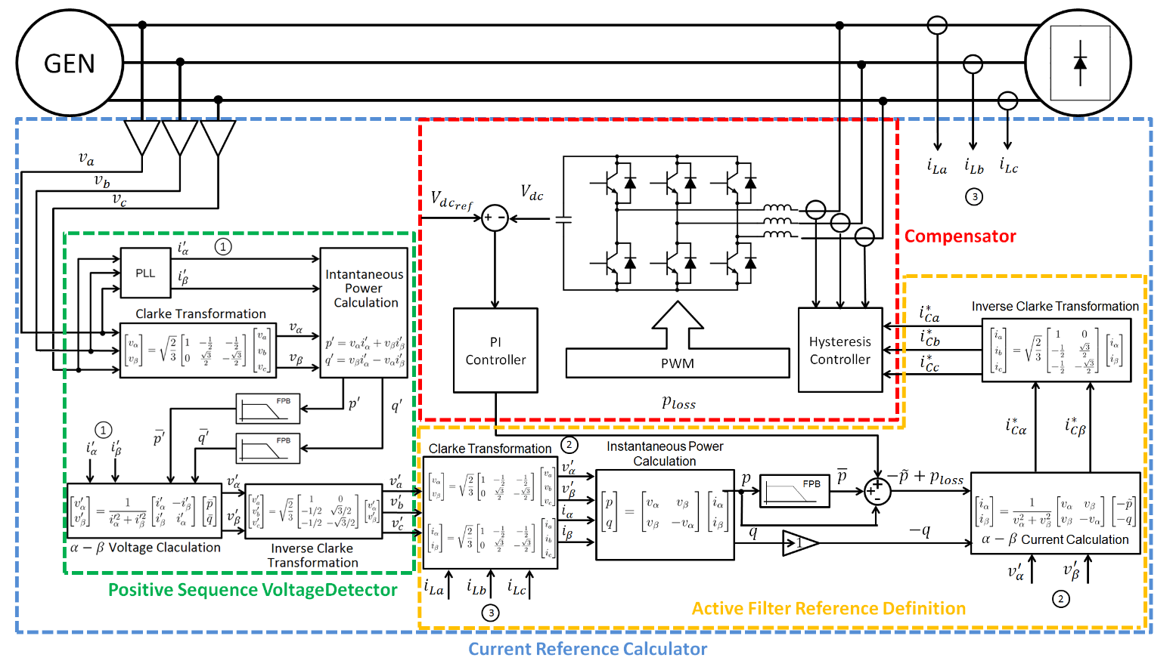
The operation of the active filter has some loss mainly due to the VSC switching devices, which reduces the capacitor voltage locate in the converter DC side. To avoid this voltage drop, a PI controller applied in the active filter defines a compensation strategy. This closed-loop error signal is processed by the compensator, managing the power flow in the VSC to hold the capacitor voltage within a specifically reference.
Fig. 5 Active Filter Model
- Simulation of the shunt active filter operating with an electrohidraulic acuator

The operation of the shunt active filter in an aircraft electrical system was evaluated by simulation. The system is composed by the generation and distribution system and some loads constituted by electrohydraulic actuators (EHAs) with shunt active filters connected to its respective inputs.

  - Active filer model

The shunt active filter consists of a Current Reference Calculator and a Compensator, as shown in Fig. \ref{fig:filtro_blocos_1.png}. This figure shows these parts with its respective internal sub-blocks. The Current Reference Calculator block is comprised by the Positive Sequence Detector (Fig. 4 \ref{fig:detector_seq_positiva.png}) and the Active Filter Reference Definition (Fig. 2 \ref{fig:diagrama_filtro.png}). These sub-blocks are responsible for the calculation algorithm (each sub-block presents its respective signals inputs and outputs) to determine the reference to be applied in the compensator. The Compensator is presented by the VSC with its respective hysteresis controller and capacitor voltage PI controller. This figure shows also the voltages and currents measurement probes connection in the electrical grid, where acquire the inputs for the active filter operaion.
The reference calculator block defines the proper reference to be applied in the compensator. Its inputs are the load currents and the grid voltages measurements, while its output is the reference applied to the compensator. The compensator block consists of a VSC with its capacitor DC voltage regulated by a closed-loop controller. The compensator also has the hysteresis controller, which creates the commands applied to the VSC switching devices.
The shunt active filter operation requires a passive capacitor filter applied in the transmission lines to eliminate the high frequency content injected in the system by the switching commutation \cite{Akagi2007}. Due to high switching commutation frequency, the passive filter is lightweight and does not impact significantly in the aircraft system. However, the presence of capacitors in the transmission lines may decrease the power factor due to current phase shift. To eliminate this, inductors may be applied in the lines to compensate the reactive power flow.

  - Electrical system model

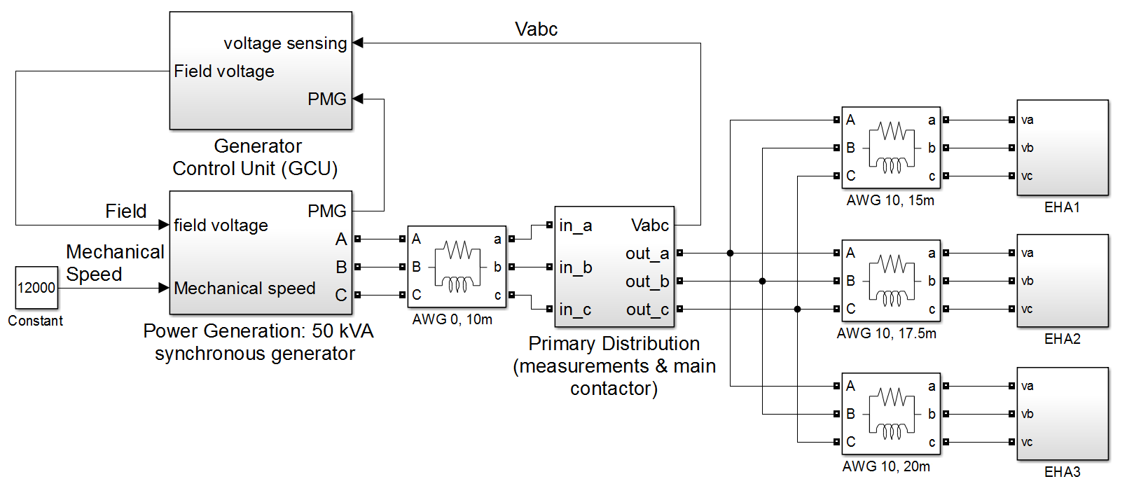
The aircraft electrical system model considers the operation of the generation and distribution system with its respective non-idealities, which affect the power quality due to voltage drop. The simulation has a generator system, a power distribution system and three EHAs connected in parallel as the loads, see Fig. \ref{fig:simulacao_simulink.png}.
The generator system consists of a synchronous machine and a generator control unit (GCU). The GCU works as a field excitation controller to set the proper voltage in the PCC. The synchronous machine also has resistive and inductive reactance connected in series with the voltage source to model the resistance and the inductance presented in the generator coils.
The power distribution system is composed by the transmission lines between the generator and the PCC and between the PCC and EHAs. Probes in the PCC measure the system voltages levels to be sent as the reference input to the GCU. The power transmission lines are modeled as resistive and inductive reactance in series for each of the 3 phase lines.
The EHA controls the latero-directional and longitudinal aerodynamics surfaces. This equipment is a non-linear load, since its input has a 3-phase diode bridge. The EHAs model has a 3 phase Graetz diode bridge with a controlled current source placed in its respective DC side. The controlled current source operation recreates the apparent power consumption of a real EHA. Thereby, this guarantees the simulation of the distorted current waveforms generated by the EHA in real operation.

  - Results

The simulation results show the voltages and currents waveforms measured in the PCC, the voltage frequency spectrum, the amplitude constraints defined by the MIL-STD 704F, and the calculated value of the voltage THD and IHC.
The test is divided in two conditions: the EHAs without operating and the EHAs starting their operation (maximum load). The results also show the cases where the active filters are connected and disconnected from the EHAs power input.
Fig. \ref{fig:artigo_unfilt_1.eps} and Fig. \ref{fig:artigo_unfilt_2.eps} show the system waveforms without active filters in the EHAs power inputs, when the EHAs are not in operation. Fig. \ref{fig:artigo_filt_1.eps} and Fig. \ref{fig:artigo_filt_2.eps} show the waveforms with the active filters connected to the EHAs power input for the same period. The active filters degrade the power quality during this time interval, since the THD increases and the frequency spectrum presents more harmonic content. This noise inserted in the system is due to the commutation of the VSC switching devices. Thus, even with the presence of the capacitor filter in the lines, some high frequency content injected in the grid was observed. However, the results are inside the limits defined by aeronautical standards.
Fig. \ref{fig:artigo_unfilt_3.eps} and Fig. \ref{fig:artigo_unfilt_4.eps} show the system waveforms without active filters connected to the grid, with the EHAs requiring maximum current. In the same time interval, Fig. \ref{fig:artigo_filt_3.eps} and Fig. \ref{fig:artigo_filt_4.eps} show the waveforms with the active filters connected to the EHAs power input. During this interval, it is clear the active filter enhancement in the system power quality. Considering these results, the active filter mitigates the harmonic content and set it within the limits of the MIL-STD 704F.
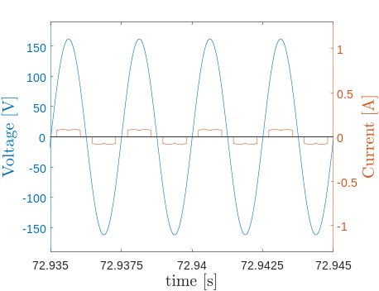
Fig. 6 Voltage and current waveforms for the system without load and filter
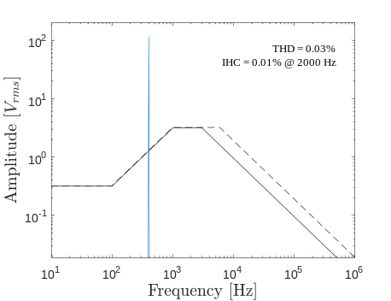
Fig. 7 Voltage spectrum for the system without load and filter
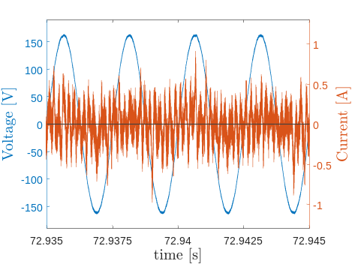
Fig. 8 Voltage and current waveforms for the system without load and with filter
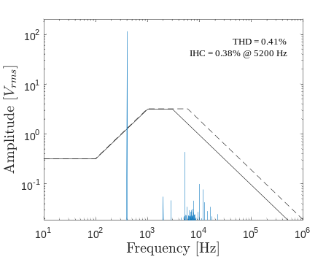
Fig. 9 Voltage spectrum for the system without load and with filter
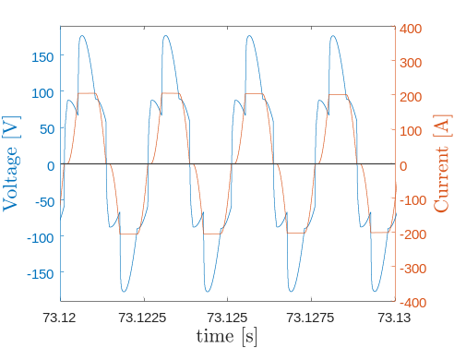
Fig. 10 Voltage and current waveforms for the system with load and without filter
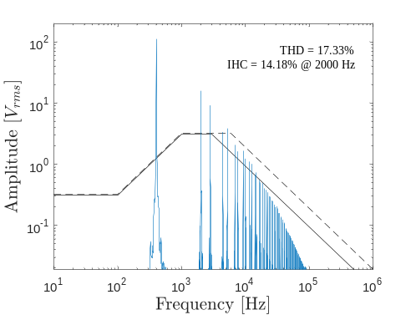
Fig. 11 Voltage spectrum for the system with load and without filter
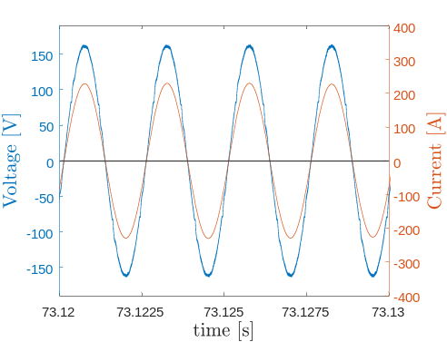
Fig. 12 Voltage and current waveforms for the system with load and filter
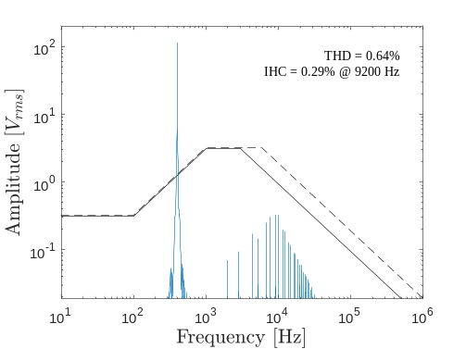
Fig. 13 - Voltage spectrum for the system with load and filter

V. Conclusions

The simulation results showed a correct active filter response under high load variation, keeping the voltage within the limits defined by the aeronautical standards in terms of harmonic content.
There are some drawbacks with non-linear loads connected with their respective active filters. In case of low power consumption, the power quality is slightly degraded. However, the deterioration does not drive the system operation out of the aeronautical standards.
It should be noticed that even without load power consumption, the set composed by loads and filters draw current from the source. This is caused by the energy loss in the filter operation, mainly due to the non-idealities of the switching devices. This loss is not negligible in comparison with the energy drawn by the load in low consumption mode.

References

Procure referências de artigos (base de dados da CAPES), livros etc. Referências da Internet podem ser empregadas com cuidado.

Todas referências citadas devem estar no texto.
\cite{[3] ABDEL-HAFEZ, A.; FORSYTH, A. A review of more-electric aircraft}
\cite{[26] GONG, G.; DROFENIK, U.; KOLAR, J. 12-pulse rectifier for more electric aircraft applications}
\cite{[27] GONG, G. et al. Comparative evaluation of three-phase high-power-factor ac-dc converter concepts for application in future more electric aircraft}
\cite{[34] ZHU, S.; MA, W. Methods of aircraft grid harmonic reduction: A review}
\cite{[39] CHEN, Z.; LUO, Y.; CHEN, M. Control and performance of a cascaded shunt active power filter for aircraft electric power system}
\cite{[40] KARATZAFERIS, J. et al. Comparison and evaluation of power factor correction topologies for industrial applications}
\cite{[1] BABIKIAN, R.; LUKACHKO, S. P.; WAITZ, I. A. The historical fuel e_ciency characteristics of regional aircraft from technological, operational, and cost perspectives.}
\cite{[2] MOIR, I. More-electric aircraft-system considerations}
\cite{[11] SINGER, C. et al. Aircraft electrical power systems and nonlinear dynamic loads}
[36] CHEN, Z. et al. A research on cascade _ve-level aeronautical active power _lter

[38] CHEN, Z.; CHEN, M. A novel 400hz shunt active power _lter for aircraft electrical
power system

Resumo ⎯ Estas instruções fornecem as orientações básicas para a preparação de um artigo para o XIV SIGE (XIV Simpósio de Aplicações Operacionais em Áreas de Defesa). O texto pode ser escrito em português ou inglês. Não cite referências no resumo. Use parágrafo, três espaços, nas seções. Após as palavras “Resumo” e “Palavras-chaves” use um traço longo (⎯). O resumo não deve exceder 150 palavras. Evite usar abreviaturas no título e, caso sejam necessárias, descreva-as no resumo. Siga atentamente estas instruções, permitindo um texto legível e uniforme.

Palavras-Chave ⎯ Coloque suas palavras-chave aqui separadas por vírgulas, até três palavras.

I. INTRODUÇÃO

Este formato apresenta a aparência usual de um artigo para o XIV SIGE, sendo semelhante ao formato adotado nos artigos do IEEE. Prepare o artigo em papel tamanho 21,0 cm × 29,7 cm, papel A4. Utilize fonte Times New Roman. Não utilize numeração nas páginas. O número mínimo e máximo de páginas é 3 e 8, respectivamente.

Preparação do artigo

1) Formato: Na configuração da página, ajuste a margem superior e inferior para 2,0 cm, a margem esquerda para 1,8 cm e a margem direita para 1,2 cm. As duas colunas devem ser ajustadas para 8,8cm de largura com afastamento entre elas de 0,5cm.
Use o formato duas colunas em todo o texto, ambas justificadas. Sempre que possível, procure manter as duas colunas com o mesmo tamanho e a última página completamente preenchida. Para obter esse resultado, o tamanho das figuras pode ser ajustado, desde que a qualidade não seja comprometida. Não utilize espaço entre os parágrafos. Utilize uma linha de espaço entre o título da seção e o texto. Utilize uma ou duas linhas de espaço entre o texto e as equações, títulos de figuras, cabeçalhos de tabelas, notas de rodapé. Utilize hifenação automática.

P. Autor, primeiro@vdr.cta.br, S. Autor, segundo@ ita.cta.br, Tel +55-12-3333333, ramal 273, Fax +55-12-3333333; terceiro@ieav.cta.br, Tel. +55-12-3333333, ramal 272, Fax +55-12-3333333
Este trabalho foi parcialmente financiado pelo COMAER, através do Projeto X-SP, No. B-12345/6789 (Financiamentos nesta nota de rodapé.)
Esta é a única nota de rodapé admitida. Não deve haver nenhuma linha após esta nota. Identifique os autores apenas na versão final, após aceitação.

TABELA I Tamanho e estilo do texto
Tamanho (pts) | Texto | Estilo
8  8  8  9  10  10  10  11  8  24 | Título de tabela  Referências e título de figuras  Notas de rodapé  Resumo e palavras-chaves  Título das seções  Título das subseções  Texto principal e equações  Nome dos autores  Instituição  Título do artigo | Maiúsculas  Normal  Normal  Negrito  Maiúsculas  Itálico  Normal  Normal  Normal  Normal

II. Observações Finais

Evite colocar figuras e tabelas antes da primeira citação no texto. Use a abreviatura “Fig.”, mesmo no início de uma sentença.



Fig. 1. Logotipo do XIV SIGE.

Não abrevie a palavra “Tabela”, usando algarismos romanos para sua numeração. Simplifique as referências através de [3] ou [5]-[8]. Não use “Ref. [3]” ou “referência [3]”, exceto no começo de sentenças: “Referência [3] apresenta….”. Limite o nome de autores a cinco; substitua os demais por “et al.”. O número das equações deve vir entre parênteses, alinhado com o lado direito da coluna,

2jk ∂u/∂z = ∂²u/∂x² + k² (n² - β²) u . (1)

Refira-se a “(1)”, e não a “Eq. (1)” ou “Equação (1)”, exceto no começo de uma sentença: “Equação (1) é…”. Apêndices, se necessários, devem aparecer antes da última seção: Referências. Não coloque figuras, ou qualquer outra coisa, após as referências. Não numere as seções apêndice e referências.

REFERÊNCIAS

- G. Eason, B. Noble, I. N. Sneddon, “On certain integrals of Lipschitz-Hankel type involving products of Bessel functions”, Phil. Trans. Roy. Soc. London, vol. A247, p. 529–551, Abril 1955.
- J. Clerk Maxwell, “A Treatise on Electricity and Magnetism”, 3ed., vol. 2. Oxford: Clarendon, 1892, p.68–73.
- I. S. Jacobs, C. P. Bean, “Fine particles, thin films and exchange anisotropy” In Magnetism, vol. III, G. T. Rado e H. Suhl, Eds. New York: Academic, 1963, p. 271–350.
- K. Elissa, “Título do paper caso conhecido”, não publicado.

- R. Nicole, “Título de papaers com somente a primeira palavra iniciando em maiúscula”, J. Name Stand. Abbrev., em publicação.
- Y. Yorozu, M. Hirano, K. Oka, Y. Tagawa, “Electron spectroscopy studies on magneto-optical media and plastic substrate interface”, IEEE Transl. J. Magn. Japão, vol. 2, p. 740–741, Agosto 1987 [Digests 9th Annual Conf. Magnetics Japan, p. 301, 1982].
- M. Young, The Technical Writer's Handbook. Mill Valley, CA: University Science, 1989.
- A. Sheth, C. Henson, e S. S. Sahoo, “Semantic Sensor Web”, IEEE Internet Computing, July/August 2008. Disponível em: <http://www.computer.org/internet/ >. Acesso em: 11/03/2009.

