

Sidwell Cadastre Tools

Parcel Workflow Extension User Training and Test Guide

Document status: Draft for SMD review
Version: V2 draft - RC12 workflow coverage added
Audience: Plan examiners, SMD supervisors, support staff, and UAT testers
Applies to: Plan Examination, Compare Survey Plan, Fabric Maintenance, RT Examination, and Plan Annexation workflows

Table of Contents
1. Purpose 4
2. Workflow Overview 4
3. Before You Start 5
4. Logging In 6
5. Transactions List 9
6. Compute Sub Workflow 10
6.1. Validate Points and Lines 13
6.1.1 General Information 14
6.1.2 Memorandum 15
6.1.3 Validation Findings 16
6.1.4 Participants 16
6.1.5 Boundary Segments 17
6.1.6 Points 19
6.2 Validation Complete 19
6.3. Create Spatial Units and Final Review 20
7. Additional Tools 23
7.1 Supporting Documents [SD] 23
7.2 M-Geo Review 25
7.3 Crop the image for Plan Examination 27
8. STAGE - Review Computation Finding - 27
9. Compare Sub Workflow 31
9.1 Load Compare Layers 32
9.2 Innola Searches 35
9.3 Save, Suspend, Finalize, and Cancel 36
10. Fabric Maintenance 38
10.1 Fabric Maintenance Detailed Procedure 39
11. RT Examination 40
12. Plan Annexation 41
13. STAGE - Prepare Examination Report 41
14. Training Use Case 45
14.1 Test Steps 45
15. User Acceptance Checklist 46
16. Troubleshooting 49
16.1 Login Failed 49
16.2 Transaction Does Not Start 49
16.3 Supporting Documents Window Is Empty 50
16.4 Configured Python Executable Could Not Be Invoked 50
16.5 ArcPy Is Not Available 50
16.6 Product License Has Not Been Initialized 50
16.7 OpenAI API Key Missing 51
16.8 Georeference Check Blocked 51
16.9 Points Validation Blocked 51
16.10 Spatial Unit Creation Failed 52
16.11 Compare Search Failed 52
16.12 Enterprise Token or SSL Error 52
16.13 ArcGIS Pro Crash 52
Appendix A. Log Locations 54
Appendix B. Configuration Notes 54
Appendix C. Training Signoff 55
Appendix D. Compute Steps Screenshots 56

1. Purpose
This guide explains how to use the Sidwell Cadastre Tools Parcel Workflow Extension inside ArcGIS Pro to complete plan examination work that begins in the Innola framework.
Use this document to:
- Train users on the end-to-end Compute and Compare workflow.
- Run a repeatable test using assigned Innola transactions.
- Capture pass/fail evidence during user acceptance testing.
- Troubleshoot common login, document, map, Python, ArcPy, georeference, and transaction-completion issues.

The main workflow is written for users. Technical checks and log paths are listed in the support appendix.

2. Workflow Overview
The transaction starts in Innola. After the transaction is assigned to an SMD user, the user completes the work in ArcGIS Pro using this extension.
High-level process:
- The transaction is created and assigned in Innola.
- The user opens ArcGIS Pro and logs into the Cadastre tools add-in.
- The user refreshes the Transactions List and selects the assigned transaction.
- For Compute Survey Plan work, the user completes all Compute stages.
- The user reviews supporting documents and, when needed, runs M-Geo to overlay the survey plan on the map.
- The user validates points and lines, creates spatial units, and completes final review.
- For Compare Survey Plan work, the user launches Compare and reviews parcel evidence.
- The user saves, suspends, finalizes, or cancels according to the state of the work.
- When finalized, the transaction is moved forward in the Innola workflow.
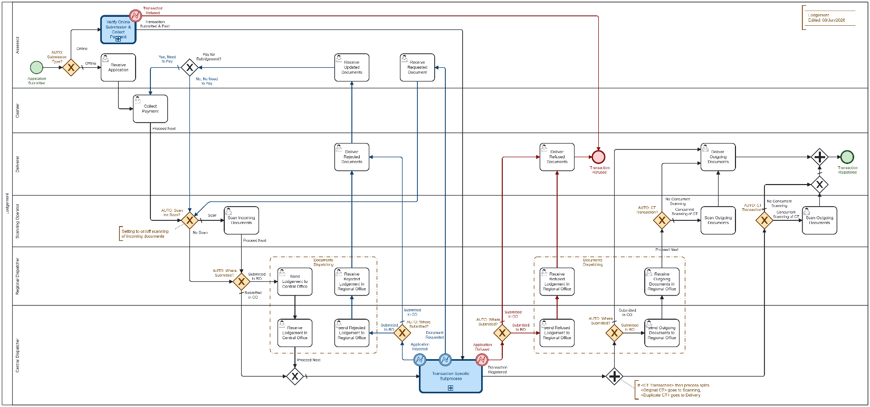
Lodgment workflow
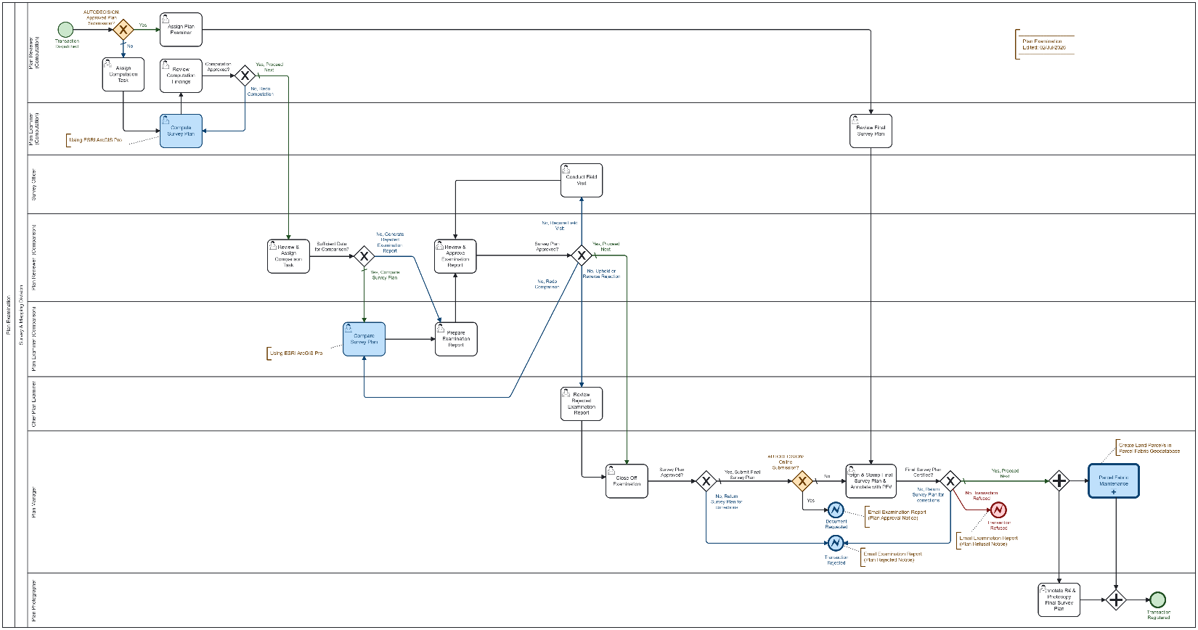
Plan examination Workflow

3. Before You Start
Confirm the following before training or testing:

- ArcGIS Pro is installed and licensed.
- The Sidwell Cadastre Tools add-in is installed and visible in ArcGIS Pro.
- The user has Innola credentials.
- The transaction is assigned to the logged-in user or the user's group.
- The computer has access to the configured Innola server.
- The working map can load the configured reference layers.
- JAD2001 / EPSG:3448 is used for all parcel geometry and map validation.
- The local case folder is configured and writable.
- The Python environment used by the tool can start.
- ArcPy is available when geoprocessing or output generation requires it.
- An OpenAI API key is configured when AI extraction is required.

Typical installed paths:
- Application root: C:\Sidwell\ParcelWorkflow
- Case folders on target computers: C:\Sidwell\ParcelWorkflow\ParcelWorkflowCases
- User case folders on development machines: C:\Users\<user>\Documents\SidwellCo\ParcelWorkflowCases
- ArcGIS Pro cloned environment: C:\Sidwell\ParcelWorkflow\envs\arcgispro-survey-ai

4. Logging In
Open ArcGIS Pro and select the Cadastre tools ribbon tab.
- Select Login.
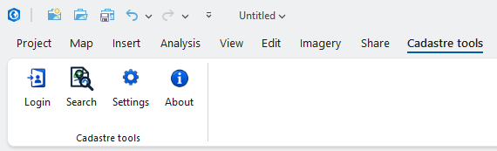

- Enter the Innola user name and password.
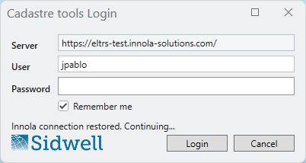
- Confirm the transaction panel shows the logged-in user and connection information.
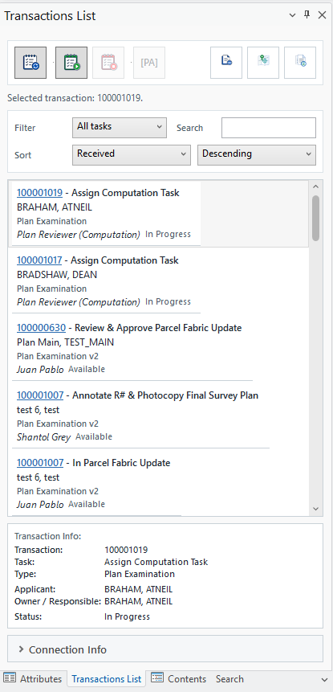

NOTE: The server value comes from configuration and is read-only. Users should not edit it during normal work.
Expected result:
- The login succeeds.
- The Transactions List panel shows the user name.
- The Refresh button is available.

If login fails:
- Confirm the user name and password.
- Confirm the server URL in settings.
- Confirm the computer can reach the Innola server.
- Check the add-in logs listed in Appendix A.

5. Transactions List

The Transactions List panel is the starting point for the workflow.
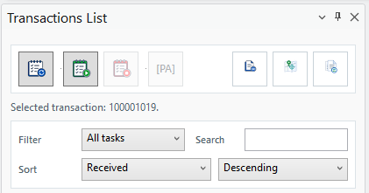
Main controls:
- Refresh: reloads available transactions from Innola.
- Filter: shows all available active tasks or tasks assigned to the logged-in user.
- Search: filters the visible list by transaction number or text.
- Sort: changes the list order.
- SD: opens Supporting Documents for the loaded transaction.
- M-Geo: opens the map georeference review workflow for the loaded transaction.
- CMP: opens the Compare form for an active Compare task.

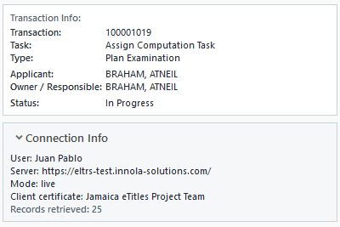
- Transaction row: selects the transaction to work on.
- Transaction Info: shows key information about the selected transaction.

Notes:
- Completed transactions are hidden from the active work list.
- Buttons that are not valid for the current transaction state are disabled. Disabled buttons should also appear visually inactive and include a tooltip explaining why the action is not available.

Expected result:
- A selected transaction shows its transaction number and task type.
- SD, M-Geo, and CMP are enabled only when valid for the loaded transaction.
- Cancel or Finalize clears the active transaction state and disables transaction-specific actions.

6. Compute Sub Workflow
Use Compute for transactions that require survey plan processing, point and line validation, and spatial unit creation.
Typical Compute stages:
Step | Name | Description
1 | Supporting Document Check | This stage copies and classifies transaction attachments into the local case folder.  Expected result:  - Required source files are copied.  - The supporting document status is Completed.  - Readable documents are available from the Supporting Documents window.
2 | Structure Check | This stage checks whether the source package contains enough files and structure to continue.  Expected result:  - The process runs without blockers.  - If a blocker appears, the message explains the missing file, invalid file, or Python/ArcPy issue.
3 | Georeference Check | This stage confirms that the plan has enough location information to build or validate geometry in JAD2001.  Expected result:  - The tool detects JAD2001 coordinates, parish, location text, or other georeference evidence.  - If JAD2001 coordinates are present in the document, they should be treated as reference coordinates.
4 | Dimension Check | This stage checks bearings, distances, area, and parcel closure information extracted from the plan.  Expected result:  - Bearings and distances are shown for review.  - Warnings can be reviewed by the examiner.  - Blockers must be corrected before moving forward.
5 | Validate Points and Lines | See paragraph 6.1
6 | Create Spatial Units
7 | Final Review
8 | Finalize

The workflow panel shows a status tile for each stage. A green tile means the stage completed. A warning or blocker means the user must review the detail before moving forward.
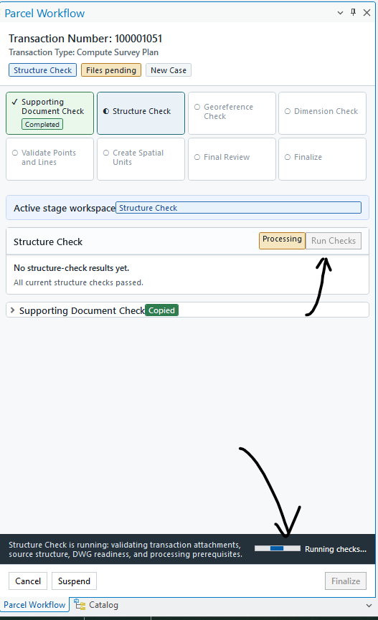
After you have run the Checks, as shown below, you have to continue with the document extraction, and you will have this interface:
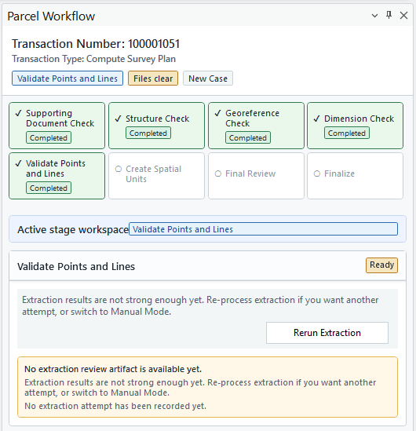
The [Rerun Extraction] will execute the internal process that extracts all the information from the source files to validate the geometry. Once this process is completed, you will have this screen with the option for the Validation.
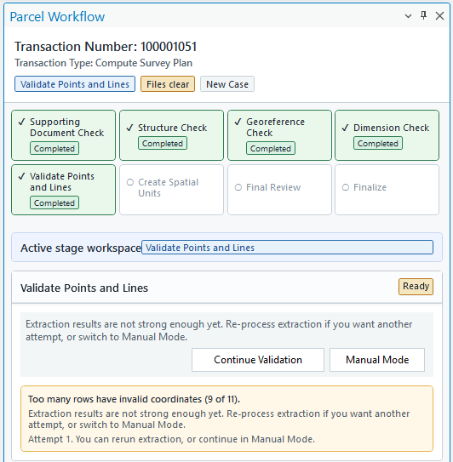
The [Continue Validation] allows you to go to the Validation Point and Lines form, described below, and the [Manual Mode] will enable you to enter all the data manually.

6.1. Validate Points and Lines
The [Points Validation Tool] is used to review and correct the extracted parcel interpretation before spatial units are created.
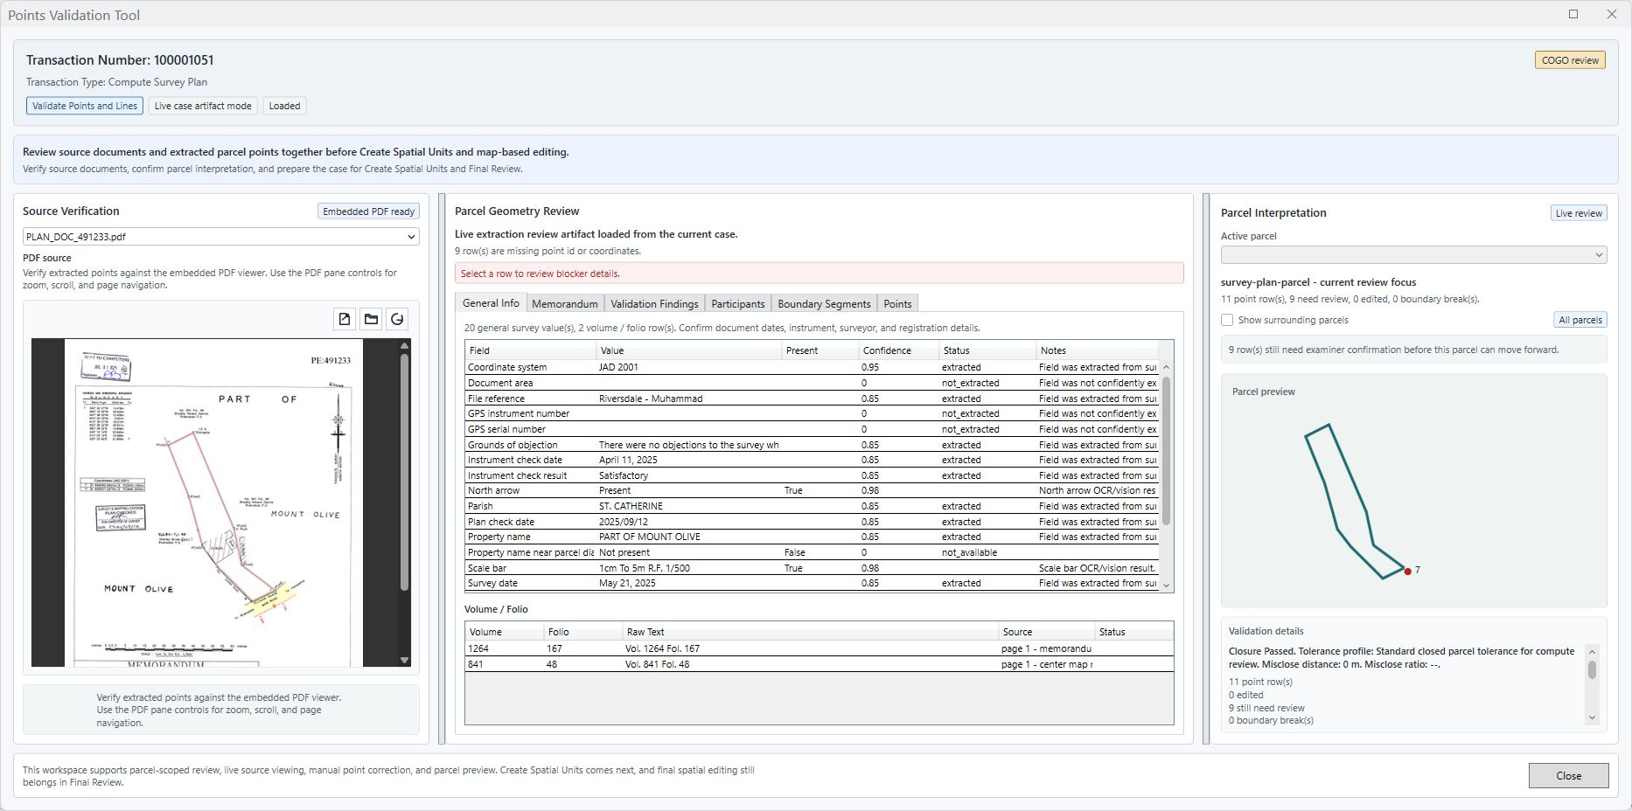
Main areas:
- Source Verification displays the source PDF.
- Boundary Segments: shows each reviewed segment with from point, to point, bearing, distance, and whether it is used for point generation.
- Points: shows printed, derived, and manually edited points.
- Parcel Interpretation: shows the parcel preview and validation details.

6.1.1 General Information
Contains all the extracted information for PDF document.
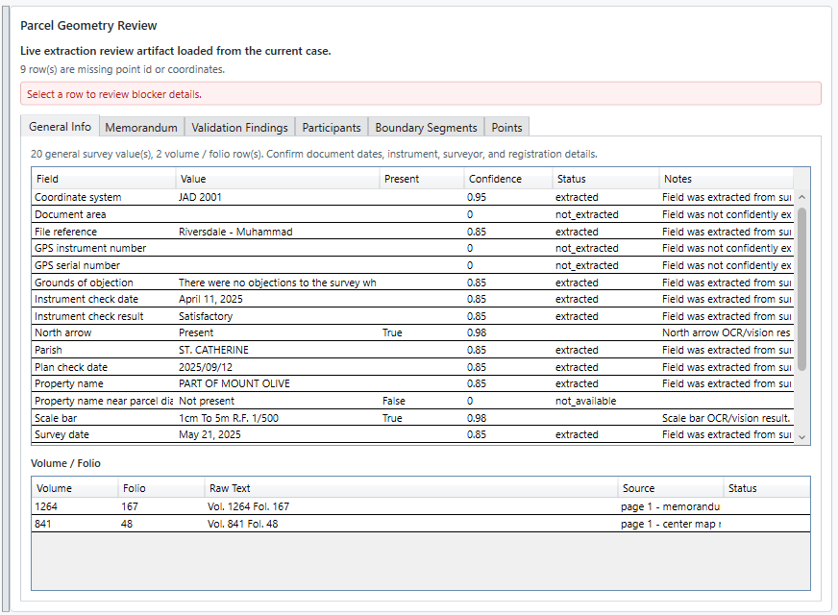

6.1.2 Memorandum
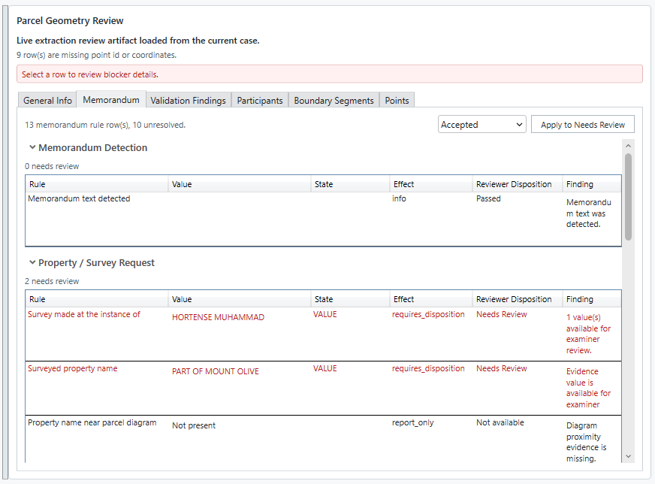

6.1.3 Validation Findings
Contains all the extracted information for PDF document.
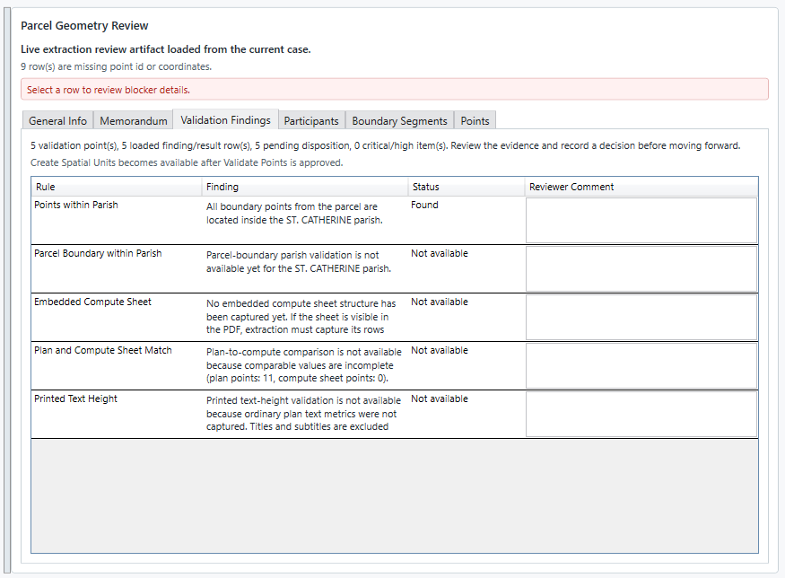

6.1.4 Participants
Contains all the extracted information for PDF document – Keep in mind that all the participants registered here, will be available during the whole validation process as references.
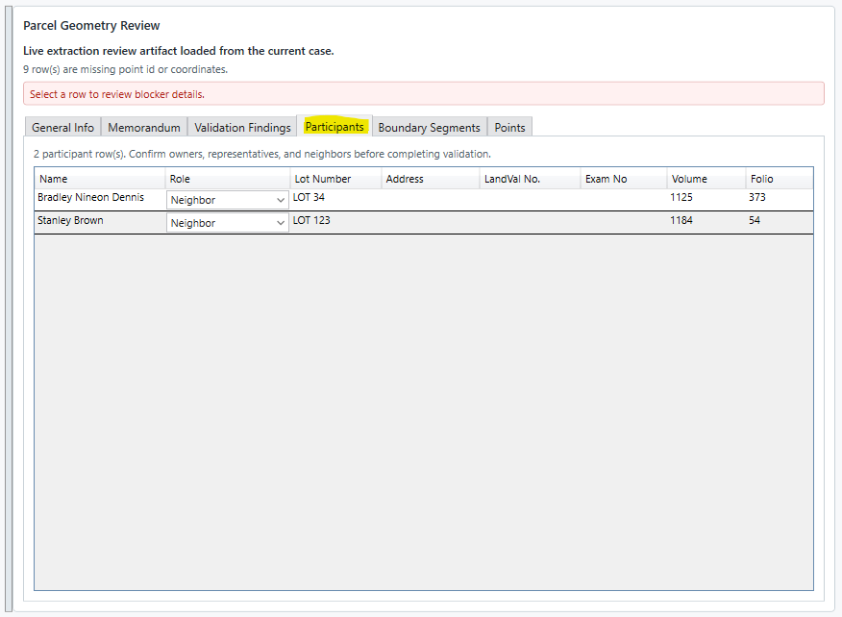

6.1.5 Boundary Segments
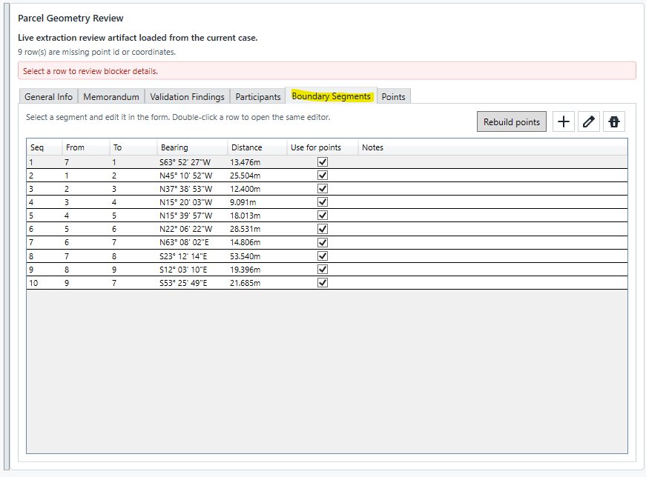
Review each segment against the PDF:
- Confirm the from/to points.
- Confirm bearing.
- Confirm distance.
- Confirm whether the segment should be used for point generation.
- Edit rows when the PDF and extracted values differ.
Rebuild points: Recreates the point validation results using the current dataset and validation rules. Use this when point data has changed or when you need to refresh the validation output.
[Add]: Adds a new point entry to the validation list.
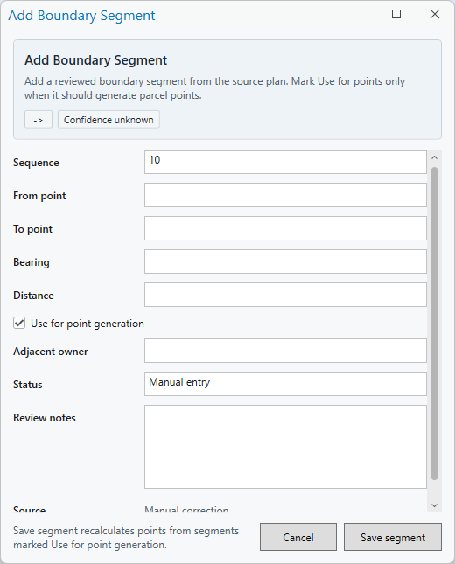
[Edit]: Opens the selected point entry so its details can be reviewed and updated.
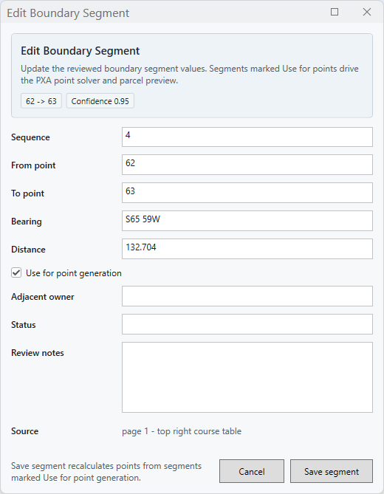
[Remove]: Deletes the selected point entry from the validation list.

6.1.6 Points
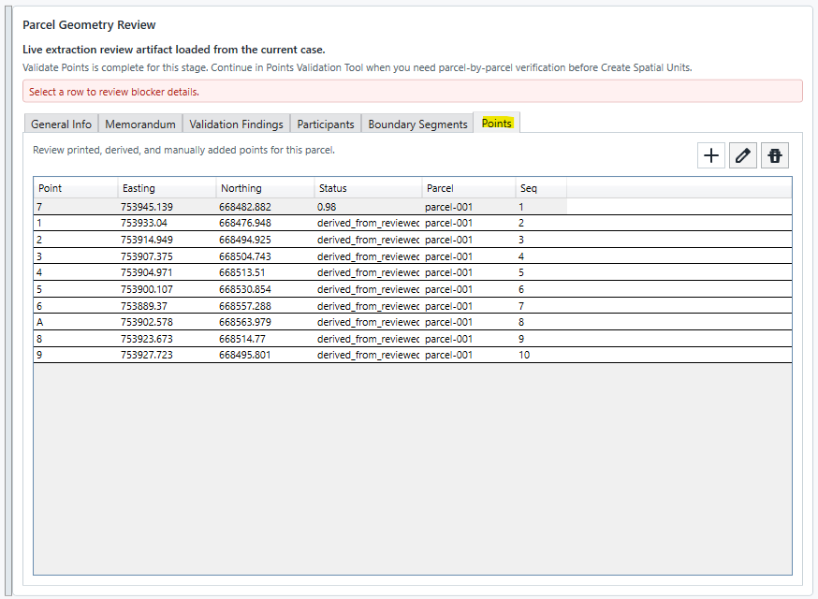
Point types:
- Printed/reference points: coordinates printed on the survey plan.
- Derived points: calculated from reviewed bearings and distances.
- Manual points: added or edited by the examiner.
User actions:
- Add point: create a point that is missing from extraction.
- Edit point: correct a label, coordinate, status, or sequence value.
- Delete point: remove an incorrect point. The tool must ask for confirmation before deletion and refresh the list afterward.
- Rebuild points: rebuild derived points from reviewed boundary segments while preserving valid printed reference points.

6.2 Validation Complete
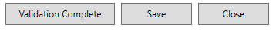
Select Validation Complete only when:
- The boundary sequence is correct.
- The required point rows are present.
- No rows still need examiner review.
- Closure validation passes or only allowed warnings remain.

Expected result:
- The tool saves the reviewed points and segments.
- The Compute panel moves to the next stage.

If validation does not complete:
- Read the validation message.
- Check whether any point still needs review.
- Check whether duplicate sequence values exist.
- Check whether a printed reference coordinate conflicts with the bearing/distance reconstruction.
- Check whether segment labels, bearings, or distances were entered incorrectly.
[Validation Complete]: Marks the point validation process as complete after all required points have been reviewed and corrected.
[Save]: Saves the current changes made in the Points Validation Tool.
[Close]: Closes the Points Validation Tool. If there are unsaved changes, save them before closing to avoid losing updates.

6.3. Create Spatial Units and Final Review
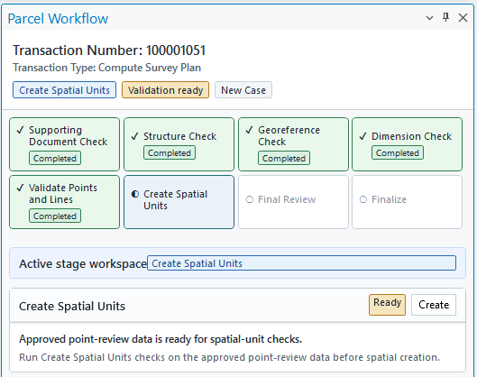
After points and lines are validated, use Create Spatial Units to create the parcel geometry for review.
Expected map behavior:
- The working map is created or reused from configuration.
- The map coordinate system is JAD2001 / EPSG:3448.
- The parcel point layer uses black border and white fill.
- The parcel polygon layer uses configured transparency.
- The Load Layers button loads local file geodatabase outputs when available and zooms to the transaction parcel.

Note: Final Review lets the examiner inspect the generated geometry in ArcGIS Pro before finalizing.
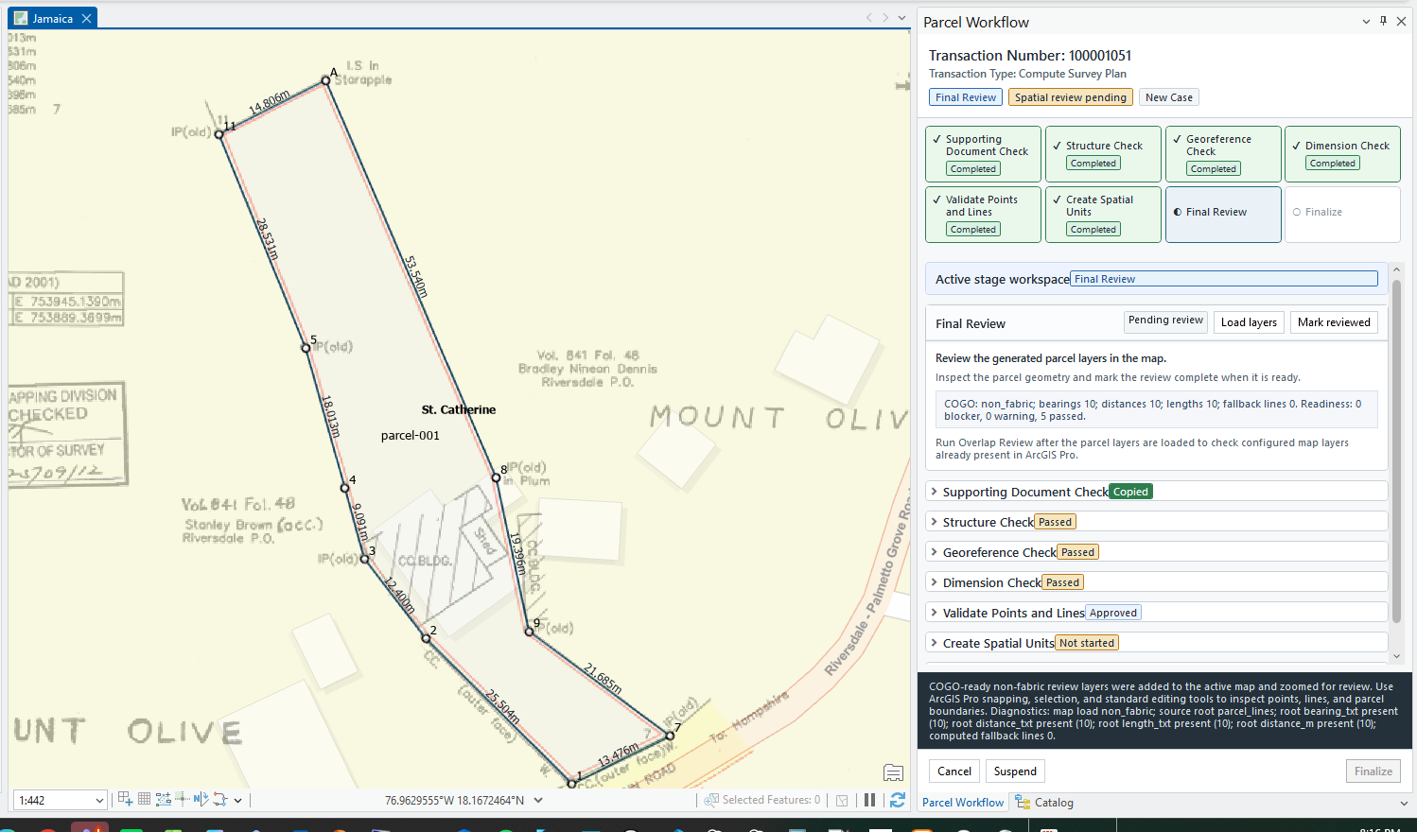
Expected result:
- The generated parcel can be visually inspected.
- The examiner can compare the temporary geometry to reference layers.
- Finalize is available only when the workflow is ready.

There are two buttons:
[Load Layers]: Adds the transaction’s review layers to the active ArcGIS Pro map so the user can inspect the parcel geometry, reference data, and spatial output before completing the review.
[Mark Reviewed]: Confirms that the loaded parcel layers and spatial output have been reviewed. This marks the spatial review step as complete and allows the workflow to continue to the next stage.
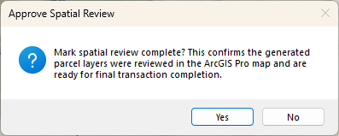
To finalize the process, [Mark Reviewed] must be completed first, and then [Finalize] must be selected. This confirms that the parcel layers and spatial output have been reviewed and allows the Compute workflow to close out the transaction.

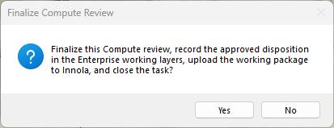
Once completed, the transaction is moved to the next stage and closed.
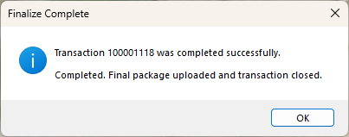
Here the transaction has been moved from Compute Survey Plan to Review Computation Finding, this in the Innola Framework.
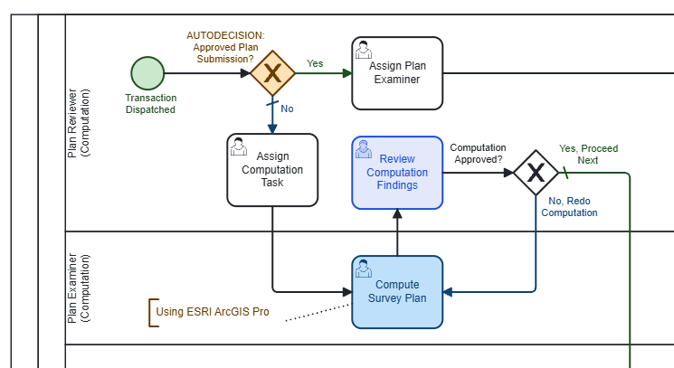

7. Additional Tools

7.1 Supporting Documents [SD]
Supporting Documents opens a transaction-scoped WPF window. It is used to view the copied source documents while the user works in Compute or Compare.
Use it to:
- Confirm the survey plan PDF.
- Review text or document attachments copied with the transaction.
- Keep the source material visible beside ArcGIS Pro.

Readable files:
- .pdf , .txt , .doc , .docx, .dwg
- when listed as a copied source file, with preview availability depending on installed viewers
Hidden files:
- .zip, .rar
- Unsupported archive or packaging files
The window title includes the transaction number, for example Supporting Documents [TR-100001118].
Only the refresh action should be visible. Open and reveal-folder actions are not part of the current training workflow.
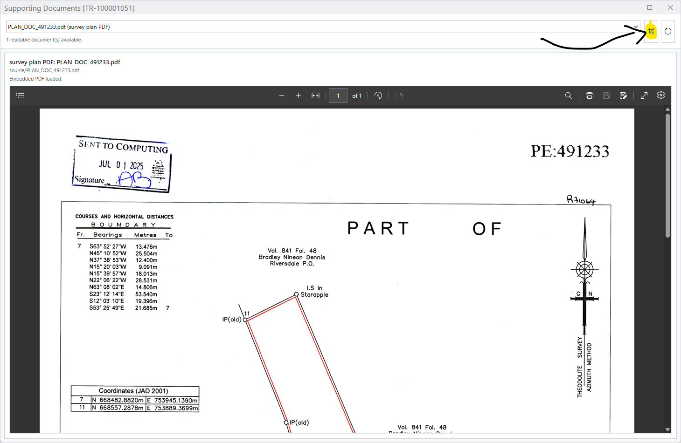
Expected result:
- The document list shows readable files from the transaction case source folder.
- The selected PDF displays in the embedded viewer.
- When the transaction is cancelled, suspended, finalized, or closed, the document window clears or closes for that transaction.

7.2 M-Geo Review
M-Geo is used when the examiner needs to compare the scanned survey plan against the map. It creates a transparent image overlay from the source document.
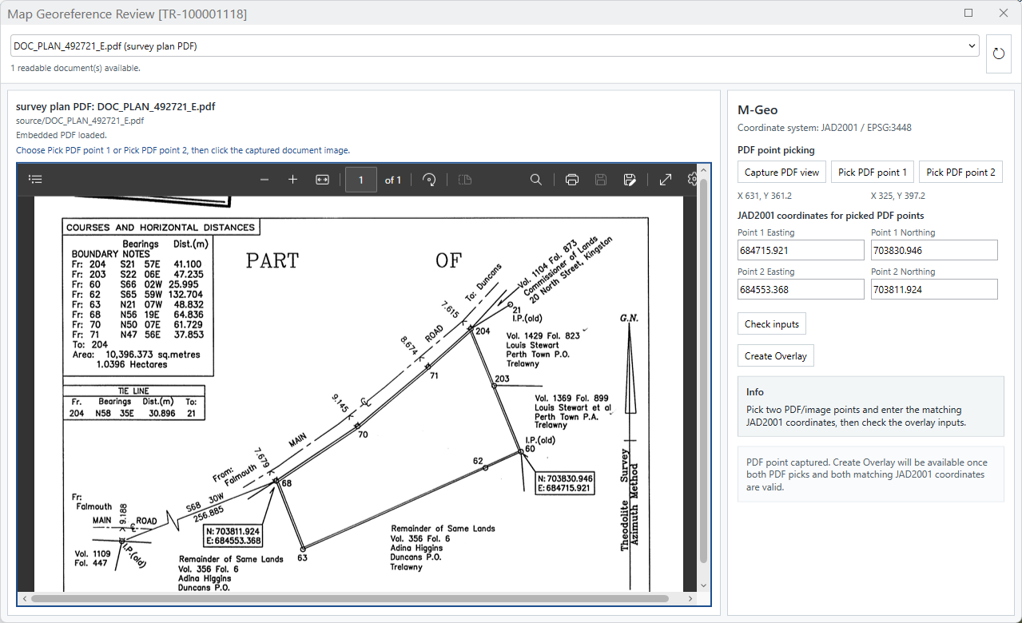
Use M-Geo when:
- The parcel appears offset from imagery or reference layers.
- The plan contains two printed JAD2001 reference coordinates.
- The examiner wants to visually compare plan linework against the map.
Process:
  - Select a loaded transaction.
  - Select M-Geo.
  - Choose the source PDF.
  - Capture the PDF view.
  - Pick PDF point 1 and PDF point 2 on the document image.
  - Enter or confirm the matching JAD2001 map/control coordinates.
  - Select Calculate fit.
  - Review the distance, rotation, scale, and warning details.
  - Select Create Overlay.
  - Review the 70% transparent overlay in the active ArcGIS Pro map.

Note: The overlay is transaction-specific. It is saved in the transaction output geodatabase when possible and can be reloaded later for the same transaction.
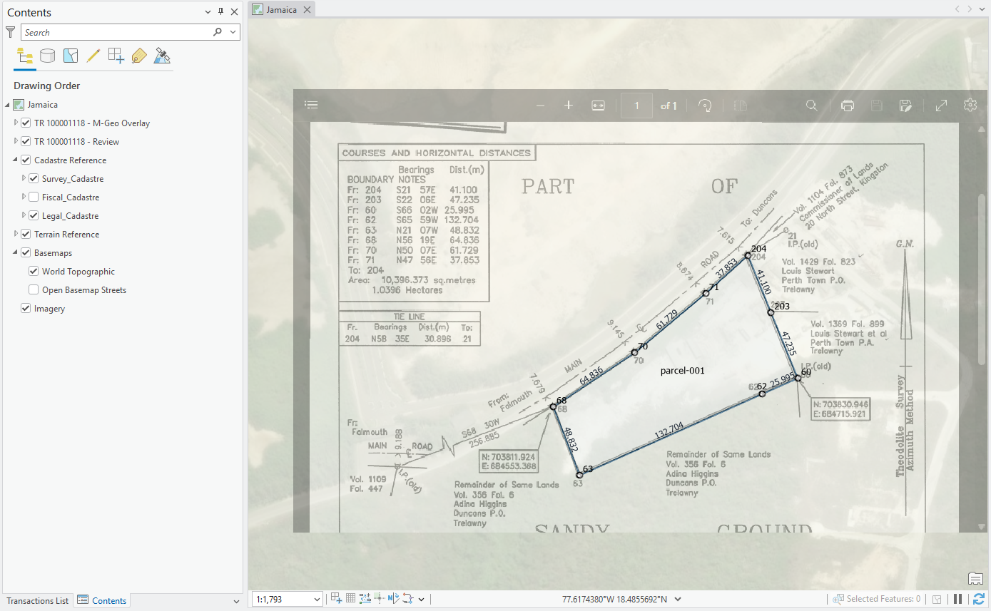
Expected result:
- The overlay is aligned using JAD2001 / EPSG:3448 control points.
- The overlay is transparent enough to compare against imagery and cadastre layers.
- If the overlay already exists in the transaction output geodatabase, M-Geo loads the existing overlay instead of forcing the user to recreate it.
- Cancel, Suspend, or Finalize removes transaction-specific M-Geo overlay layers from the map.

Important note:
- The two printed document coordinates are reference coordinates. If the bearings and distances reconstruct a parcel that differs from a printed coordinate, the tool should warn the user instead of silently changing the reference coordinate.

7.3 Crop the image for Plan Examination
The crop tool (highlighted in the previous image) is used to crop the current image of the Survey Plan and attach this to the transaction for further use.
Steps:
- Select the area to be cropped.
- Click in the Save PNG button. The image will be saved to the transaction as a png file.
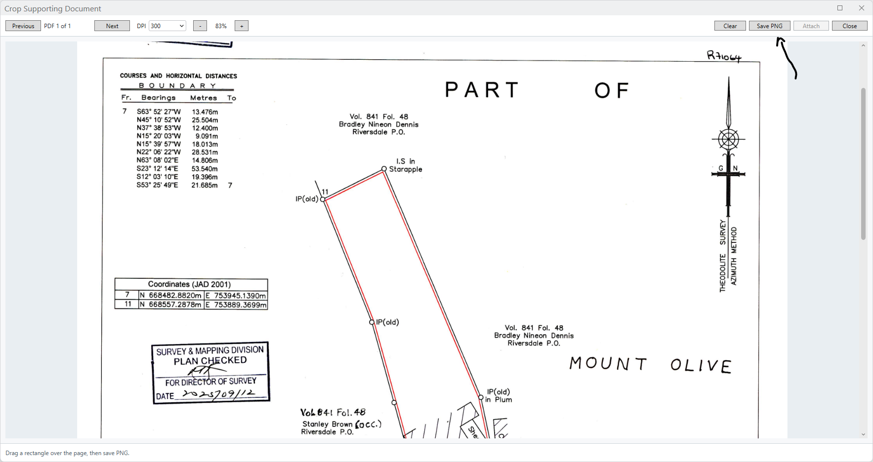

8. STAGE - Review Computation Finding -
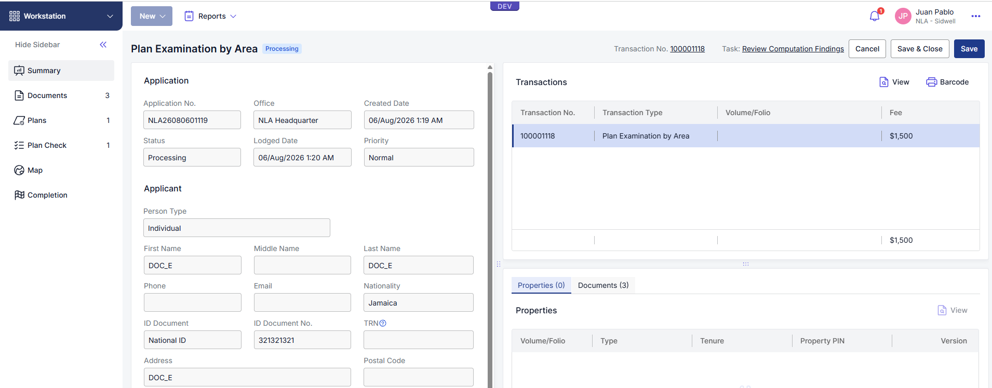

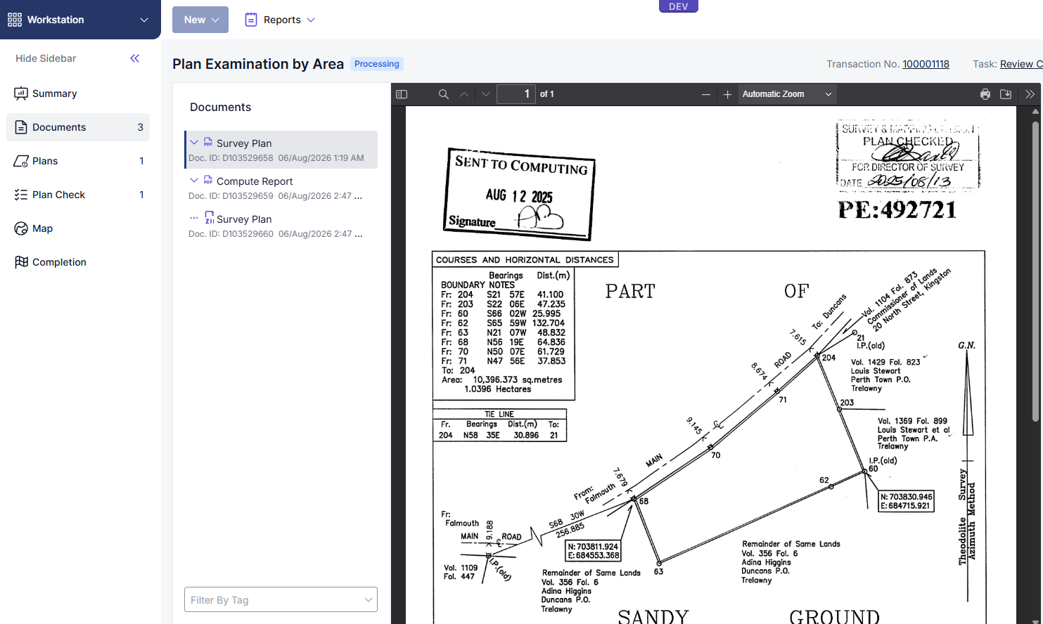

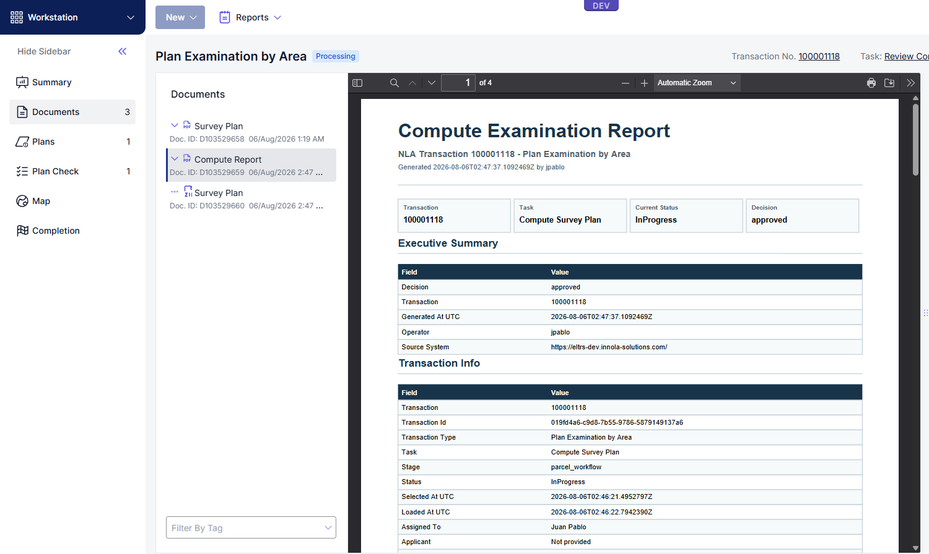
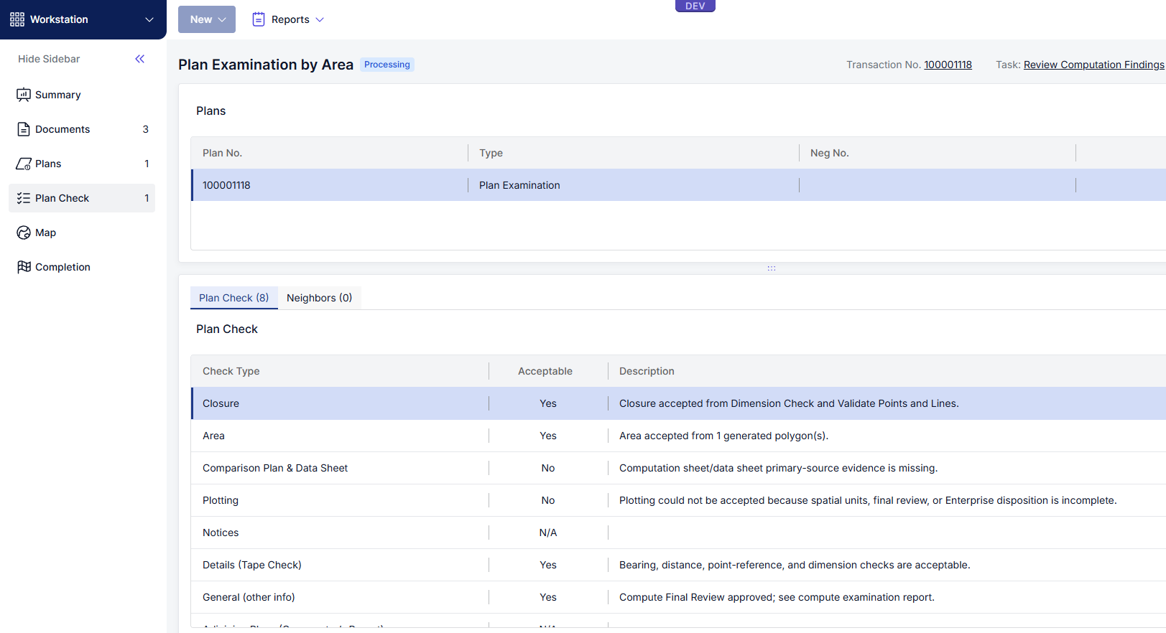
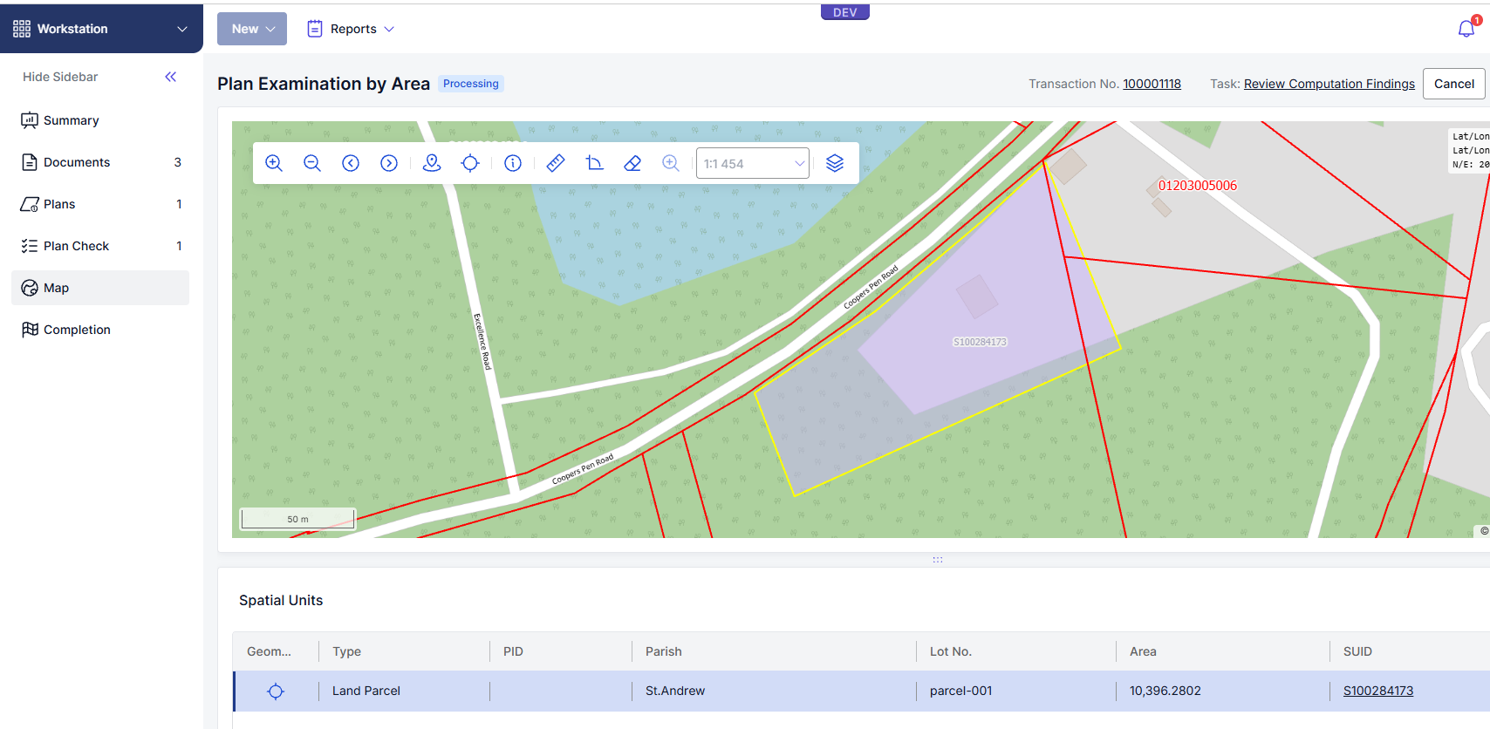
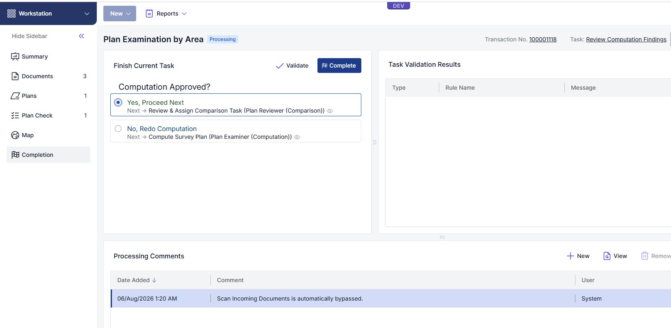
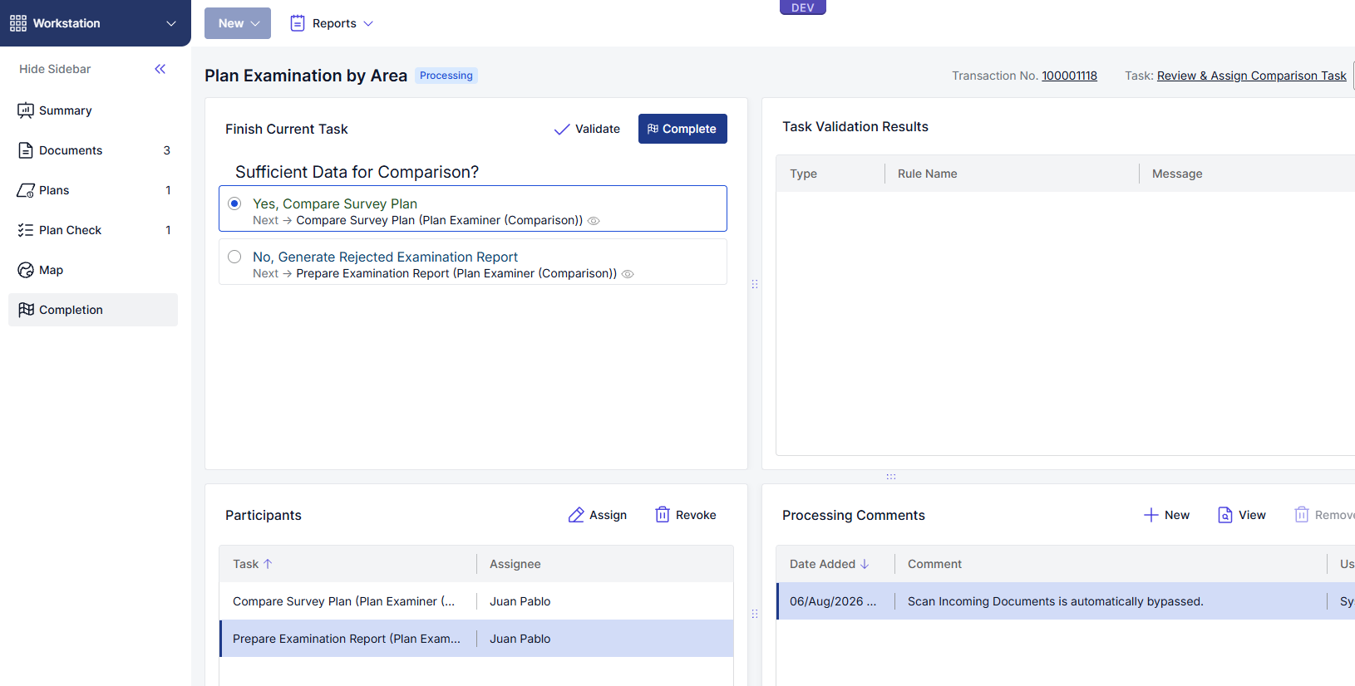

9. Compare Sub Workflow
Compare is used to review evidence around the parcel and confirm that the transaction can move forward.

Launch Compare:
- Select or load an active Compare Survey Plan transaction.
- Select CMP from the Transactions List when available.
- Confirm only one Compare window opens for the transaction.

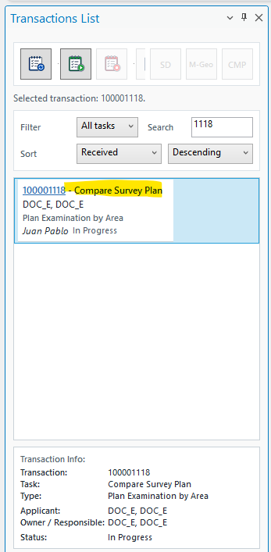

9.1 Load Compare Layers
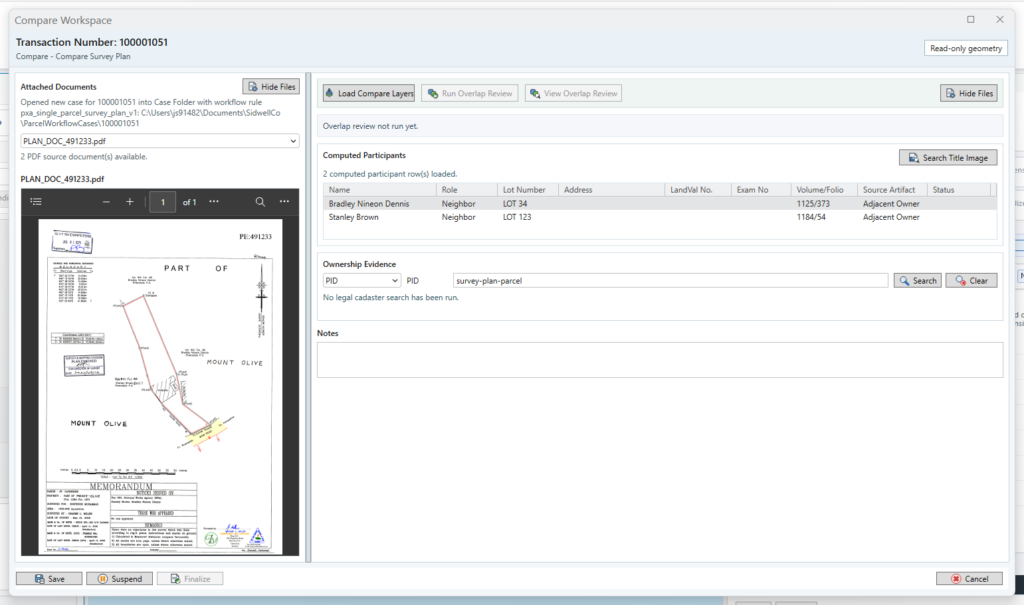
[Load Compare Layers]: Adds the Compare review layers to the active ArcGIS Pro map so the user can inspect the transaction geometry alongside the available legal, fiscal, and supporting evidence.
[Show / Hide Files]: Shows or hides the supporting files panel. Use this option to view source documents while reviewing the Compare results, or hide the files panel to give more space to the Compare review workspace.
Expected behavior:
- The transaction working polygon is loaded at 60% transparency.
- The active map stays focused on the review parcel.
- Legal Cadastre, Fiscal Cadastre, and Survey Cadastre evidence layers are queried using the configured spatial search mode.
- Neighbor evidence layers are styled as read-only context with dotted lines, 70% or greater transparency, and distinct colors.
Spatial search configuration:
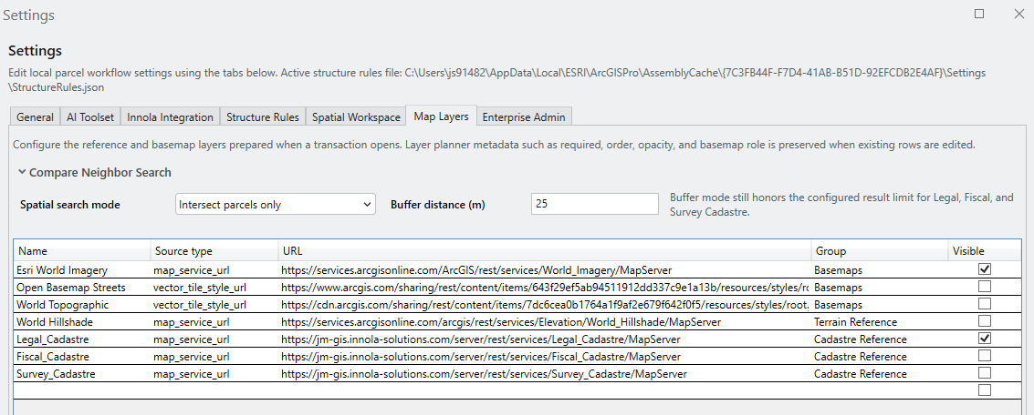
intersects: returns parcels that touch or intersect the review parcel.
buffer: returns parcels within the configured buffer distance in JAD2001 meters.
Once the Layers are load, also loads all the surrounding parcels.
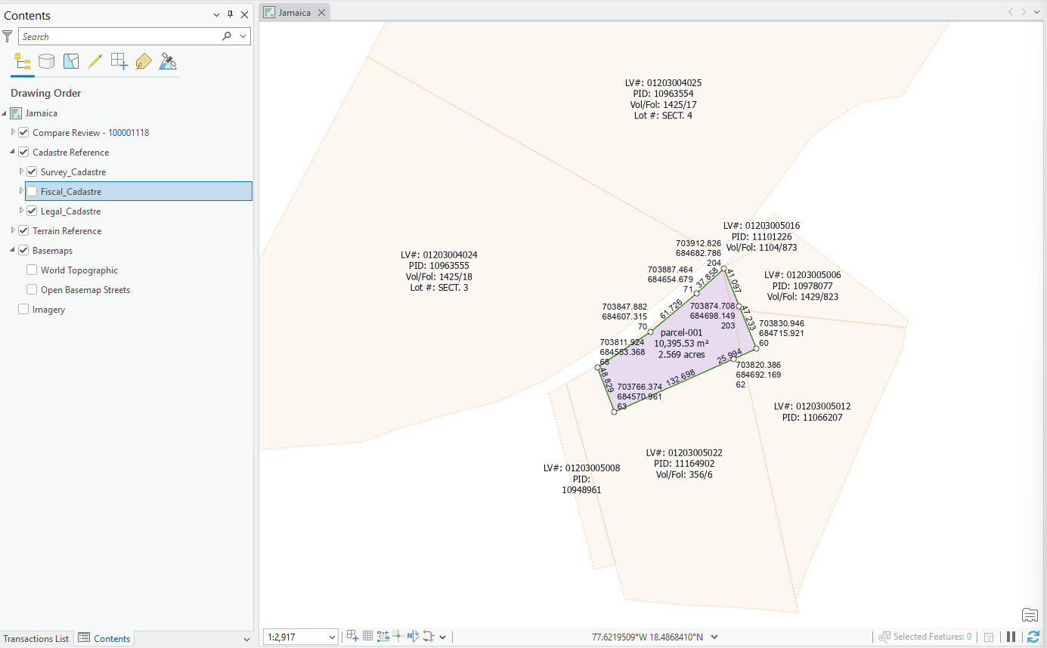
It is also possible to load the geofenced document:
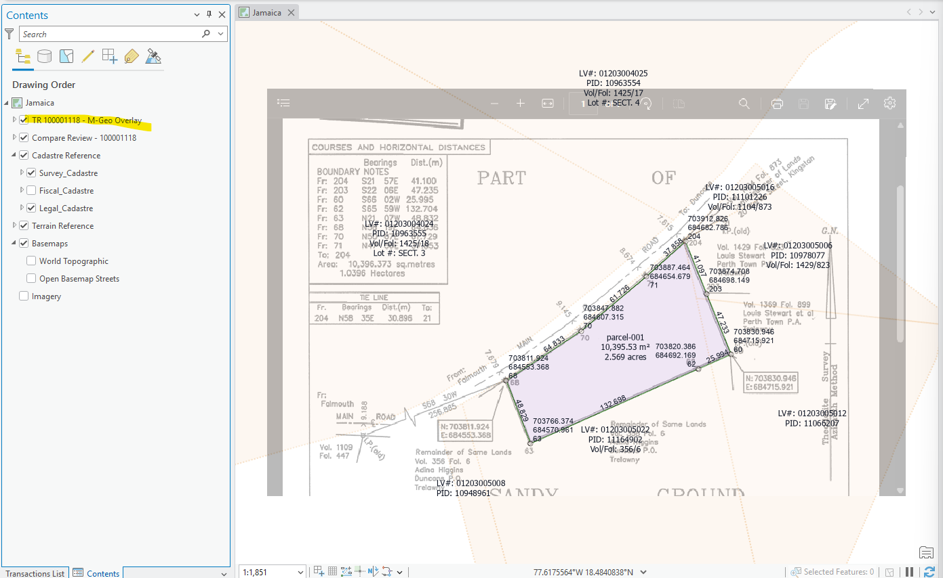
[Search Title Image]: The grid in this form shows the participants captured from the Compute stage, those are the neighbors or any participant present in the Survey Plan. The Search Title Image action queries the Innola title source repository by Volume/Folio and downloads the title document to the local case folder when a matching source exists.
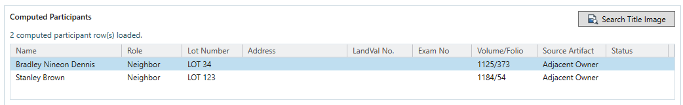

9.2 Innola Searches
The Compare form supports searches for:
- Name
- PID
- Volume/Folio
- LandVal No.

Use the exact field requested by the form. For Volume/Folio, enter the volume and folio in their separate fields when available.
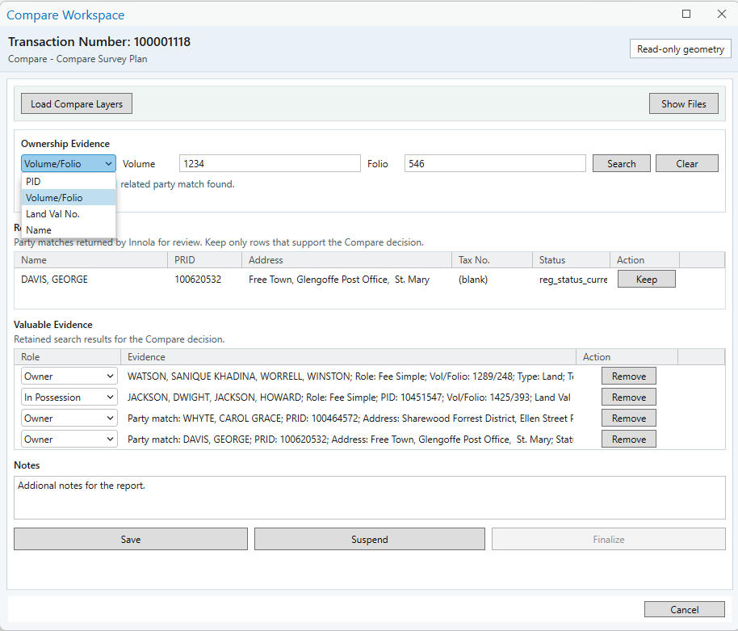
Expected result:
- Search results are shown when matching Innola records exist.
- Results can be saved with the Compare review.
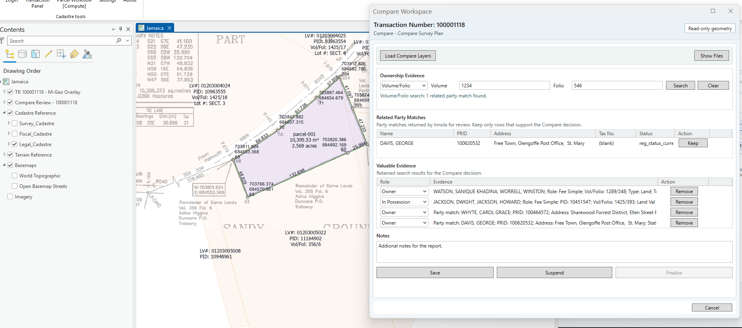

9.3 Save, Suspend, Finalize, and Cancel

The action buttons have different meanings. Use the correct action for the state of the work.

Action | Compute behavior | Compare behavior
[Save] | Saves current status and creates the current report/output where applicable. Does not close the task. | Saves current search/evidence state and regenerates the report where applicable. Finalize becomes available after at least one valid save.  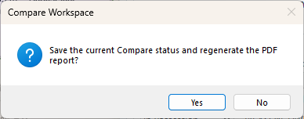
[Suspend] | Saves current status, uploads resumable status to the transaction, clears the form, and removes transaction map content. | Saves current status through the lifecycle bridge, uploads resumable status, closes Compare, and removes transaction map content.
[Finalize] | Saves final status, uploads the report/output to the transaction, moves the transaction forward, clears the form, and removes transaction map content. | Saves final status, uploads the PDF report to the transaction, moves the Compare task forward, shows a completion message, closes Compare, and removes transaction map content including M-Geo overlay.  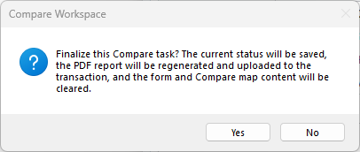
[Cancel] | Cancels the current local operation without saving, clears the form, and removes transaction map content. | Asks for confirmation, closes the Compare operation without saving, and removes Compare and M-Geo transaction map content.

Expected result after successful Finalize:
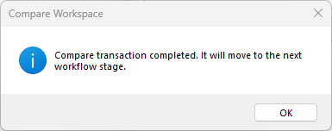
- A message confirms the transaction was completed and moved to the next workflow stage.
- Cancel and Suspend are disabled.
- SD, M-Geo, and CMP are disabled for the completed transaction.
- The Transactions List refreshes and no stale transaction content remains.

Here the transaction has been moved from Compare Survey Plan to Prepare Examination Report, this in the Innola Framework.
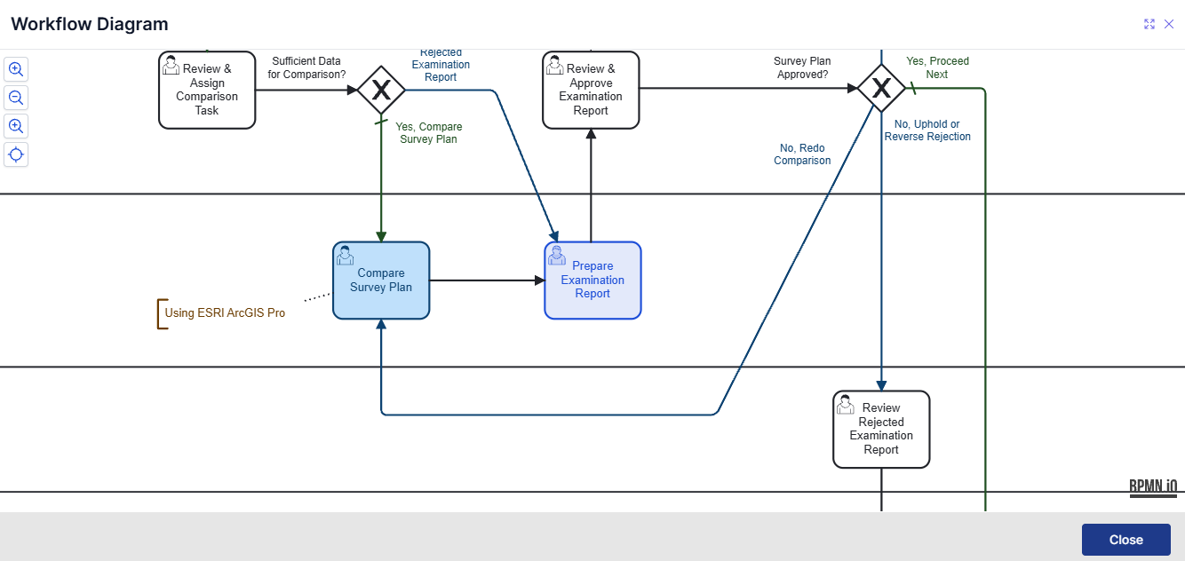

10. Fabric Maintenance
This stage is used to support the final update of the Cadastral, Legal, and Surveyed layers. The workflow is still under review, so use it only for the approved testing and review scenarios.
The current workspace is shown below.
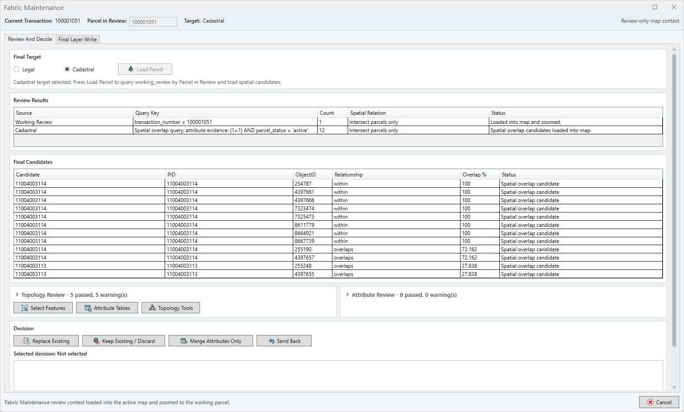
Current review steps:
- Select the Cadastral or Legal layer: To define against which layer the data must be compared.
- Review the results, and review in the final candidates all the overlay that could occur.
- Topology Review and Attribute Review must be checked before any update or change is approved.
- In the decision stage, the user must decide whether to replace, keep, merge, or send back the parcel.

10.1 Fabric Maintenance Detailed Procedure
Fabric Maintenance is the review workspace used before the final write to the selected target layer. The examiner uses it to compare the working-review parcel against the Legal, Cadastral, or Surveyed context, record a decision, and approve the final write only after the review evidence is complete.
Steps:
Select the target layer, such as Legal or Cadastral, according to the transaction being reviewed.
Select Load Parcel. The form should show the same in-progress visual used elsewhere in the add-in while parcel data is loading.
Review the candidate parcel, review results, and any overlap or attribute evidence presented by the tool.
Use the grouped Topology Review and Attribute Review sections to confirm that geometry and attributes have been checked without filling the form with long instructional text.
Record the examiner decision. The final write should not be approved until at least one review result exists, a decision is selected, and supporting notes are entered.
Select Approve for Final Write only when the evidence and decision are ready.
Use Final Layer Write to complete the save/writeback operation. If the Innola session has expired, the form should attempt the configured reconnect path and show a clear retry/login message.
Expected result:
The examiner can see the selected target, parcel in review, candidate evidence, and decision before final write.
The final write is blocked when required review evidence, decision, or notes are missing.
Progress feedback is visible while Load Parcel or Final Layer Write is running.
Cancel behaves like the form close action: it terminates the active Fabric Maintenance transaction and returns control to the Transactions List.

11. RT Examination
RT Examination is used to review a transaction that depends on a linked PE or plan transaction. The main purpose is to load the spatial unit and supporting source information from the linked transaction, review the parties and plan checks, select a decision, and move the transaction to the next stage.
Main controls:
Load Spatial Data loads the parcel geometry and supporting spatial evidence from the linked transaction into the active ArcGIS Pro map.
Decision to records the RT result selected by the examiner.
Save stores the current review state without moving the task forward.
Next Stage replaces the previous Save & Close label and moves the transaction forward when the required decision and review data are complete.
Cancel is placed on the right side of the toolbar and closes the active RT work without saving new changes.
Tabs to review:
Context: transaction identifiers, linked transaction/plan number, originating PE transaction, and current review mode.
Neighbors / Parties: owners, occupiers, neighbors, addresses, volume/folio, lot, LandVal number, and examination number where available.
Spatial Units: parcels loaded from the linked transaction and any spatial status that must be reviewed.
Plan Check: plan-check values and the RT decision evidence used for Innola writeback.
Sources / Map Evidence: supporting documents and map evidence associated with the linked transaction.
Expected result:
Load Spatial Data loads the spatial unit from the linked transaction into the map and reports how many sources and spatial units were loaded.
The progress bar/status area at the bottom of the form is visible while data is loading or saving.
Next Stage is used only after the examiner selects the RT decision and confirms the required review information.

12. Plan Annexation
Plan Annexation is used when the examiner must attach or compare plan evidence as part of the broader examination workflow. The form should be treated as a controlled document and map-evidence step: source material is reviewed, the relevant evidence is associated with the transaction, and the transaction is moved forward only when the examiner confirms the result.
Steps:
Open the Plan Annexation transaction or action from the Transactions List when it is available for the selected task.
Confirm that the expected source documents are present in the case folder and visible from the source/document pane.
Review the plan evidence against the map or transaction context required for the case.
Attach or confirm the annexation evidence according to the transaction requirement.
Save, suspend, finalize, or cancel according to the state of the work and the examiner decision.
Expected result:
The user can identify which plan evidence was reviewed and why it supports the transaction.
The transaction is not finalized until required document evidence and examiner confirmation are complete.
Any missing source document, session, or upload problem is shown as a clear actionable message.

13. STAGE - Prepare Examination Report
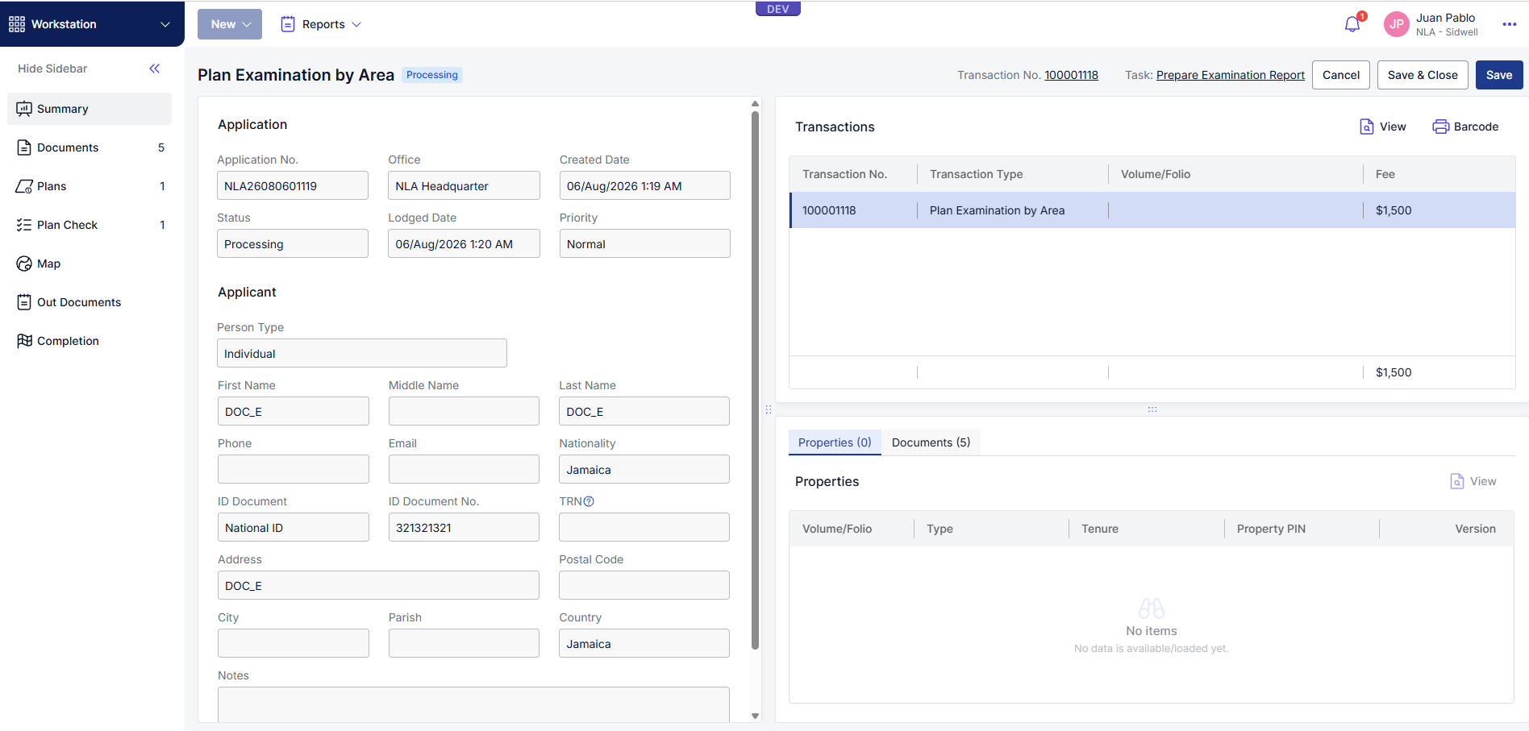
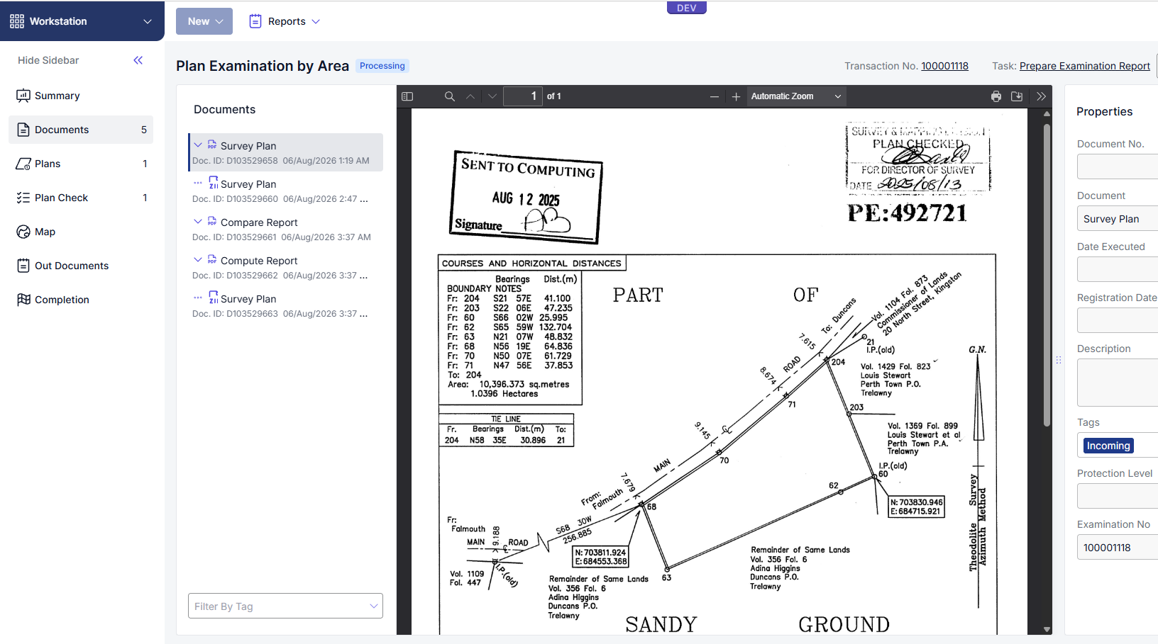
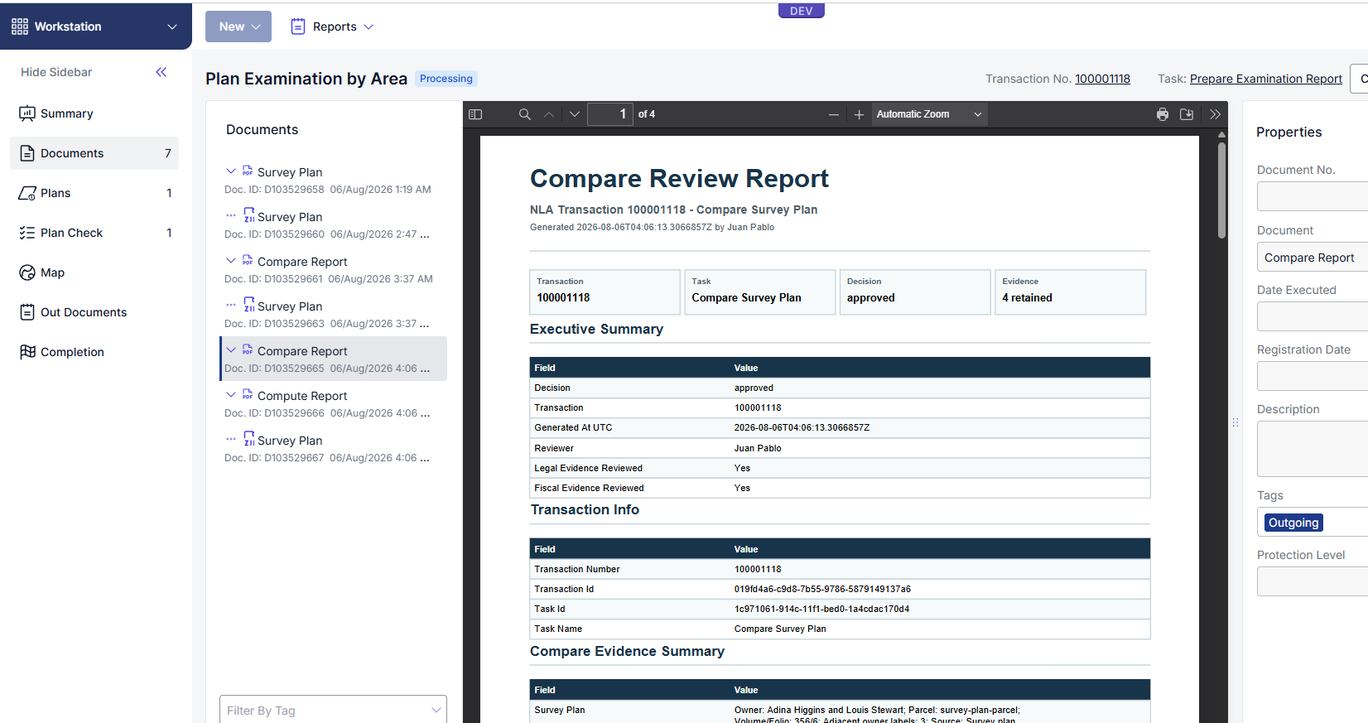

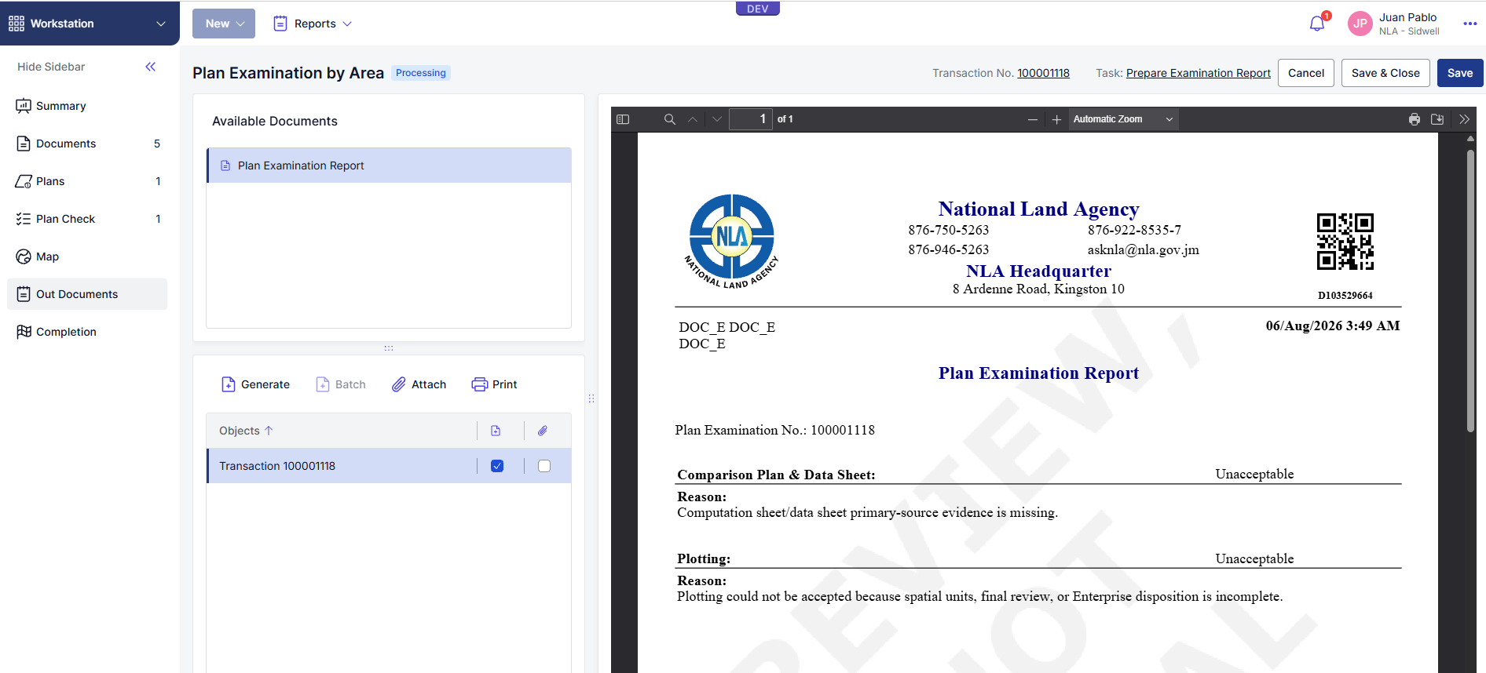

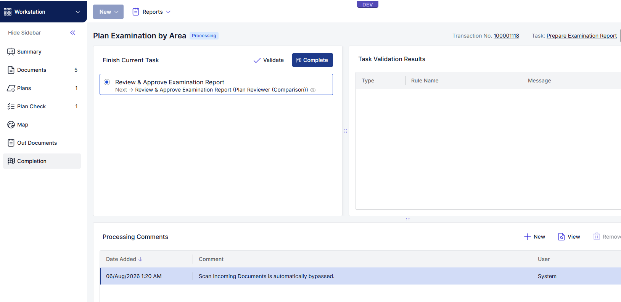

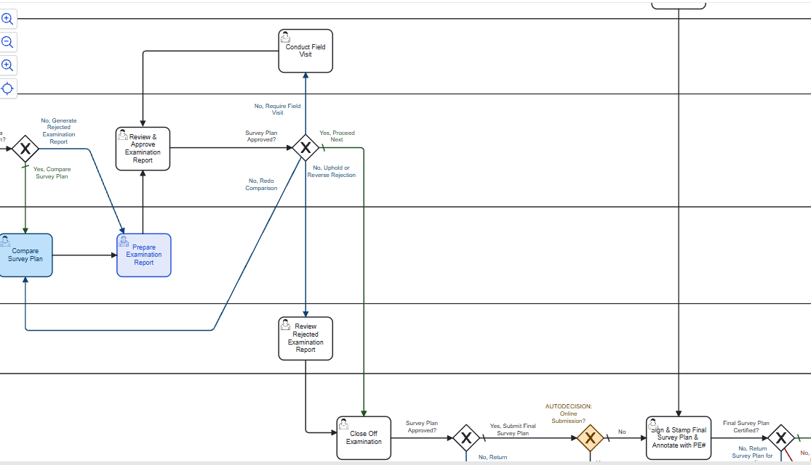

14. Training Use Case
Training coverage note: The training scenario should include Compute, Compare, Fabric Maintenance, RT Examination, and Plan Annexation when those transaction types are available in the test environment.
Use this section to run one complete training scenario.
Training transaction:

Transaction number: TR-____________
Transaction type: Compute Survey Plan or Compare Survey Plan
Assigned user: ____________
Parish: ____________
Source document: ____________

14.1 Test Steps
Step | Action | Expected result | Pass/Fail | Evidence
1 | Log into the add-in. | User name and connection details are shown.
2 | Refresh Transactions List. | Assigned active transaction is visible.
3 | Select the transaction. | Transaction Info is populated.
4 | Start Compute. | Compute panel opens and Supporting Documents opens.
5 | Review Supporting Documents. | PDF is visible and readable.
6 | Run Structure Check. | Stage passes or shows clear actionable warnings.
7 | Run Georeference Check. | JAD2001, parish, or location evidence is detected.
8 | Run Dimension Check. | Bearings and distances are available for review.
9 | Open Points Validation Tool. | Source PDF, segments, points, and preview are visible.
10 | Correct points/segments if needed. | Edits are saved and preview updates.
11 | Select Validation Complete. | Stage completes or shows clear blocker.
12 | Create Spatial Units. | Parcel geometry is created in the output workspace.
13 | Load Layers in Final Review. | Local output layers load and map zooms to parcel.
14 | Finalize Compute. | Transaction moves forward or shows clear login/output error.
15 | Launch Compare, if assigned. | Compare form opens once.
16 | Load Compare Layers. | Working polygon and neighbor evidence load.
17 | Run Innola searches. | Name, PID, Volume/Folio, or LandVal results are returned when matching records exist.
18 | Save Compare. | Search and evidence state is saved and Finalize is enabled.
19 | Finalize Compare. | Completion dialog appears and transaction moves to next stage.

15. User Acceptance Checklist
Additional RC12 workflow checks:  Fabric Maintenance: Load Parcel shows progress, review evidence is visible, and Approve for Final Write is enabled only after required review evidence, decision, and notes are present.  RT Examination: Load Spatial Data loads the linked transaction parcel, participants are visible, Decision to is selected, and Next Stage moves the task forward.  Plan Annexation: source evidence is visible, reviewed, and associated with the transaction before final action.  Long-running load/save/finalize actions show an in-progress status and produce a clear retry or login message when the Innola session cannot be restored.  Area | Check | Pass/Fail | Evidence/Notes
Login | User can log in using Innola credentials.
Transaction List | Assigned active transactions appear after refresh.
Transaction List | Completed transactions are hidden from active list.
Transaction List | Disabled buttons are visually disabled and have clear tooltips.
Supporting Documents | SD opens the transaction document window.
Supporting Documents | PDF is visible from the copied case source folder.
M-Geo | M-Geo opens only when a transaction is loaded.
M-Geo | A 70% transparent overlay can be created or reloaded.
Compute | Each stage can be run in order.
Points Validation | Add, edit, delete, and rebuild point workflows behave as expected.
Points Validation | Delete asks for confirmation and refreshes the list.
Spatial Units | Generated geometry is in JAD2001 / EPSG:3448.
Final Review | Load Layers loads local output layers and zooms to parcel.
Compare | CMP opens one Compare form only.
Compare | Legal, Fiscal, and Survey neighbor evidence loads from configuration.
Compare | Name, PID, Volume/Folio, and LandVal searches work as expected.
Compare | Save persists searches and enables Finalize.
Finalize | Successful finalize shows a completion dialog and moves the task forward.
Cleanup | Cancel, Suspend, and Finalize remove transaction-specific map layers.
Installer | Logs and installation summary are created.

16. Troubleshooting

16.1 Login Failed
What to check:
- User name and password.
- Server URL in Settings.
- Network access to the Innola server.
- Whether the Innola session expired.
Expected recovery:
- Sign in again.
- Refresh the Transactions List.

16.2 Transaction Does Not Start
What to check:
- The transaction is assigned to the user or user's group.
- The task is not already completed.
- The add-in is logged in.
- The case folder can be created or reopened.

16.3 Supporting Documents Window Is Empty
What to check:
- Case folder exists.
- source folder contains readable files.
- PDF is not locked or deleted.
- The selected transaction number matches the folder.

Example folder:
C:\Sidwell\ParcelWorkflow\ParcelWorkflowCases\<transaction>\source

16.4 Configured Python Executable Could Not Be Invoked
What to check:
- Configured Python path exists.
- User has permission to run Python from that folder.
- The path does not point to a protected ArcGIS Pro environment when local security blocks execution.
- The cloned environment exists at the configured target path.

16.5 ArcPy Is Not Available
What to check:
- ArcGIS Pro is installed.
- ArcGIS Pro is licensed.
- The Python environment matches the installed ArcGIS Pro version.
- ArcPy can be imported inside the active ArcGIS Pro session.

Support command:
python -c "import arcpy; print(arcpy.GetInstallInfo())"

16.6 Product License Has Not Been Initialized
This can happen when ArcPy is started outside a licensed ArcGIS Pro session or from an elevated/service context that cannot access the named-user license.
What to do:
- Sign into ArcGIS Pro.
- Confirm the license page shows a valid license.
- Start processing from inside ArcGIS Pro.

16.7 OpenAI API Key Missing
What to check:
- OPENAI_API_KEY is set for the user or machine.
- The key was entered during installation if required.
- The Python process can read the environment variable.

Support command:
python -c "import os; print(bool(os.getenv('OPENAI_API_KEY')))"

16.8 Georeference Check Blocked
What to check:
- The document contains JAD2001 coordinates, parish, or clear location reference.
- Coordinates were extracted with correct Northing/Easting values.
- The map is using JAD2001 / EPSG:3448.

16.9 Points Validation Blocked
What to check:
- Any row still needs review.
- Segment sequence is continuous.
- No duplicate point sequence values exist.
- Printed reference points are correct.
- Bearings and distances match the PDF.

16.10 Spatial Unit Creation Failed
What to check:
- Validate Points and Lines is completed.
- Output geodatabase exists.
- Local output layers were created.
- Innola login/session is still valid if final upload is required.

16.11 Compare Search Failed
What to check:
- Innola session is still valid.
- Search field is correct: Name, PID, Volume/Folio, or LandVal.
- For Volume/Folio, confirm volume and folio are entered separately where required.
- Confirm the record exists in the portal.

16.12 Enterprise Token or SSL Error
What to check:
- ArcGIS Pro is signed into the correct portal.
- Portal token is available from the Pro session.
- SSL certificates are trusted by the target computer.
- Enterprise URLs in Settings are correct.

16.13 ArcGIS Pro Crash
Crash dumps are usually stored under:
C:\Users\<user>\AppData\Local\ESRI\ErrorReports
Capture the dump file path, transaction number, and the action being performed when the crash occurred.

Appendix A. Log Locations
Common logs:
C:\ProgramData\Sidwell\ParcelWorkflow\logs
C:\Sidwell\ParcelWorkflow\logs
C:\Sidwell\ParcelWorkflow\ParcelWorkflowCases\<transaction>\process.log
C:\Sidwell\ParcelWorkflow\ParcelWorkflowCases\<transaction>\output
C:\Users\<user>\Documents\SidwellCo\ParcelWorkflowCases\<transaction>

Installer summary files:
installation_summary.txt
installation_summary.json
setup_arcgispro37_environment_status.json
setup_arcgispro37_environment_bat.log
register_parcel_workflow_addin_bat.log

Appendix B. Configuration Notes
Coordinate system:
- All generated parcel geometry must use JAD2001 / EPSG:3448.
- If the ArcGIS Pro map shows Web Mercator because of a basemap, generated parcel layers still need to be stored and processed in JAD2001.

Map layers:
- Legal Cadastre
- Fiscal Cadastre
- Survey Cadastre
- Open Basemap Streets / OpenStreetMap
- Esri imagery
- World Topographic
- World Hillshade

Compare spatial search:
- Use intersects for touching/intersecting parcels only.
- Use buffer when surrounding parcels within a configured distance are required.

Appendix C. Training Signoff

Reviewer | Role | Date | Result | Notes
 | SMD product owner
 | Plan examiner
 | Implementation team
 | Support lead

Appendix D. Compute Steps Screenshots
- Structure Check:
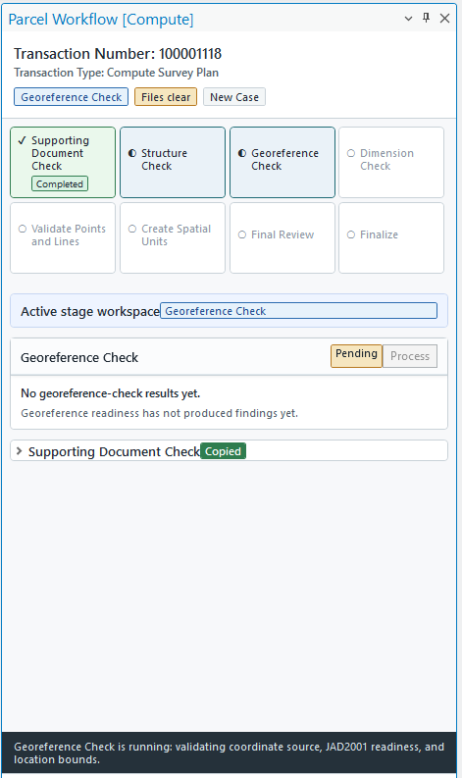
- Georeference Check:
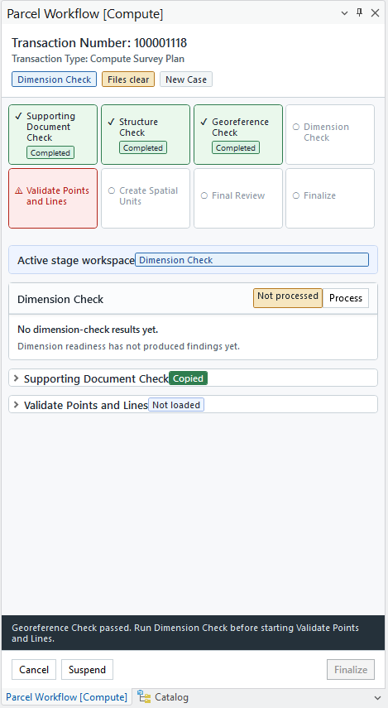
- Dimension Check:
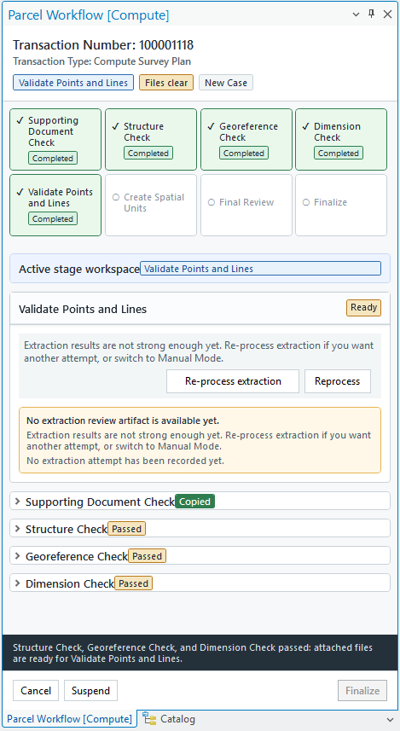
- Validate Points and Lines:
