Jamaica eTitles – SMD AI Extraction Cost Scenarios
Working estimate based on observed ExtractionAssistant API usage and published NLA plan-checking volumes
Executive conclusion. Using the current observed API spend of $0.56 for 126 ExtractionAssistant requests, the blended cost is approximately $0.00444 per request. With NLA processing about 12,000 survey plans per year and assuming 5–6 AI requests per plan, the current production-equivalent estimate is approximately $267–$320 per year. A conservative stress scenario, with higher volume, 10 requests per plan and twice the current unit cost, is approximately $1,333 per year.

1. Baseline Inputs
The model combines two independent inputs: (1) measured OpenAI API usage from the ExtractionAssistant key, and (2) official NLA Surveys & Mapping Division statistics for pre-checking survey plans.
Metric | Observed / Published Value | Use in Model
ExtractionAssistant spend (last 30 days) | $0.56 | Measured cost baseline
ExtractionAssistant requests | 126 | Measured request count
ExtractionAssistant tokens | 592,404 | Measured token volume
Average cost per request | $0.00444 | Derived: $0.56 / 126
Average tokens per request | 4,702 | Derived: 592,404 / 126
FY 2022/23 plans checked | 13,275 | Published NLA actual
FY 2023/24 plans checked | 11,845 | Published NLA actual
Current planning target | 12,000/year | Published NLA target
Important scope note: The NLA statistic is “Number of Plans Checked” under pre-checking of survey plans. It is a strong proxy for PE/PXA extraction workload, but it should not be interpreted as the total number of all SMD transactions such as map requests, RT examination, cadastral maintenance, or other services.

2. Unit Economics of the Current Extraction Process
Assumption | Formula | Result
Cost per API request | $0.56 / 126 | $0.00444
Cost per plan – 5 requests | 5 × $0.00444 | $0.0222
Cost per plan – 6 requests | 6 × $0.00444 | $0.0267
Tokens per plan – 5 requests | 5 × 4,702 | 23,508
Tokens per plan – 6 requests | 6 × 4,702 | 28,210
Interpretation: At today’s observed blended rate, five to six ExtractionAssistant calls represent only about 2.2–2.7 cents of API expenditure per plan. This is an observed test-period average, not a guaranteed future price.

3. Annual Production Scenarios
Scenario | Plans / Year | Requests / Plan | Unit-Cost Factor | API Requests / Year | Annual Cost | Monthly Avg.
Optimized / Lower Actual | 11,845 | 5 | 1.0× | 59,225 | $263 | $22
Planning Baseline | 12,000 | 6 | 1.0× | 72,000 | $320 | $27
High Production | 13,275 | 8 | 1.5× | 106,200 | $708 | $59
Stress / Worst Case | 15,000 | 10 | 2.0× | 150,000 | $1,333 | $111
Scenario definitions: Optimized uses the latest actual NLA volume (11,845) and five calls per plan. Planning Baseline uses the 12,000-plan NLA target and six calls. High Production uses the higher recent actual volume (13,275), eight calls, and a 1.5× unit-cost factor for more complex production documents/retries. Stress / Worst Case assumes 15,000 plans, ten calls per plan, and twice the current observed unit cost.
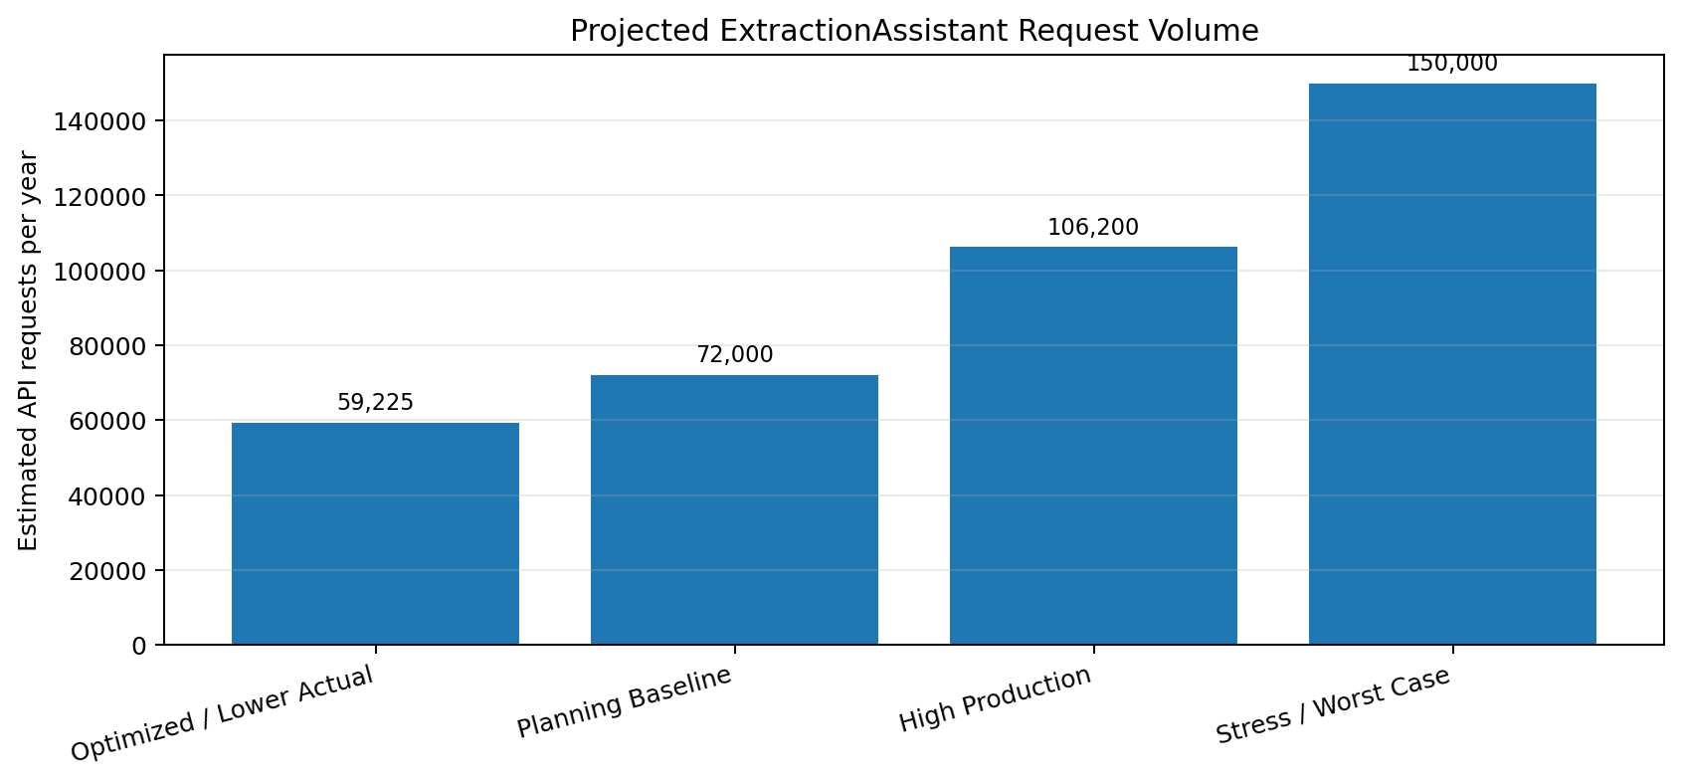
Figure 1. Projected annual ExtractionAssistant request volume
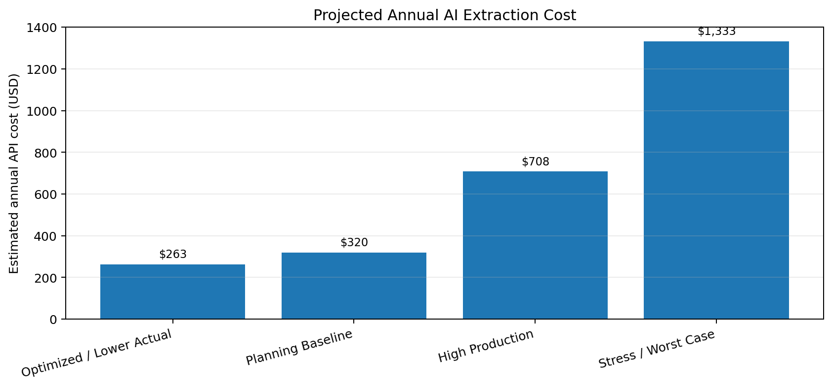
Figure 2. Projected annual API expenditure by scenario

4. Planning Baseline for the PM
Planning Item | Estimate
Survey plans processed | ~12,000/year (~1,000/month)
AI requests per plan | 5–6
Expected API requests | 60,000–72,000/year (~5,000–6,000/month)
Expected cost at current measured unit rate | $267–$320/year
Expected monthly cost at current measured unit rate | $22–$27/month
Conservative stress-case cost | ~$1,333/year
Suggested annual budget allowance | $1,500/year for API extraction usage
Recommended management message. At NLA’s current scale of approximately 12,000 survey plans per year, an AI-assisted extraction pipeline averaging five to six API calls per plan would generate approximately 60,000–72,000 API calls annually. Based on actual ExtractionAssistant usage to date, the expected direct API cost is roughly $267–$320 per year. Even under a deliberately conservative stress case, the modeled annual API expense remains around $1,333, making a $1,500 annual allowance a reasonable preliminary planning envelope.

5. What Could Increase or Reduce the Cost
Increase cost: Poor-quality scans, larger/multi-page plans, retries, repeated extraction after correction/re-lodgement, use of higher-cost models, or processing more supporting documents per transaction.
Reduce cost: Using extraction only where needed, avoiding repeat processing of unchanged documents, caching/reusing extracted results, moving deterministic geometry/closure/topology checks to ArcGIS/Python rather than AI, and using a lower-cost model for routine extraction.
Most important production metric: Track cost per successfully processed plan, not only cost per API request. A transaction-level metric should include requests, tokens, retries, model, document count/pages, and final extraction status.

6. Recommended Metrics to Capture in Production
- Plans/transactions submitted per month and year.
- Percentage of SMD transactions that invoke AI extraction.
- API requests per transaction and per document.
- Input/output tokens and API cost per transaction.
- Average number of retries or reprocessing events.
- Percentage of extractions accepted without examiner correction.
- Percentage escalated to manual review.
- Processing time saved compared with manual coordinate/document extraction.
- AI extraction cost per successful plan and total monthly API cost.

7. Sources and Assumptions
OpenAI API usage baseline: User-provided OpenAI Platform Usage screenshot filtered to the ExtractionAssistant API key, last 30 days: 126 requests, 592,404 tokens, $0.56 total spend.
National Land Agency Strategic Business Plan 2023–2027
https://nla.gov.jm/system/files/_NLA%20Strategic%20Business%20Plan-2023-2027.pdf
Reports 13,275 plans checked in FY 2022/23 and a target of 12,000.
National Land Agency Strategic Business Plan 2024–2028
https://nla.gov.jm/system/files/NLA%20Strategic%20Business%20Plan-2024-2028%20Final-min.cleaned.pdf
Reports 11,845 plans checked in FY 2023/24 and a target of 12,000 plans per year.
Modeling caveat: Future API costs depend on the model selected, token mix, prompt/output size, retries and provider pricing. This document deliberately uses the measured blended cost from the ExtractionAssistant key as the main baseline, then applies explicit scenario multipliers rather than assuming a specific model tariff.

