|  |  |  |  |  |  |
| --- | --- | --- | --- | --- | --- |
| **Student Name** | Suguru Hagiwara | | **Student Number** | | 471130213 |
| **Unit Code/s & Name/s** | ICTWEB505 – Develop complex web page layouts  ICTWEB506 – Develop complex cascading style sheets  CUAGRD504 - Create and manipulate graphics | | | | |
| **Assessment Type** | Case Study  Assignment  Portfolio  Other *(specify)* | | | | |
| **Assessment Name** | Web Form | **Assessment Task No.** | | | 3/4 |
| **Assessment Due Date** | 8/5/2020 | **Date submitted** | | | 8/5/2020 |
| **Assessor Name** | John Perry | | | | |
| **Student Declaration:** I declare that this assessment is my own work. Any ideas and comments made by other people have been acknowledged as references. I understand that if this statement is found to be false, it will be regarded as misconduct and will be subject to disciplinary action as outlined in the TAFE Queensland Student Rules. I understand that by emailing or submitting this assessment electronically, I agree to this Declaration in lieu of a written signature. | | | | | |
| **Student Signature** | Suguru Hagiwara | | | **Date** | 8/5/2020 |
| **PRIVACY DISCLAIMER:** TAFE Queensland is collecting your personal information for assessment purposes. The information will only be accessed by authorised employees of TAFE Queensland. Some of this information may be given to the Australian Skills Quality Authority (ASQA) or its successor and/or TAFE Queensland for audit and/or reporting purposes. Your information will not be given to any other person or agency unless you have given us written permission or we are required by law. | | | | | |

|  |  |
| --- | --- |
| **Instructions to Student** | **Learning Support**  Additional support is available to help you achieve your learning goals. Speak to your teacher or a Learning Skills Centre team member if you feel that you may benefit from some extra support. The Institute provides extra support through the Disability Support Unit and the Learning Skills Centre.  RPL (Recognition of Prior Learning) is available for this unit. Speak to your teacher/assessor to check if you qualify for RPL.  **General Instructions:**  This activity aims create user-registration form with at least seven input elements. This form aims to be self-validating using only HTML5 constructs. The layout needs to contain all that is necessary for JavaScript to manage the submission process. JavaScript can be incorporated by the student, if it enhances the validation process.  The student must be able to use a number of examples of form-specific HTML attributes, CSS pseudoclasses, and layout constructs to deliver adequate feedback to the user as they enter data into the form.  The design should embody mobile-first principals, and the desktop view is simply a mobile view, with minimal design alterations.  Imagery is incorporated into the interface that represents custom SVG elements that are “resolution independent” and stay tack sharp irrespective of scale. Include source files used to create said image.  Teachings may have included the use of <https://fontawesome.com/> to incorporate iconography into the form inputs.  The student needs to validate HTML & CSS, describe sources and copyright/licenses of images (if used) and test their work in at least three browsers, including a mobile phone.  NOTE: Criteria (below) form the standards by which the assessment will be graded. Please attend to all in this list to be deemed competent with this assessment.  **Information / Materials provided:**  Internet access for reference material  Web coding software  Browser with development/debugging tools  **Assessment Criteria:**  To achieve a satisfactory result, your assessor will be looking for your ability to demonstrate the following key skills/tasks/knowledge to an acceptable industry standard:    **Number of Attempts:**  You will receive up to two (2) attempts at this assessment task. Should your 1st attempt be unsatisfactory (U), your teacher will provide feedback and discuss the relevant sections / questions with you and will arrange a due date for the submission of your 2nd attempt. If your 2nd submission is unsatisfactory (U), or you fail to submit a 2nd attempt, you will receive an overall unsatisfactory result for this assessment task. Only one re-assessment attempt may be granted for each assessment task. **For more information, refer to the Student Rules.** |
| **Submission details** | *Assessment to be submitted via*   * *TAFE Queensland Learning Management System: Connect url:* [*https://connect.tafeqld.edu.au/d2l/login*](https://connect.tafeqld.edu.au/d2l/login) * *Username; 10 digit student number* * *For Password: Reset password go to* [*https://passwordreset.tafeqld.edu.au/default.aspx*](https://passwordreset.tafeqld.edu.au/default.aspx)*>* |
| **Instructions for the Assessor** |  |
| **Note to Student** | An overview of all Assessment Tasks relevant to this unit is located in the Unit Study Guide. |

# Web Form

**PART A - HTML**

|  |  |  |  |  |
| --- | --- | --- | --- | --- |
| **Assessment criteria**  **The evidence submitted demonstrates that the student satisfactorily:** | **Attempt 1** | | **Attempt 2** | |
| **S** | **U** | **S** | **U** |
| 1. Use semantic elements, restyle fieldset and legend |  |  |  |  |
| 1. Seven form elements with at least three different input types |  |  |  |  |
| 1. Attributes with input restrictions. pattern maxlength max min and title for error message |  |  |  |  |
| 1. Every input field needs a label and an error div |  |  |  |  |
| 1. Element for errors in form input empty or hidden by default |  |  |  |  |

**PART B - CSS**

|  |  |  |  |  |
| --- | --- | --- | --- | --- |
| 1. Layout demonstrates consistent width for all input fields |  |  |  |  |
| 1. Use display: grid and @mediaquery to remove the one input not required |  |  |  |  |
| 1. Override(無効にする) typical form and label inline behaviour |  |  |  |  |
| 1. Use ::before or ::after pseudoelements to denote(示す、表示する) fields with required attribute |  |  |  |  |
| 1. Mediaquery remove labels in mobile view and set width 100% |  |  |  |  |
| 1. Use four form-specific pseudoclasses to aide in user input |  |  |  |  |
| 1. Overlay an absolutely positioned video element on hover of the ‘help’ link (need a video?) |  |  |  |  |

**PART C - Images**

|  |  |  |  |  |
| --- | --- | --- | --- | --- |
| 1. Use of SVG logo created in illustrator/inkscape, include source file |  |  |  |  |
| 1. SVG scales in mediaquery still legible in mobile |  |  |  |  |
| 1. Use a relevant icon inside each text or number input field ::after |  |  |  |  |

**PART D - Validation**

|  |  |  |  |  |
| --- | --- | --- | --- | --- |
| 1. Screenshot of W3C Validation of HTML/CSS |  |  |  |  |
| 1. Correct Indentation of HTML CSS and JavaScript |  |  |  |  |
| 1. Cross-Browser test three examples including mobile phone |  |  |  |  |
| 1. Sources of all images, including copyright or license requirements |  |  |  |  |
| 1. All filenames are lowercase, no spaces and an index.html is in the root folder |  |  |  |  |
| 1. Image, css, js folders contain relevant files each should not exceed 5mb |  |  |  |  |

**PART E - Metacognition**

|  |  |  |  |  |
| --- | --- | --- | --- | --- |
| 1. Prior to commencement of task, build a wireframe denoting location of all key elements |  |  |  |  |
| 1. Confirm how images chosen for each input are photographically relevant to the type of input being sought. |  |  |  |  |
| 1. What is it that you are trying to convey in the logo design created |  |  |  |  |
| 1. What WHS principles were followed while working on this project |  |  |  |  |

|  |  |  |  |  |  |  |
| --- | --- | --- | --- | --- | --- | --- |
| Student Declaration | I have been provided with instructions about the assessment task to be undertaken. | | | | | |
| Student Signature |  | |  | Check box if this assessment is conducted online. | | |
| **Assessor Feedback:**  **Student provided with feedback** *(check box when completed)* | | | | | | |
| **Attempt 1** | Satisfactory | Unsatisfactory | | | Date | / / |
| **Attempt 2** | Satisfactory | Unsatisfactory | | | Date | / / |
| Assessor Name |  | Assessor Signature | | |  | |
| Note to assessor: Please record any reasonable adjustment that has occurred to this assessment. | | | | | | |
|  | | | | | | |
| **PRIVACY DISCLAIMER:** TAFE Queensland is collecting your personal information for assessment purposes. The information will only be accessed by authorised employees of TAFE Queensland. Some of this information may be given to the Australian Skills Quality Authority (ASQA) or its successor and/or TAFE Queensland for audit and/or reporting purposes. Your information will not be given to any other person or agency unless you have given us written permission or we are required by law. | | | | | | |

Part D

16. Screenshot of W3C Validation of HTML/CSS

18. Cross-Browser test three examples including mobile phone

Google Chrome version 80

desktop

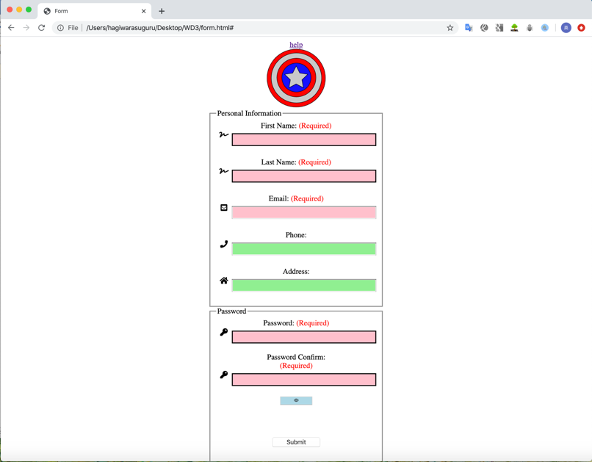

Mobile

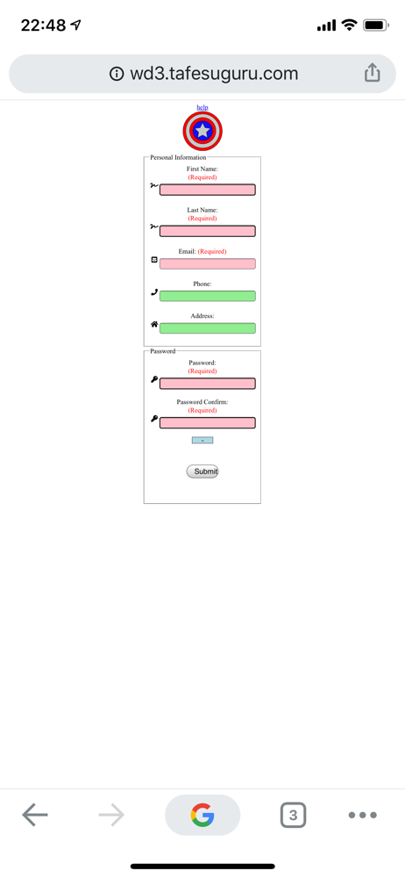

Firefox version 74

Desktop

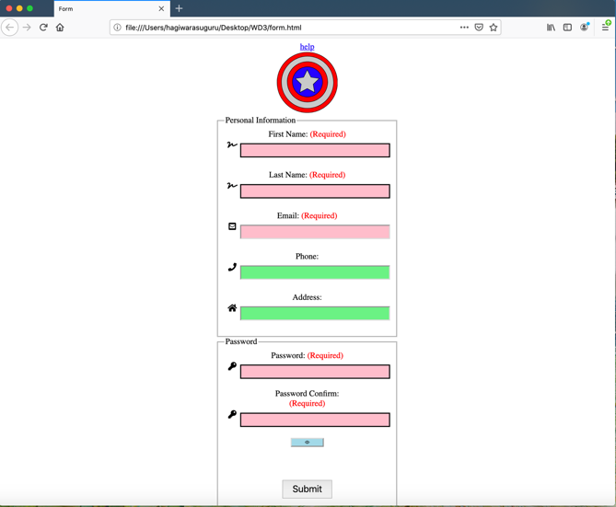

Mobile

Safari version 13

Desktop

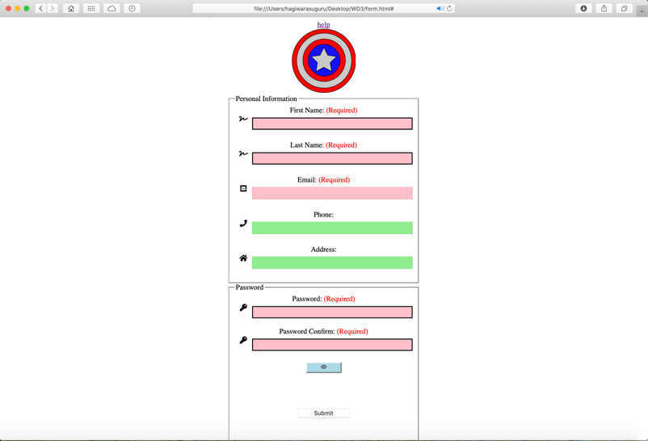

Mobile

19. Sources of all images, including copyright or license requirements

**Attached file**

22. Prior to commencement of task, build a wireframe denoting location of all key elements

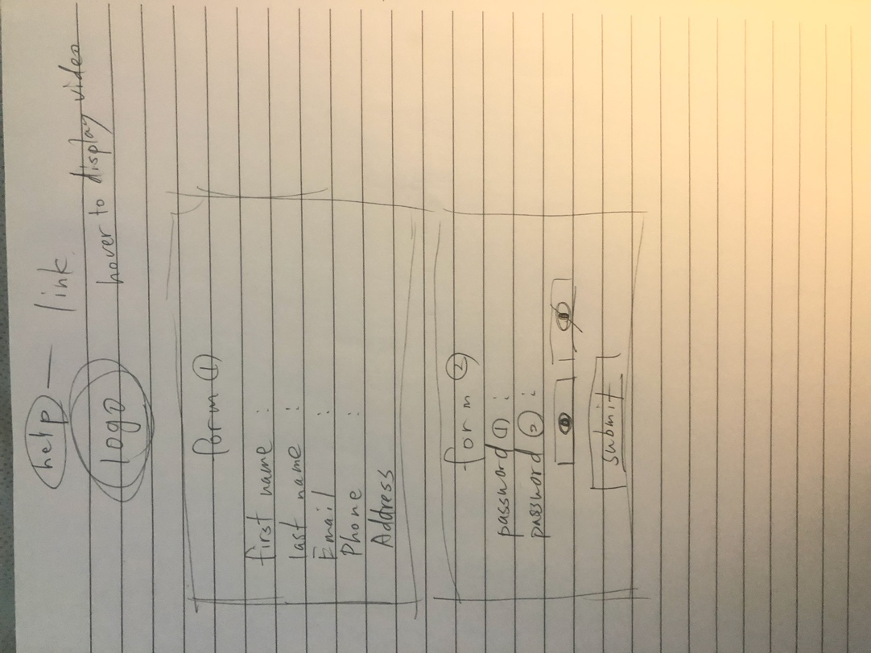

23. Confirm how images chosen for each input are photographically relevant to the type of input being sought.

* For the first name and the last name, I’ve chosen a icon that can recognise as a input that would be written by hand which will be assumed as a name.
* The mail icon and phone icon can be obviously understandable as an input for an email address and phone number
* The house icon can be considered as home address.
* The key icon can associate with a password.
* An eyeopen and eyeclose icon will be obviously recognised as password hide and show button.

24. What is it that you are trying to convey in the logo design created

I tried to use many shapes like circle to combined them with each other, and used the color not only one but also two more. Even only using a simple shape like circle and star can still allow us to make a cool logo.

25.What WHS principles were followed while working on this project

I had implemented this project not only one day but also more than two days and no more than two hours a day so that I can prevent from any injuries like musle pain or eye pain.