**UMT Exporter**

**AGI.SimGEN_UMTExporter**

This AGI.SimGEN_UMTExporter UI Plugin adds am ‘Export UMT File’ menu option to all STK vehicles. As the name suggests, this plugin will create a UMT (user motion) file for use in SimGEN.

Ensure that you place the AGI.SimGEN_UMTExporter.xml file in one of the three directories. You also need to update the file so that the CodeBase line properly points to the directory of the bin/Debug folder containing the dlls.

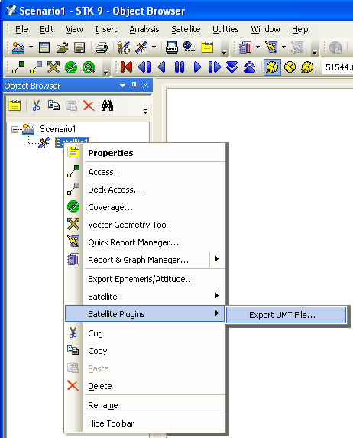

**STK HTML Utility**

This utility does the same thing as the UiPlugin above, but runs as an STK HTML Viewer utility, thus it is not STK version specific.

