EDA on sample data

# Features

|  |  |  |
| --- | --- | --- |
| **column_names** | **data_type** | **categories_count** |
| Date | date | 2 |
| Comment | string | 1000 |
| Problem | string | 10 |
| Tags | string | 30 |
| URL | url | 162 |
| Language | string | 3 |
| Institution | string | 7 |
| Section | string | 19 |
| Theme | string | 6 |

**Question:**

What are the features and labels if it is supervised learning?

-Tags

# 

# Sample size and date

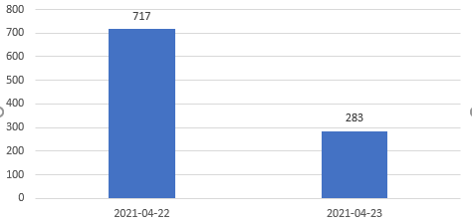

**Question:**

What is the period of the whole dataset?

-Feb 1, 2021 - past day

# Problem distributions

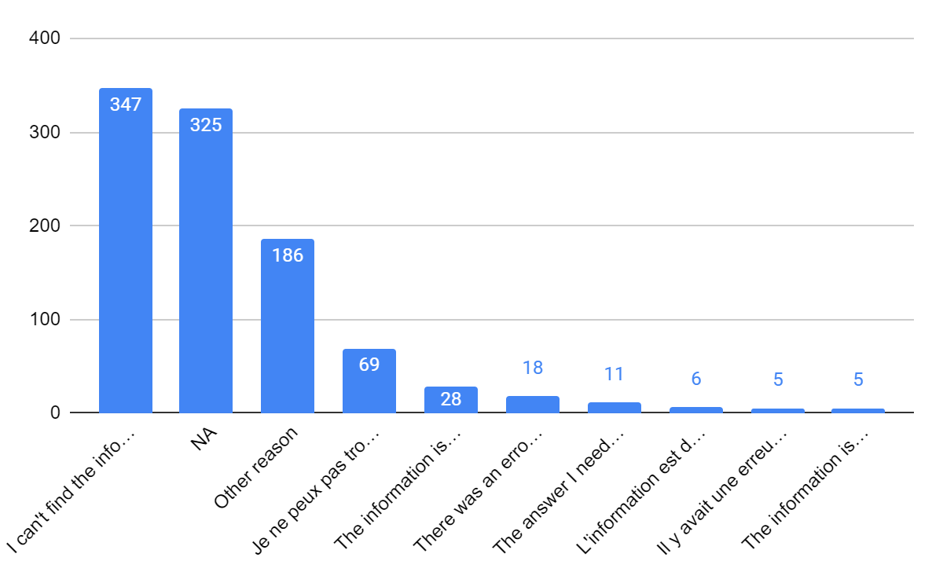

|  |  |
| --- | --- |
| **Problem** | **Number** |
| I can't find the information | 347 |
| NA | 325 |
| Other reason | 186 |
| Je ne peux pas trouver l?€?information | 69 |
| The information is hard to understand | 28 |
| There was an error / something didn't work | 18 |
| The answer I need is missing | 11 |
| L'information est difficile ?? comprendre | 6 |
| Il y avait une erreur / quelque chose ne fonctionnait pas | 5 |
| The information isn?€?t clear | 5 |

NAs in problem:

|  |  |
| --- | --- |
| **Comment** | **Problem** |
| Can I get vaccine the same day because my are giver | NA |
| je voudrais avoir mes resultats du test de covid 19 | NA |
| je veux m'inscrire, prendre un rendez-vous svp | NA |
| What number to call? | NA |
| I want to book an appt for a Covid vaccine | NA |
| Maladie auto immune sont ils accept?? dans les maladies chroniques | NA |
| Comment trouver un hotel | NA |

**Questions:**

What are the rules of problems classification ?

# Tags

|  |  |
| --- | --- |
| **Tags** | **Count** |
| NA | 198 |
| Getting vaccinated - When / Where / What | 128 |
| Hotels | 96 |
| Vaccine safety (health issues / ingredients / side effects / research) | 93 |
| Getting vaccinated - Registration / notifications | 90 |
| General Travel Restrictions | 59 |
| Can I enter Canada | 49 |
| Vaccine effectiveness / how they work / after vaccination | 44 |
| Eligibility | 36 |
| Vaccines and drugs | 33 |
| Applying / reapplying | 25 |
| Data and tracking vaccines | 23 |
| Testing | 19 |
| Accounts | 18 |
| Contact | 17 |
| Provincial restrictions | 13 |
| T4 information (T1/T4/T4A/T4E/R1) | 8 |
| Seniors (including OAS / GIS / CPP) | 8 |
| Quarantine | 7 |
| Vaccine strategy: Authorization / Eligibility / Priorities | 7 |
| Canada Recovery / Caregiver / Sickness Benefits | 6 |
| Page issue (e.g broken / link button / missing content) | 5 |
| Vaccines - Other | 4 |
| Income tax form or guide | 4 |
| Other (Contact / Travel outside / ArriveCan / Mad people ) | 3 |
| Design / content | 3 |
| EI | 1 |
| Symptoms | 1 |
| Calculation (calculator or spreadsheet) | 1 |
| Individual support (help finding support / other benefits / personal finances) | 1 |

# Language

|  |  |
| --- | --- |
| **Language** | **Count** |
| en | 831 |
| fr | 168 |
| NA | 1 |

NA: the text is the phone number.

# Institution

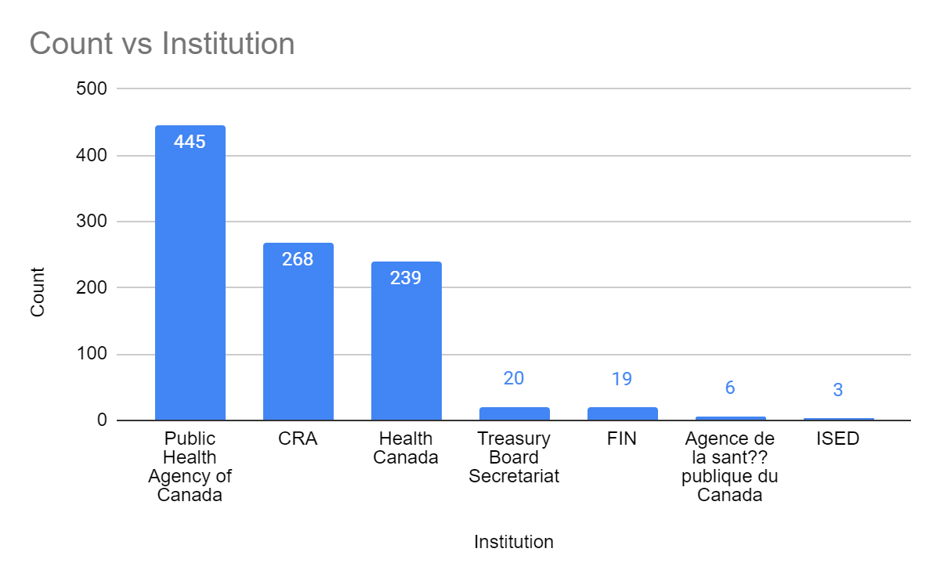

# Section and Theme

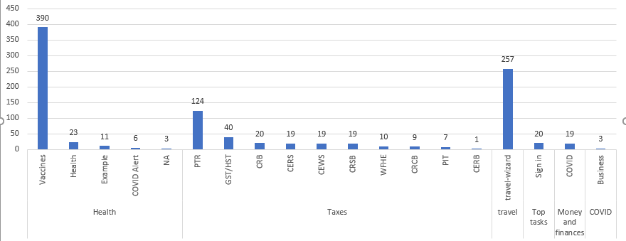

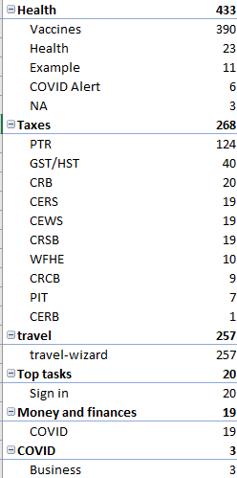

**Question:**

What’s the difference between section and tag?

**Question about communication:**

Will our industry partner be interested in joining our group channel on Slack?

**Question:**

1. URL column: What are the URLs for? Is it where the users came from when they didn’t find the answer they wanted? Or is the URL where the users are supposed to go to find the answer?
2. Institution column: Do the users already know if their problem belongs to a specific institution? (e.g. the user that asked ‘Am I eligible for vaccination?’, do they know that the problem belongs to Health Canada?)
3. Theme column: Do the users already know if the answer to their problem can be found in the specific Theme?
4. Which columns are manually annotated and which are automatically generated by the survey?
5. How do they collect the text/comments? where they write the survey? Do they write the survey under the corresponding link of the URL column?
6. Do labels have hierarchy?(predefined hierarchy/labels)
7. Are NA tags due to unfinished labeling by the annotators or did the annotator intentionally put NA because the comment is uncategorizable?

**Rough Project Plan**

1. Language detection (En/Fr) ??
2. Multi Classification task
   1. Get an ontology/hierarchy of tags first!
3. Interface
   1. upload a tsv file → generate a document with comments + tags

PROJECT PLAN

1. Description - Alex

Multi-classification tasks

2. Datasets - Jan

3. Expected deliverables - Alice

interface: user can either input a comment or a tsv/csv file

4. Methods - Yundong

5. Schedule - Everyone

May 10: Simple EDA, Experimenting with baseline model

May 17: Fine tuning, etc.

May 24:

May 31:

June 7:

June 14: Final report + presentation