Juan-Pablo Velez
July 25th, 2012

Analysis of Restaurant Inspections and Yelp Ratings

QUESTION

We want to know whether certain types of restaurants are likely to fail city health inspections.

For example, restaurants with lower Yelp ratings might be more likely to fail an inspection.

As a first step to seeing whether this is true, I want to answer a simple question:

Do Chicago restaurants that fail city health inspections have lower Yelp ratings?

METHOD

To answer this question, I compared the mean Yelp ratings of restaurants that passed inspections with those that failed.

More specifically, I looked at restaurants that passed or failed canvass inspections, which are routine and random. So I didn’t look at all inspection types. I didn’t look at restaurants that “Passed with Conditions.” And I only looked at each restaurant’s most recent canvass inspection outcome.

I took a sample of 343 such restaurants (n = 343) from the food inspection dataset on the City of Chicago’s data portal, and got their ratings from Yelp. That’s 6.3% of the 5389 restaurants that recently passed or failed a canvass inspection.

(For a detailed explanation of my methodology, and the code used to gather and analyze the data, click here.)

FINDINGS

I was then able to 1. visualize the distribution of Yelp ratings for each group, and 2. compare their mean ratings.

1. Here are histograms of the ratings for restaurants that passed and failed canvass inspections:

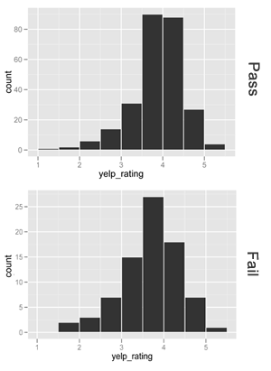

2. Restaurants that passed canvass inspections had mean ratings of 3.62 out of 5. Those that failed had mean ratings of 3.43 out of 5.

So the answer to our original question is:

Yes. Chicago restaurants that fail health inspections have lower Yelp ratings by .19 on a 5-point scale. This a modest but statistically significant difference.

How do we know the difference in means is statistically significant? If we assume that there is actually no difference in the mean Yelp ratings of the two restaurant groups, there is only a 3% chance (p = 0.031) that we would see a difference in means as big or bigger than .19 due to random chance.

In other words, it is very unlikely that the observed result is due to chance.

