# CHAPTER – 6

**TESTING**

### Testing Methods

There are different models of testing. On the basis of testing methods there are two types of testing:

#### Black-box testing

* + 1. **White-box testing**

Black-box tests are used to demonstrate that software function are operationally, that input is properly accepted and output is correctly produced, and that integrity of external information is maintained.

White-box tests are used to examine the procedural details. It checks the logical paths by test case. It can also check the conditions, loops used in the software coding. It checks that loops are working correctly on defined boundary value.

#### BLACK-BOX TESTING:

The technique of testing without having any knowledge of the interior workings of the application is Black Box testing. The tester is oblivious to the system architecture and does not have access to the source code. Typically, when performing a black box test, a tester will interact with the system's user interface by providing inputs and examining outputs.

#### We used following problems in our coding to find errors in the following categories:

* Incorrect or missing function.
* Interface errors.
* Error in database.
* Performance errors.
* Initialization and termination errors.

Unlike white-box testing, which is performed earlier in the testing process, black-box testing tends to be applied during later stages of testing.

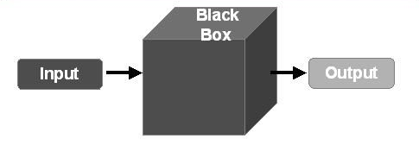By applying black-box techniques, we derive a set of test cases that satisfy following criteria. Test cases that reduce, by a count that is greater than one, the number of additional test cases must be designed to achieve reasonable testing.

**[Figure 9: Black Box Testing]**

**Advantages:**

* It is Efficient for large code segment.
* Tester doesn't need to know the internal structure of the system.
* Tester perception is very simple.
* Programmer and tester are independent of each other.
* Quicker test case development.

**Disadvantages:**

* It is inefficient testing.
* Without clear specification test cases are difficult to design.
* Only a selected number of test scenarios are actually performed. As a result, there is only limited coverage.

#### WHITE-BOX TESTING:

White-box testing sometimes called glass-box testing, is a test case design method that users the control structure of the procedural design to drive the test case. Always we are thinking that there is no necessary to execute or checks the loops and conditions. And so large number of errors is uncovered. With using white-box testing methods, we have checked that:

* All independent paths within a function have been executed at least once.
* All logical decisions on their true and false side.
* All loops working correctly at their boundary values and within their specified conditions.

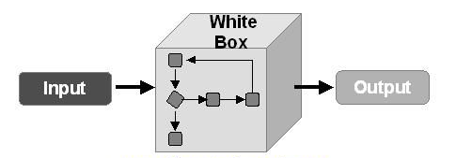In our coding we test that all the loops work truly in each module. The one technique of white-box testing is basis path testing. It contains two parts, one is flowing graph notation and the second is cyclometer complexity. In flow graph notation we are checking logical control of flow. By using cyclometer complexity, we find complexity of our project structure.

**[Figure 10: White Box Testing]**

**Advantages:**

* Reveal hidden errors in the code.
* White box testing is very thorough as the entire code and structures are tested. Software Test Suite Test Execution Mutant Generation Mutant Survived Killed Software Coding & Testing.
* Testing can start early in SDLC even if GUI is not available.
* Out product will be qualitative if white box testing is successful.

**Disadvantages:**

* White box testing can be quite complex and expensive.
* It is time consuming as it takes more time to test fully.
* In-depth knowledge about the programming language is necessary to perform white box testing.