My initial idea for a data story was “Do fitness trackers help you lose weight”. My assumption at the time was that there would be a lot of data to look at here, however I spent in excess of 8 hours looking and I was not able to find suitable data. I found lots of api’s gibing me access to my personal data however I found like anonymised mass population data. The data I did find was from a study where by subjects wore a passive device (i.e. they did not see the data it was collecting) for only 1 week. While searching I did find interesting data regarding obesity in Scotland so I decided to cut my losses and pivot to the following ….

Obesity Trends in Scotland

I’m one of those people who has had to battel with my weight all my life, at age 18 my BMI was 30 and has gradual climbed to 50 on my 44th birthday (normal BMI is 18 to 25). So I have great interest in understanding obesity. Having raised my two kids in Scotland I was interested to see what the last decade had to show for what proportion of children are suffering from obesity and what aspects make this more prevalent.

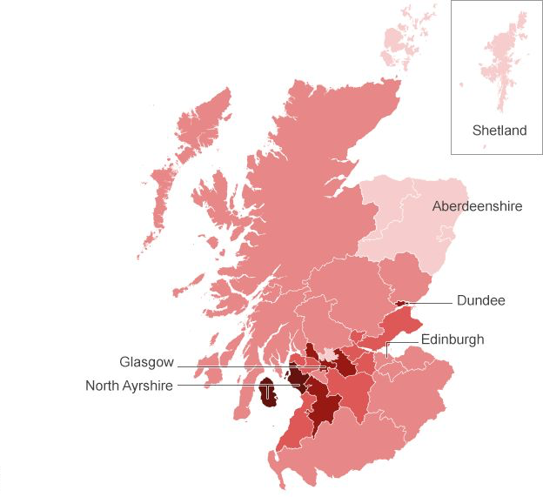The data I have is for the percentage of children overweight or obese measured at the start of school year from primary 1 children. The data ranges from school in take year 2006 to 2015 and is segmented by region, economic background and gender.

I hope to implement a heat map of Scotland with a year slider ranging from 2006 to 2015, the colour will show the percentage of children over their ideal weight. I’m hoping to use Tableau for this.

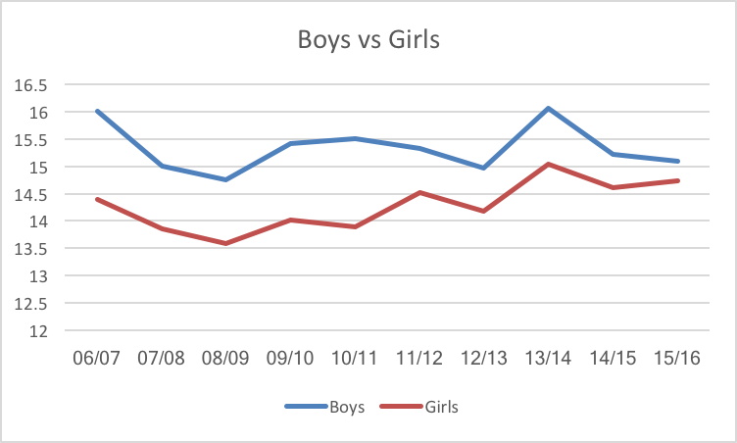Initial analysis has found that generally there are more boys over weight than girls however the gap between them has shrunk to 1/3 of what it was ten years ago. I intend to show a simple line graph showing this. I’m hoping to use D3 for this.

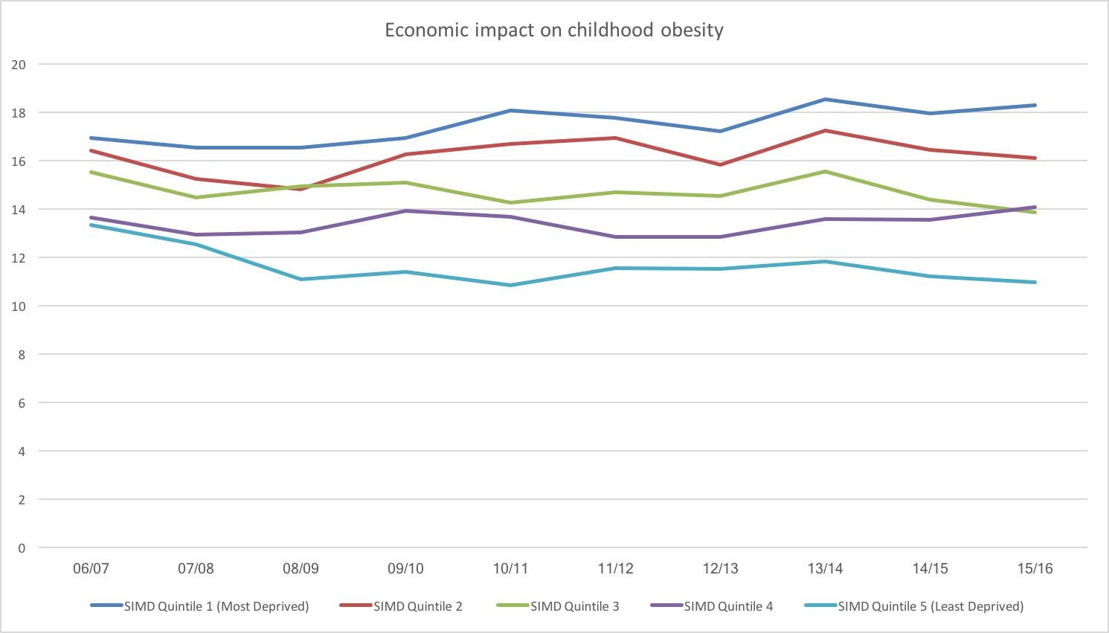

Additionally, when looking at economic background the poorest have a larger proportion of overweight children however the gap between the richest and poorest has doubled in the last 10 years. Again, I intend to show this with a line graph. I’m hoping to use D3 for this.

As yet I’ve not pinned down my specific narrative other than a report on trends however I’m hoping further analysis of the regional data over time will reveal something interesting. In most of the data there is a general inflection around the 2008 in take. Before this time there was a downward trend however after there is a marked increase. This correlated to the time of the 2008 property crash which I thought was also interesting. I had hoped to find preceding data to see if the downward trend correlates with increase in NHS spending under Labour however I am yet to find any.