T41 K9HZ Main and Front Panel Boards Test
Russ Bruhnke NQ0U
8-13-2024

This document outlines procedures to test the T41 Main board and Front panel boards designed by K9HZ. As of this writing, the program tests the display, digital switch matrix and encoders. The tests are developed to be run in sequence; certain tests require completed (and passed) prior tests. It is assumed the user has cabled the system according to K9HZ’s diagrams; pictures of the test setup used to develop the code are included.

The user will need to install the Arduino IDE for the TEENSY4.1. Instructions for this installation are not included in this document as they are available on the web. The RA8875 and Adafruit_MCP23017_Arduino_Library will need to be installed, also.

The display will be used to show test results as well as the serial monitor of the Arduino IDE. Program commands are entered using the Serial Monitor. A help command is included that shows the available test commands. These are shown on the Serial Monitor by entering ‘h’ (any case) and pressing enter once the program is loaded and running on your Teensy. The following will be displayed at startup and when ‘h’ is pressed:

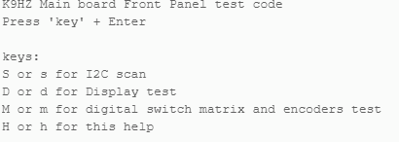
Figure 1 Serial Monitor Screen

The following tests should be followed in sequence for best results.

Power Test 1
This test verifies the power-on circuitry using the ATTiny85. It is not used if the voltage reversal circuitry is installed.

- Ensure ALL cables are removed from the main board.
- Remove the Teensy and Audio Hat.
- Connect the power switch to the two-pin connector near U4. Alternatively, you could use a tool to short the pins. Just be careful not to touch anything else!
- Connect power leads (12V to 13.8V) to J4, observing polarity. See Figure 2. I used a 4 pin connector to cover both J1 and J4.
- Turn on your power supply. No LEDS should be lit. Your board should look similar to Figure 2.
- Press the power switch or short the pins of the switch connector.
- D3 and D2 should be illuminated. See Figure 3.
- Verify voltages on TP1 and TP2 with a multimeter. Nominal voltage readings should be 5V for TP1 and 3.3V for TP2.
- Turn off the power supply. (Switch will not shutdown the board in this state)

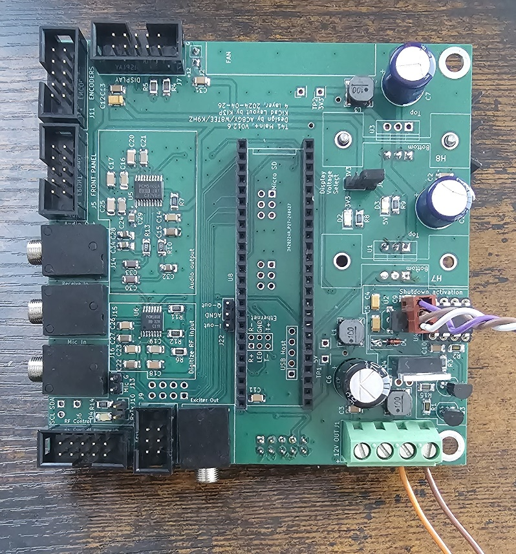
Figure 2 Switch and Power Connected, No Teensy
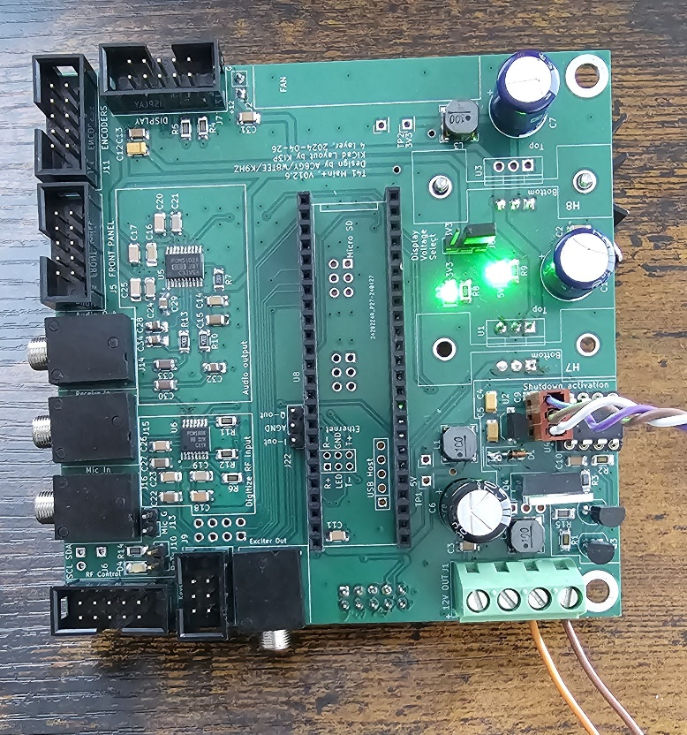
Figure 3 Power LEDs Illuminated

Power Test 2
After successfully completing the previous test, attach the Teensy to the board and a USB cable (connected to your PC) to the Teensy. No Audio Hat should be connected to the Teensy.
- Turn on the power supply
- Push the power switch. Again, D2 and D3 should illuminate.
- From the Arduino IDE load the TestMainNQ0U.ino to the Teensy.
- Select Tools-Serial Monitor from the IDE and you should see a screen like Figure 1, above on the monitor panel.
- In the Message bar, press ‘h’ (help) and Enter. Again, the help screen like Figure 1 should appear. This tests the code.
- Then, in the message bar press ‘s’ for scan and Enter. This performs an I2C scan of the three Wire instances that the T41 uses. You should see a screen like Figure 4 in the monitor panel.
- Next, push the power switch, again. The message “Shutting down…” should appear on the monitor panel. It may appear more than once. After a moment, the LEDs on the Main board should extinguish.

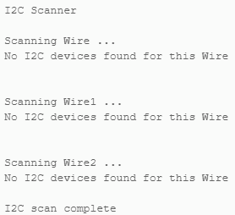
Figure 4 I2C scan with no devices

I2C Scan Tests
Next, we’ll scan for the various I2C devices that should be on the I2C busses of the Main and Front Panel boards.

Audio Hat
- Add the Audio Hat onto the Teensy.
- Turn on the power supply.
- Press the Power Switch on the Main Board. D2 and D3 LEDs should illuminate, and you should see data on the Serial Monitor of the IDE like Figure 1.

(TIP: You can clear the monitor panel by pressing the “Clear Output” icon on the far right of that panel. (Near the “clock” icon))

- In the message pane, press ‘s’ and Enter. The scan routine will run.
- You should see that the Audio Hat has been detected. See Figure 5.
- Turn off the power supply. (you don’t need to press the power switch first for any of these tests)
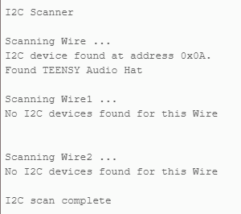
Figure 5 I2C Scan with Audio Hat

Front Panel Scan
Next, we’ll scan for the Front Panel board. You might as well connect the Switch Matrix and encoder boards to the Front Panel board. Those will be needed in subsequent tests. Use a 10-wire ribbon cable with the appropriate connectors to connect all the encoders to the Front Panel board and the Front Panel board to the Main board’s Front Panel Connector, J5. Observe proper polarity of the connections! See Figures 6 and 7. J11 IS NOT USED. DO NOT CONNECT TO THIS PORT!

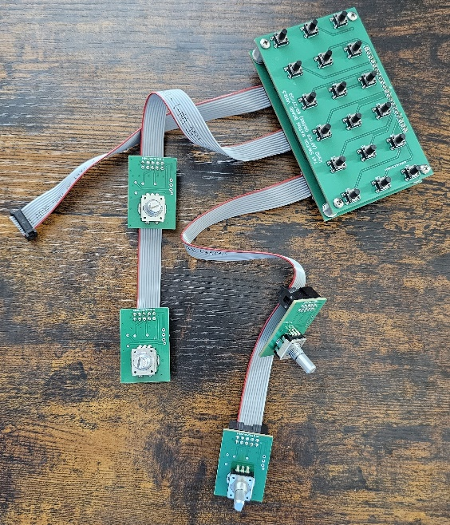
Figure 6 Switch Matrix
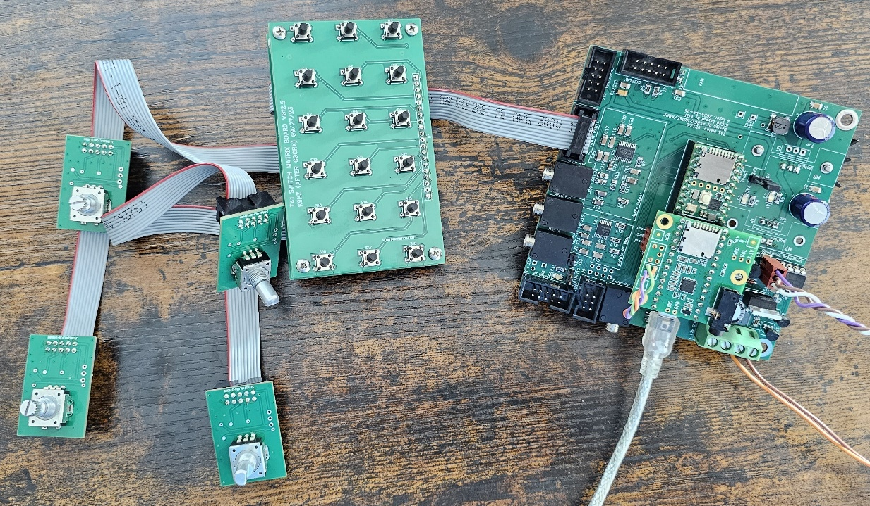
Figure 7 Switch Matrix and Front Panel connected to Main

- Once everything is cabled together and looks like Figure 7, Turn on the power supply.
- Push the Power Switch on the Main Board. D2 and D3 LEDs should illuminate, and you should see data on the Serial Monitor of the IDE like Figure 1.
- Press ‘s’ to start the I2C Scan.
- The Serial Monitor should display something like Figure 8. Look for “Found TEENSY Audio Hat” on Wire and “K9HZ or G0ORX front panel found” on Wire1.
- Turn off the power supply.

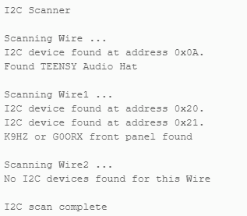
Figure 8 I2C scan of main board and front panel board.

Display Test
Next the display will be connected and tested. The Matrix and Encoder tests use the display so this must be working before continuing. Connect the ribbon cable of the display to the Front Panel board’s Display connector, J7.
- Turn on the power supply.
- Push the Power Switch on the Main Board. D2 and D3 LEDs should illuminate, and you should see data on the Serial Monitor of the IDE like Figure 1.
- Type ‘d’ and Enter on the Monitor Panel to execute the display test.
- Your display should look like Figure 9.
If you want to continue testing the Matrix, do not turn off power!
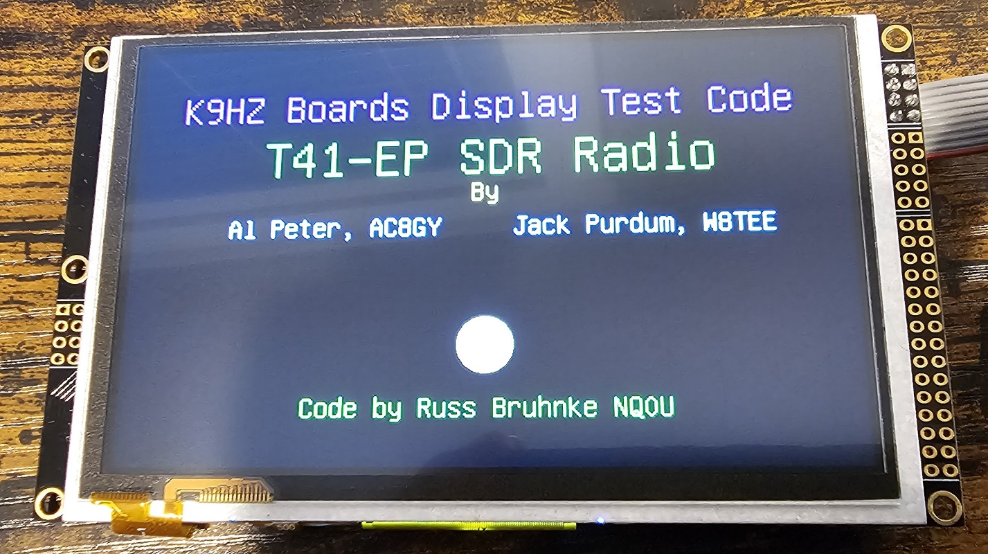
Figure 9 Display Test Screen

Switch Matrix and Encoder Test
At this point, the display and the Front Panel boards have been wired to the Main Board and have been either tested or scanned for their presence. This test is a little different as information is displayed on the display and on the Serial Monitor panel of the IDE. It also continues to run until it is explicitly ended. The following steps assume the above test has been completed and the power is still on. For the Matrix test to be run, the I2C scan (‘s’) and Display tests (‘d’) MUST be run first.
- Press the ‘m’ key and Enter on the IDE. The display will change to Figure 10. The orientation of the “dots” is as the board layout… switch 1 is upper left and switch 18 is lower right.

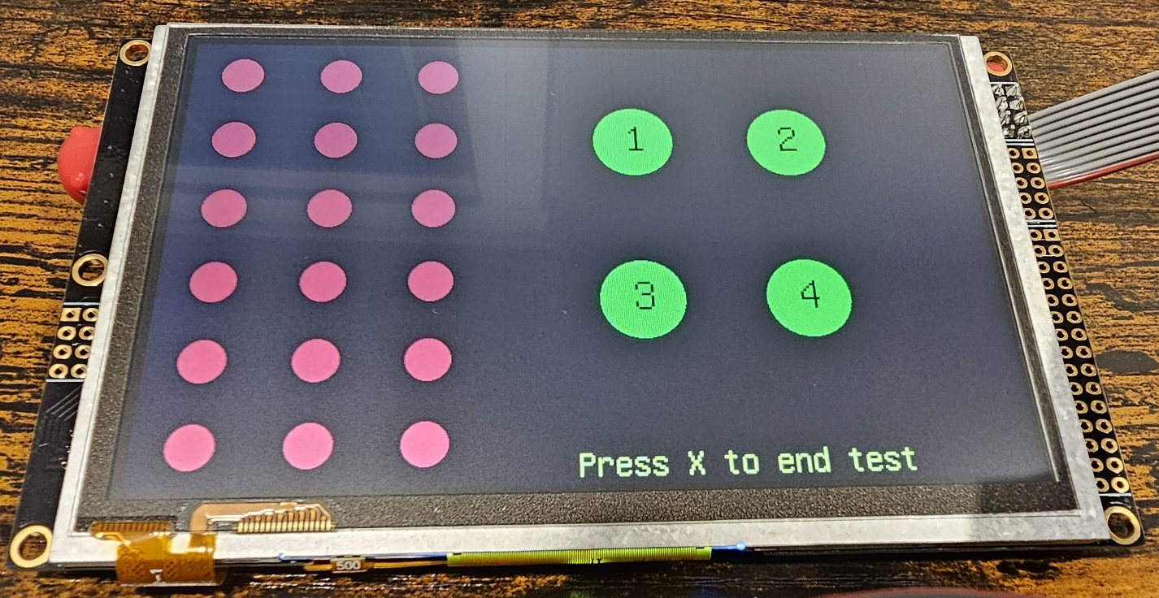
Figure 10 Switch Matrix and Encoders Test Screen
- Pressing any switch on the matrix will “light up” the corresponding dot on the display. The Serial Monitor will also show the switch number. When the switch is released, the dot on the display will go back to red and the Serial Monitor will say the switch is released. See Figures 11 and 12.

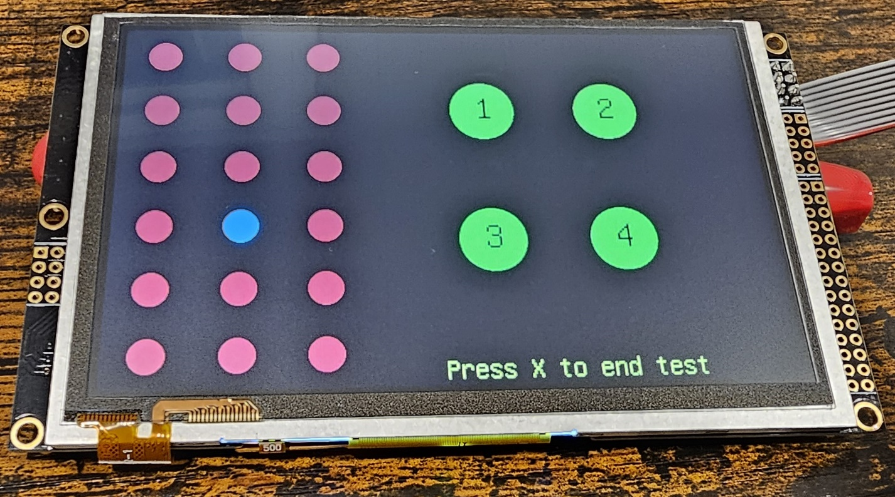
Figure 11 Display screen when switch 10 is pushed

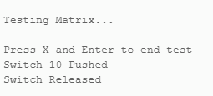
Figure 12 Serial Monitor screen when switch 10 is pushed and released
- Rotating any encoder will display the encoder direction under the Green “dot” corresponding to the encoder. The text on the screen will stay for about 2 seconds and then go away if no other encoder is rotated. The Serial Monitor will show the encoder number and either a 1 or -1, depending on the direction the encoder is rotated. See Figures 13 and 14. A -1 signifies the encoder is rotating CCW.
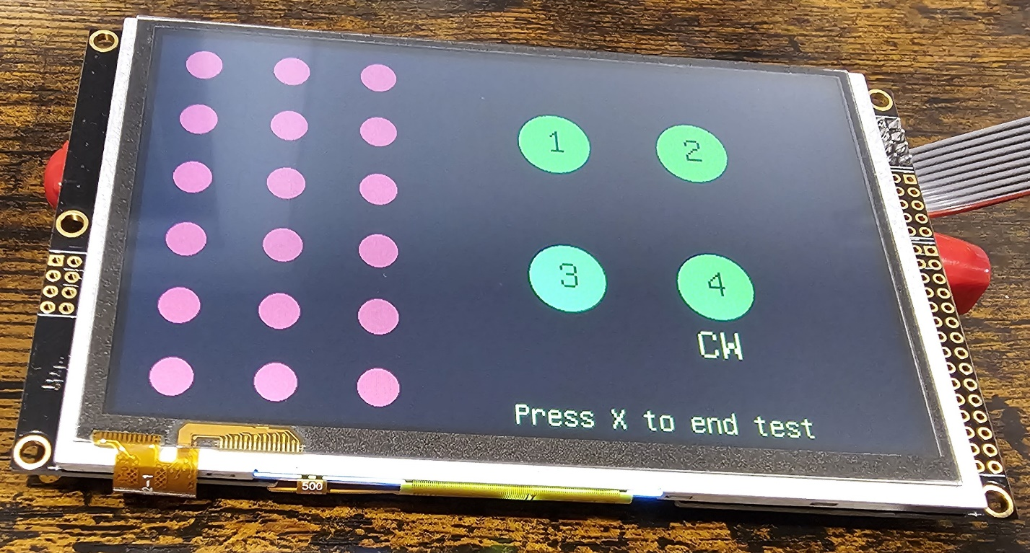
Figure 13 Encoder 4 rotating clockwise

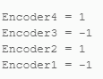
Figure 14 Encoder 4=CW, Encoder 3=CCW, Encoder 2=CW and Encoder 1=CCW
The display will also show both, simultaneously. Figure 15 shows Switch 8 being pressed while encoder 4 is rotating CCW.
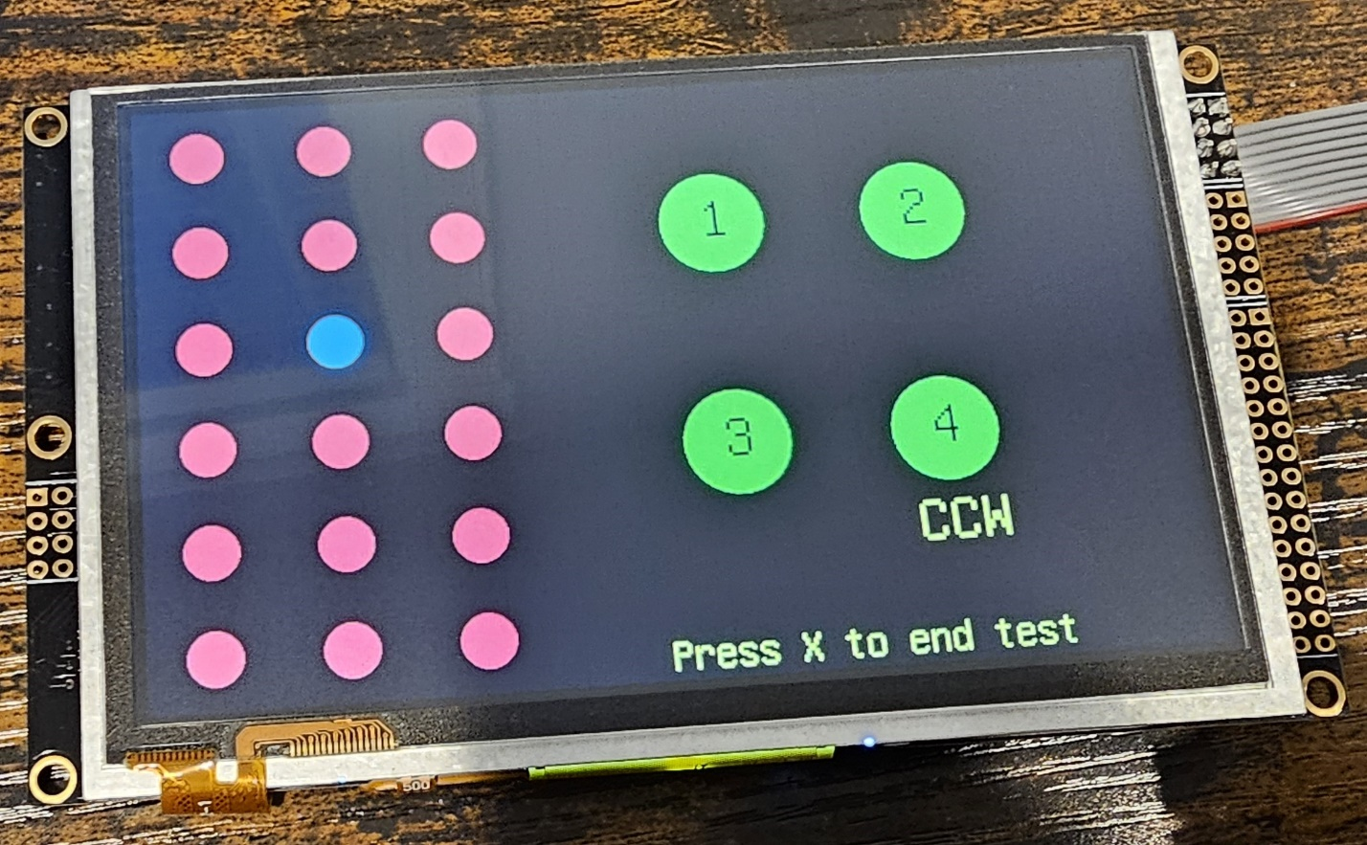
Figure 15 Switch and Encoder update

Typing ‘x’ and Enter on the Serial Monitor will terminate the test.

This ends the document. Hope you found the test program and this description Helpful!

