**Program 5 Report**

Test image:

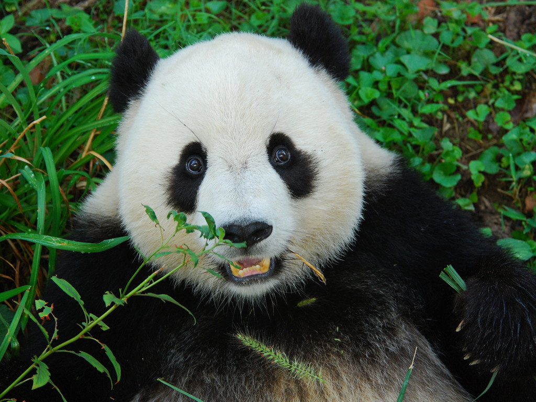

The test data:

|  |  |  |
| --- | --- | --- |
| **Block Area** | **The time of building a mosaic image (s)** | **The average time of searching for the best icon (s)** |
| 20 | 13.2532 | 0.000159814 |
| 80 | 3.33631 | 0.000161786 |
| 300 | 0.874897 | 0.000158553 |
| 690 | 0.387417 | 0.000161246 |
| 1200 | 0.220123 | 0.000162883 |
| 1900 | 0.150788 | 0.000173877 |
| 2700 | 0.120583 | 0.000190336 |
| 3710 | 0.080811 | 0.000184658 |
| 4800 | 0.061922 | 0.000186153 |
| 6120 | 0.052734 | 0.00018343 |
| 7500 | 0.045671 | 0.00018769 |

Performance Analysis:

