

IAB E-Business Standards v1.0 beta
Functional Requirements

Released October 2008

Authors: | IAB Ad Ops Council - E-Business Working Group
Creation Date: | 02-29-2008
Last Updated: | 09-30-2008
Version: | 1.0 beta

Revision History
Date | Author | Version | Change Reference
02-29-2008 | Joanna Bloor | 1.0 beta | New document
04-10-2008 | Jeremy Fain | 1.0 beta | Security additions
09-24-2008 | Jeremy Fain | 1.0 beta | Working Group Finalization and formatting

About the IAB Ad Ops Council:
The Ad Ops Council is dedicated to improving the operational efficiency of interactive advertising. Ad Ops Council working groups regularly include agency-side representatives to help improve communication, understanding, and work process in many areas of the buyer-seller relationship. A full list of Council member companies can be found at: http://www.iab.net/member_center/35088?iabid=a0350000002Cmy1AAC

This document can be found on the IAB website at: http://www.iab.net/ebiz

IAB Contact Information:
Jeremy Fain
Vice President of Industry Services, IAB
212-380-4724
jeremy@iab.net

Table of Contents

IAB E-Business Standards Overview 3
Scope – Phase 1 3
Business Documents in Scope 3
Business Documents not in Scope 3
Project Schedule 3
Schedule Assumptions and Constraints 3
Business Process Workflow Diagram 4
Business Entities 4
Interaction Summary 5
Functional Requirements 6

IAB E-Business Standards Overview
High levels of manual transmission and entry of data in the interactive advertising workflow creates large inefficiencies, high levels of errors, and increased billing difficulties. Business document delivery via standard XML schemas will allow for automated receipt and input of data, decrease manual entry and communication errors, and improve overall advertising and financial operations. It is the goal of the IAB and its members to develop a system for transmittal and receipt of all important business communications; this document specifically addresses Request For Proposal (RFP), Proposal, and Order documents with the intent that Invoice will be covered in the next release phase.

This document describes the Functional Business Requirements that were agreed upon at the beginning of the E-Business Standards process. The implementation details of these requirements are further documented in the Technical Specifications and a number of XML Schema materials. Additional documentation necessary for full implementation and understanding of the E-Business Standards are:

- Technical Specifications
- AAAA Registry Integration Guide
- XML Overview
- XML schema documentation

All documentation can be found at www.iab.net/ebiz.

Scope – Phase 1

Business Documents in Scope
The following documents are defined as within the project scope for the initial release of IAB E-business Standards:
- RFP
- Proposal
- IO

Business Documents not in Scope
The following documents and workflow activities are NOT in scope for this release but have been captured as requirements (and, in some cases, key requirements) for future Phases.
- Invoice
- Delivery Mapping
- Revisions to Proposals or IOs – these will be carried out via other methods (email, phone, etc) in Phase 1

Project Schedule
Jan – Mar ’08 XML and Functional Requirements groups to develop recommendations
Mar ‘08 Groups to present recommendations to E-Business Working Group
Mar ‘08 Working Group companies to assess and comment on recommendations
April – Oct ‘08 Development of technical specifications and finalization of XML
Oct – Mar ’09 Beta testing of E-business solutions with registered partners; revisions if necessary
Mar – Dec ‘09 Adoption of standards throughout industry

Schedule Assumptions and Constraints
As with any industry-wide initiative, the adoption of the E-business Standards within the marketplace will grow based on economic need. Based on the economic outlook, scheduling of e-business implementations will be on a publisher-by-publisher, vendor-by-vendor basis and will be hard to predict. The IAB will work with all major publishers and vendors to develop a practical yet urgent schedule for adoption, as it is believed that this e-business solution is mission critical and will be able to directly and immediately improve advertising and financial operations.

Business Process Workflow Diagram
The Business Process Workflow Diagram shows the interactions among business entities and the system being built or modified. The graphical components depict business entities and connections.

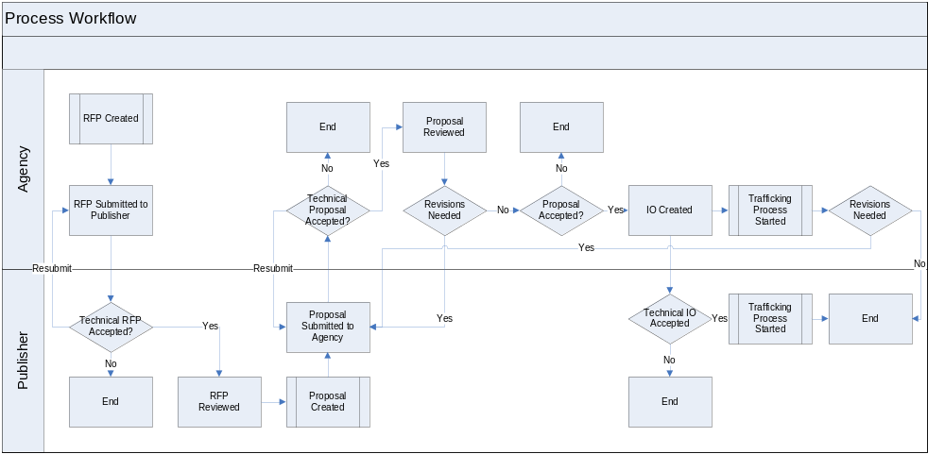

Business Entities
There are three key business entities that interact in the above workflow:

Business Entity Name | Business Entity Description
Publisher | Site owner that delivers the online ads. Owns the proposal portion of the process
Agency | Representative of purchasing client. Submits initial RFP and final IO
3rd Party Application | Owners of system tools for both Publishers and/or Agencies for RFP, Proposal and IO management.

Interaction Summary
The interactions or information flow involved in the above processes are described in more detail below:

Interaction Name | Interaction Description
AAAA Registry | All trading partners (can be Publisher, Agency, 3rd party application provider) must be registered with AAAA Registry. The Registry will authenticate and verify sender of messages to avoid malicious activity.
RFP Submission | Agency sends a request to Publisher with details such as Client Name, Target audience details, technical requests etc. and any campaign needs
Proposal Submission | Publisher response to RFP. Includes detailed ad placement information mapping to the client’s campaign needs.
IO Creation | Also known as “Order”. Once the Proposal from the Publisher, the Agency submits a final IO as a signal of their acceptance of the final document. This includes Agency-side information such as 3rd-party tag IDs, etc.

It is important to note that the direction of this workflow is a fundamental functional requirement. The RFP, if submitted electronically, must come from the buyer-side system and go to the seller-side system; the Proposal must come from the seller-side system and go to the buyer-side system; and the Order must come from the buyer-system and go to the seller-system. Although this may not necessarily reflect the current order of events or the terminology used at all sellers, for the purposes of creating a standard, consistent workflow across the interactive industry, this process is required for Version 1.0 of the interactive e-business standards. Each stage in the workflow should be considered one-way communication; support for two-way communication, such as electronic XML delivery of buy-side changes to a proposal is not supported in Version 1.0.

This approach was adopted by the E-Business working group because business entities have developed a broad spectrum of individual business rules and processes. This standard one-way workflow is meant to allow system vendors to develop to a fundamental communication standard while still enabling individual business rules and process variations to be executed through continued offline efforts. Later versions and updates to the standards will re-examine this “one-way” workflow as the E-business standards become widespread and begin to encourage the standardization of all individual workflows across vendors and entities. Until this greater convergence occurs across major partners, the fundamental communication workflow defined in this document has been deemed sufficient to accomplish the goal of minimizing errors and the double entry of information as well as maximizing the ability of a broad spectrum of entities to adopt the standards.

Functional Requirements
The Business Requirements listed in the sections that follow have been prioritized by the IAB.
Note: For the purpose of illustrative clarity, the terms “Agency” and “Publisher” are used as representatives of Buy-side and Sell-side trading partners respectively. Other types of trading partners are of course allowed, including marketers, vendors, etc.

- Direct one-to-one communication architecture is required; no central clearinghouse of data will be designed or built
  - The AAAA Registry will be used to request delivery information and schema acceptance information for receiving party
  - All trading partners must be registered with the AAAA Registry
  - All trading partners will use security protocols
- The Insertion Order (IO) will be defined as the final business document accepted by the Agency and sent to the Publisher for implementation. Therefore, the workflow and its document vocabulary are defined as:
  - Request For Proposal (RFP) is sent from Agency system with key data identified, and an allowance for attachments or large amounts of free form descriptions
  - RFP is accepted by Publisher system
    - RFP is taken into system or held in a staging area until promoted into the appropriate sales/proposal system by the receiving party
    - If Publisher decides not to respond, the system should allow for an automatically generated email to be sent
  - Publisher sends Agency system a “Proposal”
    - This Proposal has line-item detail and line-item (placement) IDs based on Publisher system
  - If any revisions need to be made, they are made at Publisher and re-sent
    - The Agency system should allow for automated messaging via email of any requested changes. This portion of the communication chain will be standardized and implemented as XML in future iterations of the standards.
    - All changes are received in some way by Publisher (phone, fax, email, etc) and reviewed
    - If changes are made, the Publisher sends back an updated Proposal with an incremented version number
  - Agency system accepts Proposal and sends back formal Insertion Order
    - Agency IO document includes line-item (placement) IDs based on Agency systems (as well as Publisher line-item IDs for cross-system mapping)
    - If Agency decides not to respond or drops Publisher from consideration, it is requested that systems be designed to allow for an automatically generated email to be sent.
  - Publisher system accepts IO
    - Publisher system should capture all relevant Agency system ID information to speed billing and reconciliation process
    - This does NOT constitute an electronic signature and electronic acceptance should not be assumed to be legally binding
      - IO contract will still have to be “signed” in whatever method Agency and Publisher have set up (may include electronic signature)

- The workflow as defined in requirement 2 above does not need to be complete to be valid
  - Any document can be sent individually without other documents in the workflow existing (e.g. a Proposal may be sent without a corresponding RFP)
- Attachments (such as Ts&Cs, additional plain-text RFP documents, etc) are supported only through URL references.
  - Future phases of standards may implement actual file attachment but security concerns keep it out of Phase 1.
- All messages sent with minimal required fields (based on XML spec) will be accepted
  - Additional required information that is unique to a system's functionality will have to be manually entered and/or communicated between parties if not present in the message
    - For instance, a Publisher receives the minimum required information for an RFP but for internal processes needs 4 pieces of additional information. The staging area where the accepted message “resides” would alert the Publisher to the information needed before promoting the RFP into the proposal (or sales) system. The Agency system, however, would be sent a “message received ok” message. Publisher would contact the Agency and obtain the additional information in a process outside the scope of this initial release.
- Verification receipt and error messaging will be required
  - If a message has all required fields, a “received OK” message will be sent back to the sender (via an address field contained in the message itself)
  - If a message does not have all required fields, is malformed, etc, an error message will be sent back
  - It is required that the codes be implemented in a standard fashion by all trading partners
  - Requirements will include additional free text descriptors to allow each trading partner to customize additional messages for each error code

