

IAB E-Business Standards v1.0 beta
XML Overview

Released October 2008

Authors: | IAB Ad Ops Council - E-Business Working Group
Creation Date: | 09-30-2008
Last Updated:
Version: | 1.0 beta

Revision History
Date | Author | Version | Change Reference
09-30-2008 | Geoff Petkus - Operative | 1.0 beta | New document

About the IAB Ad Ops Council:
The Ad Ops Council is dedicated to improving the operational efficiency of interactive advertising. Ad Ops Council working groups regularly include agency-side representatives to help improve communication, understanding, and work process in many areas of the buyer-seller relationship. A full list of Council member companies can be found at: http://www.iab.net/member_center/35088?iabid=a0350000002Cmy1AAC

This document can be found on the IAB website at: http://www.iab.net/ebiz

IAB Contact Information:
Jeremy Fain
Vice President of Industry Services, IAB
212-380-4724
jeremy@iab.net

Table of Contents

IAB E-Business Standards Overview 3
XML Solution Overview 3
XML Schema Overview 4
RequestForProposal 5
Proposal 7
InsertionOrder 9
Acknowledgement 11

IAB E-Business Standards Overview
High levels of manual transmission and entry of data in the interactive advertising workflow creates large inefficiencies, high levels of errors, and increased billing difficulties. Business document delivery via standard XML schemas will allow for automated receipt and input of data, decrease manual entry and communication errors, and improve overall advertising and financial operations. It is the goal of the IAB and its members to develop a system for transmittal and receipt of all important business communications; this document specifically addresses Request For Proposal (RFP), Proposal, and Order documents with the intent that Invoice will be covered in the next release phase.

This document describes at a high level the XML Schema organization of the E-Business Standards. The details of these schemas are further documented in additional HTML documentation for easy consumption. Additional documentation necessary for full implementation and understanding of the E-Business Standards are:

- Functional Requirements
- Technical Specifications
- AAAA Registry Integration Guide
- XML schema documentation

All documentation can be found at www.iab.net/ebiz.

XML Solution Overview
As described in the E-business Requirements document, phase 1 of this initiative has specific communication profiles that will be supported. Accordingly, the XML schemas have been built to support these communication profiles. The table below relates root XML element names to the Interaction Names defined in the Functional Requirements and Technical Specifications documents.

Interaction Name | Interaction Description | XML Root Element Name and XSD
RFP Submission | Agency sends a request to Publisher with details such as Client Name, Target audience details, tecnical requests etc. and any campaign needs | RequestForProposal  IAB_RFPCommon.XSD
Proposal Submission | Publisher response to RFP. Includes detailed ad placement information mapping to the client’s campaign needs. | Proposal  IAB_ProposalCommon.XSD
IO Creation | Also known as “Order”. Once the Proposal from the Publisher, the Agency submits a final IO as a signal of their acceptance of the final document. This includes Agency-side information such as 3rd-party tag IDs, etc. | InsertionOrder  IAB_InsertionOrderCommon.XSD

In addition, there is an XML schema defined to support the communication necessary during the interactions above:

Interaction Name | Interaction Description | XML Root Element Name
Error Message | One system communicates to another system, but there are problems. Examples include invalid login/password, or invalid XML being transmitted | Acknowledgement  IAB_Acknowledgement.XSD
Business Message | As a foundation for future functionality, systems should be able to pass uninitiated text messages to a destination system. The receiving system must at least accept and store the message, but the goal would be to attach the message to the appropriate campaign and perhaps trigger a notification within the system. | Acknowledgement  IAB_Acknowledgement.XSD

XML Schema Overview
As shown above, for clarity the root elements map directly to their functional purpose. However, for the actual XML schema documents it is usually more efficient and easier to manage if the reusable “building block” elements are stored in a common file and referenced where needed. As such, the total files that support the above root elements are the following:

AAAA_Common.XSD
IAB_Acknowledgement.XSD
IAB_AdvertiserCommon.XSD
IAB_BillingCommon.XSD
IAB_CampaignCommon.XSD
IAB_Common.XSD
IAB_ContractCommon.XSD
IAB_InsertionOrderCommon.XSD
IAB_LineItemCommon.XSD
IAB_MessageCommon.XSD
IAB_OrderCommon.XSD
IAB_ProposalCommon.XSD
IAB_PublisherCommon.XSD
IAB_RFPCommon.XSD

These XSD files are available from http://www.iab.net/ebiz as well as XML examples. In addition, detailed data dictionary documentation is available for all main schemas, which in turn include all common elements shared between those schemas. These files and documentation are intended for the technical teams who will be implementing support for such communication. The following sections provide a high level business introduction to the four main communication elements (RFP, Proposal, IO, and Acknowledgement).

RequestForProposal
Initiated by a buyer’s system, XML that meets the IAB_RFPCommon.XSD schema for RequestForProposal should be able to completely communicate the buyer’s need for a proposal from a seller/publisher.

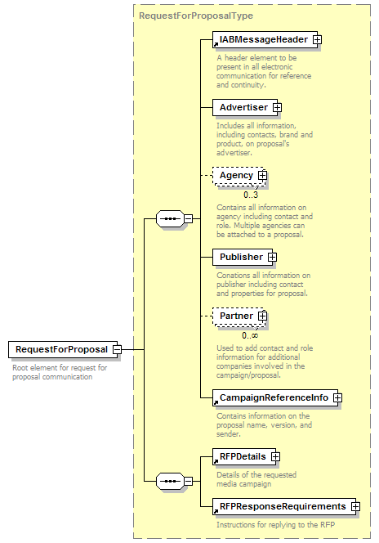

IABMessageHeader | This element will be provided with all e-business communication and contains header information about the data such as schema version, type of media, and a unique message ID.
Advertiser | An RFP will have exactly one advertiser specified. Within the element there is the ability to provide all of the details about the advertiser including unique identifiers, contacts, addresses, brands involved, etc.
Agency | Agency is an optional element if the RFP is coming direct from an advertiser. Otherwise most of the time one agency will be listed, but the schema accommodates up to three agencies. Any additional would be listed in the partner section. Within the element there is the ability to provide all of the details about the agency including unique identifiers, contacts, addresses, etc.
Publisher | Publisher is a required element and references the publisher or selling entity that the RFP is directed to. Within the element there is the ability to provide all of the details about the publisher including unique identifiers, contacts, addresses, specific sites requested, etc.
Partner | Partner is a repeatable optional element to list additional parties involved in the process.
CampaignReferenceInfo | This element will be provided with all e-business communication and provides continuity between the different interactions between buyer and seller on a given campaign.
RFP Details | This section provides multiple elements for the buyer to indicate their campaign and media goals, including publisher qualifications, types of media desired, targeting, etc.
RFPResponseRequirements | Provides information about when and how the publisher should respond if interested.

Proposal
Initiated by a seller’s system, XML that meets the IAB_ProposalCommon.XSD schema for Proposal should be able to completely communicate the seller’s response to an RFP from a buyer/agency.

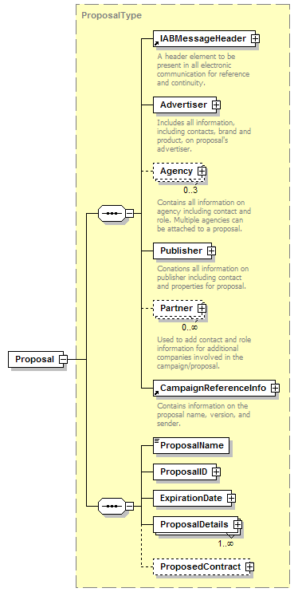

IABMessageHeader | See description in RequestForProposal
Advertiser | See description in RequestForProposal
Agency | See description in RequestForProposal
Publisher | See description in RequestForProposal
Partner | See description in RequestForProposal
CampaignReferenceInfo | See description in RequestForProposal
Proposal Name | Name of Proposal for identification purposes
Proposal ID | Seller’s system ID for Proposal
ExpirationDate | Date proposal is no longer valid
ProposalDetails | Includes all media plan details including line items/placements, creative specs, etc.
ProposedContract | Includes all terms and conditions as well as billing information necessary to complete payment terms.

InsertionOrder
Initiated by a buyer’s system, XML that meets the IAB_InsertionOrderCommon.XSD schema for InsertionOrder (IO) should be able to completely communicate the buyer’s acceptance of Proposal by a seller. In addition to information communicated through the Proposal, the IO should include buyer system line item IDs, tags, etc.

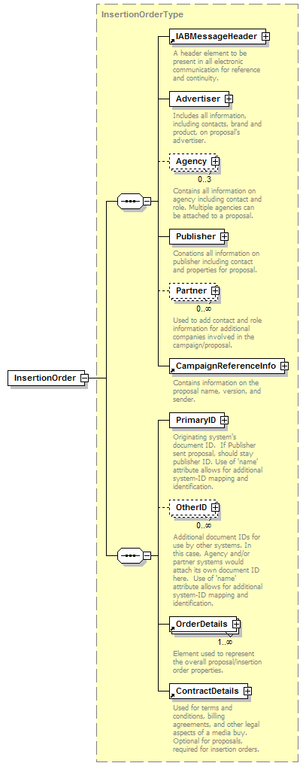

IABMessageHeader | See description in RequestForProposal
Advertiser | See description in RequestForProposal
Agency | See description in RequestForProposal
Publisher | See description in RequestForProposal
Partner | See description in RequestForProposal
CampaignReferenceInfo | See description in RequestForProposal
PrimaryID | Agency system ID for IO
OtherID | Publisher and other system IDs for IO
OrderDetails | Includes line-item information, etc
ContractDetails | Billing and other Ts&Cs

Acknowledgement
Initiated by both buyer and seller systems, XML that meets the IAB_Acknowledgement.XSD schema for Acknowledgement should be able to completely communicate the result of receiving a message (document) from another party. The IAB_Acknowledgement schema governs the message receipt communications. Use cases and further documentation on the use of this schema can be found in the Technical Specifications document.

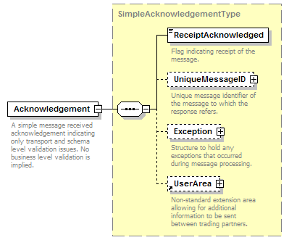

ReceiptAcknowledged | Flag indicating receipt of the message.
UniqueMessageID | Unique ID of the message received. When Acknowledgment is sent by receiving system, sending system uses this to match up sent message with response.
Exception | Can be used to hold any type of exceptions based on use cases found in the Technical Specification document, such as malformed XML.
UserArea | Additional area to allow for additional non-standard notes to be sent, including business rule failures etc. Individual entity’s business rule failures may be communicated here but are not required to be processed by the sender system upon receipt of Acknowledgement. See Technical Specifications document for further details.

