
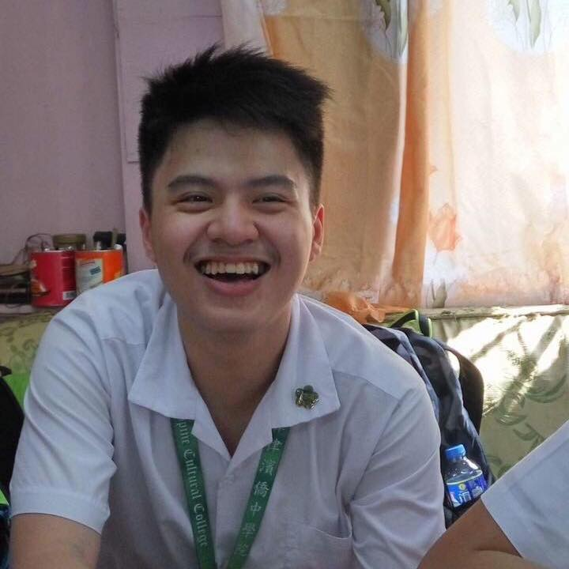
jeffrey cu
Numancia Street, San Nicolas Barangay 285
Binondo, Manila 1010 Manila, Manila City
(02)354-7609
+639179819999
jeffrey_cu@dlsu.edu.ph

OBJECTIVE

To join an organization to practice and develop my skills with the degree and develop management skills.

EDUCATION

de la salle university
Bachelor of Science degree in Mechanical Engineering, with specialization in Mechatronics Engineering

Philippine cultural college
High School Diploma, March 2018. Honorable Mention.

SEMINARS ATTENDED

December 2018 MANAGEMENT seminar
Rizal Mini Theater, Ateneo de Manila University

PERSONAL BACKGROUND

Fluent in English and Mandarin. Knowledgeable in Microsoft programs. Adaptable and detail-oriented.

