[Template for weekly studio submission]

Studio {Specify Studio #}

Name and Student Id: {Use multiple names and Ids for group work}

Self-Evaluation {To be highlighted by Student only}:

|  |  |  |  |  |  |
| --- | --- | --- | --- | --- | --- |
| Need Help | Work in Progress | Pass | **Credit** | Distinction | High Distinction |

Tutor Evaluation {To be highlighted by Tutor only}:

|  |  |  |  |  |  |
| --- | --- | --- | --- | --- | --- |
| Incomplete | Needs improvement | Pass | Credit | Distinction | High Distinction |

Task {X.1}:

{Answers}

1. With async, the process of loading and rendering subsequent document elements will be parallel to the loading and execution of script.js.
2. With defer, the process of loading subsequent document elements is done in parallel (asynchronously) with the loading of the script.js, but the execution of the script.js is done after all element parsing is complete and before the DOMContentLoaded event is triggered.

{Screenshots}

{Link to code repository}

{References}

{URLs}

Task {X.2}:

{Answers}

{Screenshots}

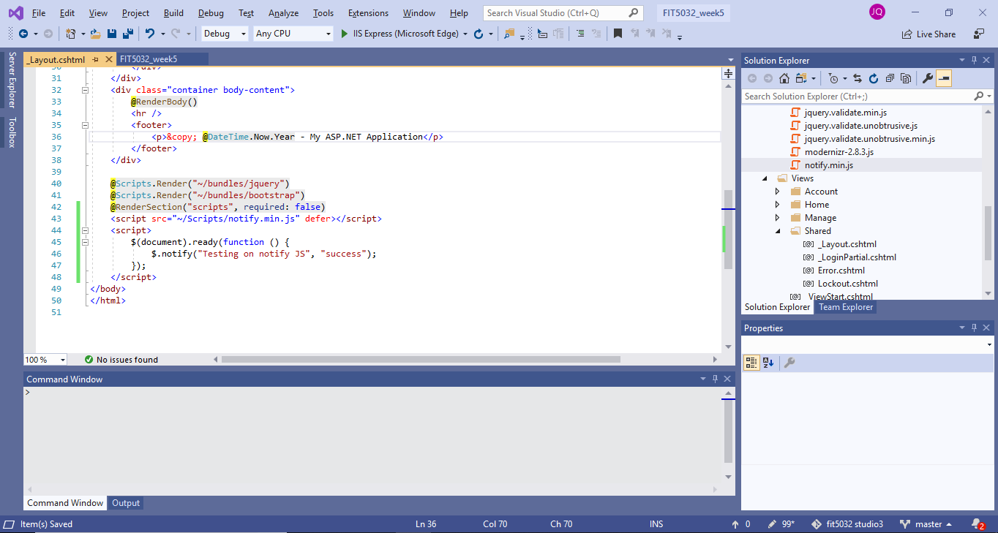

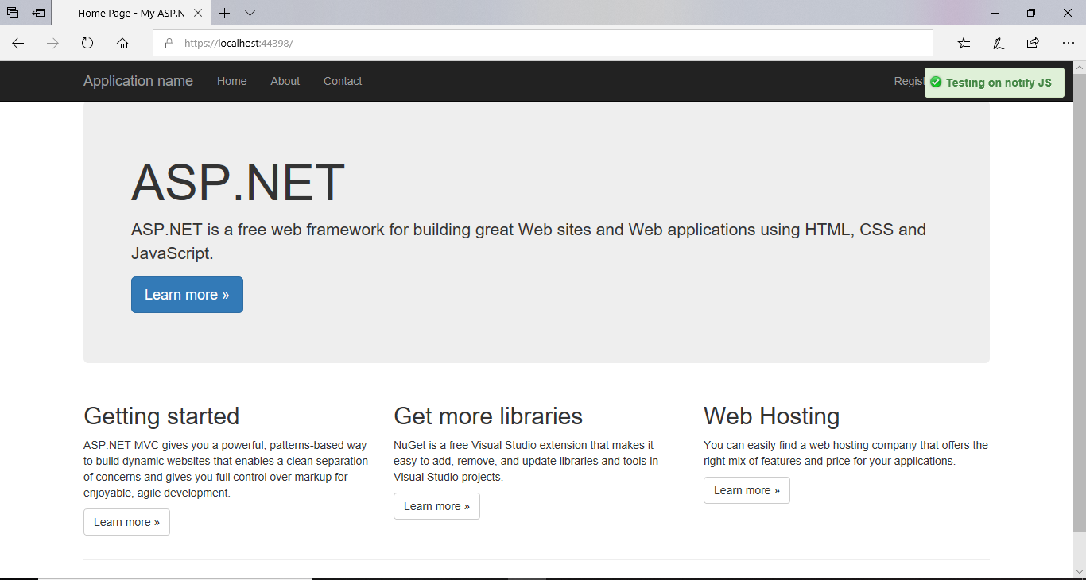

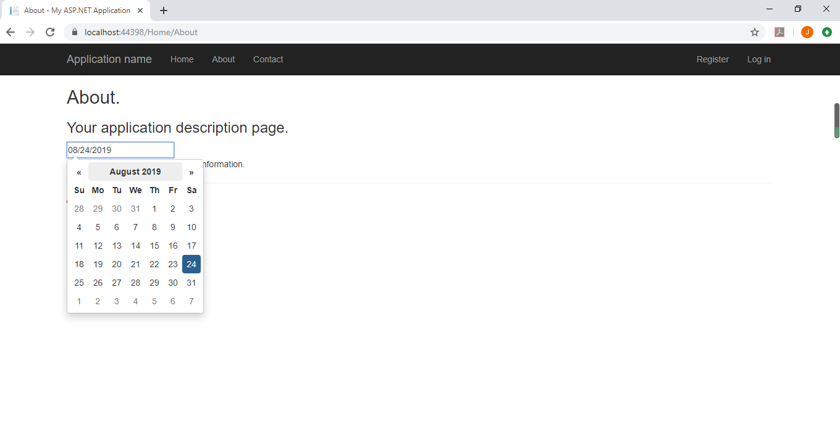

{Link to code repository}

<https://localhost:44398/Home/About>

{References}

{URLs}

<https://localhost:44398/Home/About>