[Template for weekly studio submission]

Studio {Specify Studio #}

Name and Student Id: {Use multiple names and Ids for group work}

Self-Evaluation {To be highlighted by Student only}:

|  |  |  |  |  |  |
| --- | --- | --- | --- | --- | --- |
| Need Help | Work in Progress | Pass | **Credit** | Distinction | High Distinction |

Tutor Evaluation {To be highlighted by Tutor only}:

|  |  |  |  |  |  |
| --- | --- | --- | --- | --- | --- |
| Incomplete | Needs improvement | Pass | Credit | Distinction | High Distinction |

Task {X.1}:

{Answers}

{Screenshots}

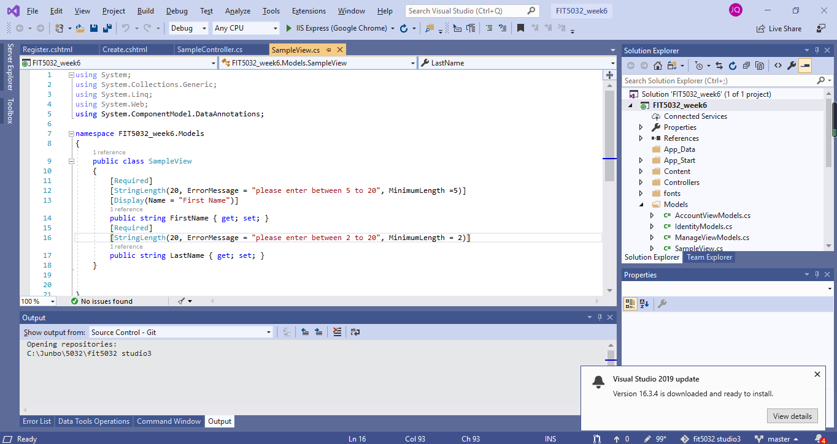

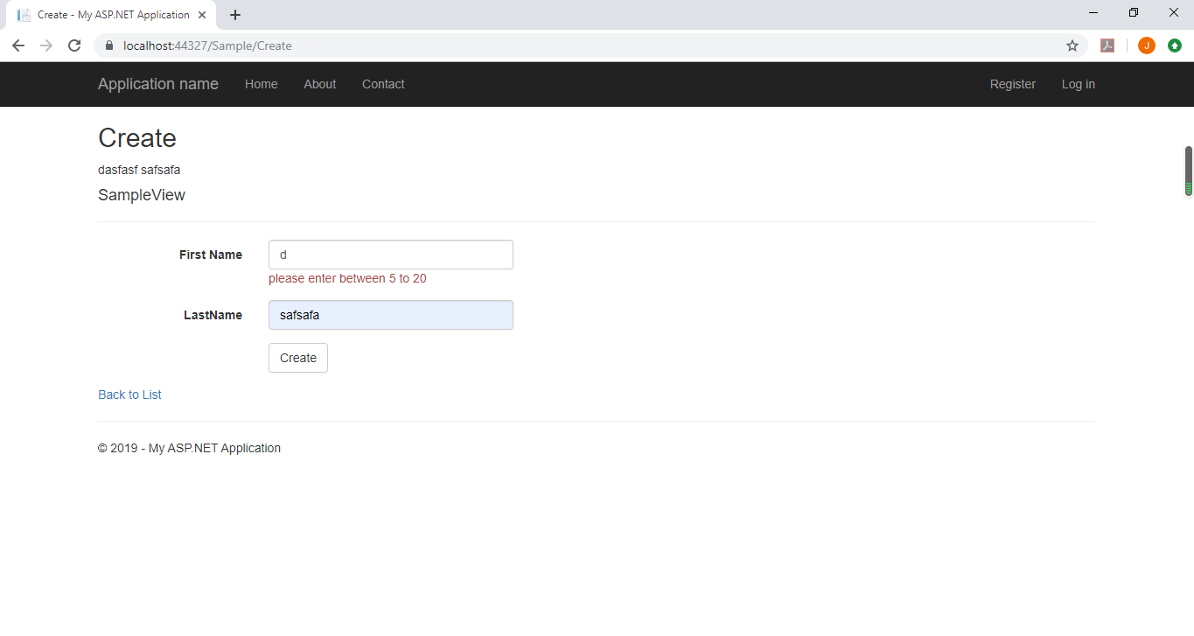

{Link to code repository}

{References}

{URLs}

<https://localhost:44327/>

Task {X.2}:

{Answers}

{Screenshots}

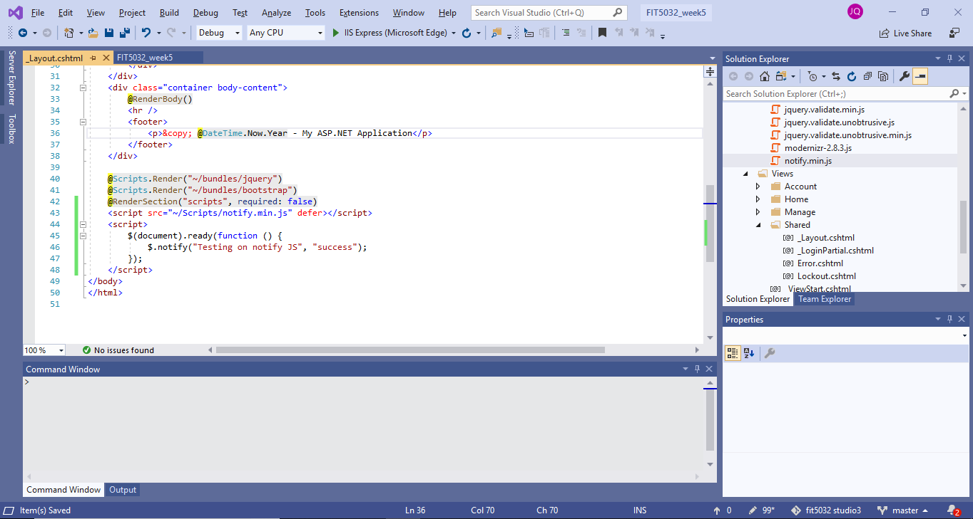

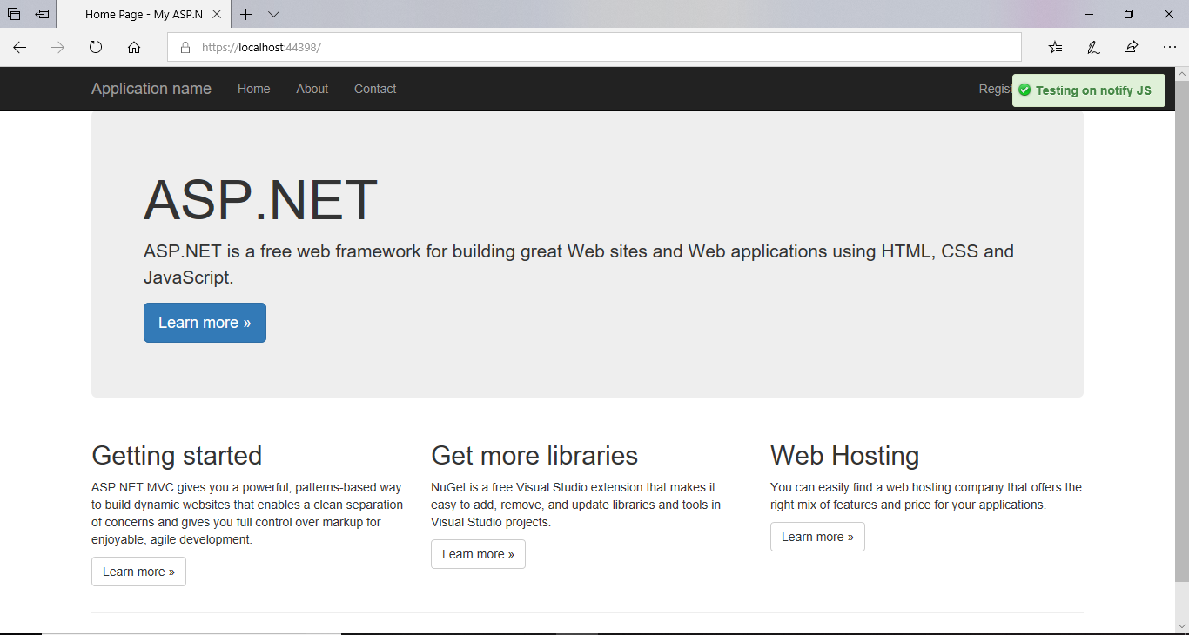

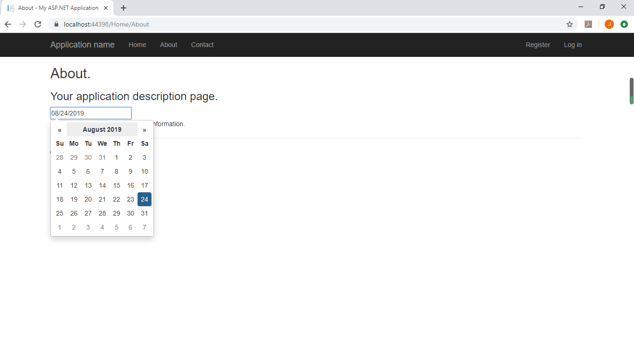

{Link to code repository}

<https://localhost:44398/Home/About>

{References}

{URLs}

<https://localhost:44398/Home/About>