Allocation Scenarios
I simulated five different allocation strategies in four varying market conditions, as outlined below.

Strategy Overview
Strategy Name | Description
Growth | Growth-focused: seek startups with high revenue traction and expansion.
Risk | Risk-minimizing: avoid vulnerable startups.
Efficiency | Capital-efficiency-focused: prioritize self-sufficient startups.
Strategic | Strategic-importance-focused: fund startups with high ecosystemic value.
Baseline | Balanced: equal weights across all composite metrics.

Market Overview
Market Condition | Description
Neutral Market | The control environment where startups perform naturally based purely on their individual business health.
Bull Market | A thriving, high-growth environment that minimizes overall market danger and allows fast-moving companies to maximize their returns.
Recession | A severe economic downturn that spikes capital risk and cuts growth potential across the entire portfolio.
Stagflation | A tricky economic trap where slow growth and rising costs squeeze smaller startups while favoring established, large-scale companies.

- Neutral Market
The neutral market is represented by the absence of external penalties and amplifiers. All four of the macroeconomic modifiers are set to 1.0. Thus, startups are evaluated purely on their business metrics, forming a baseline portfolio against which to compare portfolios from other markets.

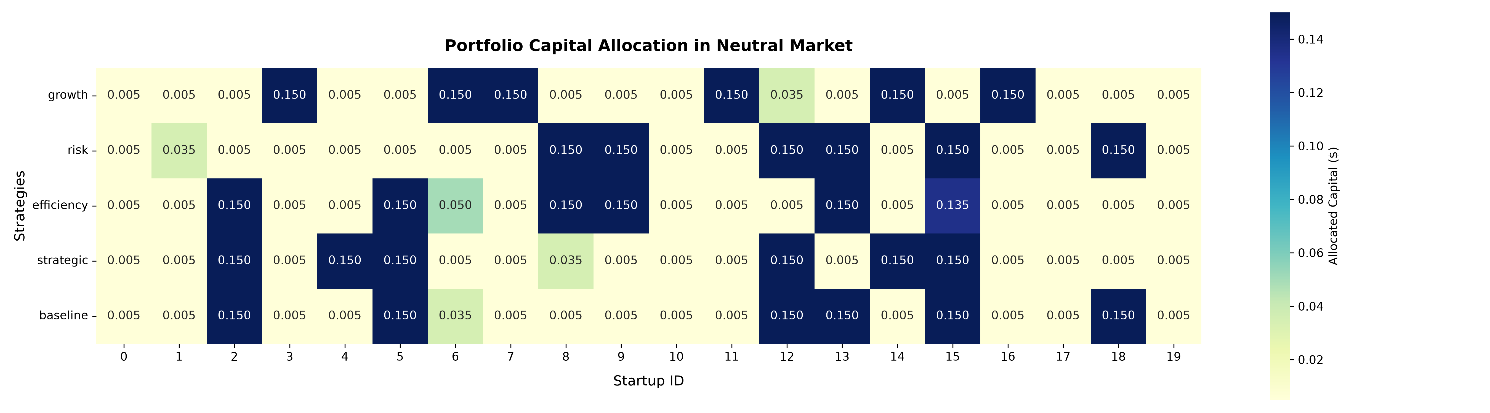
Figure 1: Heatmap of capital allocation per startup by strategy in a neutral market.

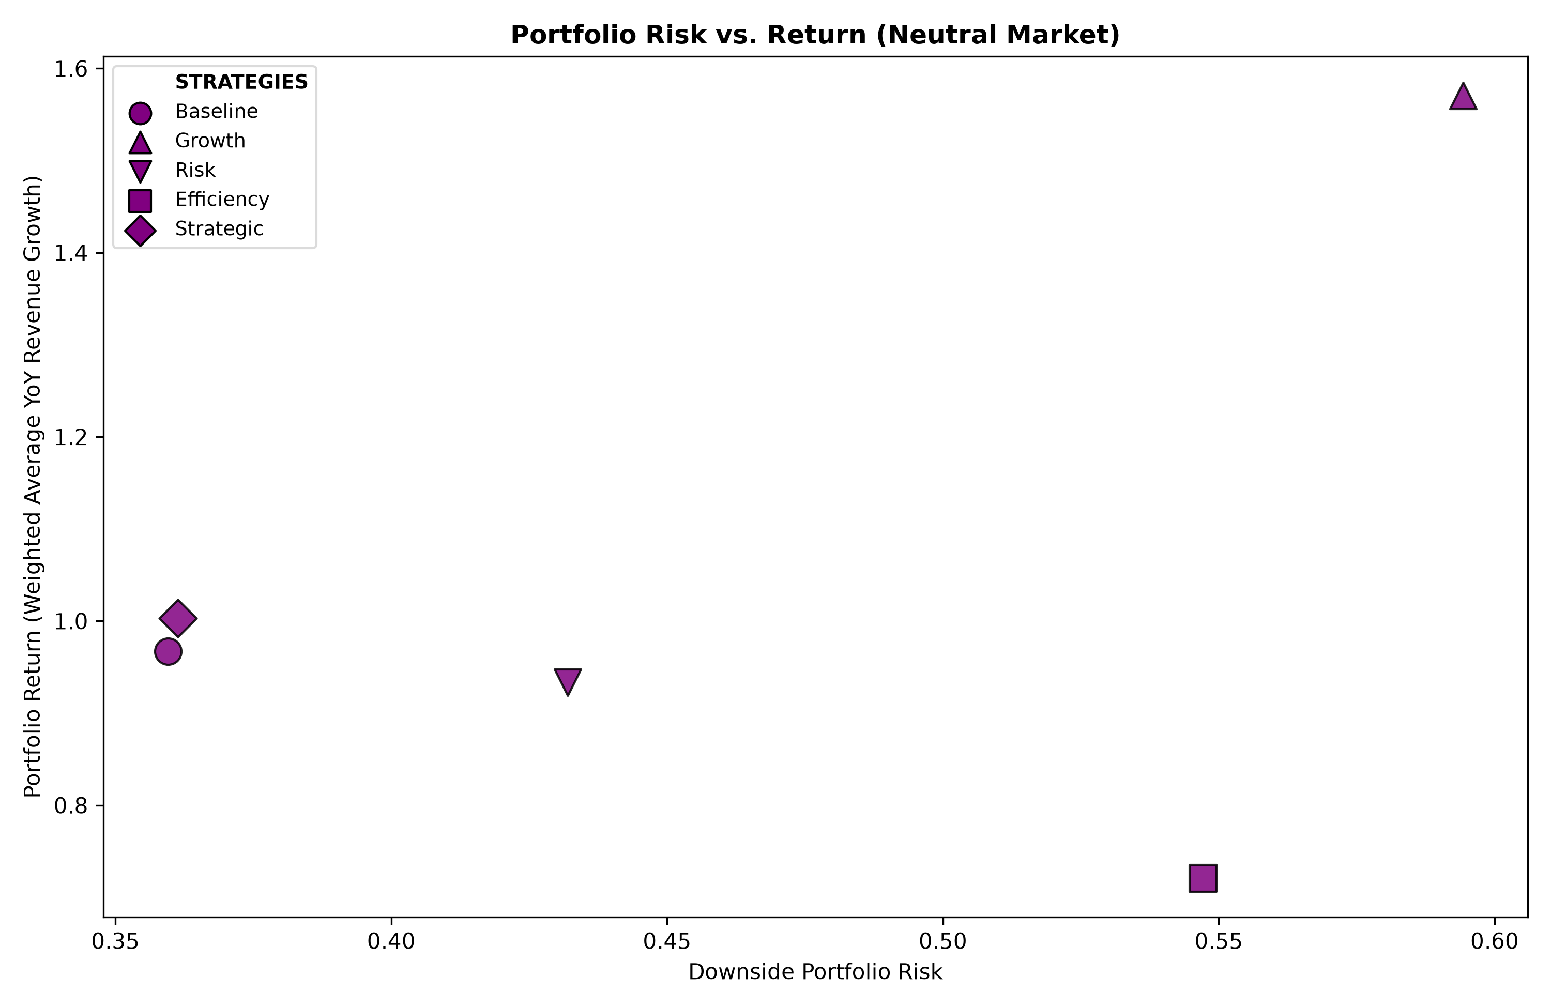
Figure 2: Scatterplot of risk vs. return tradeoff of each strategy in a neutral market.

  - Baseline
The baseline strategy allocates majority of capital into Startups 2, 5, 12, 13, 15, and 18, attaining a 0.99 (99%) return and a low 0.36 downside risk. Because it weights all four factors equally, this strategy avoids increased risk from placing extra capital in overly defensive or highly correlated, cash-preserving startups but also does not have the tactical edge to achieve a higher return.

  - Growth
The growth strategy aggressively shifts capital into rapidly expanding, high-beta companies, specifically Startups 3, 6, 7, 11, 14, and 16, which carry an average growth score of 8.60 and an average risk score of 7.03. As a result, this portfolio captures the peak performance in the neutral market, realizing a massive 1.56 (156%) return alongside a high 0.59 downside risk profile. This outcome supports that maximizing revenue velocity forces the fund to absorb maximum portfolio volatility, establishing that exceptional growth cannot be decoupled from high risk exposure.

  - Risk
The risk-mitigating strategy isolates the safest available assets, specifically Startups 8, 9, 12, 13, 15, and 18, which boast a remarkably low average standalone risk score of 1.78. However, minimizing individual asset variance introduces the hidden vulnerability of positive covariance risk, as these similarly structured companies tend to be exposed to the same underlying market pressures. Consequently, this strategy fails to achieve the lowest downside risk in the neutral market, stabilizing at a 0.43 downside risk profile. Because the algorithm focuses exclusively on minimizing statistical volatility rather than targeting revenue expansion, it locks the portfolio into a moderate 0.93 (93%) return, proving that raw variance filtration without operational scale creates a suboptimal risk-adjusted shield.

  - Efficiency
By directing investments exclusively toward the most self-sufficient companies, specifically Startups 2, 5, 8, 9, 13, and 15, the efficiency strategy starves the portfolio of high-velocity and large-scale assets. This restriction results in the poorest-performing portfolio in the neutral market, yielding a weak 0.72 (72%) return. Furthermore, because these lean companies lack the scale required to absorb operational friction, the portfolio’s internal risk correlation rises, forcing it to absorb a high 0.55 downside risk profile. This confirms that a rigid focus on capital conservation over business scale degrades risk-adjusted performance, even within a stable, unpenalized macroeconomic environment.

  - Strategic
The strategic importance strategy divests funding into fundamentally dominant assets, such as Startups 2, 4, 5, 12, 14, and 15. By focusing on companies that command core market infrastructure, this strategy builds a portfolio with the optimal risk-adjusted performance in the neutral, securing a strong 1.00 (100%) return paired with a regime-low 0.36 downside risk profile. Because these startups possess immense operational resilience and decoupled business models, they have low correlation, out-diversifying the pure risk-mitigating strategy, proving that structural enterprise scale is the ultimate defensive shield in a stable economy.

- Bull Market
A bull market is modeled as a high-growth, expansionary economic regime where capital is cheap and risk appetite is high. Within the optimization framework, this environment is simulated by amplifying growth by a factor of 1.5 and discounting risk by a factor of 0.6. Capital efficiency is de-emphasized to 0.9, and strategic importance is elevated to 1.1 to reflect a market that prioritizes scale over near-term profitability.

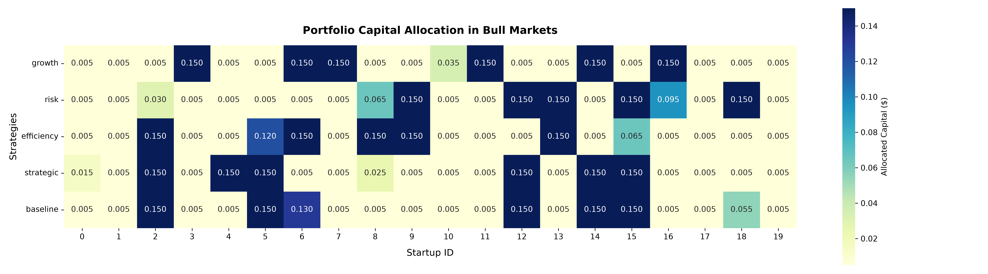
Figure 3: Heatmap of capital allocation per startup by strategy in a bull market.

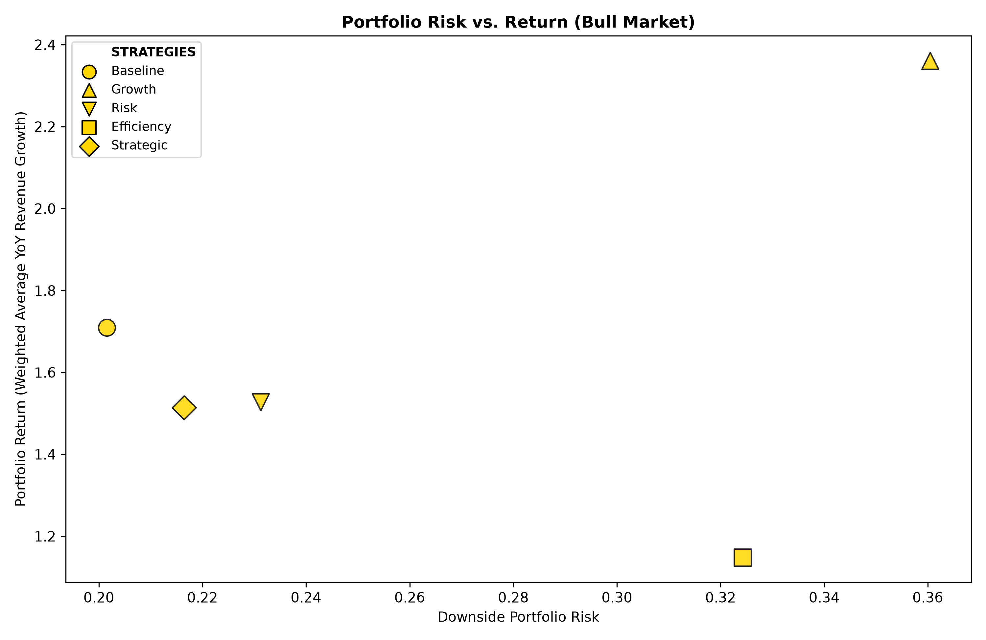
Figure 4: Scatterplot of risk vs. return tradeoff of each strategy in a bull market.

  - Baseline
The baseline strategy serves as the portfolio’s neutral benchmark, allocating majority of capital in Startups 2, 5, 6, 12, 14, and 15. By placing equal weight across all four factors, this approach avoids active concentration biases, producing a highly diversified portfolio. Consequently, it achieves the lowest risk profile across all strategies with a downside risk score of 0.20 while still capturing a strong 1.70 (170%) return. However, because a surging bull market heavily favors aggressive risk-taking, this strategy leaves substantial money on the table, lagging the growth strategy’s return by 43%.

  - Growth
Under the growth-focused strategy, the optimizer funnels capital into Startups 3, 6, 7, 11, 14, and 16, the same allocation as in the neutral market. Since the model rewards growth and discounts risk, this strategy captures higher upside momentum, achieving the portfolio’s overall highest return at 2.38 (238%) while carrying a risk of 0.36, the highest compared to other strategies in the bull market but relatively low compared to strategies across all market regimes.

  - Risk
The risk-minimizing strategy, by contrast, continues to prioritize structural downside protection despite the macro environment’s high-risk tolerance. By concentrating maximum capital into Startups 9, 12, 13, 15, and 18, the model builds the portfolio’s foundation around safe profiles with a low average risk score of 2.14 and a moderate average growth score of 4.74. This dual focus yields a highly controlled portfolio downside risk score of 0.23 while successfully capturing a respectable 1.55 (155%) return driven by broad bull market expansion.

  - Efficiency
Although bull market parameters discount the weight of capital efficiency to 0.9, the efficiency strategy still concentrates 87% of fund capital into six lean, cash-preserving Startups 2, 5, 6, 8, 9, and 13. Despite these startups maintaining a low average risk score of 2.0, this severe lack of asset diversification drives the portfolio’s aggregate risk profile up to 0.32. Because these specific companies exhibit highly correlated downside semi-covariance, a broad market contraction would trigger simultaneous operational drawdowns and funding hurdles across all six positions, leaving the entire strategy highly exposed to systemic macroeconomic shocks.

  - Strategic
The strategic-importance-focused strategy divests capital primarily into Startups 2, 4, 5, 12, 14, and 15, targeting companies that build critical market infrastructure and strong network effects. As a result, this strategy yields a balanced 1.50 (150%) return and a 0.22 risk profile. Moreover, this strategy accepts a 13% reduction in raw growth and absorbs slightly higher risk compared to the baseline strategy in exchange for a portfolio built on assets with long-term competitive moats.

- Recession
A recession is defined as a contractionary economic regime where capital tightens, valuations recede, and risk tolerance bottoms out. Within the optimization framework, this risk-averse climate is engineered by tempering growth with a 0.5 discount factor and compounding the downside risk penalty with a 1.6 multiplier. Concurrently, the model elevates the capital efficiency parameter to 1.4 to isolate cash runway and immediate profitability while restricting strategic importance to 0.5 as long-term expansion goals give way to short-term business survival.

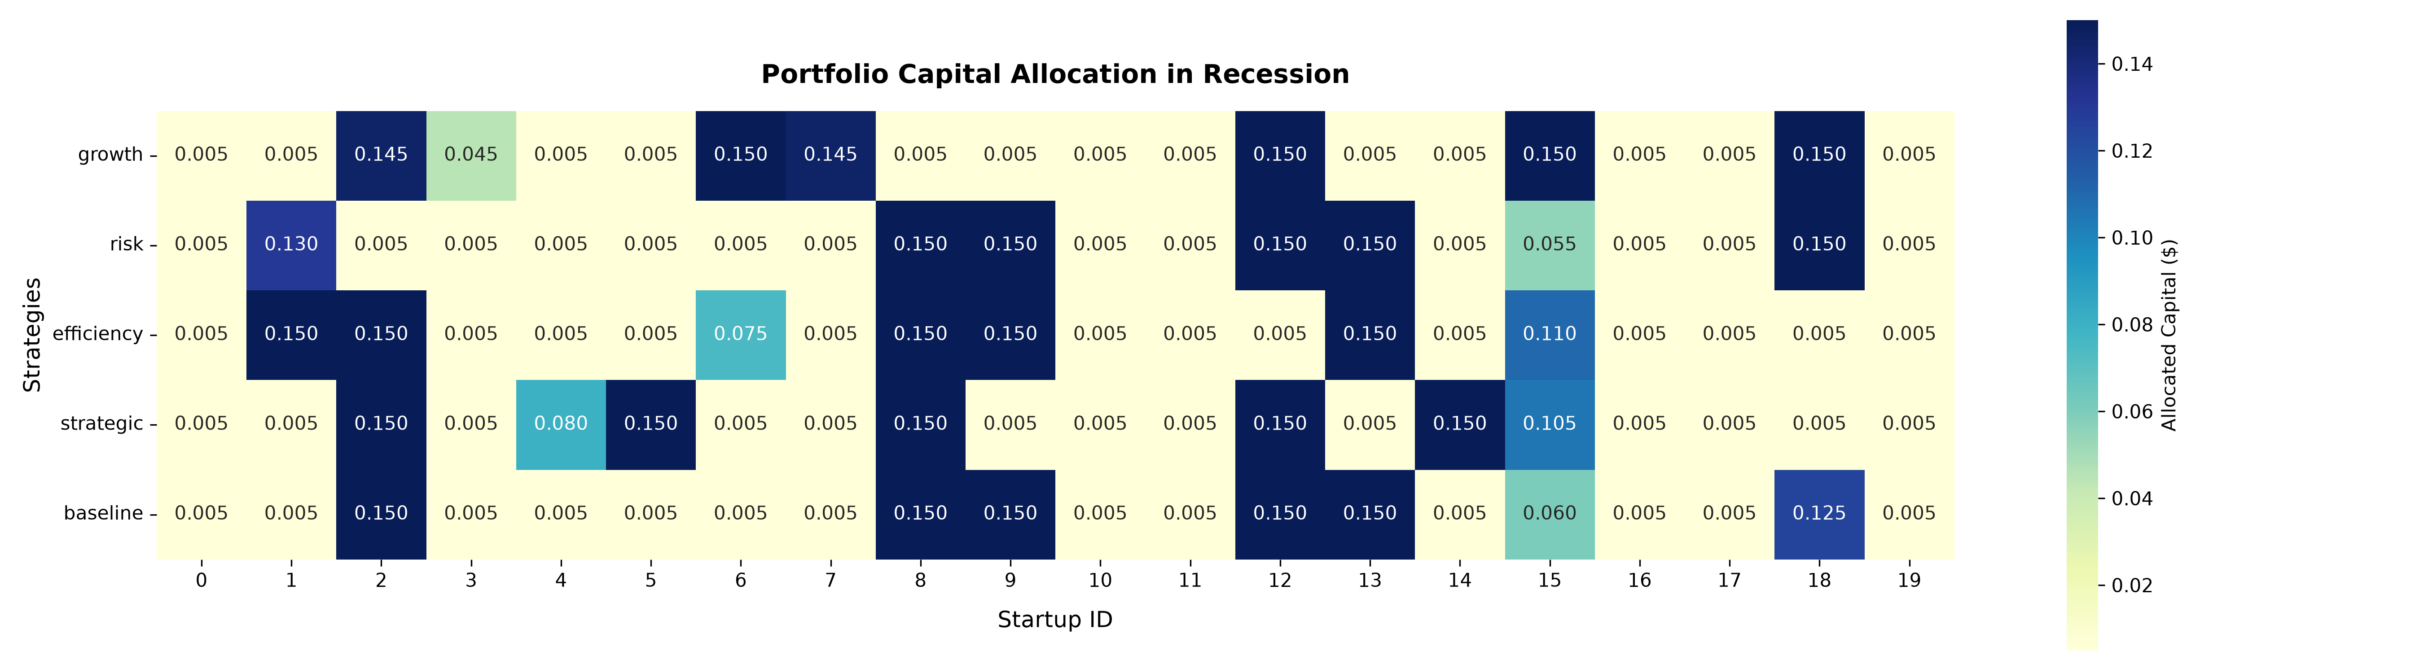
Figure 5: Heatmap of capital allocation per startup by strategy in a recession.

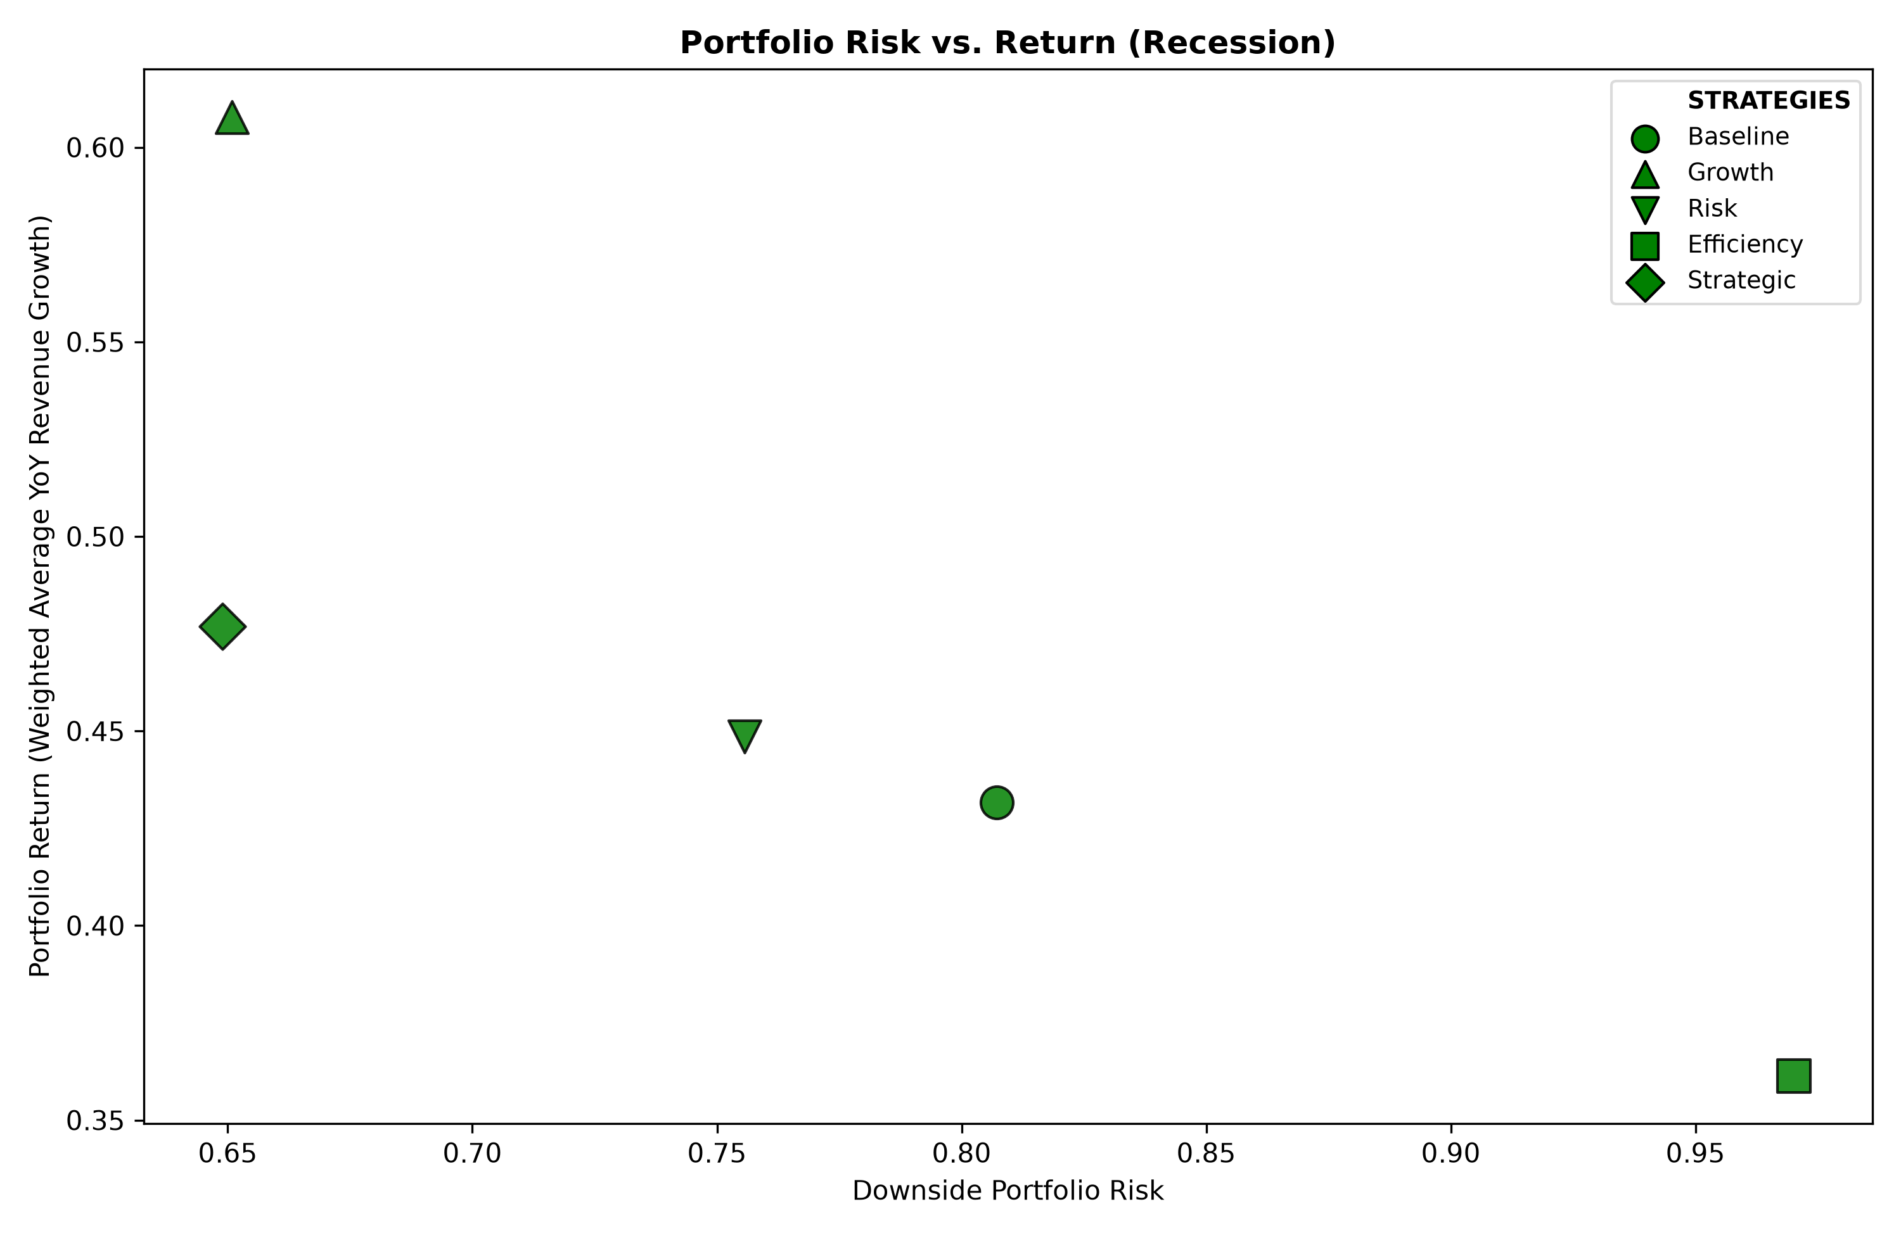
Figure 6: Scatterplot of risk vs. return tradeoff of each strategy in a recession.

  - Baseline
In a recessionary climate, the baseline strategy fully exposes the portfolio to systemic deterioration, as its equal weighting across all factors lacks the strength to counter contractionary macroeconomic forces. This strategy distributes capital into Startups 2, 8, 9, 12, 13, and 18, moving the portfolio to a heavily penalized position. Whereas in the bull market, the baseline strategy achieves the lowest risk and second-highest return, it only captures a modest 0.43 (43%) return while absorbing a massive downside risk of 0.81 in a recession. This outcome demonstrates the risk of maintaining a static, unweighted portfolio during a market downturn, a time when clear macroeconomic indicators require active shifts into defensive assets.

  - Growth
When confronted with a recession, the growth-focused strategy abandons the speculative, high-growth assets it chose in the bull market and retreats into the most robust revenue-generating startups. It pours capital into Startups 2, 6, 8, 12, 15, and 18 which have an average growth score of 4.62 and an average risk score of 2.72. While this cohort successfully buffers the portfolio to generate the regime’s highest performance at 0.61 (61%) return and lowest downside risk of 0.65, it ultimately cannot escape the broader macroeconomic climate, illustrating how widespread economic contractions drag down even the highest-growth assets.

  - Risk
The risk-minimizing strategy successfully mitigates portfolio volatility during a macroeconomic downturn. It funnels maximum capital allocations into Startups 1, 8, 9, 12, 13, and 18, which have an average risk score of 1.32. This risk management effectively shields the portfolio, yielding a downside risk profile of 0.76, reducing volatility compared to the baseline and efficiency tracks, while still capturing a resilient 0.45 (45%) return under intense market pressure. However, because this strategy solely focuses on minimizing overall portfolio variance, it fails to diversify its assets as the growth and strategic importance strategies would, leading to a slightly higher risk profile.

  - Efficiency
The efficiency strategy shifts capital into lean, low-burn operators, specifically Startups 1, 2, 8, 9, and 13. Because these cash-preserving companies sacrifice top-line expansion to extend their runway longevity, the portfolio has the lowest return of 0.36 (36%) in a recession. Furthermore, these assets tend to be highly correlated due to the severe lack of sector diversification among cash-lean startups, driving up the portfolio’s aggregate risk profile to an extreme 0.97, thus making it highly vulnerable to systemic macroeconomic shocks.

  - Strategic
Although the recession parameters discount strategic importance, this strategy still concentrates on fundamental infrastructure and network-effect anchors, namely Startups 2, 4, 5, 8, 12, and 14. These startups’ long-term survival rates form the foundation of a portfolio with the second-highest return of 0.48 (48%) and a similar risk profile as the growth strategy of 0.65. This performance demonstrates that safeguarding core market infrastructure can provide an inherent cushion while preserving vital long-term upside potential.

- Stagflation
Stagflation introduces a restrictive macroeconomic environment within the optimization model, characterized by stifled revenue growth and market-wide risk correlations. The model executes this regime by dampening the growth modifier to 0.8, leaving the risk unadjusted at 1.0, prioritizing lean structures with a 1.3 efficiency weight, and grounding the portfolio with a resilient 0.9 strategic importance setting.

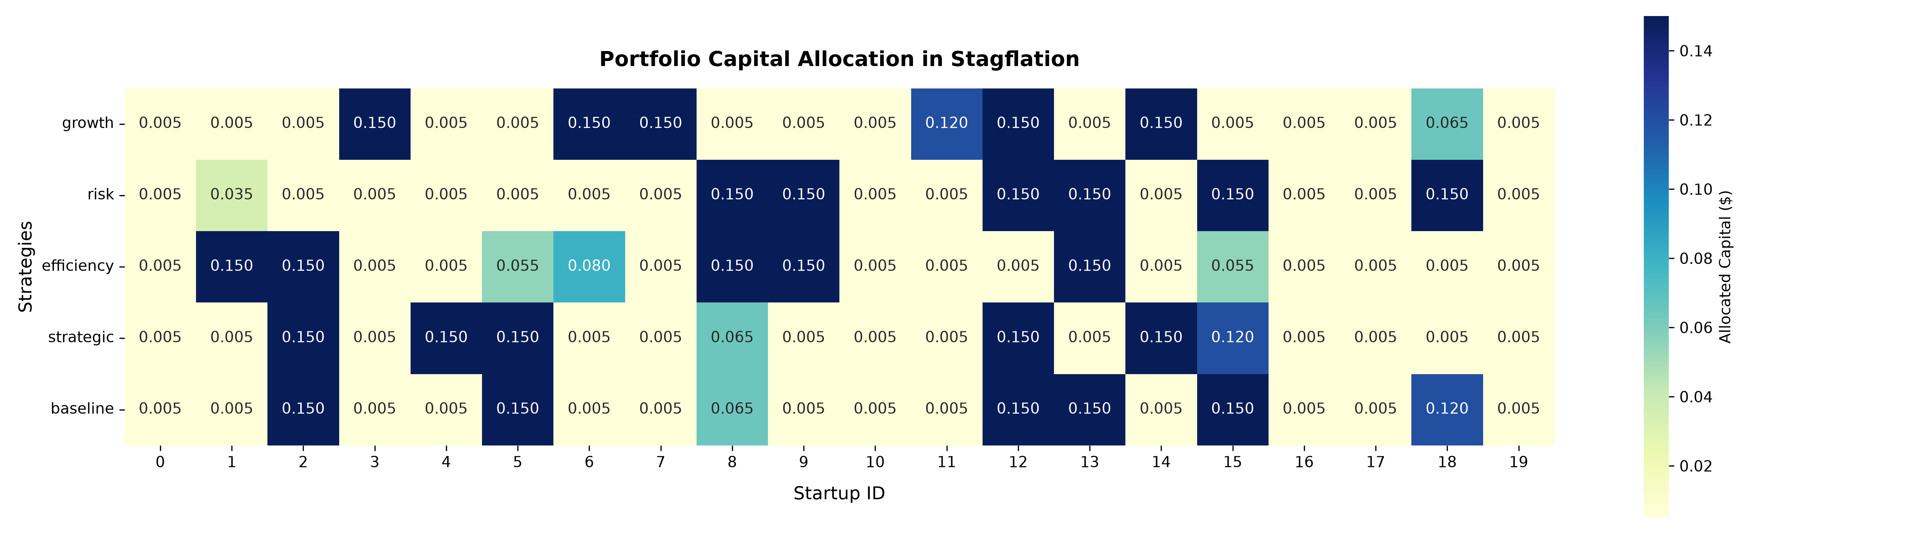
Figure 7: Heatmap of capital allocation per startup by strategy in stagflation.

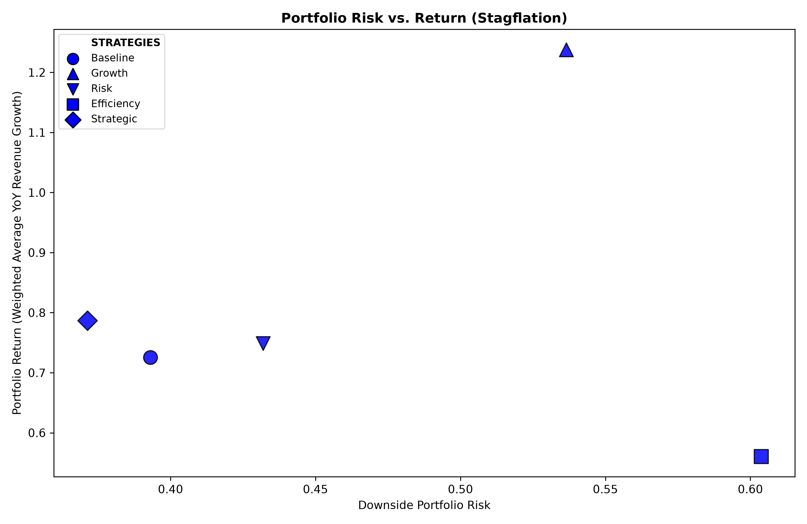
Figure 8: Scatterplot of risk vs. return tradeoff of each strategy in stagflation.

  - Baseline
By placing equal weight on all factors, the baseline strategy hedges against shifting macroeconomic parameters of stagflation with most of its capital in Startups 2, 5, 12, 13, 15, and 18. The portfolio reaches a healthy 0.73 (73%) return paired with a stable 0.39 downside risk profile. The broader market naturally lifts its performance; however, the strategy’s blind absorption of the operational drag from cash-starved startups alongside the gains of high-scale anchors prevents it from matching the higher risk-adjusted returns achieved by the strategic-importance portfolio.

  - Growth
Although the growth modifier is tuned down to 0.8, this strategy is still able to allocate majority of its capital into high-velocity assets, including Startups 3, 6, 7, 11, 12, and 14, which have an average growth score of 8.43. As a result, the portfolio achieves the highest return of 1.22 (122%). However, forcing hyper-growth in a stagnant economy proves to be inefficient as these primary startups have an average risk score of 7.02, and the portfolio attains the second-highest downside risk of 0.53.

  - Risk
Operating under a neutral 1.0 risk multiplier with no additional macroeconomic penalties, the risk-mitigating strategy pours capital into the optimal blend of low-volatility assets with minimal covariance. Startups 8, 9, 12, 13, 15, and 18 form the basis of such portfolio, with an average risk score of 1.78. This strategy locks in a moderate 0.75 (75%) return alongside a 0.43 risk profile, yet it does not obtain the lowest downside risk because the portfolio’s foundational companies lack the scale and pricing leverage necessary to guard against rising costs due to inflation.

  - Efficiency
The capital efficiency strategy collapses despite receiving a 1.3 modifier meant to favor lean operators such as Startups 1, 2, 8, 9, and 13. Since small companies lack market scale and pricing power, rising inflation-driven input costs completely choke out their margins, and thus this strategy backfires. The portfolio captures a weak 0.56 (56%) return while exploding aggregate portfolio risk to a regime-high of 0.60, demonstrating that pure cash conservation without structural scale is highly dangerous in stagflation.

  - Strategic
As the strategic importance strategy directs capital into startups building core market infrastructure and having deep network effects, especially Startups 2, 4, 5, 12, 14 and 15, it achieves the lowest risk profile of 0.36 and the second-highest return of 0.79 (79%). Due to their strong market presence, these startups retain their customers, even during periods of high inflation and economic stagnation, maintaining their strategic market positions and stable cash flows, allowing the strategy to dominate the baseline and risk portfolios, delivering superior returns with less volatility.

