Recommendation summary
This portfolio optimization model shows that no single allocation strategy delivers optimal risk-adjusted performance across all macroeconomic cycles. Investing in rapidly growing startups through the growth strategy regularly generates the highest portfolio return, but doing so also takes on the high downside risk. On the other hand, using the efficiency strategy to construct a portfolio with the most lean, self-sufficient startups routinely underperforms, providing the lowest returns while increasing exposure to correlated downside risk.

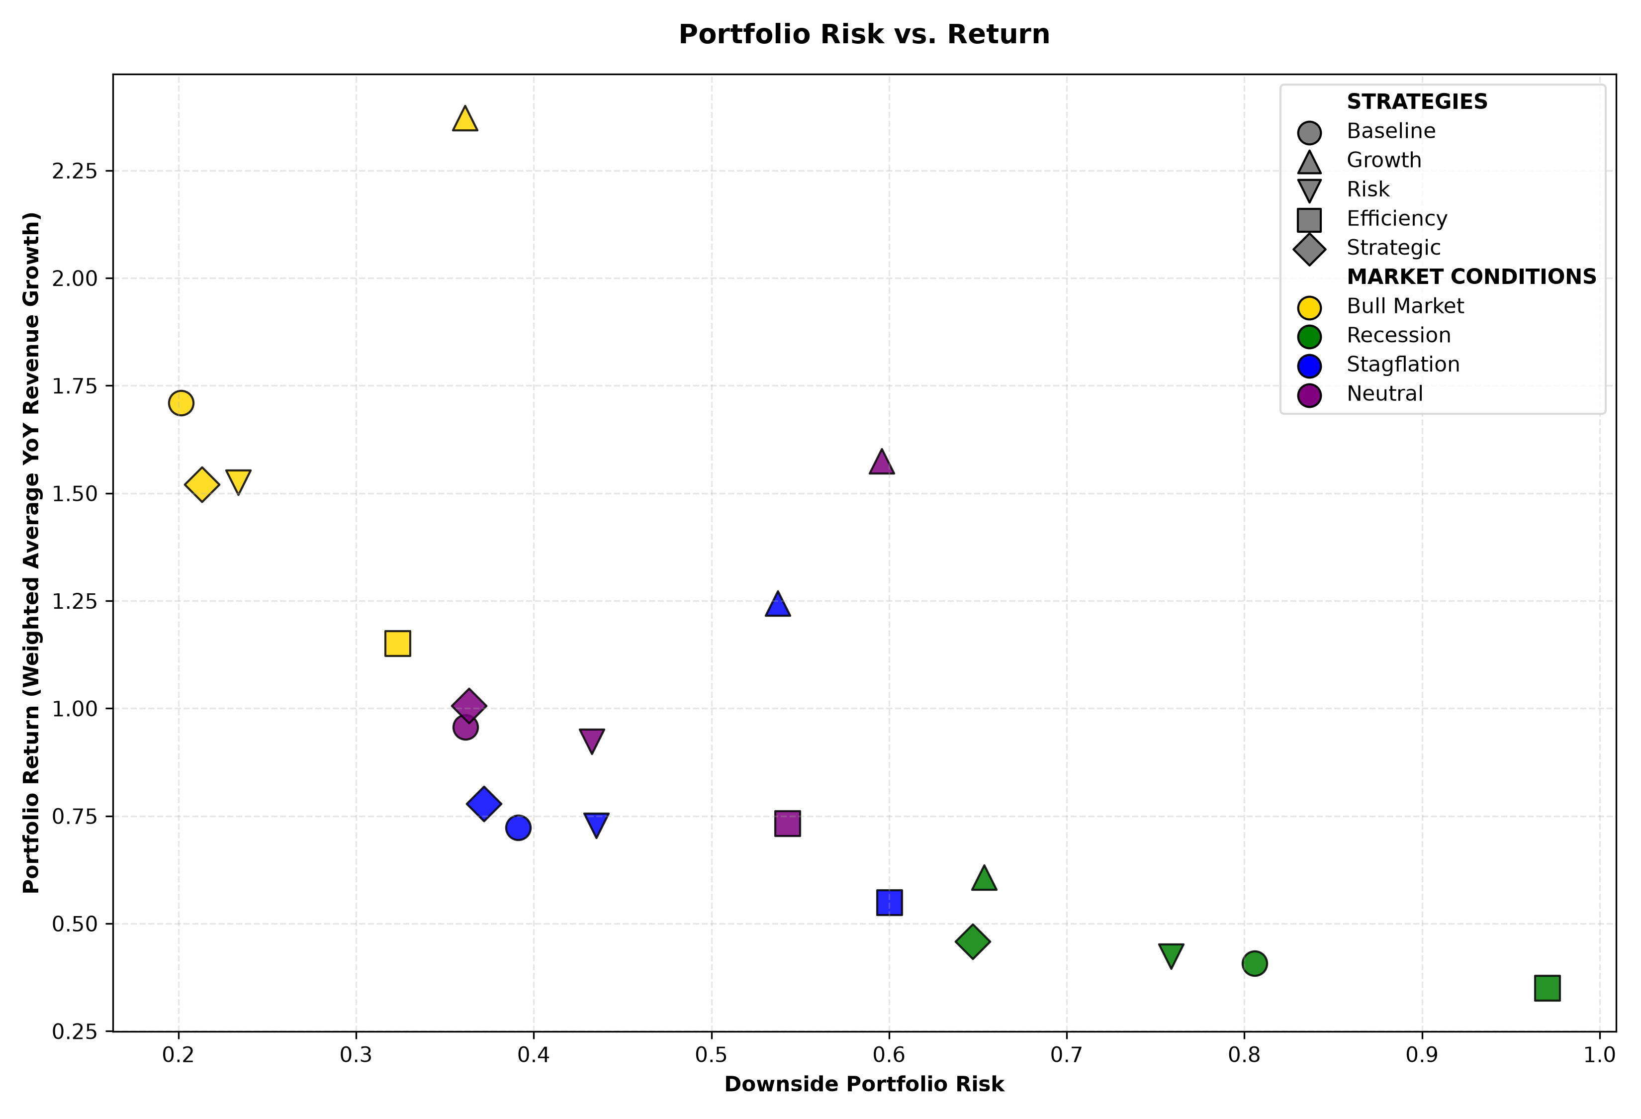
Figure 9: Scatterplot of risk vs. return tradeoff of each strategy in each market scenario.

Recommendation table
Market Condition | Recommended Strategy | Why?
Neutral Market | Strategic | Emphasize portfolio diversification to lower risk while maintaining respectable growth.
Bull Market | Growth | Capture the highest returns while risk tolerance is high.
Recession | Strategic | Prioritize a low-risk profile while managing a modest growth level.
Stagflation | Growth | Outpace inflationary pressures while accepting slightly higher downside risk.

Conclusion
The growth strategy is recommended for the bull market and stagflation scenarios to ensure that the portfolio performance exceeds that of the overall market. Although the strategy has a higher risk profile compared to others in these markets, the bull market naturally forgives higher-risk strategies while stagflation does not heavily penalize them. Meanwhile, the strategic strategy is suggested for the neutral market and recession cases where risk tolerance is low. Choosing startups with high competitive edge in the market not only promises the startups’ long-term survival, thus lowering risk, but also their future success, guaranteeing satisfactory portfolio returns.

