Model Validation Analysis
To test the stability of my model’s allocation recommendations, I vary several model parameters, as outlined in the table below.
Parameter | Description | Method of Variation | Original Value
Raw startup metrics | Generated mock business metrics to compute composite growth, risk, capital efficiency, and strategic importance scores used by the optimizer. | Use different seeds to add random 5% noise to the original generated metrics. | No noise
Initial allocation | Initial guess for optimal allocation. | Use different seeds to generate different initial allocations. | Distribute capital evenly (5% per startup)
Maximum allocation constraint | Upper bound for proportion of capital allowed to allocate to a single startup. | Define different upper bounds: 0.1, 0.2, and 0.25. | 0.15 (no startup can get more than 15% of the total capital pool)
Risk aversion | How cautious or aggressive the allocation should be for each strategy. | Scale the pre-determined risk-aversion values by 0.5, 0.75, 1.25, and 1.5. | No scaling

I compare the resulting allocations to the original one by assessing Spearman correlation, Herfindahl-Hirschman index drift, proportion of capital reallocated, and the mean and maximum change in capital allocation per startup.

- Spearman correlation
The Spearman correlation measures the relationship between two rankings: +1 means they are identical, 0 means they have no relationship, and -1 means they are reversed. In this case, the startups are ranked by how much capital they receive, and the Spearman correlation measures the relationship between the allocation produced by the original parameters and the allocation produced by changing the parameters.
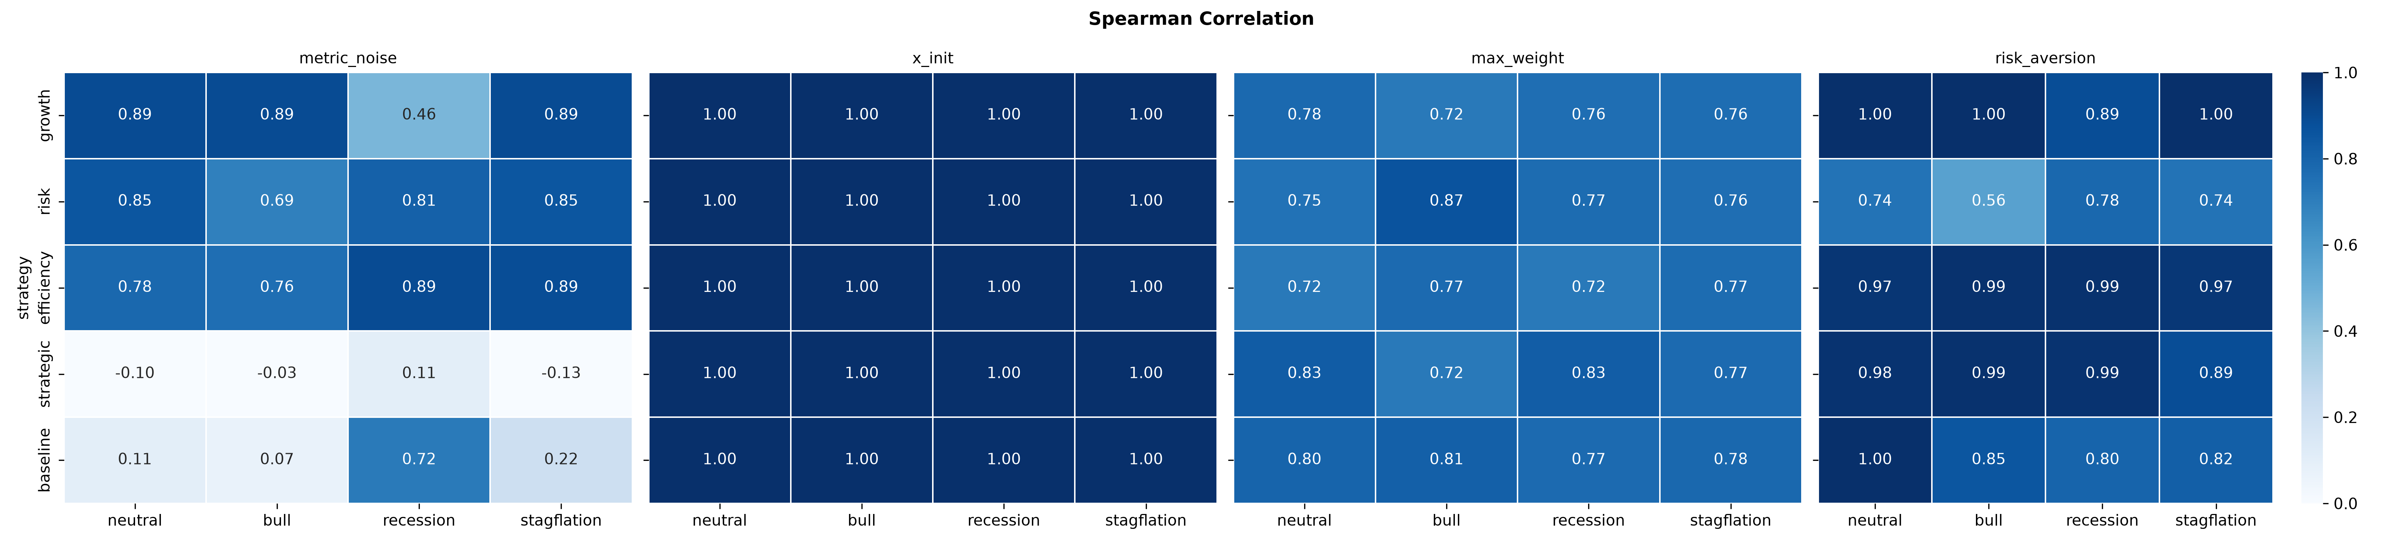
Figure 1: Heatmaps of lowest Spearman correlation between the original portfolio and the one with different parameter values for each strategy and market condition combination

Despite varying the initial allocation, maximum allocation constraint, and risk-aversion values, the model remains stable, each strategy producing similar allocation recommendations in each macroeconomic scenario as it did with the original parameter values. Meanwhile, the model is more sensitive to the underlying business metrics of each startup in the portfolio, especially when operating under the strategic importance and baseline strategies, recommending different allocations from the original portfolio as shown by the low Spearman correlation. This sensitivity results from the qualitative nature of strategic importance metrics, as they are integers from a narrow 1 to 10 range, so 5% noise changes them more than they would change financial metrics such as burn rate or LTV to CAC ratio. Since the model cannot reliably distinguish strategically important startups due to how they are scored, further inspection of the startups’ metrics is necessary before committing to the model’s suggestion of using either strategic importance or baseline strategies.

- Herfindahl-Hirschman index (concentration) drift
The Herfindahl-Hirschman index (HHI) measures the concentration of capital in the portfolio, calculated by summing up the squares of the portfolio weights. A high HHI means that capital is concentrated in only a few startups while a low HHI means that capital is evenly distributed among all startups. The HHI drift calculates how much the concentration of capital changes when the initial parameters change.
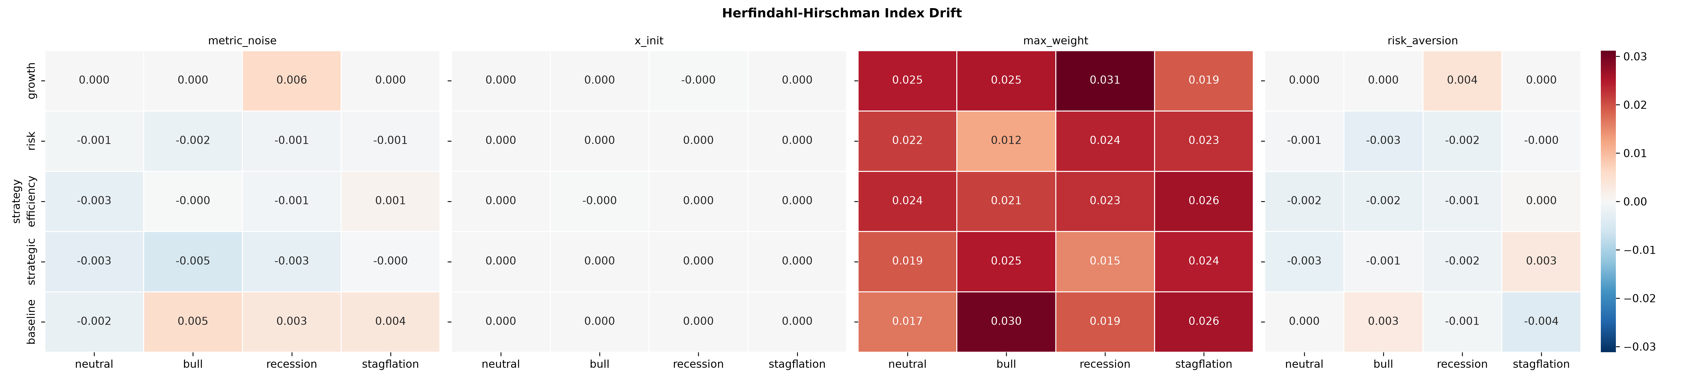
Figure 2: Heatmaps of average change in Herfindahl-Hirschman index between the original portfolio and the one with different parameter values for each strategy and market condition combination

Varying the raw metrics, initial allocation, and risk aversion exhibit minimal changes in the portfolio’s capital concentration. Naturally, adjusting the maximum allowed capital in a single startup drastically moves the concentration drift upwards because the optimizer can now increase or decrease weight in its top picks, depending on whether the upper bound is greater or less than that of the original portfolio.

- Proportion of budget reallocated
The proportion of budget reallocated shows how much of the capital pool moved around due to the changing parameters.
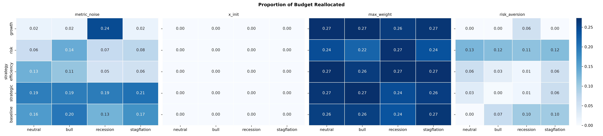
Figure 3: Heatmaps of average proportion of budget reallocated between the original portfolio and the one with different parameter values for each strategy and market condition combination

Changing the initial allocation does not move any capital around from the original allocation. Similarly, modifying the risk-aversion values reallocates under 10% of the total capital pool for the growth, efficiency, strategic, and baseline strategies. The risk-minimizing strategy reallocates 11 to 13% of capital, increasing or decreasing weight in safer startups corresponding to the risk-aversion multipliers. In response to noisy raw metrics, the optimizer reallocates more capital under the strategic and baseline strategies, agreeing with the low Spearman correlation for those strategies. Varying the maximum allocation for a single startup reallocates up to 27% of the total capital pool, aligning with the high concentration drift as the optimizer either moves capital toward or away from its top picks.

Conclusion
Overall, the model remains stable under changing initial allocation guesses and risk-aversion values. The model is most sensitive to different raw startup metrics, especially in the strategic strategy, and to different maximum allowed capital for a single startup. This instability originates not from the model itself but from the definition of these parameters. Using continuous quantitative instead of qualitative metrics for strategic importance would make them less susceptible to noise, allowing the model to more confidently distinguish startups with high strategic importance from those that do not. The maximum allowed weight on a single startup heavily influences how much capital the optimizer reallocates from the original recommendation and how concentrated the capital is in the portfolio yet generally preserves the order of which startups get the most capital, demonstrating that the model prefers to max out the amount of capital it can put in its top picks.

